*Muhammad Mufeez*

*BCS-3J*

***Coal Lab 04***

**Q1:**

*MOV AX 3d ; no , bdetween dest and source*

*MOV 23, AX ; value is the destination which is an error*

*MOV CX, CH ; registers size is not same*

*MOVE AX, 1h ; the keyword is mov not move*

*ADD 2, CX ; destination can’t be a value*

*ADD 3, 6 ; destination can’t be a value*

*INC AX, 2 ; wrong syntax*

**Q2:**

*Output:*

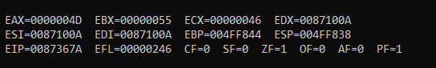

**Q3:**

*Output:*

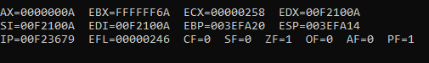

**Q4:**

*Output:*

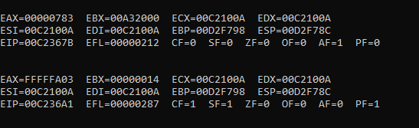

**Q5:**

*Output:*

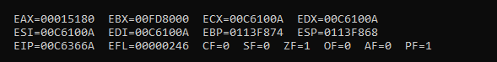

**Q6:**

*Output:*

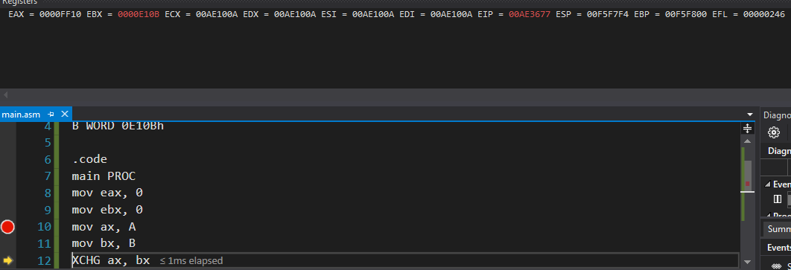

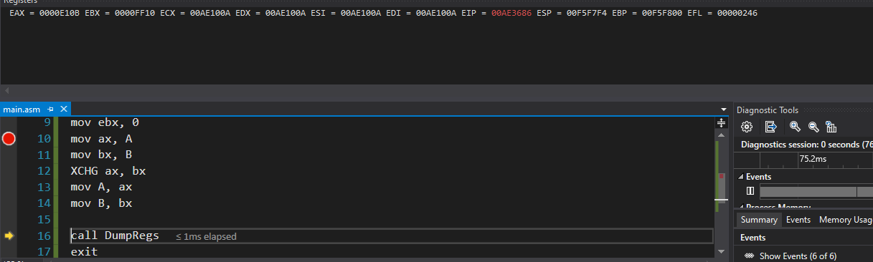

**Q7:**

*Output:*

*i. Write an instruction that increments val2.*

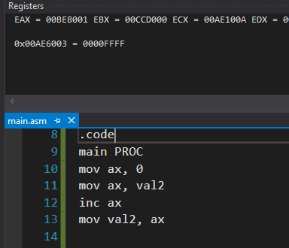

*ii. Write an instruction that subtracts val3 from EAX.*

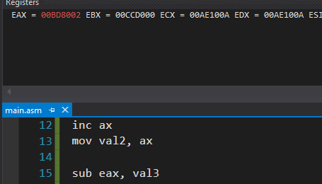

*iii. Write instructions that subtract val4 from val2.*

*val2 was updated to 8001h*

