*Muhammad Mufeez*

*BCS-3J*

***Coal Lab 05***

**Q1:**

*Output:*

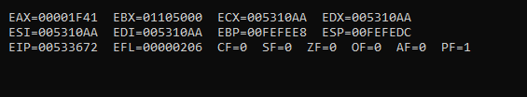

**Q2:**

*Output:*

*cf = 1, sf = 0, zf = 1, of = 0*

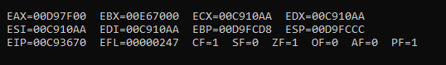

*cf = 0, sf = 1, zf = 0, of = 1*

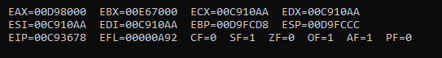

*cf = 0, sf = 1, zf = 0, of = 0*

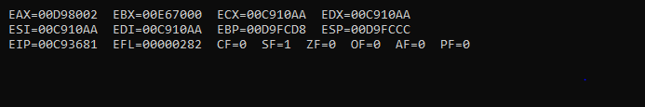

**Q3:**

*Output:*

*COMMENT @*

*If the array size is word or dword then in word, we will access the next elemen*

*by [array +2] and so on; for dword [array + 4] and so on*

*@*

**Q4:**

*Output*

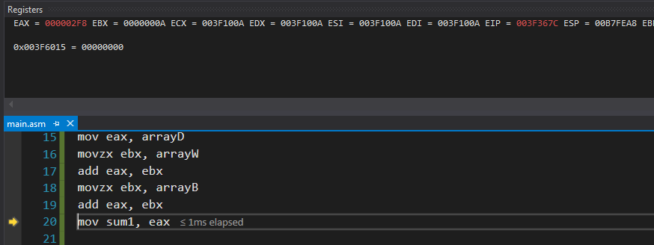

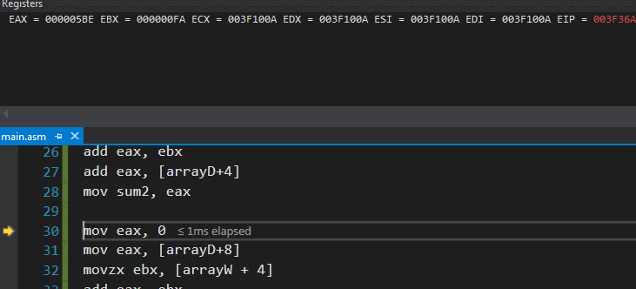

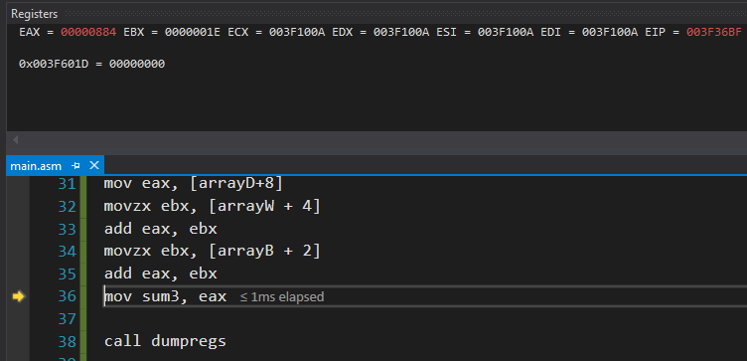

**Q7:**

*Output:*

