Name: Muhammad Mufeez

Roll No: 23k-0800

Section: J

Question #1  
**CODE:**

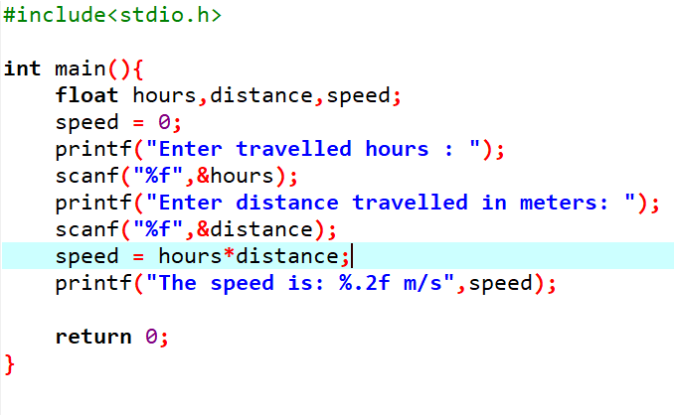

**OUTPUT:**

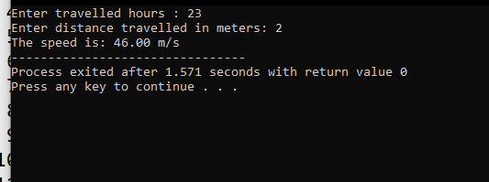

Question #2(a)  
**CODE:**

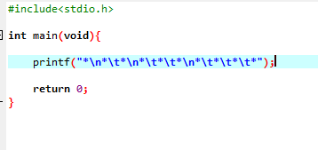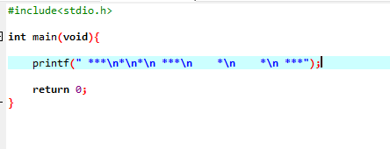

**OUTPUT:**

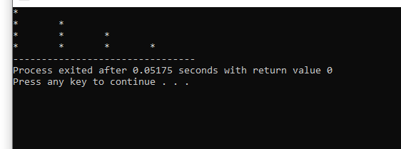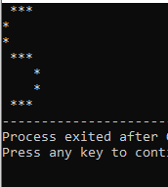

Question #2(b)  
**CODE:**

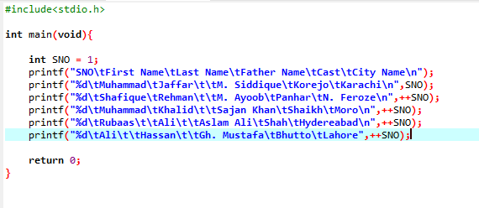

**OUTPUT:**

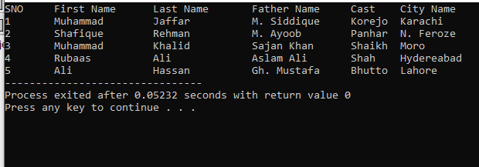

Question #3(a)  
**CODE:**

**OUTPUT:**

Question #3(B)  
**CODE:**

**OUTPUT:**

Question #4  
**CODE:**

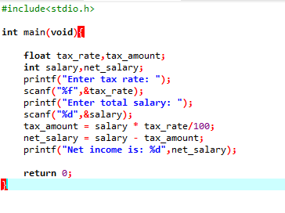

**OUTPUT:**

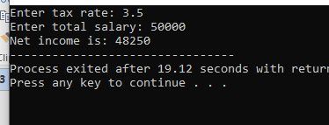

Question #5  
**CODE:**

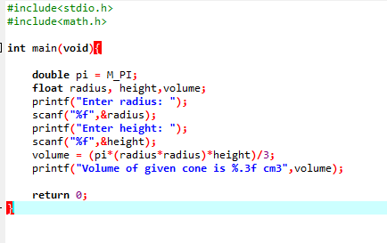

**OUTPUT:**

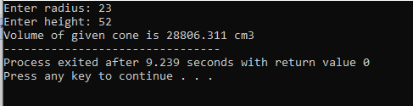

Question #6  
**CODE:**

**OUTPUT:**

