Muhammad mufeez

23k-0800

BCS-2j

Lab 02

Task 01

|  |  |  |
| --- | --- | --- |
| Input A | Input B | Output Z |
| 0 | 0 | 1 |
| 0 | 1 | 0 |
| 1 | 0 | 1 |
| 1 | 1 | 1 |

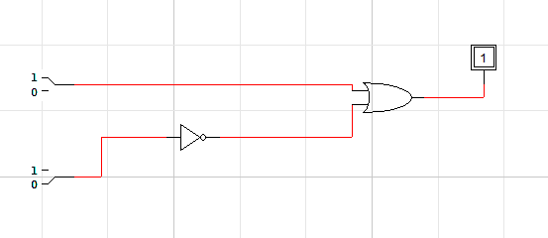

Task 02

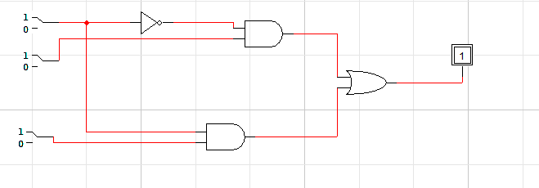

|  |  |  |  |
| --- | --- | --- | --- |
| Input X | Input Y | Input Z | Output F |
| 0 | 0 | 0 | 0 |
| 0 | 0 | 1 | 0 |
| 0 | 1 | 0 | 1 |
| 0 | 1 | 1 | 1 |
| 1 | 0 | 0 | 0 |
| 1 | 0 | 1 | 1 |
| 1 | 1 | 0 | 0 |
| 1 | 1 | 1 | 1 |

Task 03

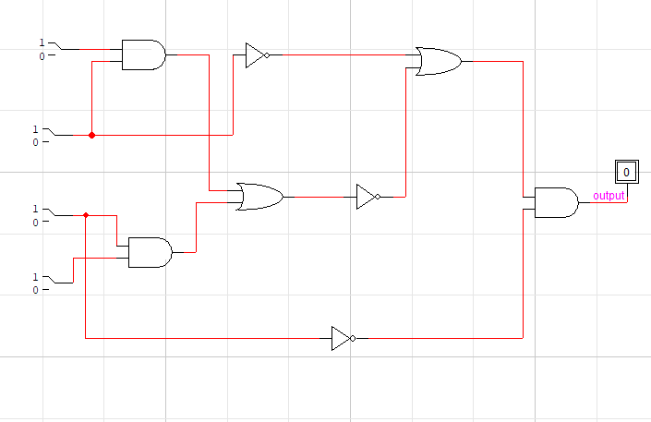

|  |  |  |  |  |
| --- | --- | --- | --- | --- |
| Input A | Input B | Input C | Input D | Output F |
| 0 | 0 | 0 | 0 | 1 |
| 0 | 0 | 0 | 1 | 1 |
| 0 | 0 | 1 | 0 | 0 |
| 0 | 0 | 1 | 1 | 0 |
| 0 | 1 | 0 | 0 | 1 |
| 0 | 1 | 0 | 1 | 1 |
| 0 | 1 | 1 | 0 | 0 |
| 0 | 1 | 1 | 1 | 0 |
| 1 | 0 | 0 | 0 | 1 |
| 1 | 0 | 0 | 1 | 1 |
| 1 | 0 | 1 | 0 | 0 |
| 1 | 0 | 1 | 1 | 0 |
| 1 | 1 | 0 | 0 | 0 |
| 1 | 1 | 0 | 1 | 0 |
| 1 | 1 | 1 | 0 | 0 |
| 1 | 1 | 1 | 1 | 0 |

EXERCISE_04

I.

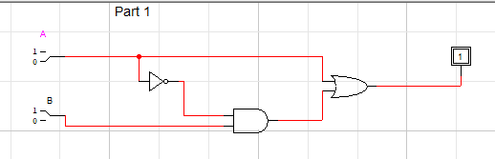

|  |  |  |
| --- | --- | --- |
| Input A | Input B | Output Z |
| 0 | 0 | 0 |
| 0 | 1 | 1 |
| 1 | 0 | 1 |
| 1 | 1 | 1 |

2.

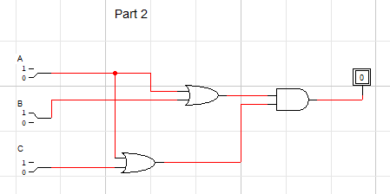

|  |  |  |  |
| --- | --- | --- | --- |
| Input A | Input B | Input C | Output |
| 0 | 0 | 0 | 0 |
| 0 | 0 | 1 | 0 |
| 0 | 1 | 0 | 0 |
| 0 | 1 | 1 | 1 |
| 1 | 0 | 0 | 1 |
| 1 | 0 | 1 | 1 |
| 1 | 1 | 0 | 1 |
| 1 | 1 | 1 | 1 |

3.

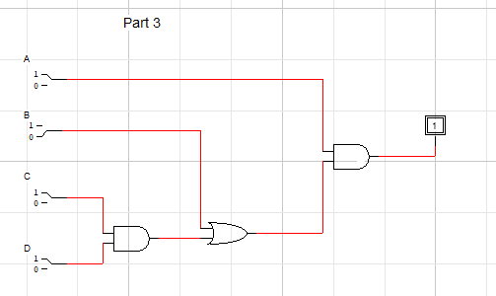

|  |  |  |  |  |
| --- | --- | --- | --- | --- |
| Input A | Input B | Input C | Input D | Output F |
| 0 | 0 | 0 | 0 | 0 |
| 0 | 0 | 0 | 1 | 0 |
| 0 | 0 | 1 | 0 | 0 |
| 0 | 0 | 1 | 1 | 0 |
| 0 | 1 | 0 | 0 | 0 |
| 0 | 1 | 0 | 1 | 0 |
| 0 | 1 | 1 | 0 | 0 |
| 0 | 1 | 1 | 1 | 0 |
| 1 | 0 | 0 | 0 | 0 |
| 1 | 0 | 0 | 1 | 0 |
| 1 | 0 | 1 | 0 | 0 |
| 1 | 0 | 1 | 1 | 1 |
| 1 | 1 | 0 | 0 | 1 |
| 1 | 1 | 0 | 1 | 1 |
| 1 | 1 | 1 | 0 | 1 |
| 1 | 1 | 1 | 1 | 1 |

4.

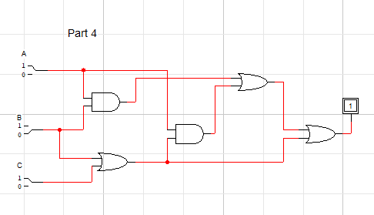

|  |  |  |  |
| --- | --- | --- | --- |
| Input A | Input B | Input C | Output |
| 0 | 0 | 0 | 0 |
| 0 | 0 | 1 | 1 |
| 0 | 1 | 0 | 1 |
| 0 | 1 | 1 | 1 |
| 1 | 0 | 0 | 0 |
| 1 | 0 | 1 | 1 |
| 1 | 1 | 0 | 1 |
| 1 | 1 | 1 | 1 |

5.

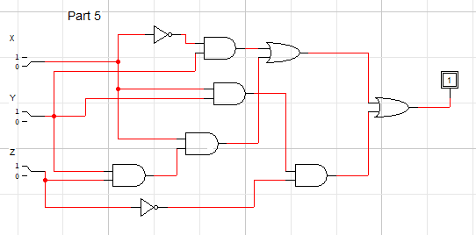

|  |  |  |  |
| --- | --- | --- | --- |
| Input A | Input B | Input C | Output |
| 0 | 0 | 0 | 0 |
| 0 | 0 | 1 | 0 |
| 0 | 1 | 0 | 1 |
| 0 | 1 | 1 | 1 |
| 1 | 0 | 0 | 0 |
| 1 | 0 | 1 | 0 |
| 1 | 1 | 0 | 1 |
| 1 | 1 | 1 | 1 |

6.

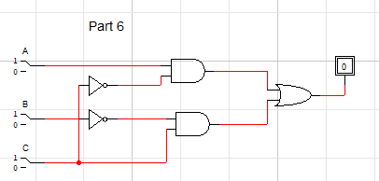

|  |  |  |  |
| --- | --- | --- | --- |
| Input A | Input B | Input C | Output |
| 0 | 0 | 0 | 0 |
| 0 | 0 | 1 | 1 |
| 0 | 1 | 0 | 0 |
| 0 | 1 | 1 | 0 |
| 1 | 0 | 0 | 1 |
| 1 | 0 | 1 | 1 |
| 1 | 1 | 0 | 1 |
| 1 | 1 | 1 | 0 |

7.

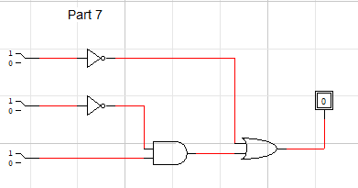

|  |  |  |  |
| --- | --- | --- | --- |
| Input A | Input B | Input C | Output |
| 0 | 0 | 0 | 1 |
| 0 | 0 | 1 | 1 |
| 0 | 1 | 0 | 1 |
| 0 | 1 | 1 | 1 |
| 1 | 0 | 0 | 0 |
| 1 | 0 | 1 | 1 |
| 1 | 1 | 0 | 0 |
| 1 | 1 | 1 | 0 |