K230800

Muhammad Mufeez

#### *Task_1:*

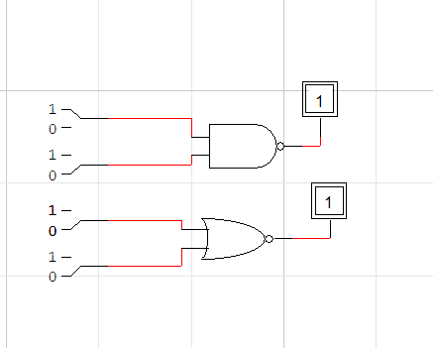

#### Task_2:

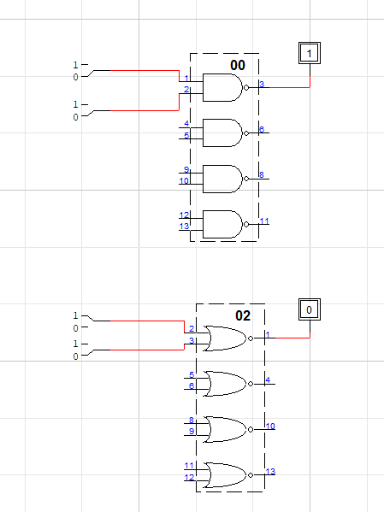

#### Task_3:

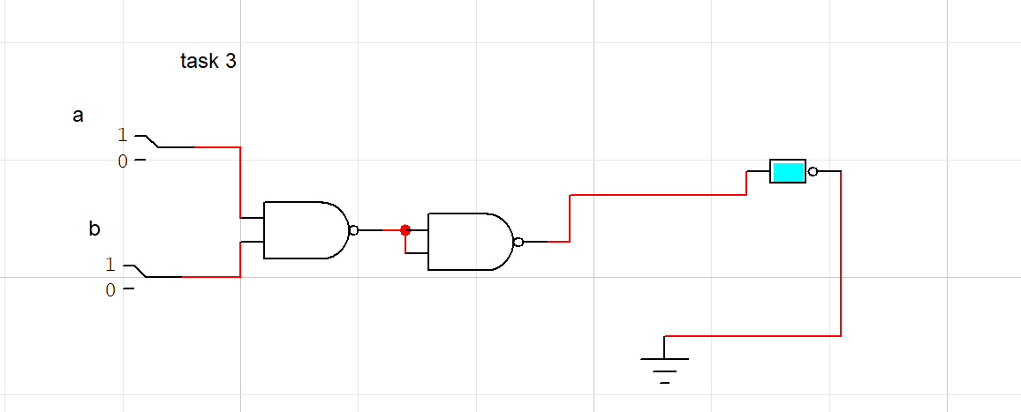

#### Task_4

|  |  |  |  |
| --- | --- | --- | --- |
| **A** | **B** | **C** | **Output** |
| 0 | 0 | 0 | 1 |
| 0 | 0 | 1 | 0 |
| 0 | 1 | 0 | 0 |
| 0 | 1 | 1 | 0 |
| 1 | 0 | 0 | 0 |
| 1 | 0 | 1 | 0 |
| 1 | 1 | 0 | 0 |
| 1 | 1 | 1 | 0 |

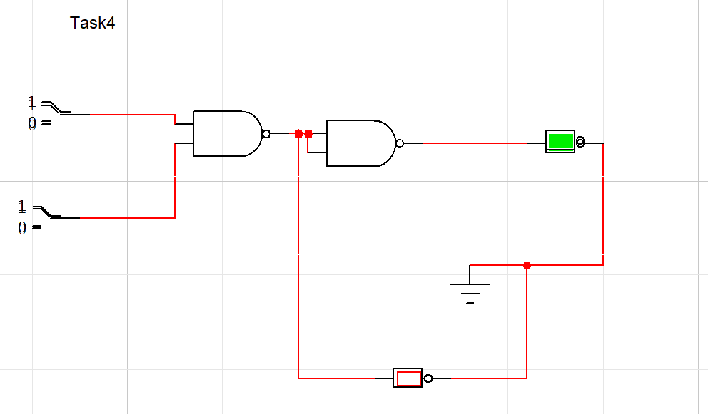

#### Task 5:

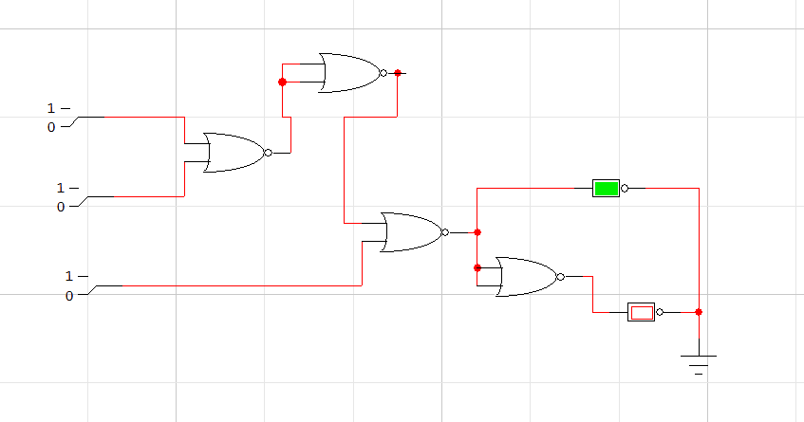

#### Task6:

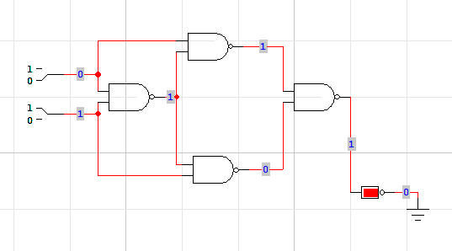

#### Task7:

1. True
2. True
3. False
4. False
5. True
6. True
7. False