K23-0800  
Lab_08

Muhammad Mufeez

#### *Task_1:*

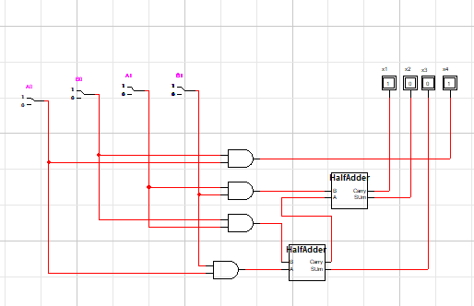

//Half Adder Circuit

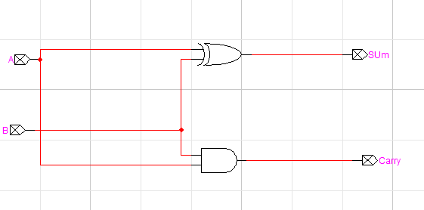

|  |  |  |  |  |  |  |  |
| --- | --- | --- | --- | --- | --- | --- | --- |
| **A0** | **B0** | **A1** | **B1** | **X1** | **X2** | **X3** | **X4** |
| 0 | 0 | 0 | 0 | **0** | **0** | **0** | **0** |
| 0 | 0 | 0 | 1 | **0** | **0** | **0** | **0** |
| 0 | 0 | 1 | 0 | **0** | **0** | **0** | **0** |
| 0 | 0 | 1 | 1 | **0** | **1** | **0** | **0** |
| 0 | 1 | 0 | 0 | **0** | **0** | **0** | **0** |
| 0 | 1 | 0 | 1 | **0** | **0** | **0** | **0** |
| 0 | 1 | 1 | 0 | **0** | **0** | **1** | **0** |
| 0 | 1 | 1 | 1 | **0** | **1** | **1** | **0** |
| 1 | 0 | 0 | 0 | **0** | **0** | **0** | **0** |
| 1 | 0 | 0 | 1 | **0** | **0** | **1** | **0** |
| 1 | 0 | 1 | 0 | **0** | **0** | **0** | **0** |
| 1 | 0 | 1 | 1 | **0** | **1** | **1** | **0** |
| 1 | 1 | 0 | 0 | **0** | **0** | **0** | **1** |
| 1 | 1 | 0 | 1 | **0** | **0** | **1** | **1** |
| 1 | 1 | 1 | 0 | **0** | **0** | **1** | **1** |
| 1 | 1 | 1 | 1 | **1** | **0** | **0** | **1** |

#### *Task_2:*

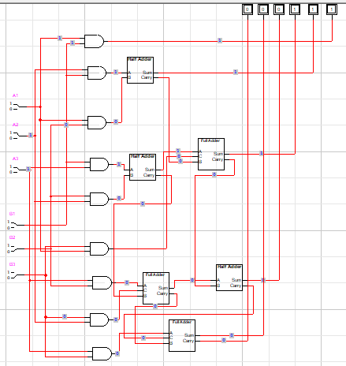

//Full Adder Circuit

