Mufeez – 23k0800

Lab 10

**Task_1:**

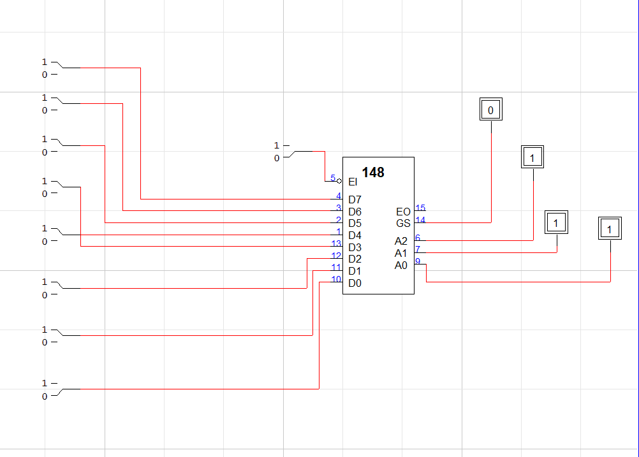

|  |  |  |  |  |  |  |  |  |  |  |
| --- | --- | --- | --- | --- | --- | --- | --- | --- | --- | --- |
|  |  |  |  |  |  |  |  |  |  |  |
| D7 | D6 | D5 | D4 | D3 | D2 | D1 | D0 | **A2** | **A1** | **A0** |
| 1 | 1 | 1 | 1 | 1 | 1 | 1 | 1 | **1** | **1** | **1** |
| 0 | X | X | X | X | X | X | X | **0** | **0** | **0** |
| 1 | 0 | X | X | X | X | X | X | **0** | **0** | **1** |
| 1 | 1 | 0 | X | X | X | X | X | **0** | **1** | **0** |
| 1 | 1 | 1 | 0 | X | X | X | X | **0** | **1** | **1** |
| 1 | 1 | 1 | 1 | 0 | X | X | X | **1** | **0** | **0** |
| 1 | 1 | 1 | 1 | 1 | 0 | X | X | **1** | **0** | **1** |
| 1 | 1 | 1 | 1 | 1 | 1 | 0 | X | **1** | **1** | **0** |
| 1 | 1 | 1 | 1 | 1 | 1 | 1 | 0 | **1** | **1** | **1** |

**Task_2:**

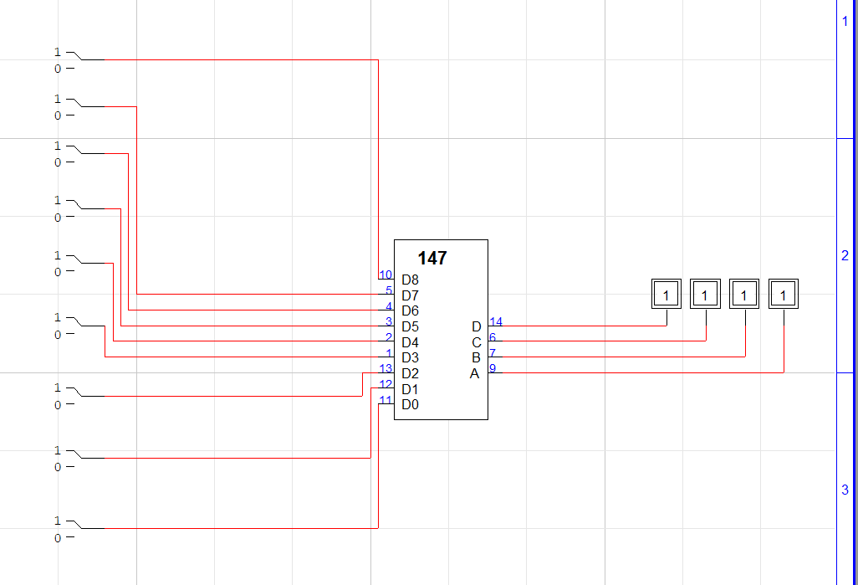

|  |  |  |  |  |  |  |  |  |  |  |  |  |
| --- | --- | --- | --- | --- | --- | --- | --- | --- | --- | --- | --- | --- |
| **1** | **2** | **3** | **4** | **5** | **6** | **7** | **8** | **9** | **A** | **B** | **C** | **D** |
| 1 | 1 | 1 | 1 | 1 | 1 | 1 | 1 | 1 | **1** | **1** | **1** | **1** |
| 0 | 1 | 1 | 1 | 1 | 1 | 1 | 1 | 1 | **1** | **1** | **1** | **0** |
| X | 0 | 1 | 1 | 1 | 1 | 1 | 1 | 1 | **1** | **1** | **0** | **1** |
| X | X | 0 | 1 | 1 | 1 | 1 | 1 | 1 | **1** | **1** | **0** | **0** |
| X | X | X | 0 | 1 | 1 | 1 | 1 | 1 | **1** | **0** | **1** | **1** |
| X | X | X | X | 0 | 1 | 1 | 1 | 1 | **1** | **0** | **1** | **0** |
| X | X | X | X | X | 0 | 1 | 1 | 1 | **1** | **0** | **0** | **1** |
| X | X | X | X | X | X | 0 | 1 | 1 | **1** | **0** | **0** | **0** |
| X | X | X | X | X | X | X | 0 | 1 | **0** | **1** | **1** | **1** |
| X | X | X | X | X | X | X | X | 0 | **0** | **1** | **1** | **0** |

Task_3:

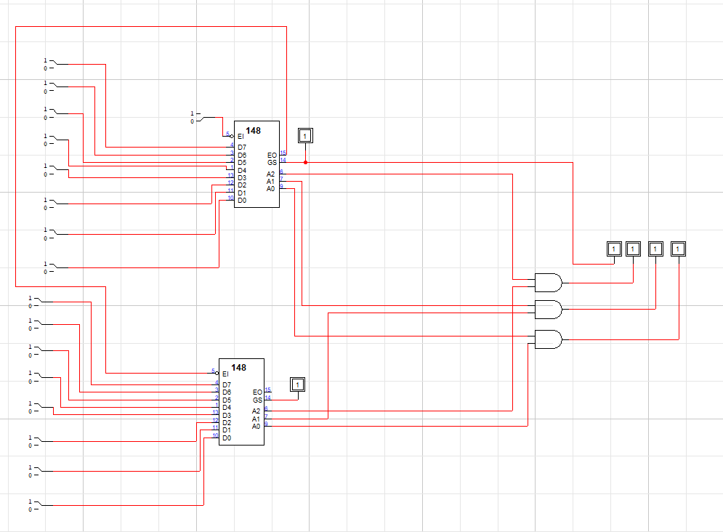

Task_4:

1. a
2. a