K23-0800  
Lab_11

Muhammad Mufeez

#### *Task_1:*

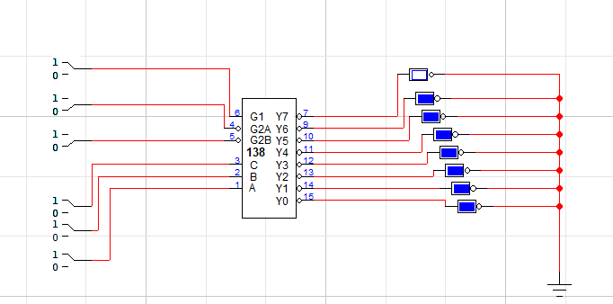

|  |  |  |  |  |  |  |  |  |  |  |  |  |  |
| --- | --- | --- | --- | --- | --- | --- | --- | --- | --- | --- | --- | --- | --- |
|  | **INPUTS** | | |  |  |  |  |  | **OUTPUTS** | |  |  |  |
|  | **Enable** | |  | **Select** |  |
| **G1** | **G2A’** | **G2B’** | **A2** | **A1** | **A0** | **Y0’** | **Y1’** | **Y2’** | **Y3’** | **Y4’** | **Y5’** | **Y6’** | **Y7’** |
| **1** | **1** | **0** | **X** | **X** | **X** | **1** | **1** | **1** | **1** | **1** | **1** | **1** | **1** |
| **1** | **0** | **1** | **X** | **X** | **X** | **1** | **1** | **1** | **1** | **1** | **1** | **1** | **1** |
| **0** | **0** | **0** | **X** | **X** | **X** | **1** | **1** | **1** | **1** | **1** | **1** | **1** | **1** |
| 1 | 0 | 0 | 0 | 0 | 0 | 0 | **1** | **1** | **1** | **1** | **1** | **1** | **1** |
| 1 | 0 | 0 | 0 | 0 | 1 | **1** | 0 | **1** | **1** | **1** | **1** | **1** | **1** |
| 1 | 0 | 0 | 0 | 1 | 0 | **1** | **1** | 0 | **1** | **1** | **1** | **1** | **1** |
| 1 | 0 | 0 | 0 | 1 | 1 | **1** | **1** | **1** | 0 | **1** | **1** | **1** | **1** |
| 1 | 0 | 0 | 1 | 0 | 0 | **1** | **1** | **1** | **1** | 0 | **1** | **1** | **1** |
| 1 | 0 | 0 | 1 | 0 | 1 | **1** | **1** | **1** | **1** | **1** | 0 | **1** | **1** |
| 1 | 0 | 0 | 1 | 1 | 0 | **1** | **1** | **1** | **1** | **1** | **1** | 0 | **1** |
| 1 | 0 | 0 | 1 | 1 | 1 | **1** | **1** | **1** | **1** | **1** | **1** | **1** | 0 |

#### *Task_2:*

|  |  |  |  |  |  |  |  |  |  |  |
| --- | --- | --- | --- | --- | --- | --- | --- | --- | --- | --- |
|  | **INPUTS** | |  |  |  | **OUTPUTS** | | |  |  |
| **A3** | **A2** | **A1** | **A0** | **a'** | **b'** | **c'** | **d'** | **e'** | **f'** | **g'** |
| 0 | 0 | 0 | 0 | **0** | **0** | **0** | **0** | **0** | **0** | **1** |
| 0 | 0 | 0 | 1 | **1** | **0** | **0** | **1** | **1** | **1** | **1** |
| 0 | 0 | 1 | 0 | **0** | **0** | **1** | **0** | **0** | **1** | **0** |
| 0 | 0 | 1 | 1 | **0** | **0** | **0** | **0** | **1** | **1** | **0** |
| 0 | 1 | 0 | 0 | **1** | **0** | **0** | **1** | **1** | **0** | **0** |
| 0 | 1 | 0 | 1 | **0** | **1** | **0** | **0** | **1** | **0** | **0** |
| 0 | 1 | 1 | 0 | **1** | **1** | **0** | **0** | **0** | **0** | **0** |
| 0 | 1 | 1 | 1 | **0** | **0** | **0** | **1** | **1** | **1** | **1** |
| 1 | 0 | 0 | 0 | **0** | **0** | **0** | **0** | **0** | **0** | **0** |
| 1 | 0 | 0 | 1 | **0** | **0** | **0** | **1** | **1** | **0** | **0** |

