K23-0800  
Lab_12

Muhammad Mufeez

#### *Task_1:*

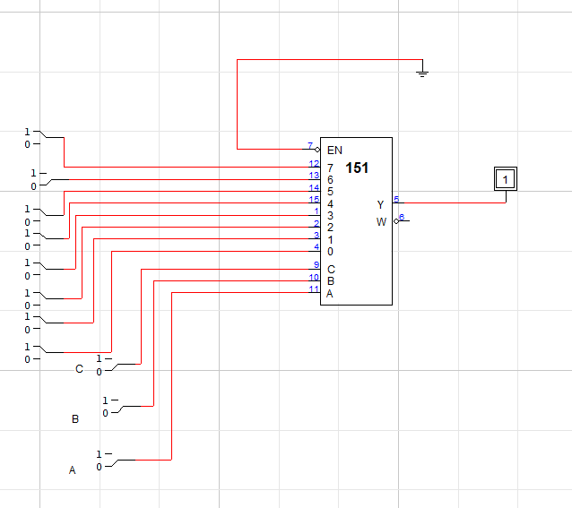

|  |  |  |  |  |  |  |  |  |  |  |  |
| --- | --- | --- | --- | --- | --- | --- | --- | --- | --- | --- | --- |
| **C** | **B** | **A** | **ENABLE** | **0** | **1** | **2** | **3** | **4** | **5** | **6** | **7** |
| 0 | 0 | 0 | 0 | 1 | X | X | X | X | X | X | X |
| 0 | 0 | 1 | 0 | X | 1 | X | X | X | X | X | X |
| 0 | 1 | 0 | 0 | X | X | 1 | X | X | X | X | X |
| 0 | 1 | 1 | 0 | X | X | X | 1 | X | X | X | X |
| 1 | 0 | 0 | 0 | X | X | X | X | 1 | X | X | X |
| 1 | 0 | 1 | 0 | X | X | X | X | X | 1 | X | X |
| 1 | 1 | 0 | 0 | X | X | X | X | X | X | 1 | X |
| 1 | 1 | 1 | 0 | X | X | X | X | X | X | X | 1 |

Task_2:

