K23-0800  
Lab_06

Muhammad Mufeez

#### *Task_1_1:*

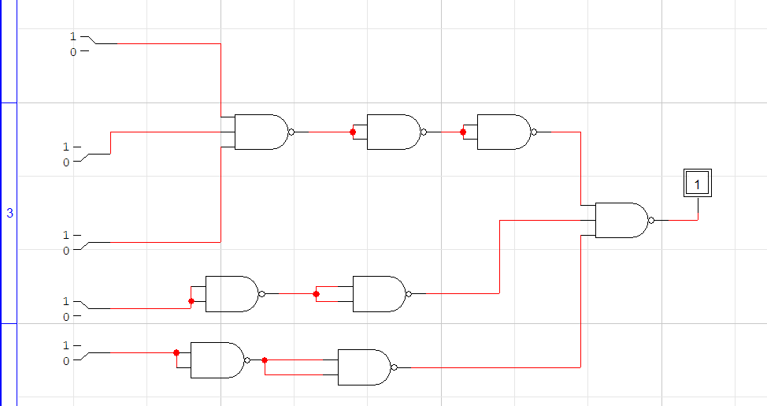

#### *Task_1_2*

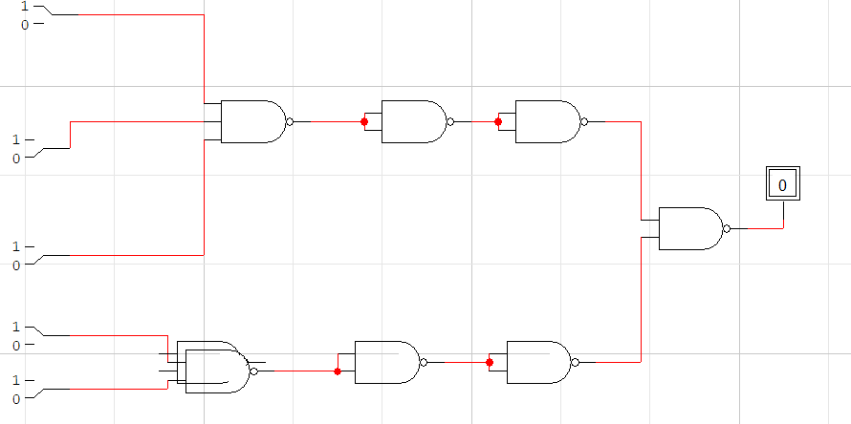

#### Task_2:

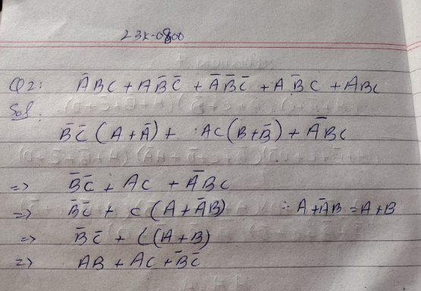

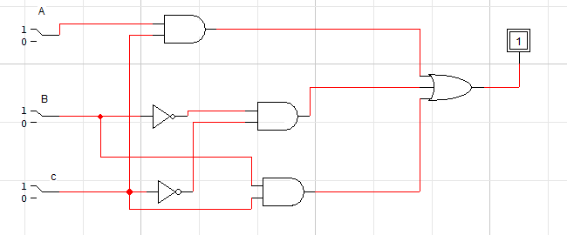

#### Task_3_1:

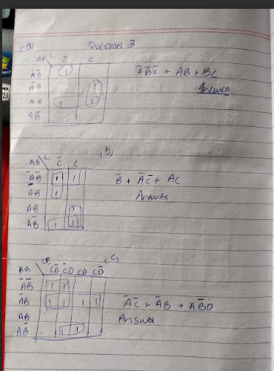

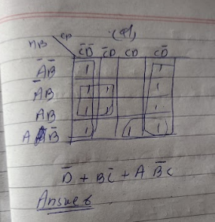

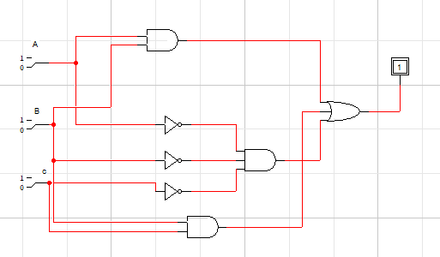

#### Task_3_2:

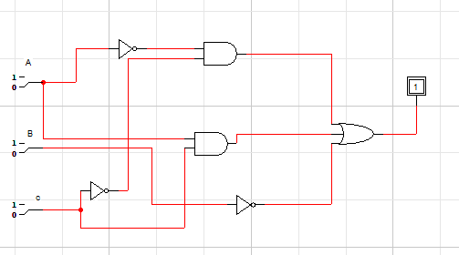

#### Task_3_3:

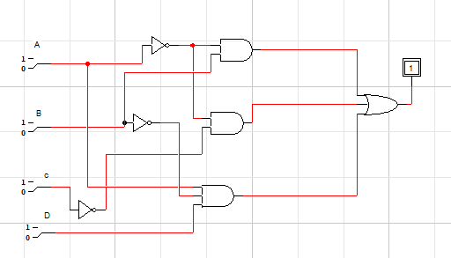

#### Task_3_4:

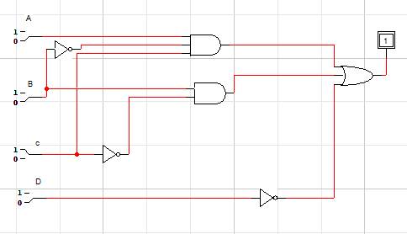

#### Task_4:

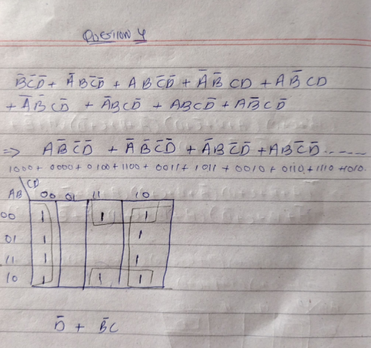

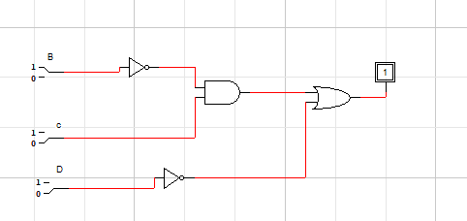

|  |  |  |  |
| --- | --- | --- | --- |
| **B** | C | D | OUTPUT X |
| 0 | 0 | 0 | 1 |
| 0 | 0 | 1 | 0 |
| 0 | 1 | 0 | 1 |
| 0 | 1 | 1 | 1 |
| 1 | 0 | 0 | 1 |
| 1 | 0 | 1 | 0 |
| 1 | 1 | 0 | 1 |
| 1 | 1 | 1 | 0 |

#### Task_5:

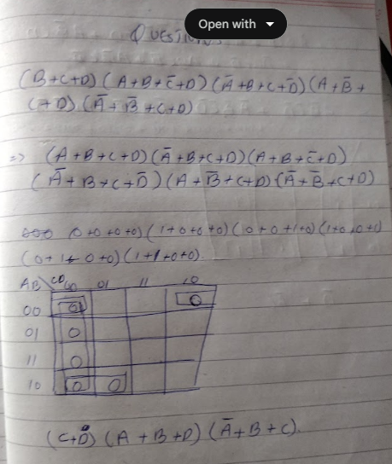

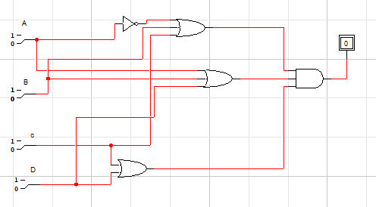

|  |  |  |  |  |
| --- | --- | --- | --- | --- |
| **A** | B | C | D | X (OUTPUT) |
| 0 | 0 | 0 | 0 | 0 |
| 0 | 0 | 0 | 1 | 1 |
| 0 | 0 | 1 | 0 | 0 |
| 0 | 0 | 1 | 1 | 1 |
| 0 | 1 | 0 | 0 | 0 |
| 0 | 1 | 0 | 1 | 1 |
| 0 | 1 | 1 | 0 | 1 |
| 0 | 1 | 1 | 1 | 1 |
| 1 | 0 | 0 | 0 | 0 |
| 1 | 0 | 0 | 1 | 0 |
| 1 | 0 | 1 | 0 | 1 |
| 1 | 0 | 1 | 1 | 1 |
| 1 | 1 | 0 | 0 | 0 |
| 1 | 1 | 0 | 1 | 1 |
| 1 | 1 | 1 | 0 | 1 |
| 1 | 1 | 1 | 1 | 1 |

#### Task_6:

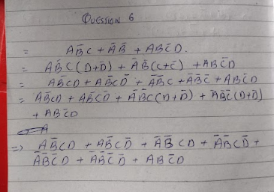

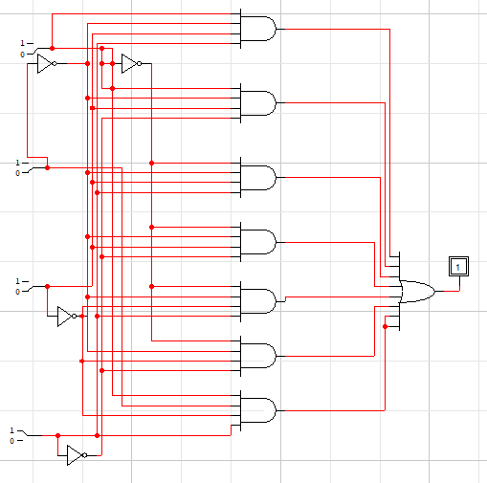

#### Task_7

#### 

#### 