import pandas as pd
import numpy as np
import matplotlib.pyplot as plt
from datetime import datetime
from datetime import timedelta
from pandas.plotting import register_matplotlib_converters
from statsmodels.tsa.stattools import acf, pacf
from statsmodels.tsa.statespace.sarimax import SARIMAX
register_matplotlib_converters()
from time import time
from matplotlib import pyplot as plt
import seaborn as sns
from statsmodels.tsa.seasonal import STL
import pandas as pd
import matplotlib.pyplot as plt
from datetime import datetime, timedelta

data_path = '/content/coursework_data.csv'
data = pd.read_csv(data_path)
data['Call_Date'] = pd.to_datetime(data['Call_Date'], dayfirst=True)
data.head()
data['Hour'] = data['Call_Date'].dt.hour
def part_of_day(hour):
if 5 <= hour < 12:
return 'Morning'
elif 12 <= hour < 17:
return 'Afternoon'
elif 17 <= hour < 21:
return 'Evening'
else:
return 'Night'
data['Part_of_Day'] = data['Hour'].apply(part_of_day)

from matplotlib import pyplot as plt
import seaborn as sns
data.groupby('Part_of_Day').size().plot(kind='barh', color=sns.palettes.mpl_palette('Dark2'))
plt.gca().spines[['top', 'right',]].set_visible(False)
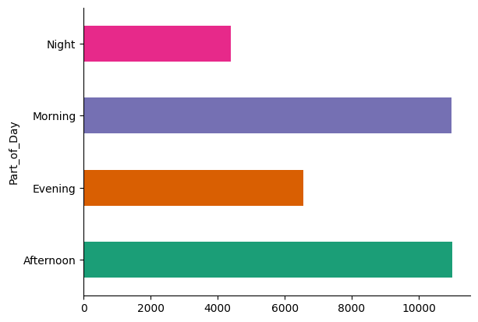
frequency, bins = np.histogram(data['Hour'], bins=24, range=(0,24))
plt.style.use('dark_background')
plt.figure(figsize=(12, 6))
plt.bar(bins[:-1], frequency, width=0.8, color='#5998ff') # Light blue bars
plt.title('Activity Frequency by Hour', color='white', fontsize=18)
plt.xlabel('Hour', color='white', fontsize=14)
plt.ylabel('Frequency', color='white', fontsize=14)
plt.xticks(ticks=np.arange(0, 24), labels=np.arange(1, 25), color='white') #
plt.yticks(color='white')
plt.grid(color='gray', linestyle='--', linewidth=0.5)
plt.gca().spines['top'].set_visible(False)
plt.gca().spines['right'].set_visible(False)
plt.show()
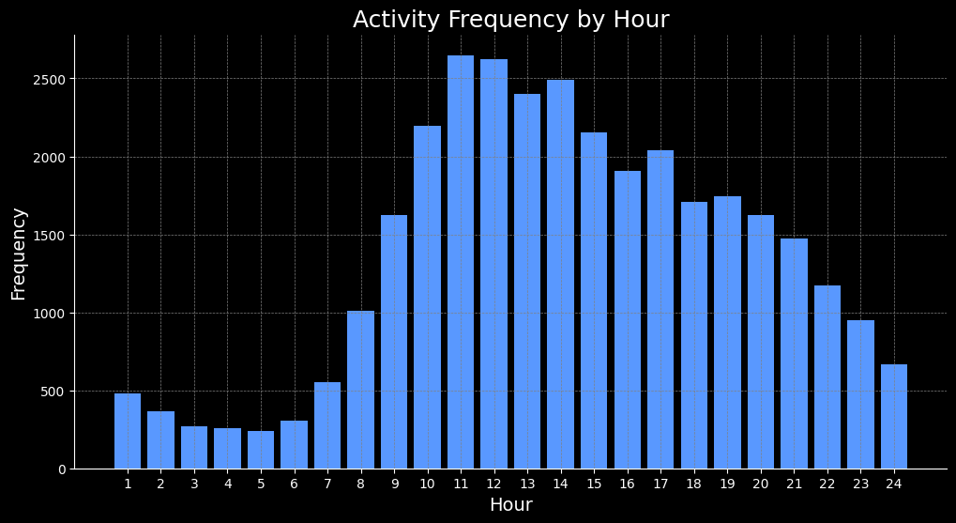
data.set_index('Call_Date', inplace=True)
daily_data = data.resample('D').size()
daily_data = pd.DataFrame({'Call_Volume': daily_data})
# Start and end dates
plt.style.use('dark_background')
start_date = datetime(2019, 3, 1)
end_date = datetime(2019, 9, 30)
daily_data = daily_data[start_date:end_date]
plt.figure(figsize=(10, 4))
plt.plot(daily_data,color='cyan')
# Add vertical lines for each week
current_date = start_date
while current_date <= end_date:
plt.axvline(current_date, color='k', linestyle='--', alpha=0.2)
current_date += timedelta(weeks=1) # Increment the date by one week
plt.show()
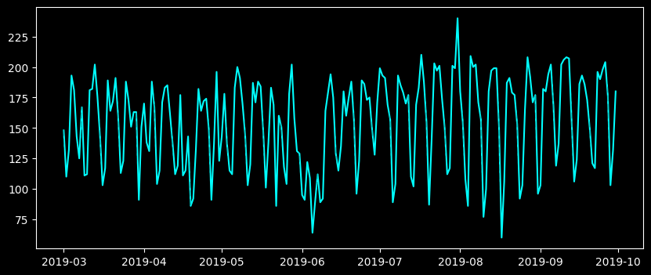
stl = STL(daily_data)
result = stl.fit()
seasonal, trend, resid = result.seasonal, result.trend, result.resid
plt.figure(figsize=(8,6))
plt.subplot(4,1,1)
plt.plot(daily_data)
plt.title('Original Series', fontsize=16)
plt.subplot(4,1,2)
plt.plot(trend)
plt.title('Trend', fontsize=16)
plt.subplot(4,1,3)
plt.plot(seasonal)
plt.title('Seasonal', fontsize=16)
plt.subplot(4,1,4)
plt.plot(resid)
plt.title('Residual', fontsize=16)
plt.tight_layout()
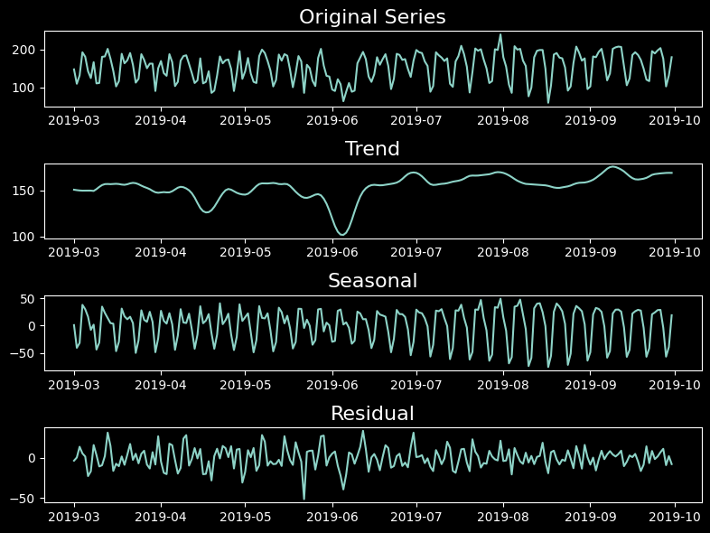
estimated = trend + seasonal
plt.figure(figsize=(12,4))
plt.plot(daily_data)
plt.plot(estimated)
plt.show()
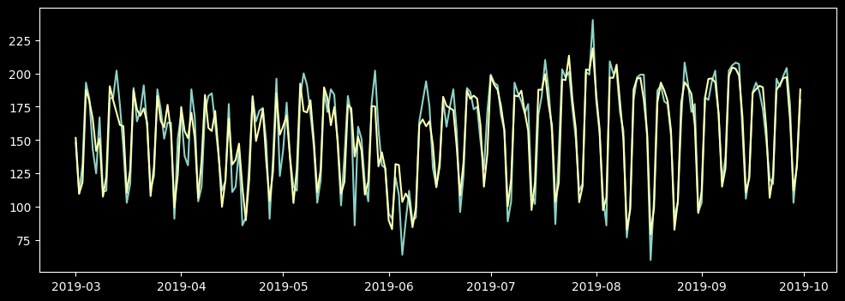
residual_mean = resid.mean()
residual_std = resid.std()
lower = residual_mean - 3*residual_std
upper = residual_mean + 3*residual_std
plt.figure(figsize=(10,4))
plt.plot(resid)
plt.fill_between([datetime(2019,3,1), datetime(2019,9,30)], lower, upper, color='y', alpha=0.25, linestyle='--', linewidth=2)
plt.xlim(datetime(2019,3,1), datetime(2019,10,1))
(17956.0, 18170.0)
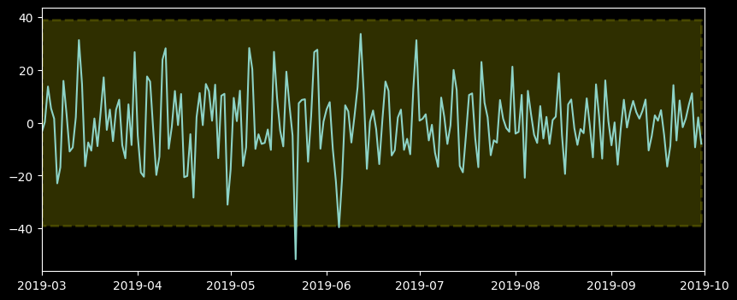
anomalies = daily_data[(resid < lower) | (resid > upper)]
plt.figure(figsize=(10,4))
plt.plot(daily_data)
current_date = start_date
while current_date <= end_date:
plt.axvline(current_date, color='k', linestyle='--', alpha=0.2)
current_date += timedelta(weeks=1)
plt.scatter(anomalies.index, anomalies.Call_Volume, color='r', marker='D')
<matplotlib.collections.PathCollection at 0x7fd5dfcf6ce0>
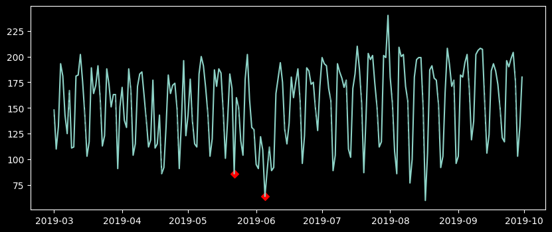
anomalies = ['2019-05-22', '2019-06-05']
# Make a copy of the data to adjust
adjusted_data = daily_data.copy()
# Loop through the anomaly dates
for anomaly_date in anomalies:
anomaly_datetime = pd.to_datetime(anomaly_date)
anomaly_weekday = anomaly_datetime.weekday()
mean_for_weekday = adjusted_data[(adjusted_data.index.weekday == anomaly_weekday) & (~adjusted_data.index.isin(pd.to_datetime(anomalies)))].mean()
adjusted_data.loc[anomaly_datetime] = mean_for_weekday
stl = STL(adjusted_data['Call_Volume'])
result = stl.fit()
seasonal, trend, resid = result.seasonal, result.trend, result.resid
plt.figure(figsize=(8,6))
plt.subplot(4,1,1)
plt.plot(adjusted_data)
plt.title('Original Series', fontsize=16)
plt.subplot(4,1,2)
plt.plot(trend)
plt.title('Trend', fontsize=16)
plt.subplot(4,1,3)
plt.plot(seasonal)
plt.title('Seasonal', fontsize=16)
plt.subplot(4,1,4)
plt.plot(resid)
plt.title('Residual', fontsize=16)
plt.tight_layout()
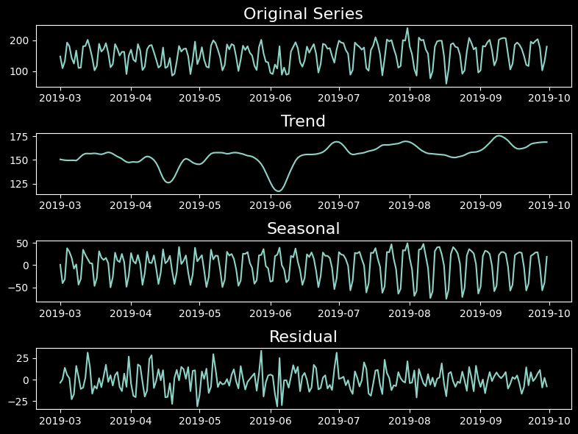
plt.figure(figsize=(10,4))
plt.plot(adjusted_data)
plt.ylabel('calls', fontsize=16)
current_date = start_date
while current_date <= end_date:
plt.axvline(current_date, color='k', linestyle='--', alpha=0.2)
current_date += timedelta(weeks=1)
plt.show()
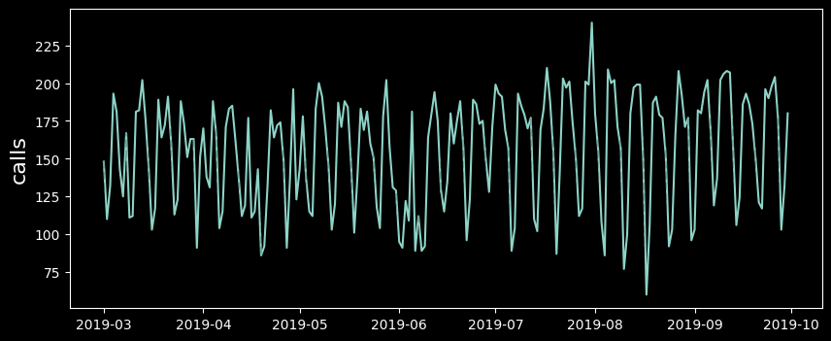

from matplotlib import pyplot as plt
# Add a column for the day of the week (Monday=0, Sunday=6)
adjusted_data['Day_of_Week'] = adjusted_data.index.dayofweek
adjusted_data['Is_Weekend'] = adjusted_data['Day_of_Week'].apply(lambda x: 1 if x >= 5 else 0)
adjusted_data['Day_of_Week'].plot(kind='hist', bins=20, title='Day_of_Week')
plt.grid(color='gray', linestyle='--', linewidth=0.5)
plt.xticks(ticks=np.arange(0, 7), labels=np.arange(1, 8), color='white'
plt.gca().spines[['top', 'right',]].set_visible(False)
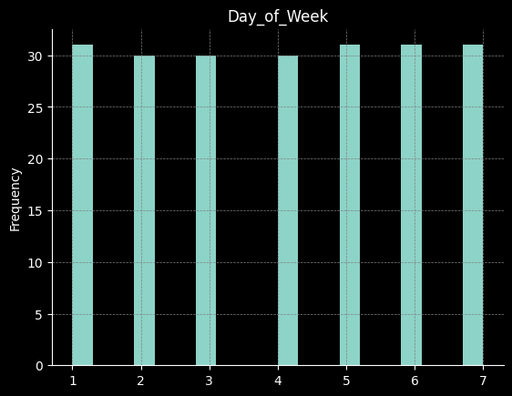

from statsmodels.tsa.stattools import adfuller, kpss
# ADF Test
adf_test = adfuller(adjusted_data['Call_Volume'])
# KPSS Test
kpss_test = kpss(adjusted_data['Call_Volume'], regression='c')
adf_result = {
"Test Statistic": adf_test[0],
"p-value": adf_test[1],
"Critical Values": adf_test[4]
}
kpss_result = {
"Test Statistic": kpss_test[0],
"p-value": kpss_test[1],
"Critical Values": kpss_test[3]
}
adf_result, kpss_result
({'Test Statistic': -2.1374343971311434,
'p-value': 0.22973079395053014,
'Critical Values': {'1%': -3.4636447617687436,
'5%': -2.8761761179270766,
'10%': -2.57457158581854}},
{'Test Statistic': 0.5831926694752528,
'p-value': 0.02416430277497701,
'Critical Values': {'10%': 0.347, '5%': 0.463, '2.5%': 0.574, '1%': 0.739}})
first_diff = adjusted_data.diff()[1:]
plt.figure(figsize=(10,4))
plt.plot(first_diff)
plt.ylabel('calls', fontsize=16)
current_date = start_date
while current_date <= end_date:
plt.axvline(current_date, color='k', linestyle='--', alpha=0.2)
current_date += timedelta(weeks=1)
plt.show()
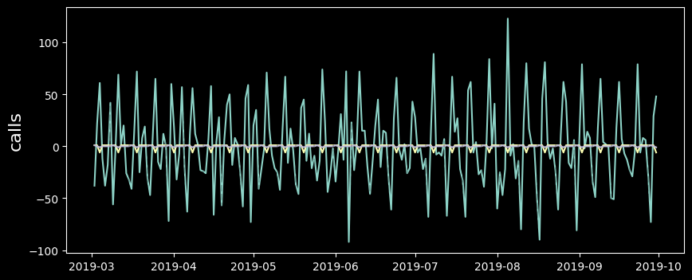
from statsmodels.tsa.stattools import adfuller, kpss
adf_test = adfuller(first_diff['Call_Volume'])
kpss_test = kpss(first_diff['Call_Volume'], regression='c')
adf_result = {
"Test Statistic": adf_test[0],
"p-value": adf_test[1],
"Critical Values": adf_test[4]
}
kpss_result = {
"Test Statistic": kpss_test[0],
"p-value": kpss_test[1],
"Critical Values": kpss_test[3]
}
adf_result, kpss_result
<ipython-input-24-1d60860372bd>:7: InterpolationWarning: The test statistic is outside of the range of p-values available in the
look-up table. The actual p-value is greater than the p-value returned.
kpss_test = kpss(first_diff['Call_Volume'], regression='c')
({'Test Statistic': -6.381012744927666,
'p-value': 2.2223599073285117e-08,
'Critical Values': {'1%': -3.4636447617687436,
'5%': -2.8761761179270766,
'10%': -2.57457158581854}},
{'Test Statistic': 0.3344021332409151,
'p-value': 0.1,
'Critical Values': {'10%': 0.347, '5%': 0.463, '2.5%': 0.574, '1%': 0.739}})
from sklearn.metrics import mean_squared_error
# splitting the data
train_end = datetime(2019, 9, 15)
test_end = datetime(2019, 9, 30)
train_data = first_diff[:train_end]
test_data = first_diff[train_end + timedelta(days=1):test_end]
# Forecasting on data
train_data['naive_forecast'] = train_data['Call_Volume'].shift(1)
train_data['ma_forecast'] = train_data['Call_Volume'].rolling(window=6).mean().shift(1)
train_data_clean = train_data.dropna()
last_value_index = adjusted_data.index.get_loc(train_data_clean.index[0]) - 1
last_actual_value = adjusted_data['Call_Volume'].iloc[last_value_index]
restored_series_train = [last_actual_value]
for diff in train_data_clean['naive_forecast']:
restored_value = restored_series_train[-1] + diff if not pd.isna(diff) else restored_series_train[-1]
restored_series_train.append(restored_value)
naive_forecast_train_restored = pd.Series(restored_series_train[1:], index=train_data_clean.index)
last_value_train = restored_series_train[-1] # Last value from train restoration
restored_series_test = [last_value_train] # Start with the last restored train value
for diff in test_data['Call_Volume']:
restored_value = restored_series_test[-1] + diff if not pd.isna(diff) else restored_series_test[-1]
restored_series_test.append(restored_value)
naive_forecast_test_restored = pd.Series(restored_series_test[1:], index=test_data.index)
last_value_index = adjusted_data.index.get_loc(train_data_clean.index[0]) - 1
last_actual_value = adjusted_data['Call_Volume'].iloc[last_value_index]
# Manually restore the original scale for the train forecasts
restored_series_train = [last_actual_value]
for diff in train_data_clean['ma_forecast']:
restored_value = restored_series_train[-1] + diff if not pd.isna(diff) else restored_series_train[-1]
restored_series_train.append(restored_value)
ma_forecast_train_restored = pd.Series(restored_series_train[1:], index=train_data_clean.index)
# Repeat for the testing data
last_value_train = restored_series_train[-1] # Last value from train restoration
restored_series_test = [last_value_train]
for diff in test_data['Call_Volume']:
restored_value = restored_series_test[-1] + diff if not pd.isna(diff) else restored_series_test[-1]
restored_series_test.append(restored_value)
ma_forecast_test_restored = pd.Series(restored_series_test[1:], index=test_data.index)

import pandas as pd
import numpy as np
from datetime import datetime, timedelta
from sklearn.metrics import mean_squared_error
import matplotlib.pyplot as plt
plt.style.use('_classic_test_patch')
mse_naive_test = mean_squared_error(adjusted_data['Call_Volume'].loc[test_data.index], naive_forecast_test_restored)
plt.figure(figsize=(20, 7))
plt.plot(adjusted_data['Call_Volume'], label='Actual Data', color='white') # Adjusted data plot
plt.plot(naive_forecast_train_restored.index, naive_forecast_train_restored, label='Naive Forecast (Train)', color='blue')
plt.plot(naive_forecast_test_restored.index, naive_forecast_test_restored, label='Naive Forecast (Test)', color='red')
predictions = [naive_forecast_test_restored.iloc[-1] + x for x in np.random.normal(0, 5, 3)]
lower_bound = [x - 10 for x in predictions]
upper_bound = [x + 10 for x in predictions]
# Add predictions and confidence interval plot
future_dates = pd.date_range(start=naive_forecast_test_restored.index[-1], periods=4, freq='D')[1:]
plt.plot(future_dates, predictions, color='green', label='Future Predictions')
plt.fill_between(future_dates, lower_bound, upper_bound, color='green', alpha=0.1)
plt.title('Naive Forecast - Restored Data with Predictions')
plt.legend()
plt.show()
print("MSE for Naive Forecast on Test Data:", mse_naive_test)
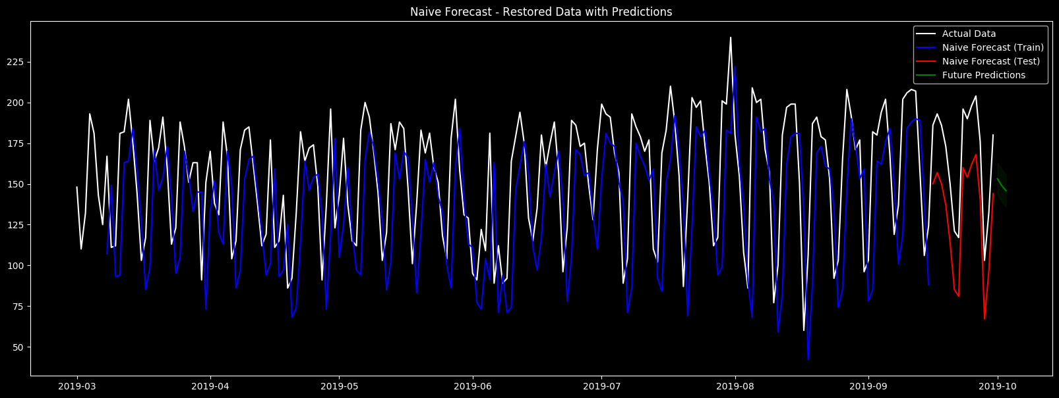
MSE for Naive Forecast on Test Data: 1296.0
import pandas as pd
import numpy as np
from datetime import datetime, timedelta
from sklearn.metrics import mean_squared_error
import matplotlib.pyplot as plt
# Calculate MSE for the test data
ma_forecast_test = mean_squared_error(adjusted_data['Call_Volume'].loc[test_data.index], ma_forecast_test_restored)
# Plotting results with confidence bounds
plt.figure(figsize=(14, 7))
# Actual and forecast data
plt.plot(adjusted_data['Call_Volume'], label='Actual Data', color='white') # Adjusted data plot
plt.plot(ma_forecast_train_restored.index, ma_forecast_train_restored, label='ma forecast (Train)', color='blue')
plt.plot(ma_forecast_test_restored.index, ma_forecast_test_restored, label='ma forecast (Test)', color='red')
predictions = [ma_forecast_train_restored.iloc[-1] + x for x in np.random.normal(0, 5, 3)]
lower_bound = [x - 10 for x in predictions]
upper_bound = [x + 10 for x in predictions]
future_dates = pd.date_range(start=ma_forecast_test_restored.index[-1], periods=4, freq='D')[1:] # Dummy future dates
plt.plot(future_dates, predictions, color='green', label='Future Predictions',linewidth=2)
plt.fill_between(future_dates, lower_bound, upper_bound, color='green', alpha=0.1)
plt.title('ma forecast- Restored Data with Predictions')
plt.legend()
plt.show()
print("MSE for ma forecast on Test Data:", ma_forecast_test)
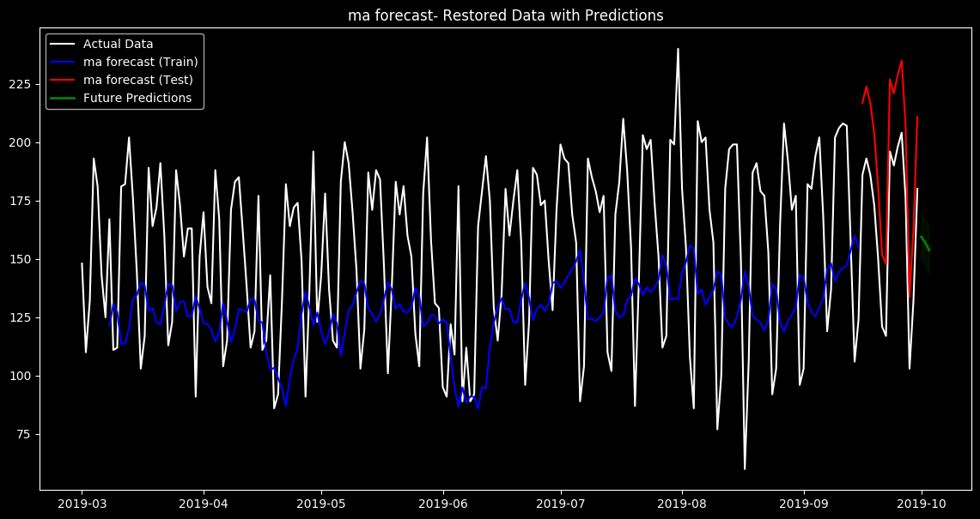
MSE for ma forecast on Test Data: 950.6944444444433

import pandas as pd
from statsmodels.tsa.api import ExponentialSmoothing
from datetime import datetime, timedelta
from sklearn.metrics import mean_squared_error
import matplotlib.pyplot as plt
train_end = datetime(2019, 9, 18)
test_end = datetime(2019, 9, 30)
train_data = first_diff[:train_end]
test_data = first_diff[train_end + timedelta(days=1):test_end]
last_value_index = adjusted_data.index.get_loc(train_data.index[-1])
last_train_value = adjusted_data['Call_Volume'].iloc[last_value_index]
# Apply Single Exponential Smoothing
ses_model = ExponentialSmoothing(train_data['Call_Volume'], trend=None, seasonal=None).fit(optimized=True)
ses_forecast_diff = ses_model.forecast(len(test_data))
# Align the forecast to the test_data index
ses_forecast_diff.index = test_data.index
# Manually restore the original scale
restored_ses_forecast = [last_train_value]
for prediction in ses_forecast_diff:
restored_value = restored_ses_forecast[-1] + prediction
restored_ses_forecast.append(restored_value)
restored_ses_forecast = pd.Series(restored_ses_forecast[1:], index=ses_forecast_diff.index)
# Calculate MSE for the test data using the forecast from SES
mse_ses_test = mean_squared_error(adjusted_data['Call_Volume'].loc[restored_ses_forecast.index], restored_ses_forecast)
# Plotting results
plt.figure(figsize=(14, 7))
# Actual data and forecasts
plt.plot(adjusted_data.index, adjusted_data['Call_Volume'], label='Actual Data (Train + Test)', color='white')
plt.plot(restored_ses_forecast.index, restored_ses_forecast, label='SES Forecast (Test)', color='red', linestyle='--', linewidth=5)
plt.title('Single Exponential Smoothing Forecast - Restored to Original Scale')
plt.xlabel('Date')
plt.ylabel('Call Volume')
plt.legend()
plt.grid(True)
plt.show()
print("MSE for SES Forecast on Test Data:", mse_ses_test)
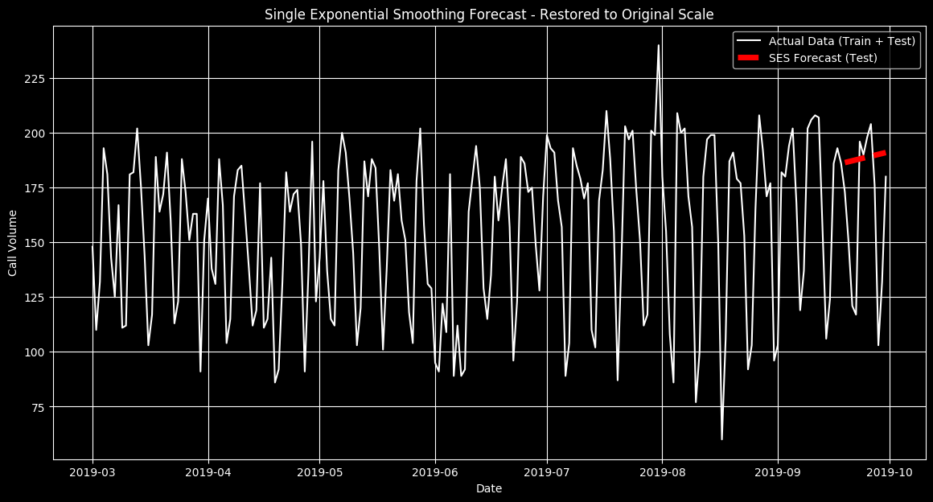
MSE for SES Forecast on Test Data: 1885.192378701587

import pandas as pd
from statsmodels.tsa.api import Holt
from datetime import datetime, timedelta
from sklearn.metrics import mean_squared_error
import matplotlib.pyplot as plt
import numpy as np
from statsmodels.tsa.seasonal import seasonal_decompose
train_end = datetime(2019, 8, 20)
test_end = datetime(2019, 9, 30)
train_data = adjusted_data[:train_end]
test_data = adjusted_data[train_end + timedelta(days=1):test_end]
seasonal_periods=7
# Decompose the time series to estimate the seasonal component
decomposition = seasonal_decompose(train_data['Call_Volume'], model='multiplicative', period=seasonal_periods)
train_data_deseasonalized = train_data['Call_Volume'] / decomposition.seasonal
# Apply Holt's Linear Trend model to the de seasonalized data
holt_model = Holt(train_data_deseasonalized).fit(smoothing_level=0.1, smoothing_slope=0.6,optimized=False)
# Forecast on the de seasonalized data up to the end of the testing period
holt_forecast_deseasonalized = holt_model.forecast(len(test_data))
last_seasonals = decomposition.seasonal[-seasonal_periods:]
seasonal_repeats = len(test_data) // seasonal_periods + 1
forecast_seasonal = np.tile(last_seasonals, seasonal_repeats)[:len(test_data)]
holt_forecast_reseasonalized = holt_forecast_deseasonalized * forecast_seasonal
holt_forecast_reseasonalized.index = test_data.index
mse_holt_test = mean_squared_error(test_data['Call_Volume'], holt_forecast_reseasonalized)
# Plotting results with connected confidence bounds
plt.figure(figsize=(14, 7))
plt.plot(adjusted_data['Call_Volume'], label='Actual Data', color='white')
plt.plot(holt_forecast_reseasonalized, label="Holt's Linear Trend Forecast (Test)", color='orange')
plt.title("Holt's Linear Trend Forecast")
plt.legend()
plt.show()
print("MSE for Holt's Linear Trend Forecast on Test Data:", mse_holt_test)
holt_linear_aic = holt_model.aic
holt_linear_bic = holt_model.bic
print(f"Holt Linear Model AIC: {holt_linear_aic}")
print(f"Holt Linear Model BIC: {holt_linear_bic}")

MSE for Holt's Linear Trend Forecast on Test Data: 241.69763494122336
Holt Linear Model AIC: 1133.3581807494722
Holt Linear Model BIC: 1145.9713471274633

import pandas as pd
from statsmodels.tsa.api import ExponentialSmoothing
from datetime import datetime, timedelta
from sklearn.metrics import mean_squared_error
import matplotlib.pyplot as plt
train_end = datetime(2019, 8, 20)
test_end = datetime(2019, 9, 30)
train_data = adjusted_data[:train_end]
test_data = adjusted_data[train_end + timedelta(days=1):test_end]
# Setup Holt-Winters model
holt_winters_model = ExponentialSmoothing(
train_data['Call_Volume'],
seasonal_periods=7,
trend='mul',
seasonal='add',
damped_trend=True
).fit()
holt_winters_forecast = holt_winters_model.forecast(len(test_data))
holt_winters_forecast.index = test_data.index
mse_holt_winters = mean_squared_error(test_data['Call_Volume'], holt_winters_forecast)
plt.figure(figsize=(14, 7))
plt.plot(adjusted_data['Call_Volume'], label='Actual Data', color='white')
plt.plot(holt_winters_forecast, label='Holt-Winters Forecast (Test)', color='orange')
plt.title('Holt-Winters Forecast')
plt.legend()
plt.show()
print("MSE for Holt-Winters Forecast on",mse_holt_winters)
holt_winters_aic = holt_winters_model.aic
holt_winters_bic = holt_winters_model.bic
print(f"Holt-Winters Model AIC: {holt_winters_aic}")
print(f"Holt-Winters Model BIC: {holt_winters_bic}")
MSE for Holt-Winters Forecast on 181.29023011954303
Holt-Winters Model AIC: 1071.0514766523092
Holt-Winters Model BIC: 1108.8909757862825

import pandas as pd
from statsmodels.tsa.api import ExponentialSmoothing
from datetime import datetime, timedelta
from sklearn.metrics import mean_squared_error
import matplotlib.pyplot as plt
train_start = datetime(2019, 1, 1)
train_end = datetime(2019, 8, 1)
test_end = datetime(2019, 9, 30)
train_data = adjusted_data[:train_end]
test_data = adjusted_data[train_end + timedelta(days=1):test_end]
rolling_predictions = pd.Series(dtype=float)
current_train_data = train_data.copy()
test_dates = pd.date_range(start=train_end + timedelta(days=1), end=test_end, freq='10D') # Create test dates every 14 days
for test_date in test_dates:
forecast_end_date = min(test_date + timedelta(days=9), test_data.index[-1])
holt_winters_model = ExponentialSmoothing(
current_train_data['Call_Volume'],
seasonal_periods=7, # Assuming weekly seasonality remains
trend='mul',
seasonal='add',
damped_trend=True
).fit()
# Forecast the next 14 days
next_forecast = holt_winters_model.forecast((forecast_end_date - test_date).days + 1)
next_forecast.index = pd.date_range(start=test_date, end=forecast_end_date, freq='D')
rolling_predictions = pd.concat([rolling_predictions, pd.Series(next_forecast, index=next_forecast.index)])
current_train_data = adjusted_data[:forecast_end_date]
# Calculate MSE for the test data using the forecast
mse_holt_winters = mean_squared_error(test_data['Call_Volume'], rolling_predictions.loc[test_data.index])
# Plot results
plt.figure(figsize=(14, 7))
plt.plot(adjusted_data['Call_Volume'], label='Actual Data', color='white')
plt.plot(rolling_predictions, label='Holt-Winters 14-Day Rolling Forecast', color='orange', linestyle='-')
plt.title('Holt-Winters 14-Day Rolling Window Forecast')
plt.legend()
plt.show()
print(f"MSE for Holt-Winters 14-Day Rolling Window Forecast: {mse_holt_winters}")
holt_winters_aic = holt_winters_model.aic
holt_winters_bic = holt_winters_model.bic
print(f"Holt-Winters Model AIC: {holt_winters_aic}")
print(f"Holt-Winters Model BIC: {holt_winters_bic}")
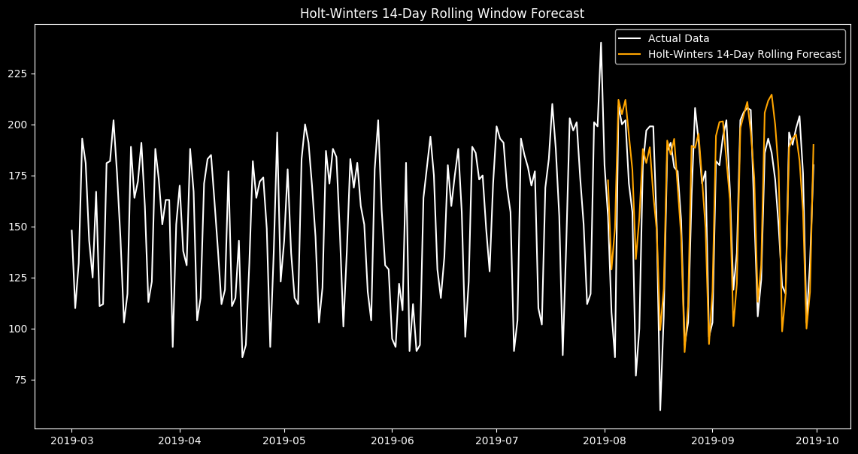
MSE for Holt-Winters 14-Day Rolling Window Forecast: 410.0770023488007
Holt-Winters Model AIC: 1241.1921963803525
Holt-Winters Model BIC: 1281.0096363064831

import pandas as pd
import numpy as np
import matplotlib.pyplot as plt
from statsmodels.tsa.stattools import acf
from statsmodels.graphics.tsaplots import plot_acf
first_diff = first_diff.dropna()
if 'Call_Volume' in first_diff.columns:
acf_vals = acf(first_diff['Call_Volume'])
else:
print("Column 'Call_Volume' not found in DataFrame")
num_lags = 20
fig, ax = plt.subplots(figsize=(10, 5))
plot_acf(first_diff['Call_Volume'], ax=ax, lags=num_lags, alpha=0.05) # 95% confidence interval
plt.title('Autocorrelation Function (ACF) with Confidence Bounds')
plt.xlabel('Lag')
plt.ylabel('ACF')
plt.show()
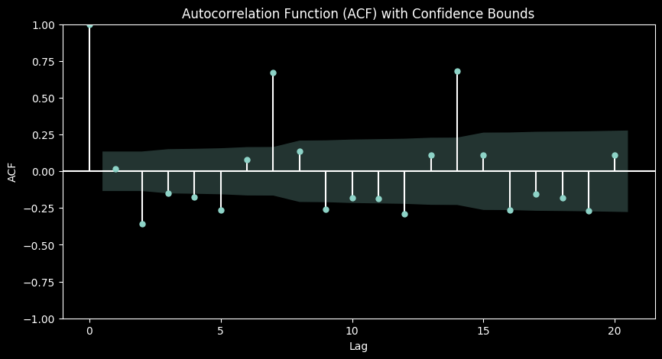

import pandas as pd
import numpy as np
import matplotlib.pyplot as plt
from statsmodels.tsa.stattools import pacf
from statsmodels.graphics.tsaplots import plot_pacf
first_diff = first_diff.dropna() # Dropping NaN values if they exist
if 'Call_Volume' in first_diff.columns:
pacf_vals = pacf(first_diff['Call_Volume'])
else:
print("Column 'Call_Volume' not found in DataFrame")
num_lags = 20
fig, ax = plt.subplots(figsize=(10, 5))
plot_pacf(first_diff['Call_Volume'], ax=ax, lags=num_lags, alpha=0.05) # 95% confidence interval
plt.title('Partial Autocorrelation Function (PACF) with Confidence Bounds')
plt.xlabel('Lag')
plt.ylabel('PACF')
plt.show()
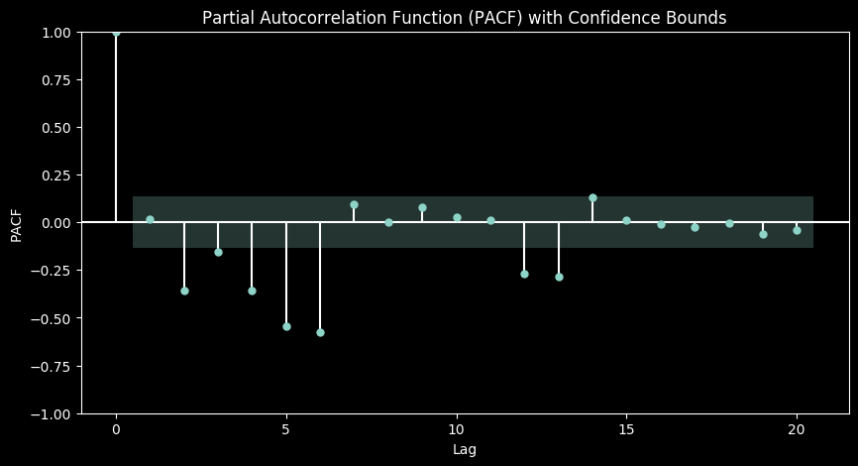

import pandas as pd
from datetime import datetime, timedelta
from statsmodels.tsa.arima.model import ARIMA
from sklearn.metrics import mean_squared_error
import matplotlib.pyplot as plt
train_start = datetime(2019, 3, 1)
train_end = datetime(2019, 9, 1)
test_end = datetime(2019, 9, 30)
train_data = first_diff[:train_end]
test_data = first_diff[train_end + timedelta(days=1):test_end]
model = ARIMA(train_data['Call_Volume'], order=(6,0,7)) # No differencing in model since data is already differenced
model_fit = model.fit()
predictions_diff = model_fit.predict(start=test_data.index[0], end=test_data.index[-1])
last_value_index = adjusted_data.index.get_loc(train_data.index[-1])
last_train_value = adjusted_data['Call_Volume'].iloc[last_value_index]
restored_arima_forecast = [last_train_value]
for prediction in predictions_diff:
restored_value = restored_arima_forecast[-1] + prediction
restored_arima_forecast.append(restored_value)
restored_arima_forecast = pd.Series(restored_arima_forecast[1:], index=predictions_diff.index)
mse_arima_test = mean_squared_error(adjusted_data['Call_Volume'].loc[restored_arima_forecast.index], restored_arima_forecast)
plt.figure(figsize=(14, 7))
plt.plot(adjusted_data['Call_Volume'], label='Actual Data', color='white') # Plotting the full original dataset
plt.plot(restored_arima_forecast, label='ARIMA Forecast (Restored)', color='blue')
plt.title('ARIMA Model Forecast Restored to Original Scale')
plt.legend()
plt.show()
print("MSE for ARIMA Forecast on Test Data:", mse_arima_test)
print("AIC:", model_fit.aic)
print("BIC:", model_fit.bic)
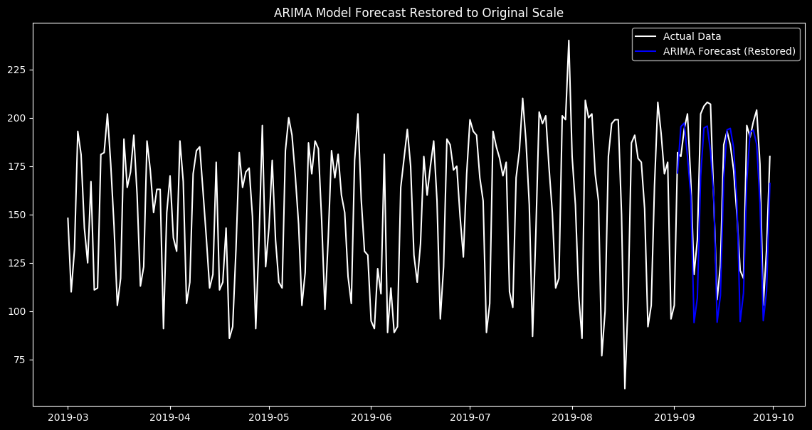
MSE for ARIMA Forecast on Test Data: 288.05894682996365
AIC: 1667.1657570754146
BIC: 1715.3897934395493

import pandas as pd
from datetime import datetime, timedelta
from statsmodels.tsa.arima.model import ARIMA
from sklearn.metrics import mean_squared_error
import matplotlib.pyplot as plt
train_start = datetime(2019, 3, 1)
train_end = datetime(2019, 8, 1)
test_end = datetime(2019, 9, 30)
rolling_predictions = pd.Series()
# Start from the end of the training period
current_train_end = train_end
current_train_data = first_diff[:current_train_end] # First part of the data for initial training
# Test dates - Generate test dates every 20 days for forecasts
test_dates = pd.date_range(start=train_end + timedelta(days=1), end=test_end, freq='10D')
for test_date in test_dates:
forecast_end_date = min(test_date + timedelta(days=9), test_data.index[-1])
model = ARIMA(current_train_data['Call_Volume'], order=(6, 0, 7))
model_fit = model.fit()
forecast = model_fit.predict(start=test_date, end=forecast_end_date)
last_known_value = adjusted_data['Call_Volume'].loc[current_train_data.index[-1]]
restored_forecast = [last_known_value]
for prediction in forecast:
restored_value = restored_forecast[-1] + prediction
restored_forecast.append(restored_value)
restored_forecast = pd.Series(restored_forecast[1:], index=forecast.index)
# Store the restored forecast in rolling predictions
rolling_predictions = pd.concat([rolling_predictions, restored_forecast])
# Update the training dataset to include the next observed data
current_train_data = first_diff[:forecast_end_date]
mse_rolling_arima = mean_squared_error(adjusted_data['Call_Volume'].loc[rolling_predictions.index], rolling_predictions)
plt.figure(figsize=(14, 7))
plt.plot(adjusted_data['Call_Volume'], label='Actual Data', color='white')
plt.plot(rolling_predictions, label='ARIMA Rolling Forecast (Restored)', color='red')
plt.title('ARIMA Rolling Forecast vs Actual Data')
plt.legend()
plt.show()
print("MSE for ARIMA Rolling Forecast on Test Data:", mse_rolling_arima)
print("AIC:", model_fit.aic)
print("BIC:", model_fit.bic)
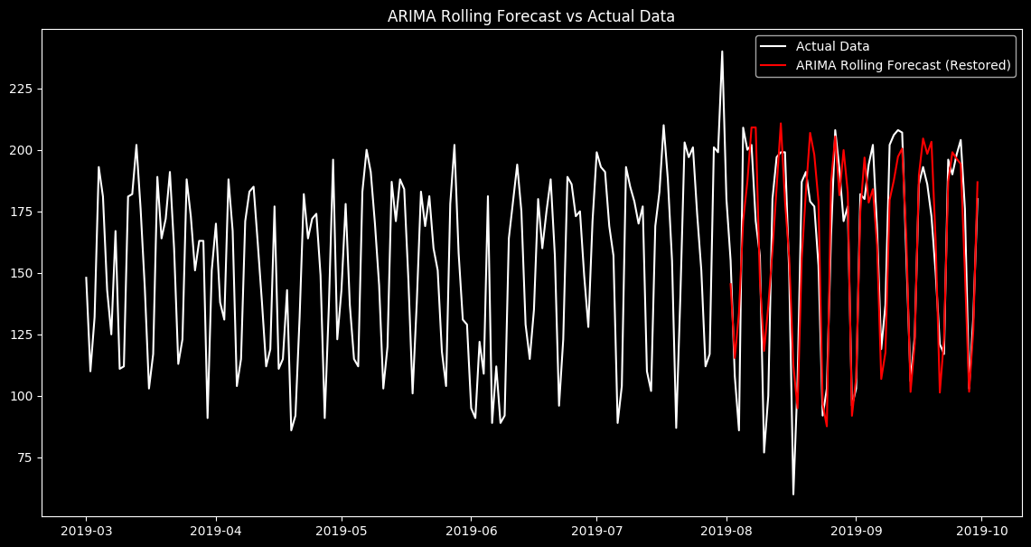
MSE for ARIMA Rolling Forecast on Test Data: 379.1534539910983
AIC: 1828.6453794374024
BIC: 1878.3434691230293

import numpy as np
import pandas as pd
from statsmodels.tsa.statespace.sarimax import SARIMAX
from sklearn.metrics import mean_squared_error
train_start = datetime(2019, 1, 1)
train_end = datetime(2019, 9, 1)
test_end = datetime(2019, 9, 30)
first_diff_ar = adjusted_data['Call_Volume']
train_data = first_diff_ar[:train_end]
test_data = first_diff_ar[train_end + timedelta(days=1):test_end]
model = SARIMAX(train_data,
order=( 6, 0, 2), # Reduced non-seasonal lags
seasonal_order=(2, 1, 5, 7), # Reduced seasonal lags
enforce_stationarity=False,
enforce_invertibility=False)
model_fit = model.fit(disp=0)
print(model_fit.summary())
predictions = model_fit.get_forecast(steps=len(test_data))
predicted_mean = predictions.predicted_mean
# Calculate MSE for the predictions
mse = mean_squared_error(test_data, predicted_mean)
print(f'Mean Squared Error of the predictions: {mse}')
plt.figure(figsize=(10, 6))
plt.plot(test_data.index, test_data, label='Actual')
plt.plot(test_data.index, predicted_mean, color='red', label='Forecast')
plt.fill_between(test_data.index,
predictions.conf_int().iloc[:, 0],
predictions.conf_int().iloc[:, 1], color='pink')
plt.title('Forecast vs Actuals')
plt.legend()
plt.show()
/usr/local/lib/python3.10/dist-packages/statsmodels/base/model.py:607: ConvergenceWarning: Maximum Likelihood optimization failed to converge. Check mle_retvals
warnings.warn("Maximum Likelihood optimization failed to "
SARIMAX Results
=======================================================================================================
Dep. Variable: Call_Volume No. Observations: 185
Model: SARIMAX(6, 0, 2)x(2, 1, [1, 2, 3, 4, 5], 7) Log Likelihood -609.273
Date: Tue, 23 Apr 2024 AIC 1250.546
Time: 01:21:16 BIC 1297.612
Sample: 03-01-2019 HQIC 1269.672
- 09-01-2019
Covariance Type: opg
==============================================================================
coef std err z P>|z| [0.025 0.975]
------------------------------------------------------------------------------
ar.L1 -0.0532 0.221 -0.240 0.810 -0.487 0.381
ar.L2 -0.7143 0.230 -3.103 0.002 -1.166 -0.263
ar.L3 0.4259 0.138 3.089 0.002 0.156 0.696
ar.L4 0.1394 0.113 1.236 0.216 -0.082 0.360
ar.L5 0.2538 0.113 2.237 0.025 0.031 0.476
ar.L6 -0.0080 0.124 -0.065 0.949 -0.252 0.235
ma.L1 0.3339 0.188 1.773 0.076 -0.035 0.703
ma.L2 0.8058 0.207 3.895 0.000 0.400 1.211
ar.S.L7 -1.5561 0.079 -19.624 0.000 -1.712 -1.401
ar.S.L14 -0.7221 0.071 -10.176 0.000 -0.861 -0.583
ma.S.L7 1.0214 1.475 0.693 0.489 -1.869 3.912
ma.S.L14 -0.3251 0.500 -0.650 0.516 -1.306 0.656
ma.S.L21 -0.6653 1.175 -0.566 0.571 -2.967 1.637
ma.S.L28 0.0369 0.196 0.188 0.851 -0.348 0.422
ma.S.L35 -0.0108 0.154 -0.070 0.944 -0.312 0.291
sigma2 293.2903 479.145 0.612 0.540 -645.816 1232.397
===================================================================================
Ljung-Box (L1) (Q): 0.00 Jarque-Bera (JB): 3.95
Prob(Q): 0.96 Prob(JB): 0.14
Heteroskedasticity (H): 0.98 Skew: -0.31
Prob(H) (two-sided): 0.96 Kurtosis: 3.54
===================================================================================
Warnings:
[1] Covariance matrix calculated using the outer product of gradients (complex-step).
Mean Squared Error of the predictions: 266.94579561393664
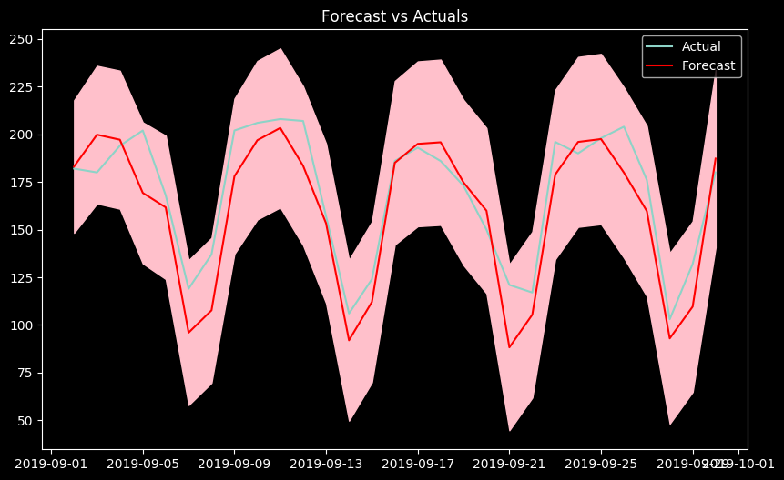

import pandas as pd
from datetime import datetime, timedelta
from statsmodels.tsa.statespace.sarimax import SARIMAX
from sklearn.metrics import mean_squared_error
import matplotlib.pyplot as plt
train_start = datetime(2019, 3, 1)
train_end = datetime(2019, 8, 1)
test_end = datetime(2019, 9, 30)
rolling_predictions = pd.Series()
current_train_end = train_end
current_train_data = adjusted_data[:current_train_end]
test_dates = pd.date_range(start=train_end + timedelta(days=1), end=test_end, freq='10D')
for test_date in test_dates:
forecast_end_date = min(test_date + timedelta(days=9), test_data.index[-1])
model = SARIMAX(train_data,
order=( 6, 0, 2), # Reduced non-seasonal lags
seasonal_order=(2, 1, 5, 7), # Reduced seasonal lags
enforce_stationarity=False,
enforce_invertibility=False)
model_fit = model.fit()
forecast = model_fit.predict(start=test_date, end=forecast_end_date)
rolling_predictions = pd.concat([rolling_predictions, forecast])
current_train_data = first_diff[:forecast_end_date]
mse_rolling_sarima = mean_squared_error(adjusted_data['Call_Volume'].loc[rolling_predictions.index], rolling_predictions)
plt.figure(figsize=(14, 7))
plt.plot(adjusted_data['Call_Volume'], label='Actual Data', color='white')
plt.plot(rolling_predictions, label='SARIMA Rolling Forecast (Restored)', color='red')
plt.title('SARIMA Rolling Forecast vs Actual Data')
plt.legend()
plt.show()
print("MSE for SARIMA Rolling Forecast on Test Data:", mse_rolling_sarima)
print("AIC:", model_fit.aic)
print("BIC:", model_fit.bic)
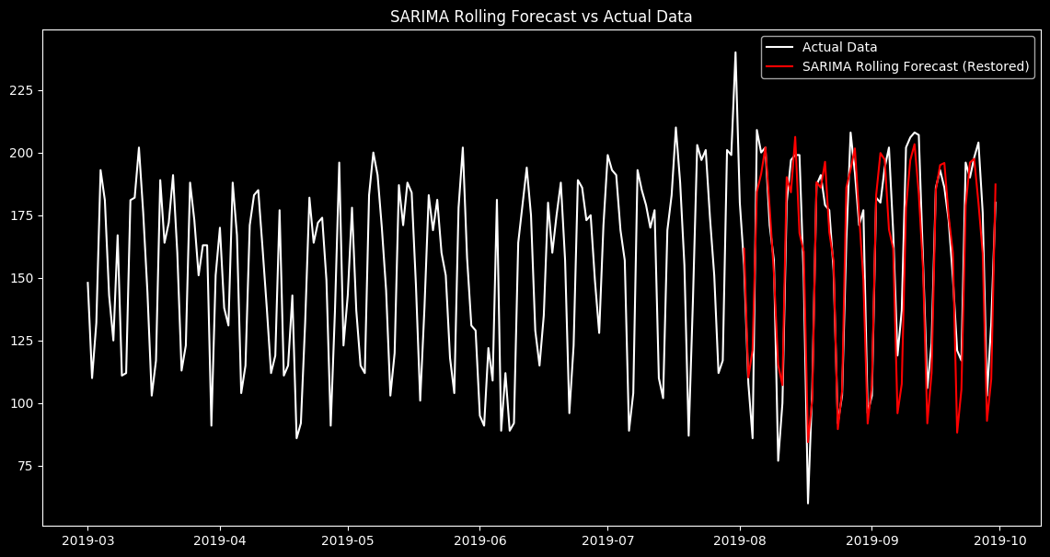
MSE for SARIMA Rolling Forecast on Test Data: 255.60340578901807
AIC: 1250.5459649915824
BIC: 1297.6122437533313

import pandas as pd
import numpy as np
from datetime import datetime
import matplotlib.pyplot as plt
from sklearn.linear_model import LinearRegression
from sklearn.metrics import mean_squared_error
# Create a DataFrame with date range and dummy 'Call_Volume' values
dates = pd.date_range(start='2019-03-01', end='2019-09-30')
adjusted_data_ln = adjusted_data.copy()
# Add a numeric time index for regression
adjusted_data_ln['Time_Index'] = np.arange(len(adjusted_data_ln))
# Split the data into training and testing
train_data_ln = adjusted_data_ln[:'2019-08-01']
test_data_ln = adjusted_data_ln['2019-08-01':]
# Initialize and fit the Linear Regression model
model = LinearRegression()
X_train_ln = train_data_ln['Time_Index'].values.reshape(-1, 1)
y_train_ln = train_data_ln['Call_Volume'].values
X_test_ln = test_data_ln['Time_Index'].values.reshape(-1, 1)
y_test_ln = test_data_ln['Call_Volume'].values
model.fit(X_train_ln, y_train_ln)
# Predictions
train_predictions = model.predict(X_train_ln)
test_predictions = model.predict(X_test_ln)
# Calculate MSE for evaluation
train_mse = mean_squared_error(y_train_ln, train_predictions)
test_mse = mean_squared_error(y_test_ln, test_predictions)
# Plot the actual data and predictions
plt.figure(figsize=(14, 7))
plt.plot(adjusted_data_ln['Call_Volume'], label='Actual Data', color='blue')
plt.plot(train_data_ln.index, train_predictions, label='Train Predictions', color='red', linestyle='-',linewidth=5)
plt.plot(test_data_ln.index, test_predictions, label='Test Predictions', color='orange', linestyle='--',linewidth=5)
plt.title('Linear Regression Forecast vs Actual Data')
plt.xlabel('Date')
plt.ylabel('Call Volume')
plt.legend()
plt.show()
print(f'Train MSE: {train_mse}')
print(f'Test MSE: {test_mse}')
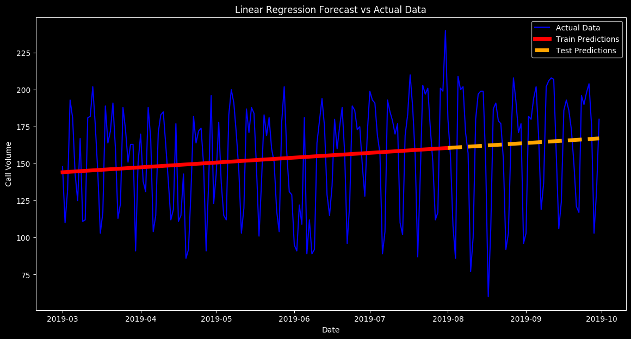
Train MSE: 1179.0185894319752
Test MSE: 1620.787702360763

import pandas as pd
from datetime import datetime, timedelta
from statsmodels.tsa.statespace.sarimax import SARIMAX
import matplotlib.pyplot as plt
train_start = datetime(2019, 3, 1)
train_end = datetime(2019, 9, 30)
current_train_data = adjusted_data[:train_end]
forecast_start_date = train_end + timedelta(days=1)
forecast_end_date = forecast_start_date + timedelta(days=60)
rolling_predictions = pd.Series(dtype=float, index=pd.date_range(start=forecast_start_date, end=forecast_end_date, freq='D'))
# Forecast in rolling windows
while forecast_start_date <= forecast_end_date:
forecast_period_end = min(forecast_start_date + timedelta(days=9), forecast_end_date)
# Fit the SARIMAX model on the updated training data
model = SARIMAX(current_train_data['Call_Volume'],
order=(6, 0, 2),
seasonal_order=(2, 1, 5, 7),
enforce_stationarity=False,
enforce_invertibility=False)
model_fit = model.fit(disp=0)
forecast = model_fit.get_forecast(steps=(forecast_period_end - forecast_start_date).days + 1)
forecast_mean = forecast.predicted_mean
# Store the forecast
rolling_predictions[forecast_start_date:forecast_period_end] = forecast_mean
additional_data = pd.Series(forecast_mean, index=pd.date_range(start=forecast_start_date, end=forecast_period_end, freq='10D'))
current_train_data = pd.concat([current_train_data, additional_data])
# Move the start date forward for the next iteration
forecast_start_date = forecast_period_end + timedelta(days=1)
# Plotting the forecast
plt.figure(figsize=(14, 7))
plt.plot(current_train_data.index, current_train_data, color='blue')
plt.plot(rolling_predictions.index, rolling_predictions, label='Forecasted Call Volume', color='red')
plt.title('Next Two Months Daily Call Volume Forecast')
plt.xlabel('Date')
plt.ylabel('Call Volume')
plt.legend()
plt.show()
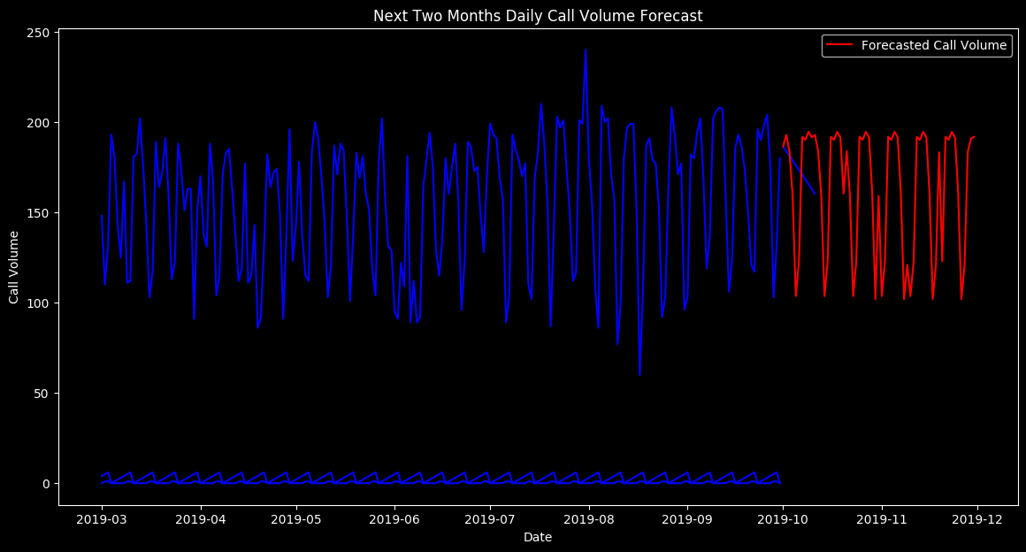
import pandas as pd
rolling_predictions
2019-10-01 186.404509
2019-10-02 192.860527
2019-10-03 183.932813
2019-10-04 159.064024
2019-10-05 103.590478
...
2019-11-26 101.927397
2019-11-27 120.783603
2019-11-28 183.205688
2019-11-29 190.810828
2019-11-30 191.757049
Freq: D, Length: 61, dtype: float64

import pandas as pd
forecasted_data = rolling_predictions.reset_index()
forecasted_data.columns = ['Date', 'Call_volume']

forecasted_data.head(), forecasted_data.describe(), forecasted_data.info()
<class 'pandas.core.frame.DataFrame'>
RangeIndex: 61 entries, 0 to 60
Data columns (total 2 columns):
# Column Non-Null Count Dtype
--- ------ -------------- -----
0 Date 61 non-null datetime64[ns]
1 Call_volume 61 non-null float64
dtypes: datetime64[ns](1), float64(1)
memory usage: 1.1 KB
( Date Call_volume
0 2019-10-01 186.404509
1 2019-10-02 192.860527
2 2019-10-03 183.932813
3 2019-10-04 159.064024
4 2019-10-05 103.590478,
Date Call_volume
count 61 61.000000
mean 2019-10-31 00:00:00 163.008681
min 2019-10-01 00:00:00 101.927211
25% 2019-10-16 00:00:00 122.808109
50% 2019-10-31 00:00:00 183.932813
75% 2019-11-15 00:00:00 191.513464
max 2019-11-30 00:00:00 194.537711
std NaN 35.118833,
None)
forecasted_data['Call_volume'] = pd.to_datetime(forecasted_data['Call_volume'])
# Setting the aesthetic style of the plots
sns.set(style="whitegrid")
fig, axes = plt.subplots(3, 1, figsize=(10, 15))
sns.lineplot(data=forecasted_data, x='Date', y='Call_volume', ax=axes[0], marker='o', color='dodgerblue')
axes[0].set_title('Forecasted Call Volume Over Time')
axes[0].set_xlabel('Date')
axes[0].set_ylabel('Call Volume')
sns.histplot(forecasted_data['Call_volume'], bins=15, kde=True, color='purple', ax=axes[1])
axes[1].set_title('Distribution of Call Volumes')
axes[1].set_xlabel('Call Volume')
axes[1].set_ylabel('Frequency')
sns.boxplot(data=forecasted_data, x='Call_volume', color='green', ax=axes[2])
axes[2].set_title('Box Plot of Call Volumes')
axes[2].set_xlabel('Call Volume')
plt.tight_layout()
plt.show()
