

Ministerul Educatiei, Culturii și Cercetarii al Republicii Moldova Universitatea Tehnică a Moldovei
Facultatea Calculatoare, Informatică şi Microelectronică Departamentul Ingineria Software și Automatica

REPORT

Laboratory work No. 3
Course: Operating Systems
Theme: Floppy Disk I/O operations

Authors: Catlabuga Corneliu,
Golban Beatricia,
Gîtlan Gabriel,
FAF-213

Checked by: univ. lect.
Călin Rostislav

Chișinău 2023
Objective:
Acquire working skills with floppy disk access methods, especially reading and writing data, but not limited to them.
Task:
The given procedures also extend to other permanent data storage media such as HDD disks. The total disk volume of 1474560 bytes will be structured in 96 logical blocks of 30 sectors each. Each student will be allocated an individual block of 15360 bytes, for recording his data as follows. The block distribution is represented in the included file ("Floppy space distribution.xlsx").
1. In the first and last sector of each student's block (on diskette), textual information must be entered in the following format (without quotes): "@@@FAF-21* First name NAME###". This text string must be duplicated 10 times without additional delimiters.
2. Create an assembly language program that will have the following functions:
- (KEYBOARD ==> FLOPPY) : Reading from the keyboard a string with a maximum length of 256 characters (backspace correction should work) and writing this string to the floppy "N" times, starting at address {Head, Track, Sector }. Where "N" can take values in the range (1-30000). After the ENTER key is detected, if the length of the string is greater than 0 (zero), a blank line and then the newly entered string should be displayed. The variables "N", "Head", "Track" and "Sector" must be read visibly from the keyboard. After the disk write operation is finished, the error code should be displayed on the screen.
- (FLOPPY ==> RAM) : Reading from floppy disk "N" sectors starting at address {Head, Track, Sector} and transferring this data to RAM memory starting at address {XXXX:YYYY}. After the read operation from the diskette is finished, the error code should be displayed on the screen. After the error code, the entire volume of data at address {XXXX:YYYY} that was read from the disk should be displayed on the screen. If the displayed data volume is larger than a video page, then it is necessary to implement pagination by pressing the "SPACE" key. The variables "N", "Head", "Track" and "Sector" as well as the address {XXXX:YYYY} must also be read from the keyboard.
- (RAM ==> FLOPPY) : Writing to the floppy disk starting from the address {Head, Track, Sector} a volume of "Q" bytes, from the RAM memory starting from the address {XXXX:YYYY}. The data block of "Q" bytes must be displayed on the screen, and after the disk write operation is finished, the error code must be displayed on the screen.

3. After executing a function above, the program must be ready to execute the next function (any of the 3 functions described above).
4. The compiled code should preferably not exceed 512 bytes. Otherwise, it is necessary to implement the bypass of this restriction and finally to create the bootable disk image that works in VirtualBox.

Theoretical considerations:
This project is a comprehensive exploration of low-level programming using assembly language. It demonstrates a deep understanding of how computer systems operate at the hardware level.
Firstly, the bootloader, an essential component of any system, is responsible for loading the operating system into memory during startup. This process, known as bootstrapping, is crucial for the system to become operational.
Secondly, the project employs direct hardware manipulation, particularly with the floppy disk drive and RAM. This requires a thorough understanding of input/output operations and memory management, as well as the specifics of the hardware being used. The project also demonstrates the use of modular programming, with different .asm files handling different aspects of the program. This enhances the readability and maintainability of the code, making it easier to understand and modify.
Furthermore, the project involves the conversion of int and hex ASCII input to binary, indicating a manipulation of data types. This is a common operation in low-level programming and cryptography, and it's often used in processes like encryption.
Lastly, the project includes a user interaction aspect, with a menu system that allows users to select various operations. This demonstrates an understanding of user interface design, even at the low level of assembly language programming.

Compilation commands:
nasm -f bin -o boot.img boot.asm &&
truncate -s 1474560 boot.img

Implementation and practical results:
boot.asm: This is the bootloader. It sets up the initial environment and reads the sectors from the disk into memory.
[bits 16]
org 0x7C00

mov bx, 0x0
mov es, bx
mov bx, 0x7E00

mov cl, 0x2
mov dh, 0x0
mov ch, 0x0

boot_read_loop:
mov ah, 0x2
mov al, 0x1
int 0x13

mov al, [boot_sectors_to_read]
mov ah, [boot_sectors_read]
cmp al, ah
je boot_finish_read

cmp cl, 0x12
jl boot_read_continue
mov cl, 0x0
add dh, 0x1

cmp dh, 0x2
jl boot_read_continue
mov dh, 0x0
add ch, 0x1

boot_read_continue:
add cl, 0x1
mov ax, 0x0
mov ah, [boot_sectors_read]
add ah, 0x1
mov [boot_sectors_read], ah
add bx, 0x200

jmp boot_read_loop

boot_finish_read:
jmp 0x7E00

; TODO: add disk read error handling

boot_sectors_to_read db 0x20
boot_sectors_read db 0x0

times 510-($-$$) db 0
dw 0xaa55

%include "main.asm"

main.asm:This is the main program file. It calls various routines from other files and includes all the necessary files.
main:

; Call "wirte_names" from "write_names.asm"
call write_names

; Go to "menu" from "menu.asm"
jmp menu

; Include all the files
%include "src/write_names.asm"

%include "src/menu.asm"
%include "src/prompts.asm"
%include "src/screen_routines.asm"
%include "src/string_convertors.asm"

%include "src/keyboard_to_floppy.asm"
%include "src/floppy_to_ram.asm"
%include "src/ram_to_floppy.asm"

%include "src/floppy_params.asm"

write_names.asm: This file contains routines to write strings to the floppy disk.
write_names:
; Write sector 1
; to 2041
mov ah, 03h
mov dl, 0x0 ; Drive 0
mov al, 0x1 ; Sector count 1
mov ch, 0x38 ; Track 56
mov dh, 0x1 ; Head 1
mov cl, 0x8 ; Sector 8
mov bx, sector_1 ; Buffer
int 13h

; to 2070
mov ah, 03h
mov dl, 0x0 ; Drive 0
mov al, 0x1 ; Sector count 1
mov ch, 0x39 ; Track 57
mov dh, 0x1 ; Head 1
mov cl, 0x1 ; Sector 1
mov bx, sector_1 ; Buffer
int 13h

; Write sector 2
; to 2281
mov ah, 03h
mov dl, 0x0 ; Drive 0
mov al, 0x1 ; Sector count 1
mov ch, 0x3F ; Track 63
mov dh, 0x0 ; Head 0
mov cl, 0xE ; Sector 14
mov bx, sector_2 ; Buffer
int 13h

; to 2310
mov ah, 03h
mov dl, 0x0 ; Drive 0
mov al, 0x1 ; Sector count 1
mov ch, 0x40 ; Track 64
mov dh, 0x0 ; Head 0
mov cl, 0x7 ; Sector 7
mov bx, sector_2 ; Buffer
int 13h

; Write sector 3
; to 2311
mov ah, 03h
mov dl, 0x0 ; Drive 0
mov al, 0x1 ; Sector count 1
mov ch, 0x40 ; Track 64
mov dh, 0x0 ; Head 0
mov cl, 0x8 ; Sector 8
mov bx, sector_3 ; Buffer
int 13h

; to 2340
mov ah, 03h
mov dl, 0x0 ; Drive 0
mov al, 0x1 ; Sector count 1
mov ch, 0x41 ; Track 65
mov dh, 0x0 ; Head 0
mov cl, 0x1 ; Sector 1
mov bx, sector_3 ; Buffer
int 13h

ret

section .data
sector_1 db "@@@FAF-213 Corneliu Catlabuga###@@@FAF-213 Corneliu Catlabuga###@@@FAF-213 Corneliu Catlabuga###@@@FAF-213 Corneliu Catlabuga###@@@FAF-213 Corneliu Catlabuga###@@@FAF-213 Corneliu Catlabuga###@@@FAF-213 Corneliu Catlabuga###@@@FAF-213 Corneliu Catlabuga###@@@FAF-213 Corneliu Catlabuga###@@@FAF-213 Corneliu Catlabuga###"
times 0x200 - ($ - sector_1) db 0x0

sector_2 db "@@@FAF-213 Beatricia Golban###@@@FAF-213 Beatricia Golban###@@@FAF-213 Beatricia Golban###@@@FAF-213 Beatricia Golban###@@@FAF-213 Beatricia Golban###@@@FAF-213 Beatricia Golban###@@@FAF-213 Beatricia Golban###@@@FAF-213 Beatricia Golban###@@@FAF-213 Beatricia Golban###@@@FAF-213 Beatricia Golban###"
times 0x200 - ($ - sector_2) db 0x0

sector_3 db "@@@FAF-213 Gabriel Gitlan###@@@FAF-213 Gabriel Gitlan###@@@FAF-213 Gabriel Gitlan###@@@FAF-213 Gabriel Gitlan###@@@FAF-213 Gabriel Gitlan###@@@FAF-213 Gabriel Gitlan###@@@FAF-213 Gabriel Gitlan###@@@FAF-213 Gabriel Gitlan###@@@FAF-213 Gabriel Gitlan###@@@FAF-213 Gabriel Gitlan###"
times 0x200 - ($ - sector_3) db 0x0

screen_routines.asm: This file contains routines to handle screen operations such as clearing the screen and printing messages.
; Clear the screen
clear_screen:
pusha
; Clear the screen with INT 10h 07h
mov ah, 07h
mov al, 0x0
mov bh, 0x7
mov cx, 0x0
mov dx, 0x184F
int 10h

; Move the cursor to the top left corner
mov ah, 02h
mov dx, 0x0
int 10h
popa

ret

; Remove the last character from the screen
remove_last_char:
; Move the cursor back
mov ah, 02h
sub dl, 0x1
int 10h

; Remove the character from the screen
mov ah, 0Ah
mov al, 0x0
int 10h

ret

; Remove the last char on previous line
remove_last_char_line:
; Move the cursor to the end of the previous line
mov ah, 02h
mov dl, 0x4F
sub dh, 0x1
int 10h

; Remove the character from the screen
mov ah, 0Ah
mov al, 0x0
int 10h

ret

; Clear the current line
clear_row:
mov ah, 03h
int 10h

mov ax, 1301h
mov bx, 0x7
mov dl, 0x0
mov bp, clean_row
mov cx, 0x50
int 10h

ret

; Print the floppy error
print_error:
cmp ah, 00h
je floppy_error_00

cmp ah, 01h
je floppy_error_01

cmp ah, 02h
je floppy_error_02

cmp ah, 03h
je floppy_error_03

cmp ah, 04h
je floppy_error_04

cmp ah, 06h
je floppy_error_06

cmp ah, 08h
je floppy_error_08

cmp ah, 09h
je floppy_error_09

cmp ah, 0Ch
je floppy_error_0C

cmp ah, 10h
je floppy_error_10

cmp ah, 20h
je floppy_error_20

cmp ah, 40h
je floppy_error_40

cmp ah, 80h
je floppy_error_80

floppy_error_00:
mov bp, flp_err_00
mov cx, flp_err_00_len
jmp floppy_error_return

floppy_error_01:
mov bp, flp_err_01
mov cx, flp_err_01_len
jmp floppy_error_return

floppy_error_02:
mov bp, flp_err_02
mov cx, flp_err_02_len
jmp floppy_error_return

floppy_error_03:
mov bp, flp_err_03
mov cx, flp_err_03_len
jmp floppy_error_return

floppy_error_04:
mov bp, flp_err_04
mov cx, flp_err_04_len
jmp floppy_error_return

floppy_error_06:
mov bp, flp_err_06
mov cx, flp_err_06_len
jmp floppy_error_return

floppy_error_08:
mov bp, flp_err_08
mov cx, flp_err_08_len
jmp floppy_error_return

floppy_error_09:
mov bp, flp_err_09
mov cx, flp_err_09_len
jmp floppy_error_return

floppy_error_0C:
mov bp, flp_err_0C
mov cx, flp_err_0C_len
jmp floppy_error_return

floppy_error_10:
mov bp, flp_err_10
mov cx, flp_err_10_len
jmp floppy_error_return

floppy_error_20:
mov bp, flp_err_20
mov cx, flp_err_20_len
jmp floppy_error_return

floppy_error_40:
mov bp, flp_err_40
mov cx, flp_err_40_len
jmp floppy_error_return

floppy_error_80:
mov bp, flp_err_80
mov cx, flp_err_80_len
jmp floppy_error_return

floppy_error_return:
mov ax, 1301h
mov bx, 0x7
mov dh, 0x0
mov dl, 0x0
int 10h

clc

mov ah, 00h
int 16h

ret

section .data
flp_err_00 db "No error"
flp_err_00_len equ $ - flp_err_00

flp_err_01 db "Bad command"
flp_err_01_len equ $ - flp_err_01

flp_err_02 db "Bad address mark"
flp_err_02_len equ $ - flp_err_02

flp_err_03 db "Write protected"
flp_err_03_len equ $ - flp_err_03

flp_err_04 db "Bad sector ID"
flp_err_04_len equ $ - flp_err_04

flp_err_06 db "Disk change line active"
flp_err_06_len equ $ - flp_err_06

flp_err_08 db "DMA failure"
flp_err_08_len equ $ - flp_err_08

flp_err_09 db "DMA overrun"
flp_err_09_len equ $ - flp_err_09

flp_err_0C db "Media type not available"
flp_err_0C_len equ $ - flp_err_0C

flp_err_10 db "Bad CRC"
flp_err_10_len equ $ - flp_err_10

flp_err_20 db "Diskete controller failure"
flp_err_20_len equ $ - flp_err_20

flp_err_40 db "Bad seek"
flp_err_40_len equ $ - flp_err_40

flp_err_80 db "Time-out"
flp_err_80_len equ $ - flp_err_80

menu.asm: This file handles the main menu display and user input for selecting options.
menu:
; Call "clear_screen" from "screen_routines.asm"
call clear_screen

; Print the main message
mov ax, 1301h
mov bx, 0x7
mov bp, main_message
mov cx, main_message_size
mov dl, 0x0
mov dh, 0x0
int 10h

; Read the option
mov ah, 00h
int 16h

; Check if option "1"
cmp al, '1'
je keyboard_to_floppy

; Check if option "2"
cmp al, '2'
je floppy_to_ram

; Check if option "3"
cmp al, '3'
je ram_to_floppy

; If the option is not valid display an unexpected option message
; Call "clear_screen" from "screen_routines.asm"
call clear_screen

; Print the unexpected option message
mov ax, 1301h
mov bx, 0x7
mov bp, unexpected_option_message
mov cx, unexpected_option_message_size
mov dl, 0x0
mov dh, 0x0
int 10h

; Wait for a key press
mov ah, 00h
int 16h

; Return to the menu
jmp menu

section .data
; Main message buffer and size
main_message db "Please select an option: ", 0xA, 0xD, "1. Keyboard to Floppy", 0xA, 0xD, "2. Floppy to RAM", 0xA, 0xD, "3. RAM to Floppy", 0xA, 0xD, 0xA, 0xD, "Your option: "
main_message_size equ $ - main_message

; Unexpected option message buffer and size
unexpected_option_message db "Unexpected option!", 0xA, 0xD, 0xA, 0xD, "Press any key to continue..."
unexpected_option_message_size equ $ - unexpected_option_message

string_convertors.asm: This file contains routines to convert string input into other formats.
; Convert ASCII string to integer
read_num:
; Read a character
mov ah, 00h
int 16h

; Check if the key is escape
; (if yes: go to "read_num_return")
cmp al, 0x1B
je read_num_return

; (if no)
; Check if the key is enter
; (if yes: go to "read_num_return")
cmp al, 0x0D
je read_num_return

; (if no)
; Check if the key is backspace
; (if yes: go to "read_num_backspace")
cmp al, 0x08
je read_num_backspace

; Check if the key is in range 0-9
; (if no: loop back to "read_num")
cmp al, 0x30
jl read_num
cmp al, 0x39
jg read_num

; (if yes)
; Subtract 0x30 from the ASCII value
sub al, 0x30

; Place number in CX
mov cl, al

; Move the number in AX
mov ax, [num_buffer]

; Check if the number is 3276
; (if yes go to "limit_num")
cmp ax, 0xCCC
je limit_num ; (accept between 0 and 7)

; (if no)
; Check if the number is less than 3276
; (if yes: go to "accept_num")
cmp ax, 0xCCC
jl accept_num

; (if no)
; Loop back to "read_num"
jmp read_num

accept_num:
; Place the number in AX
; Multiply the number by 10
mov ax, [num_buffer]
mov dx, 0xA
mul dx

; Add to ax the number in CX
add ax, cx

; Store to num_buffer the number in AX
mov [num_buffer], ax

; Print the number
mov ah, 0Eh
mov al, cl
add al, 0x30
int 10h

; Loop back to "read_num"
jmp read_num

; Return from the function
read_num_return:
ret

; Handle backspace
read_num_backspace:
; Check if the buffer is empty
; (if yes: loop back to "read_num")
mov dx, 0x0
mov ax, [num_buffer]
cmp ax, 0x0
je read_num

; (if no)
; Divide the number by 10
mov cx, 0xA
div cx

; Store the number in AX to num_buffer
mov [num_buffer], ax

; Remove the last character from the screen
pusha
mov ah, 03h
mov bh, 0x0
int 10h
mov ah, 02h
sub dl, 0x1
int 10h
mov ah, 0Ah
mov al, 0x0
int 10h
popa

; Loop back to "read_num"
jmp read_num

; Limit the number to 3276
limit_num:
; Check if the number is greater than 7
; (if yes: loop back to "read_num")
cmp cl, 0x7
jg read_num

; (if no)
; Go to "accept_num"
jmp accept_num

; Convert ASCII string to hexadecimal
read_address:
; Read a character
mov ah, 00h
int 16h

; Check if the key is escape
; (if yes: go to "read_address_return")
cmp al, 0x1B
je read_address_return

; (if no)
; Check if the key is enter
; (if yes: go to "read_address_return")
cmp al, 0x0D
je read_address_return

; (if no)
; Check if the key is backspace
; (if yes: go to "read_address_backspace")
cmp al, 0x08
je read_address_backspace

; (if no)
; Check if the key lower than 0x30
; (if yes: loop back to "read_address")
cmp al, 0x30
jl read_address

; (if no)
; Check if the less than 0x3A
; (if yes: go to "handle_number")
cmp al, 0x3A
jl handle_number

; (if no)
; Check if the key is less than 0x41
; (if yes: loop back to "read_address")
cmp al, 0x41
jl read_address

; (if no)
; Check if the key is less than 0x47
; (if yes: go to "handle_uppercase")
cmp al, 0x47
jl handle_uppercase

; (if no)
; Check if the key is less than 0x61
; (if yes: loop back to "read_address")
cmp al, 0x61
jl read_address

; (if no)
; Check if the key is less than 0x67
; (if yes: go to "handle_lowercase")
cmp al, 0x67
jl handle_lowercase

; (if no)
; Loop back to "read_address"
jmp read_address

; Handle the character as a number
handle_number:
; Subtract 0x30 from the ASCII value
sub al, 0x30

; Got to "handle_value"
jmp handle_value

; Handle the character as an uppercase letter
handle_uppercase:
; Subtract 0x37 from the ASCII value
sub al, 0x37

; Got to "handle_value"
jmp handle_value

; Handle the character as a lowercase letter
handle_lowercase:
; Subtract 0x57 from the ASCII value
sub al, 0x57

; Got to "handle_value"
jmp handle_value

; Handle the character as a value
handle_value:
; Place the value in CL
mov cl, al

; Move the buffer in AX
mov ax, [num_buffer]

; Check if the buffer is above 0xFFF
; (if yes: loop back to "read_address")
cmp ax, 0xFFF
ja read_address

; (if no)
; Multiply the buffer by 0x10
mov dx, 0x10
mul dx

; Add the value to the buffer
add ax, cx
mov [num_buffer], ax

; Print the value
mov ah, 0Eh
mov al, cl
cmp cx, 0x9
jg print_letter
; Print as number
add al, 0x30
int 10h

; Loop back to "read_address"
jmp read_address

print_letter:
; Print as letter
add al, 0x37
int 10h

; Loop back to "read_address"
jmp read_address

; Return from the function
read_address_return:
ret

; Handle backspace
read_address_backspace:
; Check if the buffer is empty
; (if yes: loop back to "read_address")
mov dx, 0x0
mov ax, [num_buffer]
cmp ax, 0x0
je read_address

; (if no)
; Divide the num_buffer by 0x10
mov cx, 0x10
div cx
mov [num_buffer], ax

; Remove the last character from the screen
pusha
mov ah, 03h
mov bh, 0x0
int 10h
mov ah, 02h
sub dl, 0x1
int 10h
mov ah, 0Ah
mov al, 0x0
int 10h
popa

; Loop back to "read_address"
jmp read_address

prompts.asm: This file contains routines to print various prompts on the screen.
; Print the sectors prompt
print_sectors_prompt:
mov ax, 1301h
mov bx, 0x7
mov dl, 0x0
mov dh, 0xB
mov bp, sectors_prompt
mov cx, sectors_prompt_size
int 10h

ret

; Print the volume prompt
print_volume_prompt:
mov ax, 1301h
mov bx, 0x7
mov dl, 0x0
mov dh, 0xB
mov bp, volume_prompt
mov cx, volume_prompt_size
int 10h

ret

; Print the text prompt
print_text_prompt:
mov ax, 1301h
mov bx, 0x7
mov dl, 0x0
mov dh, 0x2
mov bp, text_prompt
mov cx, text_prompt_size
int 10h

ret

; Print the buffer
print_buffer:
mov ax, 1301h
mov bx, 0x7
mov dl, 0x0
mov dh, 0x6
mov bp, buffer
mov cx, si
int 10h

ret

; Print the side prompt
print_side_prompt:
mov ax, 1301h
mov bx, 0x7
mov dl, 0x0
mov dh, 0xC
mov bp, side_prompt
mov cx, side_prompt_size
int 10h

ret

; Print the track prompt
print_track_prompt:
mov ax, 1301h
mov bx, 0x7
mov dl, 0x0
mov dh, 0xD
mov bp, track_prompt
mov cx, track_prompt_size
int 10h

ret

; Print the sector prompt
print_sector_prompt:
mov ax, 1301h
mov bx, 0x7
mov dl, 0x0
mov dh, 0xE
mov bp, sector_prompt
mov cx, sector_prompt_size
int 10h

ret

; Print sectors amount warning
print_sectors_warning:
mov ah, 03h
int 10h

mov ax, 1301h
mov bx, 0x7
mov dl, 0x0
add dh, 0x1
mov bp, sectors_warning
mov cx, sectors_warning_size
int 10h

mov ah, 02h
sub dh, 0x1
int 10h

ret

; Print the times prompt
print_times_prompt:
mov ax, 1301h
mov bx, 0x7
mov dl, 0x0
mov dh, 0xF
mov bp, times_prompt
mov cx, times_prompt_size
int 10h

ret

; Print the times amount warning
print_times_warning:
mov ah, 03h
int 10h

mov ax, 1301h
mov bx, 0x7
mov dl, 0x0
add dh, 0x1
mov bp, times_warning
mov cx, times_warning_size
int 10h

mov ah, 02h
sub dh, 0x1
int 10h

ret

; Print the side warning
print_side_warning:
mov ah, 03h
int 10h

mov ax, 1301h
mov bx, 0x7
mov dl, 0x0
add dh, 0x1
mov bp, side_warning
mov cx, side_warning_size
int 10h

mov ah, 02h
sub dh, 0x1
int 10h

ret

; Print the track warning
print_track_warning:
mov ah, 03h
int 10h

mov ax, 1301h
mov bx, 0x7
mov dl, 0x0
add dh, 0x1
mov bp, track_warning
mov cx, track_warning_size
int 10h

mov ah, 02h
sub dh, 0x1
int 10h

ret

; Print the sector warning
print_sector_warning:
mov ah, 03h
int 10h

mov ax, 1301h
mov bx, 0x7
mov dl, 0x0
add dh, 0x1
mov bp, sector_warning
mov cx, sector_warning_size
int 10h

mov ah, 02h
sub dh, 0x1
int 10h

ret

; Print the address prompt
print_address_prompt:
mov ax, 1301h
mov bx, 0x7
mov dl, 0x0
mov dh, 0xF
mov bp, address_prompt
mov cx, address_prompt_size
int 10h

ret

section .data
override_disk_prompt db "Found diskette end. Aborting."
override_disk_prompt_size equ $ - override_disk_prompt

text_prompt db "Text: "
text_prompt_size equ $ - text_prompt

sectors_prompt db "Sectors: "
sectors_prompt_size equ $ - sectors_prompt

sectors_warning db "Sectors must be in range 1-2880"
sectors_warning_size equ $ - sectors_warning

volume_prompt db "Volume(bytes): "
volume_prompt_size equ $ - volume_prompt

side_prompt db "Side(0-1): "
side_prompt_size equ $ - side_prompt

side_warning db "Side must be 0 or 1"
side_warning_size equ $ - side_warning

track_prompt db "Track(1-18): "
track_prompt_size equ $ - track_prompt

track_warning db "Track must be in range 1-18"
track_warning_size equ $ - track_warning

sector_prompt db "Sector(0-79): "
sector_prompt_size equ $ - sector_prompt

sector_warning db "Sector must be in range 0-79"
sector_warning_size equ $ - sector_warning

times_prompt db "Times(1-30000): "
times_prompt_size equ $ - times_prompt

times_warning db "Times must be in range 1-30000"
times_warning_size equ $ - times_warning

address_prompt db "Address(0-FFFF:0-FFFF): "
address_prompt_size equ $ - address_prompt

keyboard_to_floppy.asm: This file contains routines to handle keyboard input and write it to the floppy disk.
; Call "clear_screen" from "screen_routines.asm"
call clear_screen

; Move si to the beginning of the buffer
mov si, buffer

; Call "print_text_prompt" from "prompts.asm"
call print_text_prompt

ktf_input:
; Read a character from the keyboard
mov ah, 00h
int 16h

; Check if enter was pressed and handle it
; (if yes: go to "ktf_input_done")
cmp al, 0x0D
je ktf_input_done

; (if no)
; Check if backspace was pressed and handle it
cmp al, 0x08
je ktf_bakcspace

; Check if escape was pressed and handle it
; (if yes: go to "escape")
cmp al, 0x1B
je escape

; (if no)
; Check if the buffer is full
; (if yes: loop back to "ktf_input")
cmp si, buffer + 0x100
je ktf_input

; (if no)
; Check if the character is in printable ASCII limit
; (if no: loop back to "ktf_input")
cmp al, 0x20
jl ktf_input
cmp al, 0x7E
jg ktf_input

; (if yes)
; Store the character in the buffer
mov [si], al
add si, 0x1

; Print the character
mov ah, 0Eh
int 10h

; Loop back to "ktf_input"
jmp ktf_input

; Handle enter
ktf_input_done:
; Check if the buffer is empty
; (if yes: go to "menu" from "menu.asm")
sub si, buffer
jz menu

; (if no)
; Get the current cursor position
mov ah, 03h
int 10h

; call "print_buffer" from "prompts.asm"
call print_buffer

; Get side loop
get_side:
; Clear num_buffer
mov ax, 0x0
mov [num_buffer], ax

; Move cursor to line 12, column 0
mov ah, 02h
mov dl, 0x0
mov dh, 0xC
int 10h

; Call "clear_row" from "screen_routines.asm"
call clear_row

; Call "print_side_prompt" from "prompts.asm"
call print_side_prompt

; Call "read_num" from "string_convertors.asm"
call read_num

; Check if read_num returned 0x1B (escape)
; (if yes: go to "escape")
cmp al, 0x1B
je escape

; (if no)
; Load num_buffer into ax and store in side buffer
mov ax, [num_buffer]
mov [side], ax

; Check if side is in range [0, 1]
; (if yes: go to "get_track")
mov ax, [side]
cmp ax, 0x2
jl get_track

; (if no)
; Call "print_side_warning" from "prompts.asm"
call print_side_warning

; Clear the buffers
mov ax, 0x0
mov [num_buffer], ax
mov [side], ax

; Loop back to "get_side"
jmp get_side

; Get track loop
get_track:
; Clear num_buffer
mov ax, 0x0
mov [num_buffer], ax

; Move cursor to line 13, column 0
mov ah, 02h
mov dl, 0x0
mov dh, 0xD
int 10h

; Call "clear_row" from "screen_routines.asm"
call clear_row

; Call "print_track_prompt" from "prompts.asm"
call print_track_prompt

; Call "read_num" from "string_convertors.asm"
call read_num

; Check if read_num returned 0x1B (escape)
; (if yes: go to "escape")
cmp al, 0x1B
je escape

; (if no)
; Load num_buffer into ax and store in track buffer
mov ax, [num_buffer]
mov [track], ax

; Check greater than 18
; (if yes: go to "track_fault")
mov ax, [track]
cmp ax, 0x12
jg track_fault

; (if no)
; Check if track is 0
; (if yes: go to "track_fault")
cmp ax, 0x0
je track_fault

; (if no)
; Go to "get_sector"
jmp get_sector

; Track fault
track_fault:
; Call "print_track_warning" from "prompts.asm"
call print_track_warning

; Clear the buffers
mov ax, 0x0
mov [num_buffer], ax
mov [track], ax

; Loop back to "get_track"
jmp get_track

; Get sector loop
get_sector:
; Clear num_buffer
mov ax, 0x0
mov [num_buffer], ax

; Move cursor to line 14, column 0
mov ah, 02h
mov dl, 0x0
mov dh, 0xE
int 10h

; Call "clear_row" from "screen_routines.asm"
call clear_row

; Call "print_sector_prompt" from "prompts.asm"
call print_sector_prompt

; Call "read_num" from "string_convertors.asm"
call read_num

; Check if read_num returned 0x1B (escape)
; (if yes: go to "escape")
cmp al, 0x1B
je escape

; (if no)
; Load num_buffer into ax and store in sector buffer
mov ax, [num_buffer]
mov [sector], ax

; Check if sector is less than 80
; (if yes: go to "get_times")
mov ax, [sector]
cmp ax, 0x50
jl get_times

; (if no)
; Call "print_sector_warning" from "prompts.asm"
call print_sector_warning

; Clear the buffers
mov ax, 0x0
mov [num_buffer], ax
mov [sector], ax

; Loop back to "get_sector"
jmp get_sector

; Get times loop
get_times:
; Clear num_buffer
mov ax, 0x0
mov [num_buffer], ax

; Move cursor to line 15, column 0
mov ah, 02h
mov dl, 0x0
mov dh, 0xF
int 10h

; Call "clear_row" from "screen_routines.asm"
call clear_row

; Call "print_times_prompt" from "prompts.asm"
call print_times_prompt

; Call "read_num" from "string_convertors.asm"
call read_num

; Place num_buffer in write_times
mov ax, [num_buffer]
mov [write_times], ax

; Check if write_times is less than 30001
; (if yes: go to "write_to_floppy")
mov ax, [write_times]
cmp ax, 0x7531
jl write_to_floppy

; (if no)
; Call "print_times_warning" from "prompts.asm"
call print_times_warning

; Clear the buffers
mov ax, 0x0
mov [num_buffer], ax
mov [write_times], ax

; Loop back to "get_times"
jmp get_times

; Write to floppy
write_to_floppy:
; Place di at the beginning of floppy_buffer
mov di, floppy_buffer

; Reset ax (used to count len of floppy_buffer)
mov ax, 0x0

; Write to floppy_buffer loop
repeated_write:
; Place si at the beginning of buffer
mov si, buffer

; Get the number times to copy
mov cx, [write_times]

; Check if write_times is 0
; (if yes: go to "to_floppy")
cmp cx, 0x0
je to_floppy

; (if no)
; Decrement write_times by 1
sub cx, 0x1
mov [write_times], cx

; Read char from buffer loop
char_write:
; Place the char from si to di
mov cx, 0x0
mov cl, byte [si]
mov byte [di], cl

; Advance si, di
add si, 0x1
add di, 0x1

; Increment ax
add ax, 0x1

; Check reached end of buffer
; (if yes: go to "repeated_write")
cmp byte [si], 0x0
je repeated_write

; (if no)
; Read next char from buffer
jmp char_write

; Write floppy_buffer to floppy
to_floppy:
; Get the number of sectors to write by dividing ax by 512
; (ax is storing the length of floppy_buffer)
mov dx, 0x0
mov cx, 0x200
div cx

; Check if dx is 0 (dx is remainder of division)
; (if yes: go to "dx_zero")
cmp dx, 0x0
je dx_zero

; (if no)
; Increment ax by 1 (ax is number of sectors to write)
add ax, 0x1

dx_zero:
; Place ax in cx
mov cx, ax
mov ax, 0x0

; Move bx to the beginning of floppy_buffer
mov bx, floppy_buffer

; Write to floppy loop for each sector
write_loop:
; Write to floppy at track, side, sector
push cx
mov ah, 03h
mov al, 0x1
mov dl, 0x0
mov cl, [track]
mov dh, [side]
mov ch, [sector]
int 13h

; Increment track
add cl, 0x1

; Check if track is less than 19
; (if yes: go to "write_continue")
cmp cl, 0x13
jl write_continue

; (if no)
; Reset track, increment side
mov cl, 0x1
add dh, 0x1

; Check if side is less than 2
; (if yes: go to "write_continue")
cmp dh, 0x2
jl write_continue

; (if no)
; Reset side, increment sector
mov dh, 0x0
add ch, 0x1

; Save track, side, sector
write_continue:
mov [track], cl
mov [side], dh
mov [sector], ch

pop cx

; Decrement cx (number of sectors to write) by 1
sub cx, 0x1

; Advance bx by 512
add bx, 0x200

; Check if cx is 0
; (if no: go to "write_loop")
cmp cx, 0x0
jne write_loop

; (if yes)
; Call "print_write_success" from "prompts.asm"
call clear_screen

; Check if cf is set to cy
; (if no: go to "ktf_write_success")
jnc ktf_write_success

; (if yes)
; Print the error
call print_error

; Go to "ktf_write_success"
jmp ktf_write_success

ktf_write_success:
; Move si to the beginning of buffer
mov si, buffer

; Clear buffer loop
clear_buffer:
; Place 0x0 at si
mov byte [si], 0x0

; Advance si by 1
add si, 0x1

; Check if si is at the end of buffer
; (if no: loop to "clear_buffer")
cmp si, buffer + 0x100
jne clear_buffer

; (if yes)
; Move di to the beginning of floppy_buffer
mov di, floppy_buffer

; Clear floppy_buffer loop
clear_floppy_buffer:
; Place 0x0 at di
mov byte [di], 0x0

; Advance di by 1
add di, 0x1

; Check if di is pointing to a null
; (if no: loop to "clear_floppy_buffer")
cmp byte [di], 0x0
jne clear_floppy_buffer

; (if yes)
; Go to "menu" from "menu.asm"
jmp menu

; Handle backspace
ktf_bakcspace:
; Get the current cursor position
mov ah, 03h
int 10h

; Check if the cursor is at the start of buffer
; (if yes: loop back to "ktf_input")
cmp si, buffer
je ktf_input

; (if no)
; Decrement si by 1
sub si, 0x1

; Replace the last char with a null
mov byte [si], 0x0

; Check if the cursor is at the start of line
; (if yes: go to "ktf_bakcspace_no_newline")
cmp dl, 0x0
jz ktf_bakcspace_no_newline

; (if no)
; Call "remove_last_char" from "screen_routines.asm"
call remove_last_char

; Loop back to "ktf_input"
jmp ktf_input

; Handle backspace with to previous line
ktf_bakcspace_no_newline:
; Call "remove_last_char_line" from "screen_routines.asm"
call remove_last_char_line

; Loop back to "ktf_input"
jmp ktf_input

; Handle escape key
escape:
; Move si to the beginning of buffer
mov si, buffer

; Go to "clear_buffer"
jmp clear_buffer

floppy_to_ram.asm: This file contains routines to read data from the floppy disk and write it to RAM.
floppy_to_ram:
; Call "clear_screen" from "screen_routines.asm"
call clear_screen

; Get the number of sectors to read
ftr_get_sectors:
; Clear the buffer
mov ax, 0x0
mov [num_buffer], ax

; Move the cursor to the top left corner
mov ah, 02h
mov dl, 0x0
mov dh, 0xB
int 10h

; Call "clear_row" from "screen_routines.asm"
call clear_row

; Call "print_sectors_prompt" from "promts.asm"
call print_sectors_prompt

; Call "read_num" from "string_convertors.asm"
call read_num

; Check if escape was pressed
; (if yes: go to "menu")
cmp al, 0x1B
je menu

; (if no)
; Move the number from the buffer to "sectors"
mov ax, [num_buffer]
mov [sectors], ax

mov ax, [sectors]
cmp ax, 0x0
je sectors_fault

; Check if sectors is less than 2881
; (if yes: go to "ftr_get_side")
cmp ax, 0xB40
jg sectors_fault

; (if no)
; Go to "ftr_get_side"
jmp ftr_get_side

; Print a warning message
sectors_fault:
; Call "print_sectors_warning" from "propts.asm"
call print_sectors_warning

; Reset the buffers
mov ax, 0x0
mov [num_buffer], ax
mov [sectors], ax

; Go to "ftr_get_sectors"
jmp ftr_get_sectors

; Prompt the user for side
ftr_get_side:
; Clear the buffer
mov ax, 0x0
mov [num_buffer], ax

; Move the cursor to row 12, column 0
mov ah, 02h
mov dl, 0x0
mov dh, 0xC
int 10h

; Call "clear_row" from "screen_routines.asm"
call clear_row

; Call "print_side_prompt" from "promts.asm"
call print_side_prompt

; Call "read_num" from "string_convertors.asm"
call read_num

; Check if read_num returned escape
; (if yes: go to "menu")
cmp al, 0x1B
je menu

; (if no)
; Move the number from the buffer to "side"
mov ax, [num_buffer]
mov [side], ax

; Check if side is less than 2
; (if yes: go to "ftr_get_track")
mov ax, [side]
cmp ax, 0x2
jl ftr_get_track

; (if no)
; Call "print_side_warning" from "screen_routines.asm"
call print_side_warning

; Reset the buffers
mov ax, 0x0
mov [num_buffer], ax
mov [side], ax

; Go to "ftr_get_side"
jmp ftr_get_side

; Prompt the user for track
ftr_get_track:
; Clear the buffer
mov ax, 0x0
mov [num_buffer], ax

; Move the cursor to row 13, column 0
mov ah, 02h
mov dl, 0x0
mov dh, 0xD
int 10h

; Call "clear_row" from "screen_routines.asm"
call clear_row

; Call "print_track_prompt" from "promts.asm"
call print_track_prompt

; Call "read_num" from "string_convertors.asm"
call read_num

; Check if read_num returned escape
; (if yes: go to "menu")
cmp al, 0x1B
je menu

; (if no)
; Move the number from the buffer to "track"
mov ax, [num_buffer]
mov [track], ax

; Check if track is greater than 19
; (if yes: go to "ftr_track_fault")
mov ax, [track]
cmp ax, 0x12
jg ftr_track_fault

; (if no)
; Check if track is 0
; (if yes: go to "ftr_track_fault")
cmp ax, 0x0
je ftr_track_fault

; (if no)
; Go to "ftr_get_sector"
jmp ftr_get_sector

; Print a warning message
ftr_track_fault:
; Call "print_track_warning" from "screen_routines.asm"
call print_track_warning

; Reset the buffers
mov ax, 0x0
mov [num_buffer], ax
mov [track], ax

; Go to "ftr_get_track"
jmp ftr_get_track

; Prompt the user for sector
ftr_get_sector:
; Clear the buffer
mov ax, 0x0
mov [num_buffer], ax

; Move the cursor to row 14, column 0
mov ah, 02h
mov dl, 0x0
mov dh, 0xE
int 10h

; Call "clear_row" from "screen_routines.asm"
call clear_row

; Call "print_sector_prompt" from "promts.asm"
call print_sector_prompt

; Call "read_num" from "string_convertors.asm"
call read_num

; Check if read_num returned escape
; (if yes: go to "menu")
cmp al, 0x1B
je menu

; (if no)
; Move the number from the buffer to "sector"
mov ax, [num_buffer]
mov [sector], ax

; Check if sector is less than 80
; (if yes: go to "ftr_get_address_1")
mov ax, [sector]
cmp ax, 0x50
jl ftr_get_address_1

; (if no)
; Call "print_sector_warning" from "screen_routines.asm"
call print_sector_warning

; Reset the buffers
mov ax, 0x0
mov [num_buffer], ax
mov [sector], ax

; Go to "ftr_get_sector"
jmp ftr_get_sector

; Read the address
ftr_get_address_1:
; Clear the buffer
mov ax, 0x0
mov [num_buffer], ax

; Move the cursor to row 15, column 0
mov ah, 02h
mov dl, 0x0
mov dh, 0xF
int 10h

; Call "clear_row" from "screen_routines.asm"
call clear_row

; Call "print_address_prompt" from "promts.asm"
call print_address_prompt

; Call "read_address" from "string_convertors.asm"
call read_address

; Check if read_address returned escape
; (if yes: go to "menu")
cmp al, 0x1B
je menu

; (if no)
; Move the number from the buffer to "xxxx"
mov ax, [num_buffer]
mov [xxxx], ax

; Read the second part of the address
ftr_get_address_2:
; Clear the buffer
mov ax, 0x0
mov [num_buffer], ax

; Print to screen ":"
mov ah, 0Eh
mov al, ':'
int 10h

; Call "read_address" from "string_convertors.asm"
call read_address

; Check if read_address returned escape
; (if yes: go to "menu")
cmp al, 0x1B
je menu

; (if no)
; Move the number from the buffer to "yyyy"
mov ax, [num_buffer]
mov [yyyy], ax

; Read the floppy
ftr_read_floppy:
; Read the floppy at the specified address
mov ah, 02h
mov dl, 0x0
mov al, [sectors]
mov cl, [track]
mov dh, [side]
mov ch, [sector]

mov bx, [xxxx]
mov es, bx
mov bx, [yyyy]

int 13h

; Call "clear_screen" from "screen_routines.asm"
call clear_screen

; Check if the read was successful
; (if yes: go to "ftr_read_success")
jnc ftr_read_success

; (if no)
; Call "print_error" from "screen_routines.asm"
call print_error

; Print the floppy to the screen
ftr_read_success:
mov dx, [sectors]

; Move pointer to the start of the buffer
mov bp, [xxxx]
mov es, bp
mov bp, [yyyy]

; Print the floppy to the screen
ftr_print_loop:
push dx
call clear_screen
mov ax, 1301h
mov bx, 0x7
mov cx, 0x200
mov dh, 0x0
mov dl, 0x0
int 10h
pop dx

sub dx, 0x1
add bp, 0x200

; Wait for a key to be pressed
mov ah, 00h
int 16h

; Check if all sectors have been printed
; (if no: go to "ftr_print_loop")
cmp dx, 0x0
jne ftr_print_loop

; (if yes)
; Go to "menu" in "menu.asm"
jmp menu

ram_to_floppy.asm: This file contains routines to read data from RAM and write it to the floppy disk.
ram_to_floppy:
; Call "clear_screen" from "screen_routines.asm"
call clear_screen

; Prompt user to enter volume number
rtf_get_volume:
; Clear "num_buffer"
mov ax, 0x0
mov [num_buffer], ax

; Set cursor position
mov ah, 02h
mov dl, 0x0
mov dh, 0x0
int 10h

; Call "clear_row" from "screen_routines.asm"
call clear_row

; Call "print_volume_prompt" from "prompts.asm"
call print_volume_prompt

; Call "read_num" from "string_convertors.asm"
call read_num

; Check if read_num returned escape
; (if yes: go to "menu")
cmp al, 0x1B
je menu

; (if no)
; Move "num_buffer" to "volume"
mov ax, [num_buffer]
mov [volume], ax

; Prompt user to enter side number
rtf_get_side:
; Clear "num_buffer"
mov ax, 0x0
mov [num_buffer], ax

; Set cursor position
mov ah, 02h
mov dl, 0x0
mov dh, 0xC
int 10h

; Call "clear_row" from "screen_routines.asm"
call clear_row

; Call "print_side_prompt" from "prompts.asm"
call print_side_prompt

; Call "read_num" from "string_convertors.asm"
call read_num

; Check if read_num returned escape
; (if yes: go to "menu")
cmp al, 0x1B
je menu

; (if no)
; Move "num_buffer" to "side"
mov ax, [num_buffer]
mov [side], ax

; Check if "side" is less than 2
; (if yes: go to "rtf_get_side")
mov ax, [side]
cmp ax, 0x2
jl rtf_get_track

; (if no)
; Call "print_side_warning" from "prompts.asm"
call print_side_warning

; Clear the buffers
mov ax, 0x0
mov [num_buffer], ax
mov [side], ax

; Go to "rtf_get_side"
jmp rtf_get_side

; Prompt user to enter track number
rtf_get_track:
; Clear "num_buffer"
mov ax, 0x0
mov [num_buffer], ax

; Set cursor position
mov ah, 02h
mov dl, 0x0
mov dh, 0xD
int 10h

; Call "clear_row" from "screen_routines.asm"
call clear_row

; Call "print_track_prompt" from "prompts.asm"
call print_track_prompt

; Call "read_num" from "string_convertors.asm"
call read_num

; Check if read_num returned escape
cmp al, 0x1B
je menu

; (if no)
; Move "num_buffer" to "track"
mov ax, [num_buffer]
mov [track], ax

; Check if "track" is greater than 18
; (if yes: go to "rtf_track_fault")
mov ax, [track]
cmp ax, 0x12
jg rtf_track_fault

; (if no)
; Check if "track" is 0
; (if yes: go to "rtf_track_fault")
cmp ax, 0x0
je rtf_track_fault

; (if no)
; Go to "rtf_get_sector"
jmp rtf_get_sector

; Print warning message
rtf_track_fault:
; Call "print_track_warning" from "prompts.asm"
call print_track_warning

; Clear the buffers
mov ax, 0x0
mov [num_buffer], ax
mov [track], ax

; Go to "rtf_get_track"
jmp rtf_get_track

; Prompt user to enter sector number
rtf_get_sector:
mov ax, 0x0
mov [num_buffer], ax

; Set cursor position
mov ah, 02h
mov dl, 0x0
mov dh, 0xE
int 10h

; Call "clear_row" from "screen_routines.asm"
call clear_row

; Call "print_sector_prompt" from "prompts.asm"
call print_sector_prompt

; Call "read_num" from "string_convertors.asm"
call read_num

; Check if read_num returned escape
cmp al, 0x1B
je menu

; (if no)
; Move "num_buffer" to "sector"
mov ax, [num_buffer]
mov [sector], ax

; Check if "sector" is less than 80
; (if yes: go to "rtf_get_address_1")
mov ax, [sector]
cmp ax, 0x50
jl rft_get_address_1

; (if no)
; Call "print_sector_warning" from "prompts.asm"
call print_sector_warning

; Clear the buffers
mov ax, 0x0
mov [num_buffer], ax
mov [sector], ax

; Go to "rtf_get_sector"
jmp rtf_get_sector

; Prompt user to enter address
rft_get_address_1:
; Clear "num_buffer"
mov ax, 0x0
mov [num_buffer], ax

; Set cursor position
mov ah, 02h
mov dl, 0x0
mov dh, 0xF
int 10h

; Call "clear_row" from "screen_routines.asm"
call clear_row

; Call "print_address_prompt" from "prompts.asm"
call print_address_prompt

; Call "read_address" from "string_convertors.asm"
call read_address

; Check if read_address returned escape
; (if yes: go to "menu")
cmp al, 0x1B
je menu

; (if no)
; Move "num_buffer" to "xxxx"
mov ax, [num_buffer]
mov [xxxx], ax

; Get the second part of the address
rft_get_address_2:
; Clear "num_buffer"
mov ax, 0x0
mov [num_buffer], ax

; Print ":"
mov ah, 0Eh
mov al, ':'
int 10h

; Call "read_address" from "string_convertors.asm"
call read_address

; Check if read_address returned escape
; (if yes: go to "menu")
cmp al, 0x1B
je menu

; (if no)
; Move "num_buffer" to "yyyy"
mov ax, [num_buffer]
mov [yyyy], ax

; Read form RAM and write to floppy
rtf_read_ram:
; Call "clear_screen" from "screen_routines.asm"
call clear_screen

; Print to screen
mov ax, 1301h
mov bl, 0x7
mov cx, [volume]
mov bp, [xxxx]
mov es, bp
mov bp, [yyyy]
int 10h

; Move the data to the floppy
mov ah, 03h
mov cl, [track]
mov dh, [side]
mov ch, [sector]
mov bx, [xxxx]
mov es, bx
mov bx, [yyyy]
int 13h

; Wait for key press
push ax
mov ah, 00h
int 16h
pop ax

; Call "clear_screen" from "screen_routines.asm"
call clear_screen

; Check if the read was successful
; (if yes: go to "rtf_read_success")
jnc rtf_write_success

; (if no)
; Call "print_error" from "screen_routines.asm"
call print_error

rtf_write_success:
; Go to "menu" in "menu.asm"
jmp menu

floppy_params.asm: This file reserves memory for the floppy and RAM parameters.
section .data
; Buffer for read_num and read_address
num_buffer dw 0x0

; Buffers for floppy parameters
sectors dw 0x0
write_times dw 0x0
volume dw 0x0
side dw 0x0
track dw 0x0
sector dw 0x0

; Buffers for address
xxxx dw 0x0
yyyy dw 0x0

; Empty clean row
clean_row times 0x50 db 0x0

; Buffer for text input
buffer times 0x100 db 0x0

; Buffer for floppy write
floppy_buffer db 0x0

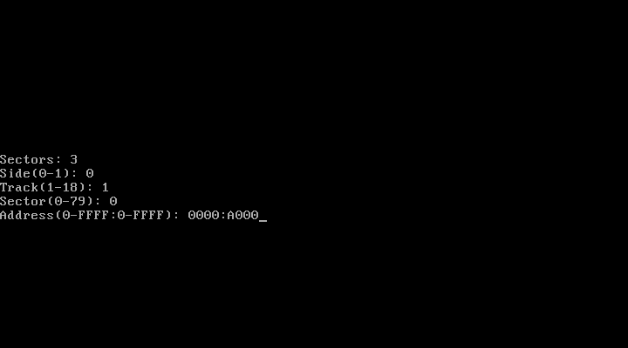
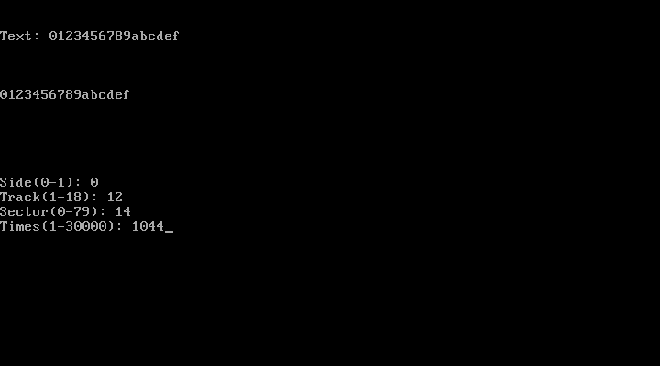
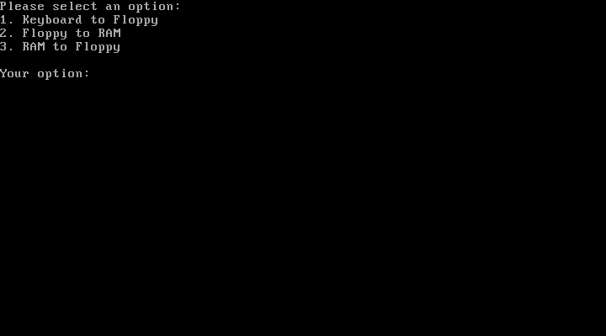
Screenshots:

Figure 1 – Main menu

Figure 2 – Keyboard to floppy menu

Figure 3 – Floppy to RAM menu
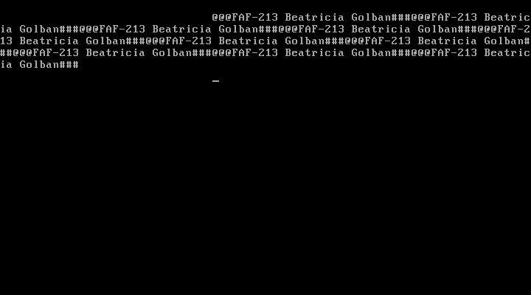
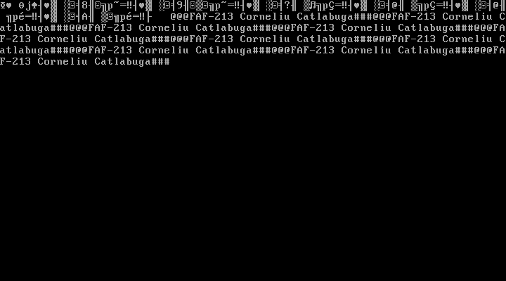
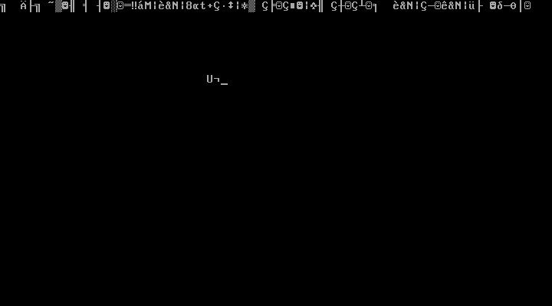

Figure 4 – Floppy to RAM output no.1

Figure 5 – Floppy to RAM output no.2

Figure 6 – Floppy to RAM output no.3

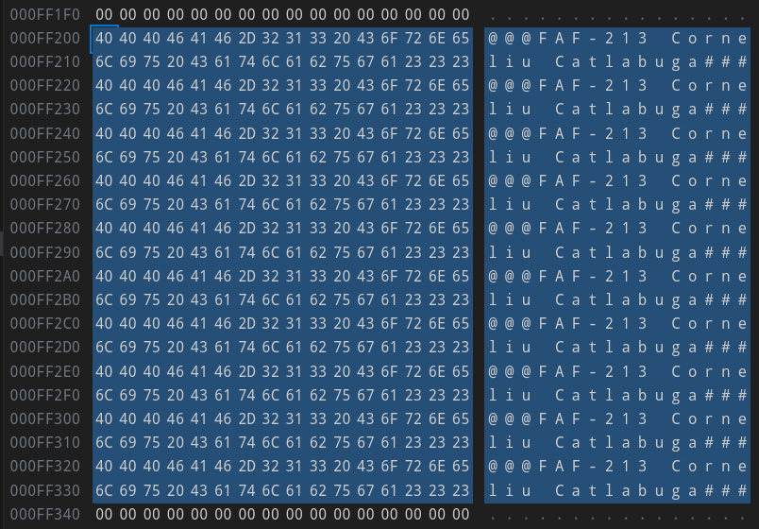
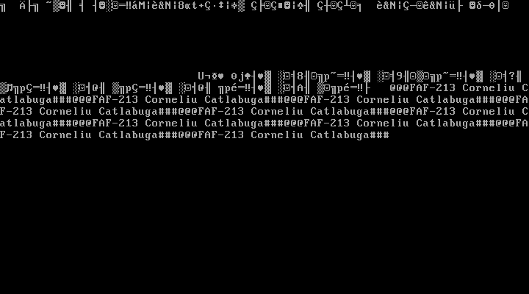
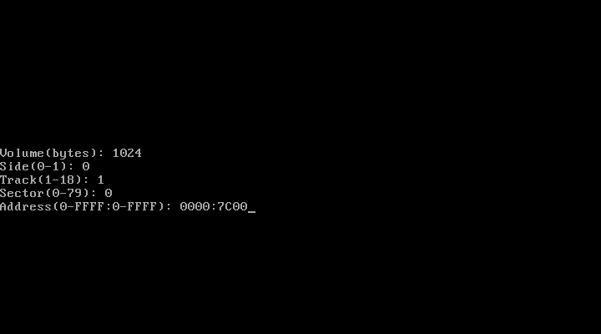

Figure 7 – RAM to floppy menu

Figure 8 – RAM to floppy output

Figure 9 – Task 1.1.1: Sector 2041 Name String

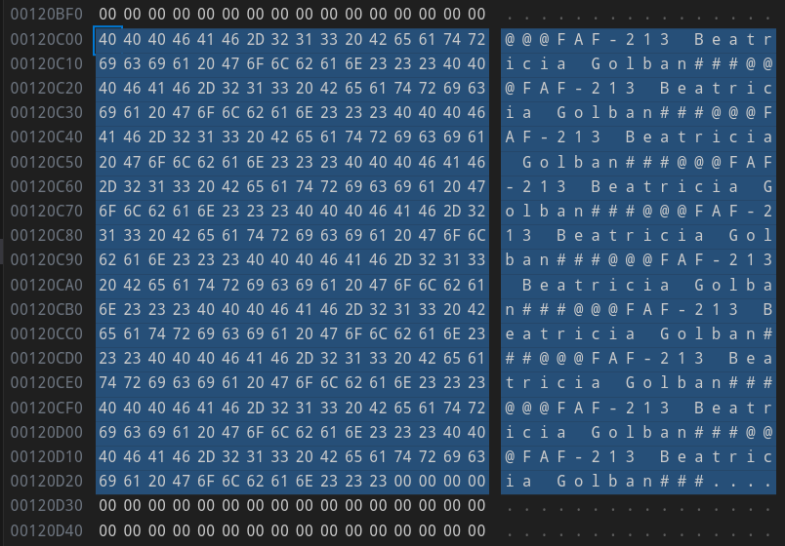
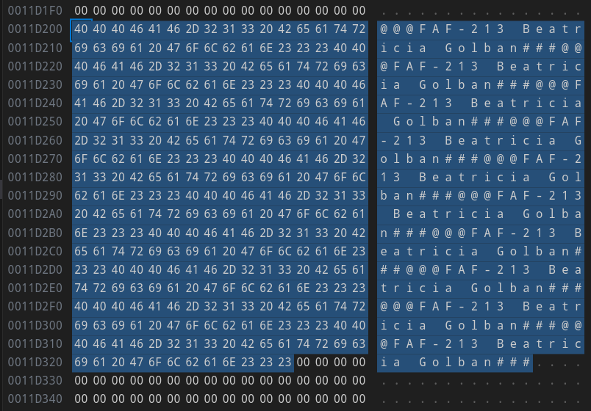
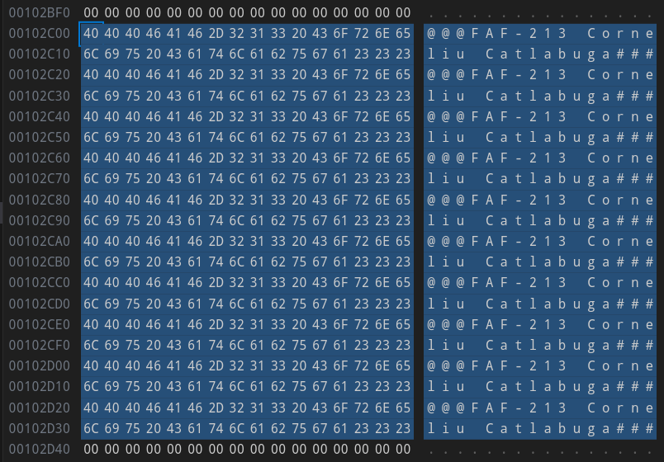

Figure 10 – Task 1.1.2: Sector 2070 Name String

Figure 11 – Task 1.2.1: Sector 2281 Name String

Figure 12 – Task 1.2.2: Sector 2310 Name String

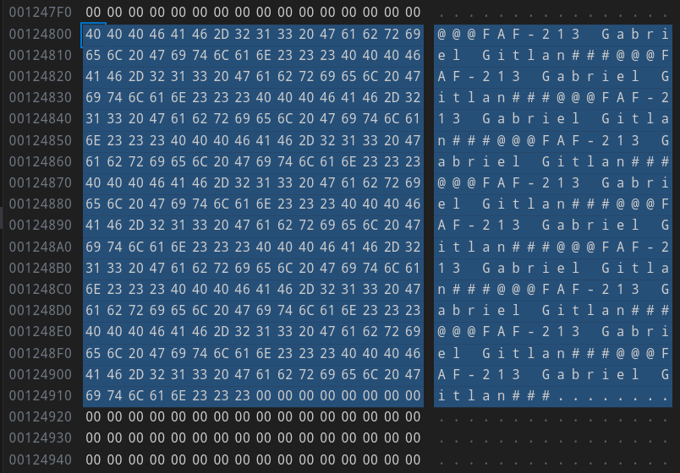
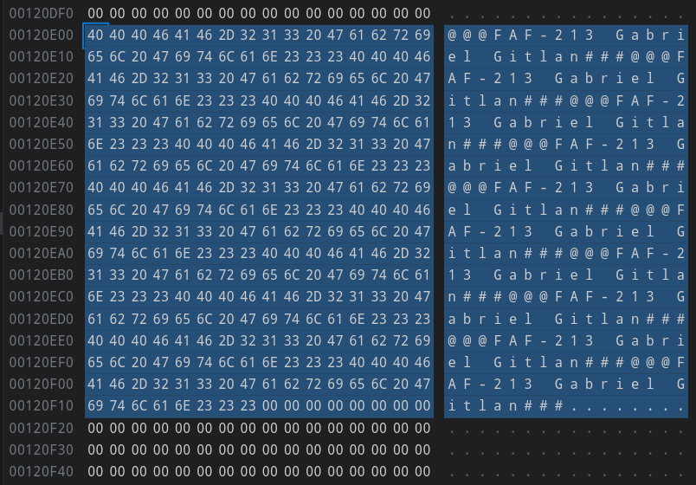

Figure 13 – Task 1.3.1: Sector 2311 Name String

Figure 14 – Task 1.3.2: Sector 2340 Name String

Conclusions:
This project in assembly language serves as an example of the breadth and depth of knowledge needed to operate computer systems at a low level. The system adeptly incorporates several intricate features, such as direct hardware manipulation and bootloading, showcasing a strong understanding of system-level programming. Despite the inherent difficulty of assembly language, the construction of a user-friendly menu system demonstrates the potential to build intuitive interfaces even in low-level contexts. The project's modular structure, which divides its many operations into separate files, exemplifies a best practice in software development and improves the code's readability and maintainability.
The project's emphasis on effective memory management, as seen by the temporary data storage of buffers, shows a deep comprehension of resource optimization — a crucial component of low-level programming. Moreover, the addition of error handling procedures highlights the program design's resilience by demonstrating a careful foresight of possible problems. A high degree of expertise in assembly language programming is demonstrated by the ability to convert between multiple data kinds, manage complicated tasks like reading and writing to a floppy drive, and handle keyboard inputs.
To sum up, this project provides an outstanding example of the versatility and strength of assembly language in system-level programming. It is a thorough examination of low-level programming and how it may be used to develop reliable, effective, and user-friendly software. It not only showcases the user's proficiency in assembly language but also their understanding of computer systems and hardware manipulation.
References:
- Laboratory work GitHub repository: https://github.com/muffindud/SO_Team_2
- Image Creator Script: https://github.com/muffindud/ImgCreator
- INT 10H Video Services: http://www.techhelpmanual.com/113-int_10h__video_services.html
- INT 13H BIOS Disk I/O: http://www.techhelpmanual.com/185-int_13h__bios_disk_i_o.html
- INT 16 Keyboard Services: http://www.techhelpmanual.com/228-int_16h__keyboard_services.html
- NASM Quick Reference: https://www.cs.uaf.edu/2017/fall/cs301/reference/x86_64.html

