Supplemental Digital Content
  - Reproductive Services Offered by Restorative Reproductive Medicine Practices: A National Secret-Shopper Audit
September 05, 2026
Table of Contents

This supplement contains material referenced in the main text. It is generated from the same analysis outputs as the manuscript; no number here is independently recomputed.

Appendix Table S1. Caller concentration and contrast separability
Each scenario arm was dominated by a different caller, so a scenario contrast is also a caller contrast. The second table shows which contrasts have any caller placing calls under both scenarios; a contrast with zero such callers cannot be separated from a caller effect by any adjustment.
Table S1a. Concentration of each scenario arm in a single caller.
Scenario | Calls placed | Largest single caller | Their share of the arm
Straight couple | 77 | Caller D | 53 (68.8%)
Lesbian couple | 83 | Unrecorded | 29 (34.9%)
Single mother | 74 | Caller C | 38 (51.4%)

Table S1b. Caller overlap by contrast.
Contrast | Callers placing both | Which callers | Calls contributed | Separable from caller?
Straight couple vs Lesbian couple | 0 | none | 0 | No
Straight couple vs Single mother | 0 | none | 0 | No
Lesbian couple vs Single mother | 3 | Caller A, Caller C, Caller E | 59 | Partly

Table S1c. Call volume and outcome rates by caller. Rates vary widely across callers, which is why a scenario arm dominated by one caller cannot be read as a scenario effect.
Caller | Calls placed | Reached a live office | Offer-eligible calls | Appointment available
Caller A | 18 | 88.9% | 15 | 26.7%
Caller B | 1 | 100.0% | 1 | 100.0%
Caller C | 68 | 48.5% | 33 | 69.7%
Caller D | 56 | 48.2% | 23 | 82.6%
Caller E | 15 | 100.0% | 15 | 21.4%
Caller F | 17 | 52.9% | 9 | 77.8%
Unrecorded | 59 | 11.9% | 6 | 0.0%

Appendix Table S2. Documentation completeness by caller scenario
Documentation completeness differed by arm in the same direction as the exploratory outcome. Because the derived availability outcome is read off the appointment date, a call recorded less completely is scored as less available regardless of what the practice said. Differential documentation and differential availability cannot be separated in these data.
Table S2. Documentation completeness by caller scenario.
Scenario | Calls placed | No call date | Reached staff | No appointment date
Straight couple | 77 | 6 (7.8%) | 39 | 11 (28.2%)
Lesbian couple | 83 | 19 (22.9%) | 37 | 23 (62.2%)
Single mother | 74 | 12 (16.2%) | 32 | 17 (53.1%)

Appendix Table S3. Reproductive services offered, numeric detail
Numeric detail underlying Figure 1, among the 98 calls that reached staff and completed the service interview. Intrauterine insemination and in vitro fertilization each rest on a single practice; those two intervals should be read as an upper bound on availability rather than as stable rates.
Table S3. Reproductive services offered (N = 98 calls reaching staff).
Reproductive Service | Proportion Offered (95% CI)
Cycle tracking | 94.9% (95% CI 88.6-97.8%; 93/98)
Hormonal labs / fertility timing | 63.3% (95% CI 53.4-72.1%; 62/98)
Ovulation induction | 11.2% (95% CI 6.4-19.0%; 11/98)
Intrauterine insemination (IUI) | 1.0% (95% CI 0.2-5.6%; 1/98)
In vitro fertilization (IVF) | 1.0% (95% CI 0.2-5.6%; 1/98)
Works with donor sperm | 3.1% (95% CI 1.0-8.6%; 3/98)

Appendix Table S4. STROBE checklist for cross-sectional studies
Table S4. Completed STROBE checklist.
Item | Section | Recommendation | Study response
1a | Title and abstract | Indicate the design in the title or abstract | Title and abstract identify this as a national secret-shopper (audit) study.
1b | Title and abstract | Balanced summary of what was done and found | Structured abstract reports the service menu as primary and states that the access comparison was uninformative.
2 | Introduction | Scientific background and rationale | RRM service scope determines which patients can be served; national data were previously absent.
3 | Introduction | State specific objectives and any prespecified hypotheses | Primary: define the service menu. Secondary and exploratory: access by caller scenario. No power analysis was prespecified in the protocol; achieved precision is reported instead.
4 | Methods | Present key elements of study design early | Cross-sectional audit; each practice eligible for one call per scenario.
5 | Methods | Setting, locations, and relevant dates | United States, 2025-2026; RRM practices compiled from professional directories.
6 | Methods | Eligibility criteria and selection | National roster of RRM practices; call dispositions mapped to standard access-audit exclusion codes.
7 | Methods | Define all outcomes, exposures, predictors, confounders | Primary outcome: reported service menu. Secondary: appointment availability inferred from call documentation, strict and broad definitions. Reached and offer-eligible are distinct denominators.
8 | Methods | Sources of data and measurement | Trained callers using standardized scripts; responses entered in REDCap (pid 39546).
9 | Methods | Describe any efforts to address potential sources of bias | Within-practice matched design for the secondary outcome; caller-overlap analysis reports which contrasts can be separated from caller effects; duplicate practice-scenario cells handled by a prespecified rule with first-vs-last sensitivity.
10 | Methods | Explain how the study size was arrived at | No a priori sample-size calculation was performed. The achievable sample was the national roster of RRM practices. Minimum detectable effects are reported for every paired contrast.
11 | Methods | Explain how quantitative variables were handled | Proportions with 95% Wilson or Clopper-Pearson intervals; wait time in business days, log-transformed and reported as geometric mean ratios.
12 | Methods | Statistical methods, subgroups, missing data, sensitivity | Exact McNemar for matched contrasts; mixed-effects logistic regression with practice random intercept; two-part hurdle model for wait; Mantel-Haenszel stratification where caller overlap permits. Missingness by arm reported in Appendix Table S2.
13 | Results | Report numbers at each stage | 234 calls placed, 108 reached a live office, 98 completed the service interview; Figures 2 and 3.
14 | Results | Characteristics of study participants | Practice-level characteristics and per-scenario cascade in Table 1 and Figure 3.
15 | Results | Report numbers of outcome events or summary measures | Service prevalences in Figure 1 and Appendix Table S3.
16 | Results | Give unadjusted and, if applicable, adjusted estimates with precision | All estimates reported with 95% confidence intervals. P-values are not reported for the exploratory access contrasts, with the reason stated in the text.
17 | Results | Report other analyses done | Strict vs broad availability, first-vs-last duplicate-call sensitivity, caller-stratified Mantel-Haenszel estimate.
18 | Discussion | Summarise key results with reference to objectives | Primary finding is the structural absence of donor-gamete and ART services.
19 | Discussion | Discuss limitations, including bias and imprecision | Derived availability outcome; caller-scenario confounding with no within-caller information for two of three contrasts; documentation completeness differing by arm; low reachability; single call per scenario.
20 | Discussion | Cautious overall interpretation | The service finding is stated as structural; the access comparison is stated as uninformative rather than null.
21 | Discussion | Generalisability | Findings describe the reachable subset of RRM practices nationally.
22 | Other | Give the source of funding | No external funding; COMIRB 25-2596.

Appendix Table S5. Duplicate practice-scenario calls and their adjudication
The protocol specifies one call per practice per scenario. Eight cells contained two. Where a contact attempt (voicemail, wrong number, abandoned or over-long hold) preceded a completed call, the completed call determined the cell. Where two protocol-valid completed calls existed, the cell was treated as a protocol deviation and excluded from the primary paired analysis rather than resolved by preferring the earlier or later call. Practice identifiers are redacted.
Table S5a. All calls in a practice-scenario cell containing more than one call. Practices are identified by study ID only.
Record ID | Practice ID | Scenario | Call date | Disposition | Analytic inclusion
141 | 1 | Lesbian couple | NA | Went to voicemail | FALSE
142 | 1 | Lesbian couple | NA | Went to voicemail | FALSE
22 | 7 | Straight couple | 2026-06-01 | Number contacted did not correspond to expected office/specialty | FALSE
30 | 7 | Straight couple | NA | Number contacted did not correspond to expected office/specialty | FALSE
93 | 17 | Lesbian couple | 2026-06-01 | Greater than 5 minutes on hold | FALSE
102 | 17 | Lesbian couple | 2026-06-02 | Went to voicemail | FALSE
177 | 57 | Single mother | NA | Went to voicemail | FALSE
179 | 57 | Single mother | 2026-06-30 | Included where physician was able to be contacted | TRUE
126 | 65 | Lesbian couple | 2026-06-05 | Included where physician was able to be contacted | TRUE
156 | 65 | Lesbian couple | NA | Included where physician was able to be contacted | TRUE
164 | 67 | Straight couple | 2026-06-10 | Included where physician was able to be contacted | TRUE
193 | 67 | Straight couple | 2026-06-30 | Included where physician was able to be contacted | TRUE
37 | 97 | Straight couple | 2026-06-01 | Went to voicemail | FALSE
198 | 97 | Straight couple | 2026-07-14 | Included where physician was able to be contacted | TRUE
56 | 104 | Straight couple | 2026-06-01 | Greater than 5 minutes on hold | FALSE
163 | 104 | Straight couple | 2026-06-05 | Went to voicemail | FALSE

Table S5b. Cells with two protocol-valid completed calls. Practices are identified by study ID only.
Practice ID | Scenario | Completed calls | Disposition
65 | Lesbian couple | 2 | Excluded from the primary paired analysis as a protocol deviation
67 | Straight couple | 2 | Excluded from the primary paired analysis as a protocol deviation

Appendix Table S7. Caller variance components
The proportion of outcome variance lying between callers rather than within them, from a one-way variance-components model. A scenario arm dominated by a single caller cannot be read as a scenario effect when this much of the variation tracks who placed the call. Method follows the sibling urogynecology mystery-caller study (mufflyt/lizeth, caller_icc.R), which reached the same fallback: a paired inter-caller ICC is not estimable with so few practices called by two callers, so a variance-components ICC is used instead.
Table S7. Proportion of outcome variance attributable to the caller.
Outcome | ICC | Callers | Calls
Business-day wait | 0.36 | 5 | 56
Inferred appointment availability | 0.31 | 6 | 99
Reached a live office | 0.29 | 6 | 233

Appendix Table S8. What the paired intervals exclude
A minimum detectable effect states what the design could have found. This states what the data actually rule out, on the percentage-point scale. The upper limit of each interval is the largest disadvantage compatible with these data. Presentation follows mufflyt/lizeth, null_verification.R: “the upper CI is the LARGEST delay compatible with our data.”
Table S8. Paired differences in inferred appointment availability, with the range of effects the data are compatible with.
Contrast | Paired practices | Discordant | Difference (pp) | 95% CI (pp)
Straight couple vs Single mother | 16 | 7 | +31.2 | -6.9 to +43.4
Lesbian couple vs Single mother | 22 | 2 | -9.1 | -9.1 to +6.2
Straight couple vs Lesbian couple | 19 | 8 | +42.1 | +11.0 to +42.1

Appendix Table S6. Restriction checkbox, why it is excluded
The instrument’s three “restrictions to the individuals you would provide care to” checkboxes are excluded from every analysis. The codebook defines a ticked box as a restriction applying to that group, with no field note or branching logic, but the recorded responses follow two incompatible conventions keyed to the person completing the form. One caller ticked all three boxes on most of her entries, which under the codebook definition would mean those practices serve no one. Every other caller ticked only the box matching the scenario they called as, which echoes the assignment rather than describing the practice. Because the convention belongs to the caller rather than the response, and a quarter of calls record no caller, no recoding rule can separate them.
Table S6. Combination of restriction boxes ticked, by person completing the form.
Caller | Boxes ticked | Calls
Caller C | Lesbian + Straight + SingleMother | 19
Caller F | Straight | 9
Caller D | Straight | 4
Caller A | Lesbian | 3
Caller C | Straight | 3
Caller C | Lesbian + Straight | 2
Caller E | Lesbian | 2
Unrecorded | Lesbian | 1

Appendix Figure S1. Wait time to first available appointment
Restricted to the 57 calls with an observed appointment date. Panels are a raincloud plot, a ridgeline density, the empirical cumulative distribution, and within-practice paired differences. These estimates condition on having been offered an appointment and are descriptive; see Limitation 5 in the main text.
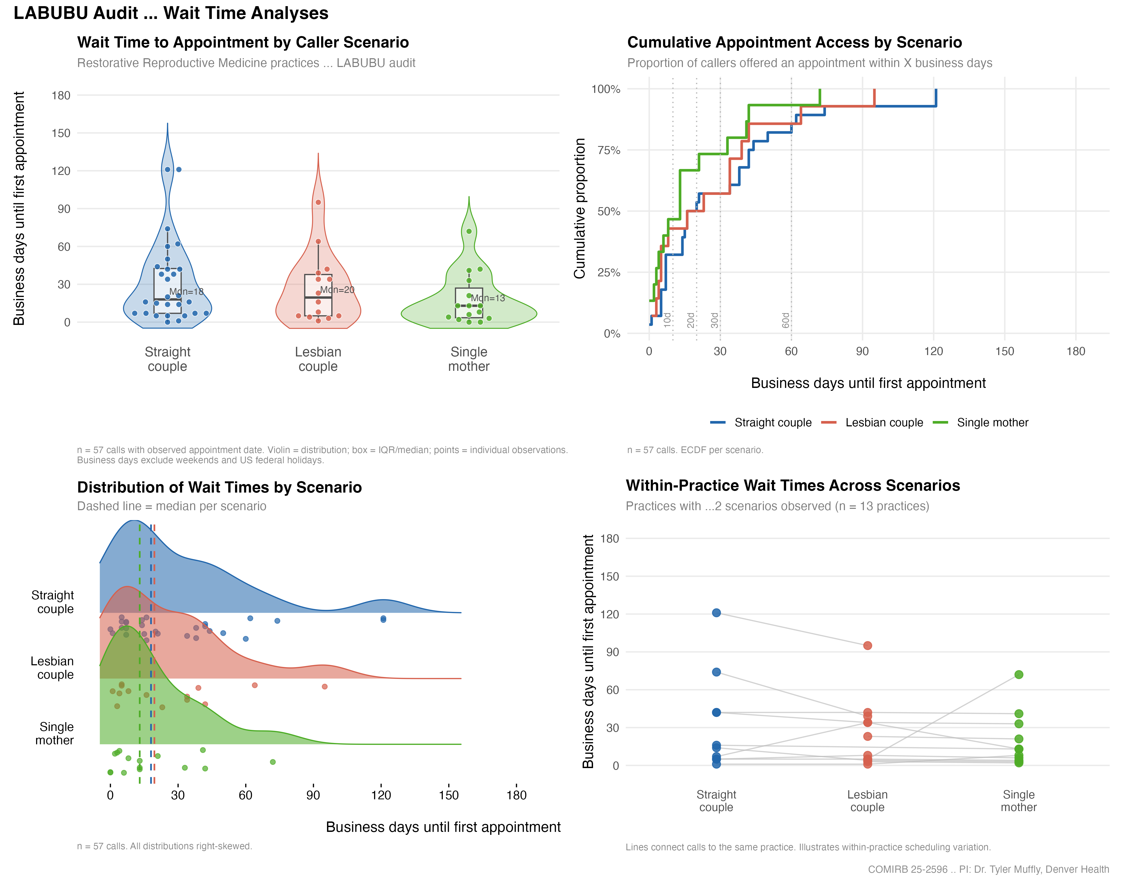
Figure S1. Wait time to first available appointment by caller scenario.

Generated 2026-09-05 15:20 MDT from commit 2efb601.

