Reproductive Services Offered by Restorative Reproductive Medicine Practices: A National Secret-Shopper Audit
Sofie Rosenberg, MD; Melanie Mandell, MPH; Elizabeth Steiner, MD; Samuel Raine, MD; Tyler M. Muffly, MD
September 05, 2026
Table of Contents

Obstetrics & Gynecology Original Research
Authors: Sofie Rosenberg, MD; Melanie Mandell, MPH; Elizabeth Steiner, MD; Samuel Raine, MD; Tyler M. Muffly, MD Affiliation: Department of Obstetrics and Gynecology, Denver Health and Hospital Authority, University of Colorado School of Medicine, Denver, Colorado Institutional Review Board: COMIRB 25-2596 (Approved) Financial Disclosure: The authors report no conflicts of interest or relevant financial disclosures Data Sharing: De-identified call-level data, the analysis code, and the full generated output are available at github.com/mufflyt/LABUBU. Raw exports carrying practice contact information are withheld. Data Audit & Provenance: Automatically compiled from active dataset LABUBU_DATA_LABELS_2026-08-11_2017.csv (234 calls across 105 practices)
Tables: 2 | Figures: 3 | Supplemental digital content: 5 items
Précis
One in 98 Restorative Reproductive Medicine practices offers intrauterine insemination or in vitro fertilization, and three in 98 work with donor sperm.

ABSTRACT
OBJECTIVE: To characterize the reproductive services offered by Restorative Reproductive Medicine (RRM) practices in the United States, and secondarily to explore whether appointment access differs by caller family structure.
METHODS: In a national mystery-caller audit, RRM practices were telephoned by trained callers presenting one of three standardized scenarios: a straight couple, a lesbian couple, or a single mother seeking donor sperm care. The primary outcome was the reported service menu: cycle tracking, hormonal laboratory monitoring, ovulation induction, intrauterine insemination (IUI), in vitro fertilization (IVF), and willingness to work with donor sperm, with 95% Wilson score confidence intervals. A secondary, exploratory analysis compared appointment access across scenarios using within-practice matched contrasts. Because the instrument contained no item asking whether staff agreed to schedule, that outcome is appointment availability inferred from call documentation.
RESULTS: 234 calls were placed to 105 practices; 98 reached staff and completed the service interview. Cycle tracking was offered by 94.9% (95% CI 88.6-97.8%; 93/98) and hormonal laboratory monitoring by 63.3% (95% CI 53.4-72.1%; 62/98). Ovulation induction was offered by 11.2% (95% CI 6.4-19.0%; 11/98), IUI by 1.0% (95% CI 0.2-5.6%; 1/98), IVF by 1.0% (95% CI 0.2-5.6%; 1/98), and donor sperm care by 3.1% (95% CI 1.0-8.6%; 3/98). The exploratory access comparison was uninformative: only 7, 2, 8 practices were discordant across the three contrasts, and 2 of three contrasts had no caller placing calls under both scenarios, leaving scenario and caller effects inseparable.
CONCLUSION: RRM practices almost never offer IUI, IVF, or donor sperm care. Because single women and same-sex female couples require donor gametes to conceive, this is a structural absence of necessary services rather than a discretionary scheduling decision, operating independently of staff attitudes. The audit was not powered to evaluate differential scheduling by caller identity.

INTRODUCTION
Restorative Reproductive Medicine (RRM) is an approach to reproductive healthcare that emphasizes diagnosing and treating underlying physiological causes of subfertility rather than utilizing assisted reproductive technology (ART) such as in vitro fertilization (IVF).[1,2] Because RRM clinical frameworks explicitly omit interventions like IVF or intrauterine insemination (IUI), prospective patients may encounter service menus that differ substantially from conventional fertility clinics. Furthermore, access to these specialized practices may vary depending on patient family structure, particularly for patients requiring donor gametes or non-traditional family building.[3]
Mystery-caller (audit) methodology employs standardized simulated callers to objectively evaluate real-world access to healthcare while eliminating social desirability bias.[4-9] Prior healthcare audit studies in obstetrics, gynecology, and primary care have documented significant disparities in appointment access based on insurance coverage, socioeconomic status, and demographic characteristics.[4-7] However, national audit data regarding service availability and scheduling access across RRM practices remain unstudied in the peer-reviewed literature.
This national secret-shopper audit had one primary objective and one secondary, exploratory objective. The primary objective was to define the scope of reproductive services RRM practices actually offer, because that scope determines which patients can be served at all. For a single woman or a same-sex female couple, conception requires donor sperm and usually IUI or IVF; if a practice does not provide those services, the question of how its staff treat such a caller does not arise. The secondary objective was to explore whether willingness to schedule differs by caller family structure. We report the second as exploratory throughout, for reasons of statistical power and design that we set out explicitly in the Limitations.

SOURCES AND METHODS

Study Design and Scenarios
We conducted a national within-practice audit of RRM practices in the United States between 2025 and 2026, using a roster compiled from professional directories and clinical registries. Trained callers telephoned each practice during business hours (08:00–17:00 local time, excluding 12:00–13:00), once for each of three standardized scenarios: a female caller seeking fertility evaluation with a male partner (straight couple), with a female partner (lesbian couple), or alone using donor sperm (single mother). Scripts were identical apart from the caller’s stated partner status and the donor sperm inquiry. Because each practice served as its own control across scenarios, practice identity was treated as a random intercept in all models. The Colorado Multiple Institutional Review Board approved the protocol (COMIRB 25-2596).

Main Outcome Measures
The primary outcome was the service menu: for each practice reached, whether staff reported offering cycle tracking, hormonal laboratory monitoring, ovulation induction, intrauterine insemination (IUI), in vitro fertilization (IVF), and whether the practice works with donor sperm. Staff reported these directly in response to a standardized question; they require no derivation and do not depend on which caller placed the call.
Secondary, exploratory outcomes were appointment availability and business-day wait time by caller scenario. Call dispositions were mapped to the standard access-audit exclusion codes, which separate three nested constructs that are frequently conflated: whether a live office was reached (staff engaged with the caller, including stated refusals and extended holds; voicemail, wrong numbers, unanswered lines, personal phones and closed systems were not reached), whether the call was eligible for the offer analysis, and whether an appointment was available. Availability was scored strictly for the primary analysis, requiring a recorded first-available date and scoring a stated “not accepting new patients” as unavailable, and broadly as a sensitivity analysis, additionally counting a concrete scheduling timeframe reported without a specific date. The strict definition is primary because it requires less investigator interpretation. Wait time was the number of business days (Monday–Friday, excluding US federal holidays) between the call and the first available appointment, with same-day appointments retained as a wait of zero.
The data-collection instrument contained no item asking whether staff agreed to schedule the caller. Throughout this paper the outcome is therefore described as appointment availability inferred from call documentation, not as a practice “offering an appointment”: the latter would assert something the instrument never measured. This is the study’s principal measurement limitation.
The protocol specifies one call per practice per scenario; eight cells contained two. Where a contact attempt (voicemail, wrong number, abandoned or over-long hold) preceded a completed call, the completed call determined the cell; where two protocol-valid completed calls existed, the cell was treated as a protocol deviation and excluded from the primary paired analysis rather than resolved by preferring the earlier or later call. All calls are retained in the call-level dataset, and first- versus last-successful selection is reported as a sensitivity analysis (Appendix Table S5).

Statistical Analysis and Power
Proportions carry 95% Wilson score confidence intervals.[10] The access cascade reports each stage against its own denominator, nested within the preceding stage.
Mixed-effects logistic regression with a practice random intercept was fitted to the availability outcome, first on the subset of complete practice triads (N = 48 practices) to remove practice-selection dialing bias, then on the full offer sample, and finally under the broad definition. Because the appointment date was missing for a scenario-dependent share of calls, a two-part hurdle model estimated the obtainment and wait-given-obtainment steps jointly rather than conditioning on complete cases. Wait time was additionally modeled with a linear mixed model on the log scale, with estimates back-transformed to geometric mean ratios (GMR) rather than reported as differences in days.
Within-practice matched contrasts used exact McNemar tests.[11] Power in paired audit designs is governed by the number of discordant practices, which here was small; minimum detectable effect odds ratios at 80% power (α = .05) ranged from OR 30.9 to OR 35.4 and are reported alongside every paired contrast. In accordance with the Statistical Analyses and Methods in the Published Literature (SAMPL) guidelines,[12] point estimates are presented with 95% confidence intervals to establish precision limits rather than relying on underpowered null hypothesis significance tests. All analyses were conducted in R version 4.4.2 using the mysterycall package.

RESULTS

Reproductive Services Offered: primary outcome
Among the 98 calls that reached staff and completed the service interview, RRM practices almost uniformly offered natural cycle tracking and hormonal monitoring, and almost never offered assisted reproductive technology or donor gametes (Figure 1; numeric detail in Appendix Table S3).
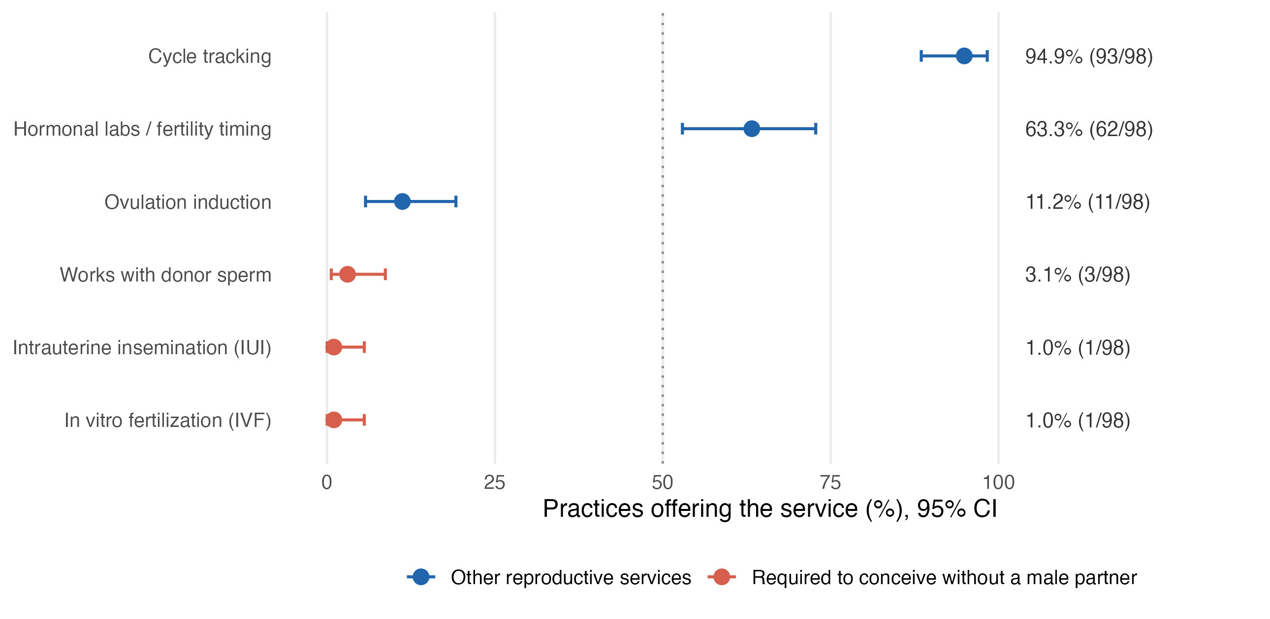
Figure 1. Reproductive services offered by RRM practices, with 95% confidence intervals.
Cycle tracking was offered by 94.9% (95% CI 88.6-97.8%; 93/98) and hormonal laboratory monitoring by 63.3% (95% CI 53.4-72.1%; 62/98). Ovulation induction was offered by 11.2% (95% CI 6.4-19.0%; 11/98). IUI and IVF were each offered by 1.0% (95% CI 0.2-5.6%; 1/98), a single practice in each case, and donor sperm care by 3.1% (95% CI 1.0-8.6%; 3/98). The IUI and IVF estimates rest on one practice apiece and should be read as an upper bound on availability rather than as stable rates; the confidence intervals reflect that.
The services a single woman or same-sex female couple requires to conceive are therefore effectively absent from this sample, while the services RRM practices do provide are those appropriate to a couple attempting unassisted conception.

Access Cascade
A total of 234 telephone calls were placed to 105 unique RRM practices. A live office was reached on 108 calls (46.2% (95% CI 39.9-52.6%; 108/234)). Of these, 10 reached calls ended in a stated refusal or extended hold, and 98 proceeded to the full interview. 48 practices completed all three scenario calls (complete triads), 25 completed two, and 32 completed one.
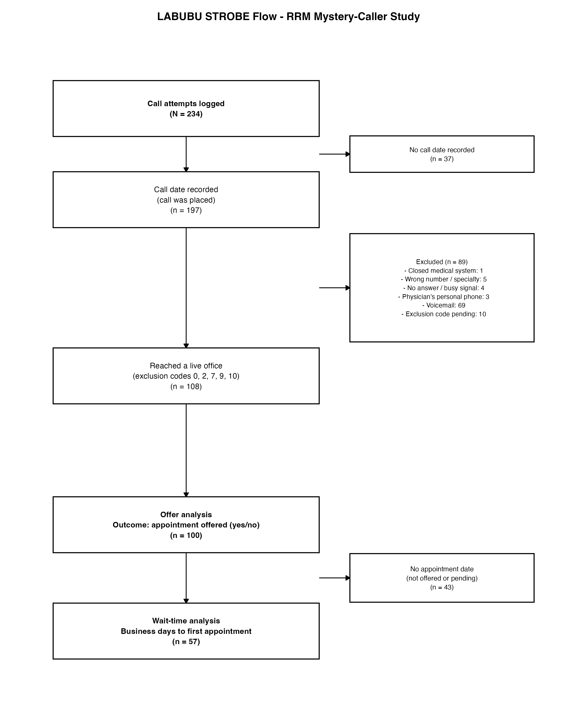
Figure 2. STROBE flow diagram. Reaching a live office and being offered an appointment are separate stages with separate denominators.
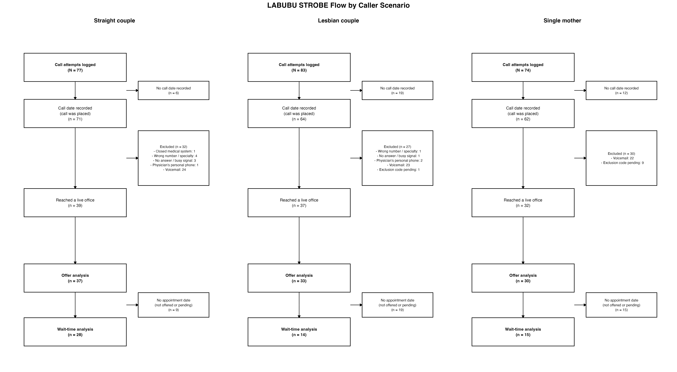
Figure 3. STROBE flow by caller scenario. The three arms enter the cascade at comparable widths and leave at very different ones.
Table 1. Access cascade by caller scenario. Each stage is nested within the preceding one.
Scenario | Calls placed | Reached live office | Offer-eligible | Offered (strict) | Offered (broad)
Straight couple | 77 | 39 | 37 | 28 (75.7%) | 29 (78.4%)
Lesbian couple | 83 | 37 | 34 | 14 (42.4%) | 20 (60.6%)
Single mother | 74 | 32 | 31 | 15 (50.0%) | 18 (60.0%)

Appointment Availability by Caller Identity
Inferred appointment availability among eligible calls was 75.7% for straight couples, 42.4% for lesbian couples, and 50.0% for single mothers (Table 1).
In complete-triad mixed-effects logistic regression (N = 48 practices), relative to straight-couple callers, the odds of inferred appointment availability were OR 0.04 (0.01-0.28) for lesbian couples and OR 0.09 (0.01-0.65) for single mothers. We report intervals without p-values throughout this section. A significance test presumes a design capable of detecting the effect it is testing for, and the minimum detectable effects here are OR 30.9 to OR 35.4; a p-value computed under those conditions carries no information the interval does not already carry, and invites a reading the data cannot support. The intervals themselves span orders of magnitude, reflecting near-separation at this sample size: direction is interpretable, magnitude is not.
The magnitude of these estimates depends materially on the measurement definition, and this is a substantive result rather than a robustness check. Under the broad definition, which additionally credits a stated scheduling timeframe, the same contrasts attenuate to OR 0.31 (0.08-1.25) for lesbian couples and OR 0.29 (0.06-1.27) for single mothers, an order-of-magnitude change in the point estimate, with intervals that include unity. Both definitions place the effect in the same direction; only the strict definition places it far from the null. Because neither definition was measured directly, the direction is the more defensible claim and the magnitude should not be quoted without its definition.
Table 2. Within-practice matched paired analysis of inferred appointment availability (exploratory). Only discordant practices contribute information.
Paired Comparison | Paired Practices (n) | Concordant | Discordant | Exact McNemar P | MDE (80% Power)
Straight couple vs Single mother | 16 | 9 | 7 | 0.125 | OR 30.9
Lesbian couple vs Single mother | 22 | 20 | 2 | 0.500 | OR NA
Straight couple vs Lesbian couple | 19 | 11 | 8 | 0.008 | OR 35.4
Within-practice paired differences in inferred availability were: Straight vs Single Mother +31.2 percentage points (95% CI +2.7 to +59.8; n = 16 practices); Lesbian vs Single Mother -9.1 percentage points (95% CI -21.1 to +2.9; n = 22 practices); Straight vs Lesbian +42.1 percentage points (95% CI +19.9 to +64.3; n = 19 practices). Practices treated callers identically in 68%-81% of paired reachability comparisons.

Caller Assignment
Scenarios were not randomized across callers (Appendix Table S1). Caller identity was strongly associated with scenario (Cramér’s V = 0.66), and per-caller availability rates varied widely. Consequently, a scenario contrast and a caller contrast are numerically the same comparison, and within-practice pairing does not separate them because the paired calls were placed by different callers.

Wait Time to First Available Appointment
Among calls with an observed appointment date (N = 57), the median wait was 18 business days (IQR 7-42; n = 28) for straight couples, 20 business days (IQR 5-38; n = 14) for lesbian couples, and 13 business days (IQR 4-27; n = 15) for single mothers. In the log-transformed mixed model, waits relative to straight-couple callers had a geometric mean ratio of 0.83 (95% CI 0.47-1.46) for lesbian couples and 0.82 (95% CI 0.46-1.45) for single mothers; a ratio below 1.00 indicates a shorter wait. Because appointment dates are missing for a scenario-dependent share of calls, these complete-case estimates condition on having been offered an appointment and are reported as descriptive.

DISCUSSION

Principal Findings
The principal finding of this audit is structural. RRM practices in this national sample almost uniformly provide natural cycle tracking (94.9% (95% CI 88.6-97.8%; 93/98)) and hormonal monitoring (63.3% (95% CI 53.4-72.1%; 62/98)), and almost never provide the interventions required for conception without a male partner: IUI 1.0% (95% CI 0.2-5.6%; 1/98), IVF 1.0% (95% CI 0.2-5.6%; 1/98), donor sperm care 3.1% (95% CI 1.0-8.6%; 3/98).
A methodological point from prior audit work in otolaryngology applies directly here: when a practice declines a caller because it does not treat that complaint, the refusal is itself access data rather than a nuisance exclusion. The same logic governs this study. A practice that does not offer donor sperm has not made a scheduling decision about a single mother; it has made a service decision that precedes any scheduling decision.
The clinical consequence is direct. A single woman or a same-sex female couple requires donor sperm, and usually IUI or IVF, to conceive. A practice that does not offer those services cannot serve such a patient, whatever its staff intend and however courteously the telephone is answered. This is a barrier of provision rather than of disposition, and it does not depend on inferring anyone’s motives.
We regard this as the more consequential result, and it is also the better measured one. It comes from staff answering a direct question about their own services, in a sample of 98 completed interviews, with confidence intervals narrow enough to support the claim. It requires no derived outcome, no matched design, and no assumption about which caller placed the call.

The access comparison was not informative
We had also intended to test whether practices differ in willingness to schedule by caller identity. That comparison did not succeed, and we report it as exploratory rather than as a null result, because the design could not have detected a plausible effect.
Two features are responsible, and they are separable.
First, power. Within-practice matched contrasts draw information only from practices that answered differently to two callers. Concordance was high, since most practices treated callers alike, leaving 7, 2, 8 discordant practices across the three contrasts, with minimum detectable effects of OR 30.9 to OR 35.4. Audit-study effects of interest are far below that floor. For the Lesbian couple versus Single mother contrast in particular, the number of discordant practices is small enough that the exact test cannot return a significant result at any effect size.
Second, caller assignment. Callers were not randomised across scenarios. Of the three contrasts, 2 had no caller who placed at least three calls under both scenarios (Straight couple vs Lesbian couple; Straight couple vs Single mother): for those, the scenario variable and the caller variable are the same column of data, and no covariate adjustment recovers the difference. Where overlap did exist, in Lesbian couple versus Single mother, in which three callers placed calls under both, the caller-stratified estimate was OR 0.57 (95% CI 0.15-2.15, p = 0.61; n = 59), consistent with the unadjusted estimate and with no difference.
The contrast with enough discordant practices to be informative is therefore the one with no caller overlap, and the contrast free of caller confounding is the one with too few discordant practices to test. That is a property of how the calls were allocated, not a result about how practices behave, and it cannot be repaired analytically.

Interpretation and Literature Context
Patients presenting to RRM clinics encounter a clinical menu focused on natural cycle monitoring.[1,2] For patients whose path to pregnancy requires donor gametes or ART, the absence of those services is a primary structural barrier to care, independent of staff attitudes.[3,13-15] Our estimates place that absence at approximately one practice in a hundred for IUI and IVF.

Strengths and Limitations
Strengths include the national scope, direct measurement of the primary outcome, business-day calendar modeling, and explicit cascade reporting with stage-specific denominators.
Limitations of the primary outcome first. Service availability was reported by the staff member answering the telephone, not verified against what a practice would do for an enrolled patient; a practice might decline a service on the telephone that it provides in other circumstances, or the reverse. Services were ascertained only among the 98 calls that reached staff, which is 42% of calls placed, so the estimates describe the reachable subset of practices. The IUI and IVF proportions rest on one practice each.
Limitations:
- The offer outcome is derived, not measured. No instrument item recorded whether staff agreed to schedule the caller. Results are sensitive to the coding rule, as shown by the strict versus broad comparison.
- Caller is confounded with scenario. Scenario arms were dominated by different callers, and caller-level availability rates vary widely. Scenario effects cannot be distinguished from caller effects.
- Limited statistical power for matched contrasts. With 7, 2, 8 discordant practices, only very large effects (OR 30.9 to OR 35.4) are detectable.
- Data completeness differed by arm, in the same direction as the outcome. A call date was absent for 7.8% of straight-couple calls but 22.9% of lesbian-couple and 16.2% of single-mother calls; among calls that reached staff, an appointment date was absent for 28.2%, 62.2% and 53.1% respectively (Appendix Table S2). Because the derived availability outcome is read off the appointment date, differential documentation and differential availability are confounded: a call recorded less completely is scored as less available regardless of what the practice said. We cannot distinguish the two, and the direction of this asymmetry matches the direction of the exploratory finding, which is a reason to treat that finding with more caution rather than less.
- Informative missingness. Appointment dates are absent for a scenario-dependent share of calls; complete-case wait-time results condition on having been offered an appointment and do not generalize to all callers.
- Reachability is low. A live office was reached on 46.2% (95% CI 39.9-52.6%; 108/234) of calls, so all interview-based results describe the reachable subset of practices.
- Single call per scenario. Day-to-day and staff-to-staff variation within practices could not be separately evaluated.
- Geographic representativeness is unverified. The instrument recorded no practice address. A state was identifiable from the practice name for 78 of 105 practices, spanning 32 states, so the roster is not regionally concentrated; but with location missing for the remainder and no population weighting, we cannot establish that the sample represents the national distribution of RRM practices.

Recommendations for the Next Wave
Adding an explicit item asking whether staff agreed to schedule the caller, and randomizing or blocking caller assignment across scenarios, would convert the exploratory contrast reported here into an estimable effect. The instrument’s only directly measured discrimination item, three checkboxes asking whether there are “restrictions to the individuals you would provide care to” (lesbian couple, straight couple, single mother), is excluded from all analyses reported here, and the study codebook establishes that it cannot be recovered. The codebook defines a ticked box as a restriction applying to that group, with no field note or branching logic. The recorded responses are inconsistent with that definition and with one another. A box was ticked on 43 of 234 calls. One caller ticked all three boxes on 19 occasions, which under the codebook definition would mean those practices serve no one and plainly means its inverse, while every other caller ticked only the box matching the scenario they themselves called as, an echo of the assignment rather than an observation about the practice (22 calls). The convention is therefore a property of the caller rather than of the response, and 25% of calls record no caller at all, so no post hoc recoding can separate the two. This is an instrument defect rather than an analytic one, and the fix belongs in the next wave: three explicit yes/no items with the direction stated in the stem, made required so that blank is distinguishable from “no restriction”, and caller identity mandatory on every record.

Conclusion
Restorative Reproductive Medicine practices in the United States uniformly provide natural cycle tracking but rarely offer IUI, IVF, or donor sperm management, a structural limitation for patients who require donor gametes. Observed differences in appointment offers by caller family structure were sensitive to outcome definition and confounded with caller assignment, and require a randomized-caller design with an explicit offer measure to evaluate.

FIGURE LEGENDS
Figure 1. Reproductive services offered by Restorative Reproductive Medicine practices, among the 98 calls that reached staff and completed the service interview. Points are proportions with 95% Clopper-Pearson confidence intervals; the dotted line marks 50%. Services shown in red are those a patient requires to conceive without a male partner. Intrauterine insemination and in vitro fertilization each rest on a single practice, which the intervals reflect.
Figure 2. STROBE flow for the whole cohort. Of 234 calls placed, 197 had a call date recorded, 108 reached a live office, 100 were eligible for the appointment-availability analysis, and 57 had an observed appointment date. Exclusions are itemized by disposition code.
Figure 3. STROBE flow by caller scenario. The three arms enter the cascade at comparable widths (39, 37, 32 reached for straight couple, lesbian couple and single mother respectively) and leave at very different ones (28, 14, 15 with an observed appointment date). Documentation completeness also differed by arm (Appendix Table S2), so this figure should be read alongside that table rather than as an access finding on its own.

SUPPLEMENTAL DIGITAL CONTENT
Appendix Table S1. Concentration of each scenario arm in a single caller, with the caller-overlap analysis showing which contrasts can be separated from caller effects.
Appendix Table S2. Documentation completeness by caller scenario.
Appendix Table S3. Reproductive services offered, numeric detail underlying Figure 1.
Appendix Table S4. Completed STROBE checklist for cross-sectional studies.
Appendix Table S5. Adjudication of the eight practice-scenario cells containing duplicate calls, with the primary and sensitivity cell assignments side by side.
Appendix Table S6. Combination of restriction checkboxes ticked, by person completing the form, showing the two incompatible conventions that make the item unusable.
Appendix Figure S1. Wait time to first available appointment (raincloud, ridgeline, empirical cumulative distribution, and within-practice pairs), restricted to the 57 calls with an observed appointment date.

REFERENCES
- Stanford JB, Parnell TA, Boyle PC. Restorative reproductive medicine: an overview. Curr Med Res Opin. 2012;28(9):1451-1463.
- Tham E, Schliep K, Stanford J. Natural procreative technology for infertility and recurrent miscarriage. Can Fam Physician. 2012;58(5):e267-e274.
- Practice Committee of the American Society for Reproductive Medicine. Access to fertility care for LGBTQ+ individuals and single parents: a committee opinion. Fertil Steril. 2021;115(4):870-877.
- Kugelmass H. “Sorry, I’m Not Accepting New Patients”: An Audit Study of Access to Mental Health Care. J Health Soc Behav. 2016;57(2):168-183.
- Kugelmass H. Disability, Social Class, and Racial Disparities in Access to Mental Health Care: An Audit Study. J Health Soc Behav. 2019;60(4):460-476.
- Bisgaier J, Rhodes KV. Auditing access to specialty care for children with public insurance. N Engl J Med. 2011;364(24):2326-2333.
- Rhodes KV, Kenney GM, Wissoker D, et al. Primary care access for new patients on Medicaid. Ann Intern Med. 2014;160(12):813-820.
- Gross CP, Andersen MS, Krumholz HM. Audit studies in health services research. JAMA. 2019;322(3):205-207.
- Lauster N, Easterbrook A. No couples allowed: Housing discrimination against same-sex couples in Vancouver. Can Stud Popul. 2011;38(3-4):57-75.
- Newcombe RG. Two-sided confidence intervals for the single proportion: comparison of seven methods. Stat Med. 1998;17(8):857-872.
- Agresti A, Min Y. Simple statistical methods for estimating relative risk in 2x2 contingency tables with paired data. Stat Med. 2005;24(5):729-740.
- Lang TA, Altman DG. Statistical analyses and methods in the published literature: the SAMPL guidelines. Int J Nurs Stud. 2015;52(1):5-9.
- Agrawal S, Kallen AN. Infertility disparities: a review of care access and outcomes. Curr Opin Obstet Gynecol. 2020;32(3):210-215.
- Quinn GP, Sanchez JA, Sutton SK, et al. LGBTQ fertility and family building: a review of provider knowledge and attitudes. J Assist Reprod Genet. 2015;32(10):1507-1513.
- Cwiak C, Edelman A, Ross L. Family planning access and non-traditional family building. Obstet Gynecol Clin North Am. 2019;46(4):711-724.

