Geographic and Subspecialty Determinants of Access to Otolaryngology Care: A National Mystery-Caller Study
[Author list]
July 2026

Abstract
Objective. To quantify subspecialty- and geography-related disparities in access to and timeliness of otolaryngology (ENT) care in the United States using a national simulated-patient design.
Methods. In a cross-sectional mystery-caller study, trained callers requested new-patient appointments from a national sample of board-certified otolaryngologists using subspecialty-matched scripts. We modeled two outcomes with a two-part (hurdle) approach: appointment offer (mixed-effects logistic regression) and business-day wait among offers (mixed-effects negative binomial regression), each adjusting for requested subspecialty, county ENT supply, the state Medicaid fee index, social vulnerability, dual-eligibility, and rurality, with a core-based statistical area random intercept. Geographic reach was assessed with drive-time isochrones (Valhalla routing) around each practice.
Results. Of 960 calls, 731 complete calls with a known subspecialty were analyzed; an appointment was offered in 433 (59.2%), with a median wait of 14 business days (IQR 5–30). Requested subspecialty was the dominant determinant: pediatric otolaryngology had higher odds of an offer (OR 2.26 (95% CI 1.08–4.75; p = 0.031)), and waits were longer for laryngology (IRR 2.25 (95% CI 1.13–4.46; p = 0.020)) and pediatric otolaryngology (IRR 1.54 (95% CI 1.04–2.28; p = 0.031)). No geographic covariate was associated with either outcome. Drive-time analysis showed 78% of continental U.S. land lies within a 180-minute drive of a sampled practice, leaving roughly one-fifth of the country beyond a 3-hour drive.
Conclusions. Access to otolaryngology care is shaped more by the requested subspecialty and by large under-served geographic areas than by local supply, insurance generosity, or social vulnerability.

Introduction
[Introduction to be written: burden of otolaryngologic disease, prior access literature, rationale for a national mystery-caller design, and the specific gap this study fills.]

Methods
(Full Methods text is maintained in docs/manuscript_draft.md; the key elements are summarized here.)
We conducted a cross-sectional, simulated-patient (“mystery caller”) study of a national sample of board-certified otolaryngologists. Trained callers requested a new-patient appointment for a subspecialty-matched chief complaint; each physician was contacted once. Analyses were restricted to calls with a completed data-collection record and a determinable subspecialty. Two outcomes were modeled separately to avoid conditioning wait time on the offer: access (an appointment offered, logistic mixed model over all analytic calls) and timeliness (business days to the next available appointment, negative binomial mixed model over the offered subset; the negative binomial was selected over Poisson given substantial overdispersion). Both models adjusted for requested subspecialty (reference: general otolaryngology), county ENT supply per 100,000, the state Medicaid-to-Medicare fee index, the CDC/ATSDR Social Vulnerability Index, county dual-eligible fraction, and rurality (reference: urban), with a random intercept for core-based statistical area and a fixed adjustment for caller. Drive-time isochrones (30/60/120/180 minutes) were computed for each practice with the Valhalla routing engine and dissolved into national coverage polygons. Analyses used R (packages glmmTMB, emmeans); α = 0.05, two-sided.

Results

Sample and attrition
Callers placed 960 calls; 749 (78.0%) were completed, of which 731 had a determinable subspecialty and formed the analytic sample. An appointment was offered in 433 of 731 (59.2%); the median next-available wait was 14 business days (IQR 5–30). Sample characteristics are shown in Table 1, and the participant flow in Figure 1.
Table 1. Characteristics of the analytic sample.
Characteristic | Value
N (complete calls, subspecialty known) | 731
Subspecialty: Facial Plastics | 78 (10.7%)
Subspecialty: General | 501 (68.5%)
Subspecialty: Head and Neck Cancer | 27 (3.7%)
Subspecialty: Laryngology | 13 (1.8%)
Subspecialty: Otology/neurotology | 32 (4.4%)
Subspecialty: Pediatrics | 45 (6.2%)
Subspecialty: Rhinology | 19 (2.6%)
Subspecialty: Sleep | 16 (2.2%)
Rurality: Rural | 57 (7.8%)
Rurality: Suburban | 307 (42.0%)
Rurality: Urban | 367 (50.2%)
AAO-HNS region: Central | 109 (14.9%)
AAO-HNS region: Mid-Atlantic/Southeast | 67 (9.2%)
AAO-HNS region: Middle Atlantic | 91 (12.4%)
AAO-HNS region: Midwest | 154 (21.1%)
AAO-HNS region: Mountain/Southwest | 45 (6.2%)
AAO-HNS region: New England | 48 (6.6%)
AAO-HNS region: Pacific | 88 (12.0%)
AAO-HNS region: Southeast | 129 (17.6%)
ENT per 100k [median (IQR)] | 4.65 (3.17-6.94)
Medicaid fee index [median (IQR)] | 0.74 (0.64-0.83)
SVI (overall) [median (IQR)] | 0.48 (0.36-0.63)
Dual-eligible fraction [median (IQR)] | 0.16 (0.12-0.21)
Appointment offered | 433 (59.2%)
Business-day wait, if offered [median (IQR)] | 14 (5-30)

Access to appointments
The requested subspecialty was the dominant determinant of whether an appointment was offered. Relative to general otolaryngology, pediatric otolaryngology had over twice the odds of an offer (OR 2.26 (95% CI 1.08–4.75; p = 0.031)), while otology/neurotology trended lower (OR 0.49 (95% CI 0.23–1.07; p = 0.074)). No geographic covariate was associated with access: county ENT supply (OR 0.96 (95% CI 0.81–1.13; p = 0.603) per SD), the Medicaid fee index (OR 0.91 (95% CI 0.77–1.07; p = 0.250)), social vulnerability (OR 0.95 (95% CI 0.80–1.13; p = 0.583)), and dual-eligibility (OR 1.00 (95% CI 0.83–1.20; p = 0.975)) were all null (Figure 2).

Timeliness of appointments
Among offering offices, waits again varied by subspecialty and not geography. Relative to general otolaryngology, waits were longer for laryngology (IRR 2.25 (95% CI 1.13–4.46; p = 0.020)) and pediatric otolaryngology (IRR 1.54 (95% CI 1.04–2.28; p = 0.031)). No geographic covariate was associated with wait time (Figure 2; Table 2).
Table 2a. Access model (odds ratios).
Term | OR (95% CI) | p
ent_typeFacial Plastics | 0.90 (0.54–1.52) | 0.696
ent_typeHead and Neck Cancer | 0.83 (0.36–1.91) | 0.661
ent_typeLaryngology | 1.74 (0.50–6.08) | 0.385
ent_typeOtology/neurotology | 0.49 (0.23–1.07) | 0.074
ent_typePediatrics | 2.26 (1.08–4.75) | 0.031
ent_typeRhinology | 2.11 (0.72–6.17) | 0.174
ent_typeSleep | 1.66 (0.55–5.03) | 0.371
ent_per_100k_z | 0.96 (0.81–1.13) | 0.603
medicaid_fee_index_z | 0.91 (0.77–1.07) | 0.250
svi_overall_z | 0.95 (0.80–1.13) | 0.583
dual_pct_z | 1.00 (0.83–1.20) | 0.975
ruralRural | 0.93 (0.49–1.75) | 0.823
ruralSuburban | 1.03 (0.71–1.50) | 0.857
Table 2b. Timeliness model (incidence rate ratios).
Term | IRR (95% CI) | p
ent_typeFacial Plastics | 1.04 (0.72–1.50) | 0.852
ent_typeHead and Neck Cancer | 1.26 (0.72–2.23) | 0.421
ent_typeLaryngology | 2.25 (1.13–4.46) | 0.020
ent_typeOtology/neurotology | 1.21 (0.64–2.26) | 0.557
ent_typePediatrics | 1.54 (1.04–2.28) | 0.031
ent_typeRhinology | 1.55 (0.89–2.68) | 0.121
ent_typeSleep | 1.17 (0.61–2.24) | 0.646
ent_per_100k_z | 0.95 (0.81–1.11) | 0.499
medicaid_fee_index_z | 0.96 (0.84–1.10) | 0.545
svi_overall_z | 0.95 (0.84–1.07) | 0.423
dual_pct_z | 0.98 (0.86–1.12) | 0.801
ruralRural | 1.14 (0.72–1.81) | 0.579
ruralSuburban | 1.08 (0.81–1.42) | 0.606

Geographic reach (drive-time access)
Drive-time isochrones around the 565-plus sampled practices show that access is limited less by local supply than by large under-served areas: 7.6%, 29.3%, 61.2%, and 78.3% of continental U.S. land area lies within a 30-, 60-, 120-, and 180-minute drive of a sampled practice, respectively (Figure 3). Roughly one-fifth of the country is more than a 3-hour drive from any sampled otolaryngologist, concentrated in the Mountain West, Great Plains, and desert Southwest.

Robustness and missing data
Under Tukey-adjusted pairwise comparison no subspecialty pair reached significance, and the subspecialty effect did not vary by rurality or supply (interaction likelihood-ratio tests, both non-significant). In a metropolitan sensitivity model, greater hospital-market concentration was associated with a borderline increase in wait time (HHI IRR 1.20 per SD; p = 0.058). Call incompleteness was unrelated to practice geography, supporting a missing-at-random mechanism with respect to location (Supplement).

Discussion
[Discussion to be written.] Three findings anchor the interpretation. First, who you ask for matters more than where you are: the requested subspecialty drove both the odds of an appointment and the wait, whereas local ENT supply, Medicaid generosity, social vulnerability, and dual-eligibility were uniformly null. Second, pediatric and laryngology care are timeliness bottlenecks even where access exists. Third, the apparent absence of a geographic covariate effect coexists with a stark geographic coverage gap — roughly a fifth of the U.S. land area is beyond a 3-hour drive of any sampled practice — indicating that the access problem is one of absolute absence in large regions rather than gradients in supply where practices exist. Limitations include modest power for the rural and geographic contrasts, a single call per physician, and ZIP-centroid geolocation for the drive-time analysis.

Figures
Figure 1. Participant flow (STROBE). Generated with mysterycall_strobe_flow().
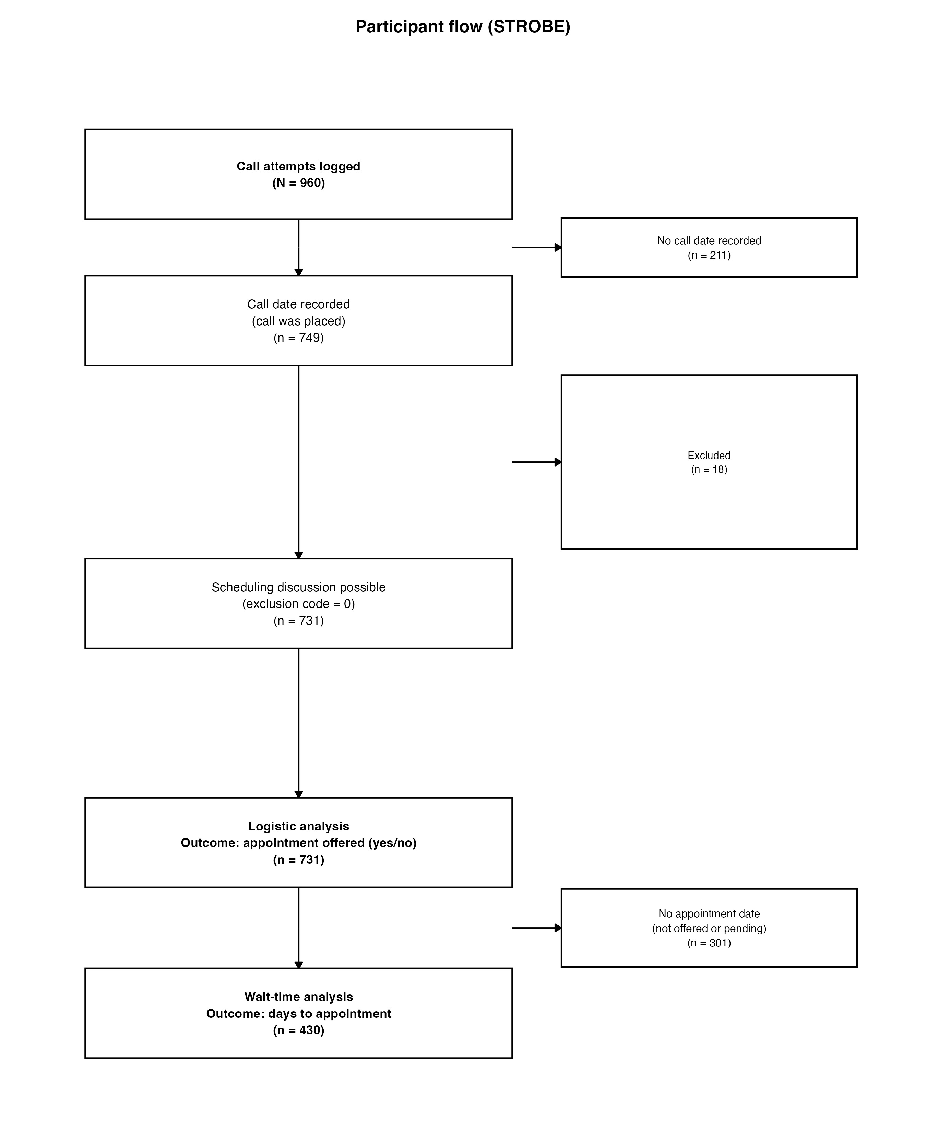
Figure 1. Participant flow from calls placed to the two analytic samples.
Figure 2. Access (odds ratios) and timeliness (incidence rate ratios).
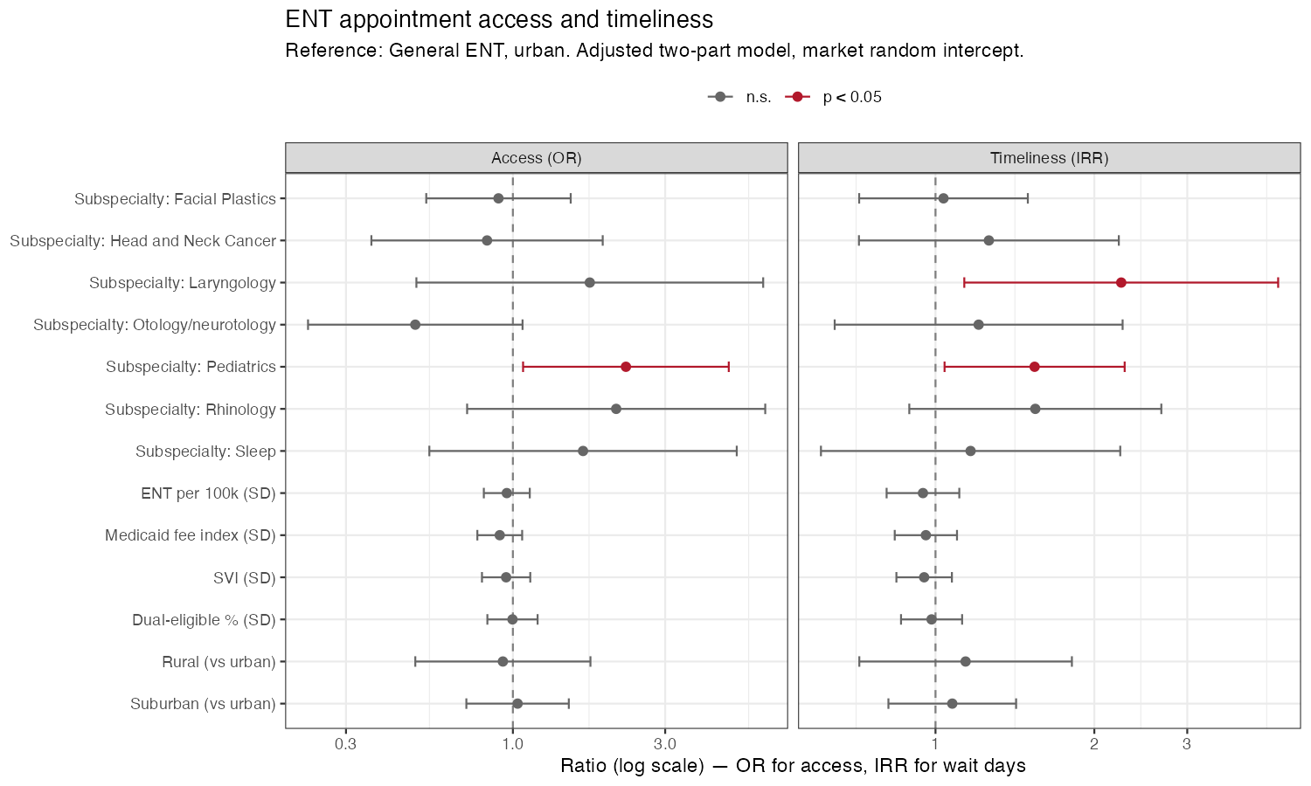
Figure 2. Adjusted access and timeliness effects.
Figure 3. National drive-time access to sampled ENT practices.
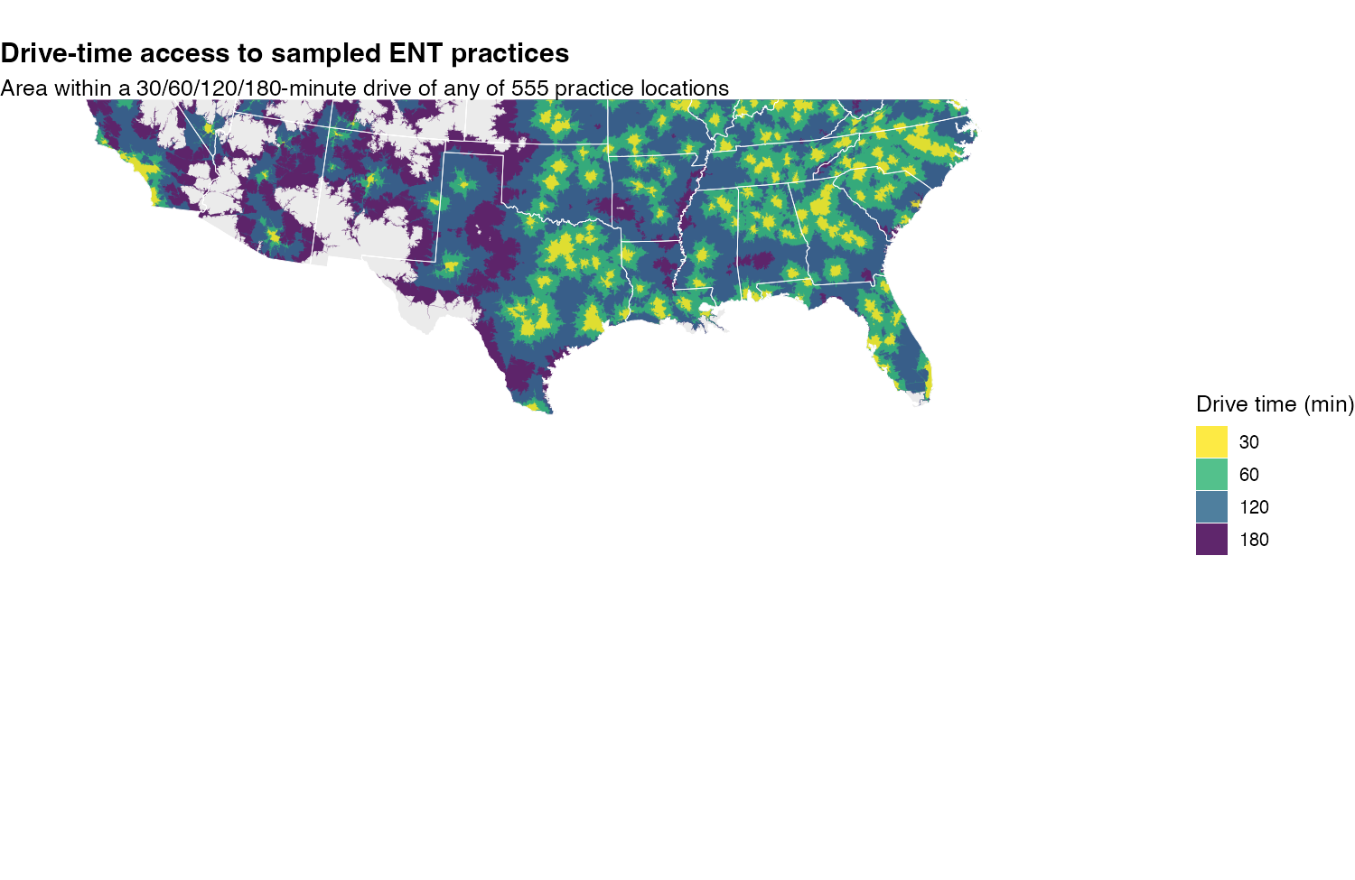
Figure 3. Land area within a 30/60/120/180-minute drive of any sampled practice.

Supplementary material
Supplementary tables S1–S7 (full models; wait time by subspecialty, rurality, and region; offer-rate disparities) and figures S1–S6 (Kaplan–Meier time-to-appointment, wait-time distribution, model diagnostics, and geographic choropleths) are provided; legends are in docs/supplementary_legends.md.
