Subspecialty and Geographic Determinants of New-Patient Appointment Access and Wait Times in Otolaryngology: A National Mystery-Caller Study
Grace E. Falk; Eric J. Dobratz, MD; [RA co-authors — full names & degrees to confirm: Chin, Deol, Gregg, Kim, Roesch, Walsh]; Tyler M. Muffly, MD; Cristina Cabrera-Muffly, MD
July 2026

Abstract
Objective. To quantify subspecialty- and geography-related disparities in access to and timeliness of otolaryngology (ENT) care in the United States using a national simulated-patient design.
Methods. In a cross-sectional mystery-caller study, trained callers requested new-patient appointments from a national sample of board-certified otolaryngologists using subspecialty-matched scripts. We modeled two outcomes with a two-part (hurdle) approach: appointment offer (mixed-effects logistic regression) and business-day wait among offers (mixed-effects negative binomial regression), each adjusting for requested subspecialty, county ENT supply, the state Medicaid fee index, social vulnerability, dual-eligibility, and rurality, with a core-based statistical area random intercept.
Results. Of 960 calls, 731 complete calls with a known subspecialty were analyzed; an appointment was offered in 436 (59.6%), with a median wait of 14 business days (IQR 5–30). Requested subspecialty was the dominant determinant: pediatric otolaryngology had higher odds of an offer (OR 2.29 (95% CI 1.09–4.80; p = 0.028)), and waits were longer for laryngology (IRR 2.24 (95% CI 1.13–4.41; p = 0.020)) and pediatric otolaryngology (IRR 1.62 (95% CI 1.11–2.38; p = 0.013)). No geographic covariate—supply, Medicaid fee generosity, social vulnerability, dual-eligibility, or rurality—was associated with either outcome.
Conclusions. New-patient access to otolaryngology care is shaped more by the requested subspecialty than by local physician supply, insurance generosity, social vulnerability, or rurality. Getting an appointment and being seen promptly are distinct dimensions that diverge by subspecialty.
Keywords: otolaryngology; access to care; health services accessibility; simulated patient; mystery caller; appointment wait time; rural health; workforce.
Running head: Subspecialty and geography in otolaryngology access.
Corresponding author: Cristina Cabrera-Muffly, MD; Department of Otolaryngology–Head and Neck Surgery, University of Colorado School of Medicine, Aurora, CO; [address; email; telephone].
Affiliations: Grace E. Falk, Old Dominion University / Eastern Virginia Medical School, Norfolk, VA. Eric J. Dobratz, Department of Otolaryngology–Head and Neck Surgery, Eastern Virginia Medical School at Old Dominion University, Norfolk, VA. [Research-assistant co-authors — affiliations to confirm.] Tyler M. Muffly, Denver Health and Hospital Authority, Denver, CO; Department of Obstetrics and Gynecology, University of Colorado School of Medicine, Aurora, CO. Cristina Cabrera-Muffly, Department of Otolaryngology–Head and Neck Surgery, University of Colorado School of Medicine, Aurora, CO.
Word count: abstract ≈ 200; main text [to finalize]. Tables: 2 main, 10 supplementary. Figures: 2 main, 7 supplementary.

Introduction
Otolaryngologic conditions—from chronic rhinosinusitis and otitis media to airway disorders and head-and-neck malignancy—are among the most common reasons patients seek specialty care, and for many of these conditions timely evaluation influences diagnosis and outcome, with delays in the diagnosis-to-treatment interval associated with worse survival in head-and-neck cancer¹. Whether a new patient can actually reach an otolaryngologist, however, is not guaranteed by the presence of physicians in a region; it depends on whether an office will offer an appointment and, if so, how long the patient must wait.
Access to specialty care thus has two distinct dimensions that are often conflated: availability—whether a new-patient appointment is offered at all—and timeliness—how quickly the patient is seen. These dimensions can move independently: an office that readily books new patients may nonetheless carry a long queue, and measuring only one can mislead. Administrative and survey data capture both imperfectly, reflecting patients who have already navigated the system and remaining subject to recall and reporting bias.
Simulated-patient (“mystery caller”) studies address this gap by having trained callers pose as new patients and request appointments under a standardized script, directly measuring the experience a real patient would encounter². The design has been applied across specialties to reveal access barriers invisible in claims data. Within otolaryngology, the determinants of new-patient access remain incompletely characterized. Two classes of determinant are plausible: the clinical nature of the request—the requested subspecialty (general otolaryngology versus pediatric otolaryngology, laryngology, head-and-neck oncology, and others)—and the contextual environment of the practice—local physician supply, the generosity of the state Medicaid fee schedule, community social vulnerability, the share of dual-eligible beneficiaries, and rurality³.
We conducted a national mystery-caller study of board-certified otolaryngologists to quantify how the requested subspecialty and the geographic-contextual environment relate to (1) whether a new-patient appointment is offered and (2) the business-day wait when one is offered. To keep these two dimensions of access distinct, we analyzed them with a two-part model.

Methods

Study design and sample
We conducted a cross-sectional, simulated-patient (“mystery caller”) study of access to otolaryngology (ENT) care in the United States⁴. Trained callers telephoned a national sample of practicing, board-certified otolaryngologists and, following a standardized script, requested a new-patient appointment for a subspecialty-matched chief complaint. Each sampled physician was contacted once. The sampling frame was the American Board of Otolaryngology–Head and Neck Surgery roster of board-certified otolaryngologists practicing in the United States (N = 11,333), linked to National Provider Identifier records for practice location and rurality. Because rural otolaryngologists were scarce in this frame (791 of 11,333; 7.0%), we drew a rurality-stratified sample of 480 urban and 480 rural physicians (960 total) to obtain balanced representation; the rural stratum accordingly included a majority of all rural board-certified otolaryngologists in the frame. Calls were placed between May 29 and July 6, 2026, to physicians in 48 states, each under a commercial Blue Cross Blue Shield insurance scenario held constant across calls, with the chief complaint matched to the sampled physician’s subspecialty (general otolaryngology, facial plastic surgery, head and neck oncology, laryngology, otology/neurotology, pediatric otolaryngology, rhinology, or sleep medicine). Script selection followed the physician’s fellowship training (subspecialty-specific script if fellowship-trained, otherwise the general otolaryngology script), and callers verified board certification and coded practice rurality before each call; the full pre-call procedure and the verbatim subspecialty scripts are provided in the Supplementary Appendix (Table S9). [To confirm from the protocol: the number and timing of call attempts before a physician was recorded as unreachable, and caller-training procedures.] The Human Subjects Protection Program at Old Dominion University (Macon & Joan Brock Virginia Health Sciences / Eastern Virginia Medical School) determined that this project (IRB #24-12-NH-0285) does not involve human subjects research and is therefore not subject to IRB review; informed consent was not required. The covert measurement of clinician behavior has been debated—most publicly when a 2011 federally commissioned “mystery shopper” survey of primary-care access was shelved amid concern about deceiving physician practices^{5,6}—but a formal ethical analysis has since established that simulated-patient research without prior consent is justified when risks and burdens are minimal, a consent waiver is necessary for scientifically valid data, and the study carries substantial social value⁷. This study was designed to satisfy those conditions. Consistent with established simulated-patient practice, the covert design incorporated several safeguards: no protected health information was collected and no calls were recorded; each contact was a single brief call that booked no real appointment and imposed minimal burden on office staff; and identifying information about individual staff members was neither requested nor stored. Covert simulated calling was necessary because non-covert methods—for example, surveys of offices aware of being observed—would systematically bias access estimates through social desirability, the same rationale that underlies the design’s measurement validity^{4,8,9}. Aggregate, market-level findings will be made available through specialty-society and state channels as a benefit to participating communities, in the spirit of the participant-feedback provisions used in prior covert simulated-patient studies¹⁰.
Analyses were restricted to calls with a completed data-collection record and a determinable physician subspecialty. This study did not manipulate patient insurance; the exposures of interest were the requested subspecialty and the geographic context of the practice.

Outcomes
Two outcomes were analyzed as a two-part (hurdle) process. The first, access, was whether the office offered a new-patient appointment with the sampled physician (binary). The second, timeliness, was the number of business days from the call to the next available appointment, counted excluding weekends and U.S. federal holidays, and defined only for calls in which an appointment was offered. We recorded the first-available appointment; prior simulated-patient work has shown that the more elaborate third-next-available metric adds little beyond first-available while reducing reliability¹¹.

Geographic covariates
Each practice was linked to contextual covariates by practice ZIP code and state. County was assigned from a 2020 Census ZCTA-to-county crosswalk (dominant county by land area). Covariates comprised: county otolaryngologist supply per 100,000 population; the state Medicaid-to-Medicare fee index (Kaiser Family Foundation, 2024, all services)¹²; the CDC/ATSDR Social Vulnerability Index (SVI, 2022, tract-level, population-weighted to the practice ZIP)¹³; the county fraction of Medicare beneficiaries dual-eligible for Medicaid (CMS); metropolitan hospital-market concentration (Herfindahl–Hirschman Index [HHI], KFF 2024; available for metropolitan areas only); rurality, dichotomized from Rural–Urban Commuting Area (RUCA) codes as urban (RUCA 1–3) versus rural (RUCA 4–10); and the American Academy of Otolaryngology–Head and Neck Surgery (AAO-HNS) Board of Governors region.

Statistical analysis
Because business-day wait time is observed only when an appointment is offered, we modeled access and timeliness separately to avoid conditioning wait-time estimates on the offer. Access was modeled with a mixed-effects logistic regression over all analytic calls; timeliness with a mixed-effects negative binomial regression over the offered subset. The negative binomial distribution was selected over Poisson on the basis of substantial overdispersion (Pearson φ = 6.22). Both models included a random intercept for core-based statistical area (CBSA; county FIPS where CBSA was undefined) to account for within-market correlation, and adjusted for the requested subspecialty (reference: general otolaryngology), county ENT supply, Medicaid fee index, SVI, dual-eligible fraction, and rurality (reference: urban). The identity of the caller (research assistant) was included as a fixed nuisance term to adjust for operator-level differences in call handling. Continuous covariates were standardized and, for the few missing values (<3%), median-imputed.
Effects are reported as odds ratios (access) and incidence rate ratios (timeliness) with 95% Wald confidence intervals. Pairwise differences between subspecialties were estimated with Tukey-adjusted estimated marginal means¹⁴. Effect modification of the geographic covariates by subspecialty was tested by likelihood-ratio tests. Market-level clustering was summarized by the intraclass correlation coefficient (ICC). Because the HHI is defined only in metropolitan areas, its association with timeliness was assessed in a sensitivity model restricted to the metropolitan subset. Two additional sensitivity analyses were performed: a three-level rurality specification (urban, RUCA 1–3; suburban, 4–6; rural, 7–10) in place of the binary contrast, and a complete-case refit that excluded records with any missing covariate rather than median-imputing them. Whether call incompleteness was related to the measured covariates was assessed with chi-square and Wilcoxon rank-sum tests. Analyses used R 4.4.2¹⁵ (packages glmmTMB¹⁶, emmeans¹⁴, and the study package mysterycall); two-sided α = 0.05. Reporting follows the STROBE guideline for observational studies¹⁷ and the simulated-patient–specific CRiSP/CRiSPHe reporting checklist^{18,19}.

Sample size and power
The sample size was fixed a priori by a call budget of 800, with the rural-versus-urban difference in business-day wait time as the primary contrast. The power analysis was pre-specified before data collection and implemented in a purpose-built simulation application. Its assumptions were anchored to empirical data rather than convention: the expected rural wait penalty, the negative binomial dispersion (φ = 1.7), and the state-level intraclass correlation (ICC = 0.08) were estimated by pooling 273 rural otolaryngology observations from two published access series^{20,21}. Under these assumptions and a two-sided α = 0.05, an 800-call budget provided greater than 99% power to detect the anticipated eight-business-day rural–urban gap; the minimum detectable difference at 90% power was approximately six business days. The design was robust to two realistic threats: after a 20% non-response buffer (analyzable n ≈ 640) power remained near 98%, and although a balanced 50/50 rural/urban allocation was optimal, sampling at the natural rural prevalence (~15%) still yielded 83% power. A balanced urban/rural allocation was therefore targeted. The realized dispersion (φ = 6.22) substantially exceeded the planned value, reducing achieved power relative to plan; the resulting reconciliation is reported in the Limitations.

Results

Sample and attrition
Callers placed 960 calls; 749 (78.0%) were completed, of which 731 had a determinable subspecialty and formed the analytic sample. An appointment was offered in 436 of 731 (59.6%); the median next-available wait was 14 business days (IQR 5–30). Sample characteristics are shown in Table 1, and the participant flow in Figure 1.
**Table 1. Sample characteristics by requested subspecialty.**
 | Requested subspecialty
Characteristic | Overall  N = 731¹ | General  N = 501¹ | Facial Plastics  N = 78¹ | Pediatrics  N = 45¹ | Otology/neurotology  N = 32¹ | Head and Neck Cancer  N = 27¹ | Rhinology  N = 19¹ | Sleep  N = 16¹ | Laryngology  N = 13¹
Appointment offered
Offered | 436 (60%) | 292 (58%) | 47 (60%) | 34 (76%) | 14 (44%) | 15 (56%) | 14 (74%) | 11 (69%) | 9 (69%)
Not offered | 295 (40%) | 209 (42%) | 31 (40%) | 11 (24%) | 18 (56%) | 12 (44%) | 5 (26%) | 5 (31%) | 4 (31%)
Business-day wait, if offered | 14 (5, 30) | 14 (5, 26) | 12 (5, 23) | 26 (6, 47) | 22 (5, 42) | 11 (4, 24) | 16 (9, 40) | 15 (2, 44) | 32 (13, 41)
Rurality
Urban | 367 (50%) | 197 (39%) | 57 (73%) | 37 (82%) | 24 (75%) | 23 (85%) | 14 (74%) | 4 (25%) | 11 (85%)
Rural | 364 (50%) | 304 (61%) | 21 (27%) | 8 (18%) | 8 (25%) | 4 (15%) | 5 (26%) | 12 (75%) | 2 (15%)
ENT per 100,000 | 4.7 (3.2, 6.9) | 4.4 (2.9, 6.5) | 4.8 (3.5, 6.9) | 5.9 (4.0, 7.6) | 5.7 (3.6, 11.0) | 6.2 (4.6, 8.2) | 7.5 (3.9, 10.9) | 2.7 (1.9, 4.9) | 4.9 (3.4, 5.8)
Medicaid fee index | 0.74 (0.64, 0.83) | 0.76 (0.66, 0.83) | 0.69 (0.64, 0.83) | 0.67 (0.64, 0.76) | 0.76 (0.67, 0.94) | 0.69 (0.63, 0.76) | 0.69 (0.64, 0.76) | 0.74 (0.64, 0.83) | 0.76 (0.68, 0.76)
Social Vulnerability Index | 0.48 (0.36, 0.63) | 0.49 (0.37, 0.63) | 0.44 (0.27, 0.58) | 0.52 (0.37, 0.73) | 0.45 (0.38, 0.58) | 0.37 (0.29, 0.60) | 0.56 (0.29, 0.70) | 0.55 (0.44, 0.74) | 0.42 (0.27, 0.61)
Dual-eligible fraction | 0.16 (0.12, 0.21) | 0.15 (0.12, 0.20) | 0.18 (0.13, 0.23) | 0.17 (0.15, 0.23) | 0.14 (0.11, 0.23) | 0.16 (0.15, 0.23) | 0.18 (0.14, 0.24) | 0.16 (0.12, 0.22) | 0.19 (0.16, 0.22)
¹n (%); Median (Q1, Q3)

Access to appointments
The requested subspecialty was the dominant determinant of whether an appointment was offered. Relative to general otolaryngology, pediatric otolaryngology had over twice the odds of an offer (OR 2.29 (95% CI 1.09–4.80; p = 0.028)), while otology/neurotology trended lower (OR 0.58 (95% CI 0.27–1.25; p = 0.167)). No geographic covariate was associated with access: county ENT supply (OR 0.96 (95% CI 0.81–1.13; p = 0.617) per SD), the Medicaid fee index (OR 0.90 (95% CI 0.76–1.06; p = 0.191)), social vulnerability (OR 0.93 (95% CI 0.78–1.11; p = 0.425)), and dual-eligibility (OR 0.98 (95% CI 0.82–1.17; p = 0.816)) were all null (Figure 2).

Timeliness of appointments
Among offering offices, waits again varied by subspecialty and not geography. Relative to general otolaryngology, waits were longer for laryngology (IRR 2.24 (95% CI 1.13–4.41; p = 0.020)) and pediatric otolaryngology (IRR 1.62 (95% CI 1.11–2.38; p = 0.013)). Anchored to the roughly two-week median wait for general otolaryngology (14 business days), these rate ratios correspond to a substantially longer typical wait—on the order of an additional two to three weeks for laryngology and about one to one-and-a-half weeks for pediatric otolaryngology—consistent with the observed subspecialty medians (Table S3). No geographic covariate was associated with wait time (Figure 2; Table 2).
Table 2a. Access model (odds ratios). Subspecialty reference: general otolaryngology; rurality reference: urban.
Term | OR (95% CI) | p
Facial plastic surgery | 1.00 (0.59–1.69) | 0.995
Head and neck oncology | 0.82 (0.36–1.90) | 0.650
Laryngology | 1.80 (0.51–6.32) | 0.357
Otology/neurotology | 0.58 (0.27–1.25) | 0.167
Pediatric otolaryngology | 2.29 (1.09–4.80) | 0.028
Rhinology | 2.21 (0.75–6.50) | 0.151
Sleep medicine | 1.71 (0.56–5.21) | 0.344
Otolaryngologist density (per SD) | 0.96 (0.81–1.13) | 0.617
Medicaid fee index (per SD) | 0.90 (0.76–1.06) | 0.191
Social Vulnerability Index (per SD) | 0.93 (0.78–1.11) | 0.425
Dual-eligible share (per SD) | 0.98 (0.82–1.17) | 0.816
Rural (vs urban) | 1.04 (0.73–1.49) | 0.830
Table 2b. Timeliness model (incidence rate ratios). Subspecialty reference: general otolaryngology; rurality reference: urban.
Term | IRR (95% CI) | p
Facial plastic surgery | 1.06 (0.74–1.52) | 0.743
Head and neck oncology | 1.29 (0.74–2.26) | 0.369
Laryngology | 2.24 (1.13–4.41) | 0.020
Otology/neurotology | 1.31 (0.72–2.41) | 0.377
Pediatric otolaryngology | 1.62 (1.11–2.38) | 0.013
Rhinology | 1.56 (0.90–2.68) | 0.110
Sleep medicine | 1.21 (0.64–2.30) | 0.551
Otolaryngologist density (per SD) | 0.94 (0.82–1.08) | 0.391
Medicaid fee index (per SD) | 0.94 (0.83–1.06) | 0.318
Social Vulnerability Index (per SD) | 0.96 (0.85–1.08) | 0.489
Dual-eligible share (per SD) | 0.99 (0.87–1.12) | 0.832
Rural (vs urban) | 1.19 (0.92–1.53) | 0.191

Secondary access measures
Beyond the two modeled outcomes, the call log captured intermediate steps of the access pathway (Table S10, Figure S7). Of the 731 analytic calls, a live office was reached in 569 (78%); the practice was accepting new patients in 432 (59%); and an appointment was offered in 436 (60%). Critically, only 370 calls (51%) yielded an appointment with the specific board-certified otolaryngologist requested: among the 436 offers, 58 (13%) were with a different physician and 9 with an advanced practice provider only. Two front-desk barriers stood out: 25 practices stated they do not see the presented complaint despite the sampled physician’s matched subspecialty, and among practices not accepting new patients the most common documented reasons were that the physician had retired or left (81) or an unspecified closure (104)—a signal that provider directories overstate the reachable workforce.

Robustness and missing data
Market-level clustering was modest: the core-based statistical area random intercept accounted for a latent intraclass correlation of 0.043 in the access model (CBSA variance 0.26 on the log scale in the timeliness model), indicating that most variation in access and timeliness lay within rather than between markets. Under Tukey-adjusted pairwise comparison no subspecialty pair reached significance, and the subspecialty effect did not vary by rurality or supply (interaction likelihood-ratio tests, both non-significant). In a metropolitan sensitivity model, greater hospital-market concentration was associated with a borderline increase in wait time (HHI IRR 1.20 per SD; p = 0.058). Call incompleteness was unrelated to practice geography, supporting a missing-at-random mechanism with respect to location (Supplement). The main findings were stable across two sensitivity analyses (Table S8). Under a three-level rurality specification (urban, RUCA 1–3; suburban, 4–6; rural, 7–10), no urban-to-rural gradient emerged—neither suburban (wait IRR 1.15) nor the sparse rural stratum (IRR 1.29) differed significantly from urban—while the subspecialty effects were unchanged. A complete-case analysis without imputation (n = 412 recorded waits) likewise reproduced the longer waits for laryngology (IRR 2.51) and pediatric otolaryngology (IRR 1.52) and the null rural–urban contrast (IRR 1.14).

Discussion
In this national simulated-patient study of otolaryngology access, the requested subspecialty was the dominant determinant of both whether a new-patient appointment was offered and how long the patient waited, whereas none of the measured contextual factors—county physician supply, Medicaid fee generosity, social vulnerability, dual-eligibility, or rurality—was associated with either outcome.
Three observations follow. First, who the patient asks for matters more than the local environment in which they ask. After adjustment, subspecialty effects were substantial—pediatric otolaryngology carried more than twice the odds of an appointment offer—while the contextual covariates clustered tightly around the null. This suggests that, among the practices reachable in this sample, the decision to accept a new patient is governed more by practice-level factors tied to the clinical request than by the socioeconomic or supply characteristics of the surrounding area. This parallels an emerging pattern in other access studies, in which disparities track the type of practice a patient reaches rather than whether that practice is urban or rural: rural populations may face barriers less because they are rural than because they are more likely to reach practices with different acceptance behavior. Framed this way, the relevant unit for intervention is the practice and the clinical request, not the community.
Second, availability and timeliness are distinct dimensions that can diverge. Pediatric otolaryngology was among the easiest subspecialties to reach yet carried one of the longest waits once an appointment was secured, and laryngology showed the longest waits of all. A patient-centered account of access must report both dimensions: a subspecialty that “opens the door” quickly may still leave the patient waiting weeks, and an intervention aimed at one dimension will not necessarily improve the other.
Third, the null contextual findings are informative rather than merely negative. They argue against a simple supply-gradient model in which access improves smoothly with local otolaryngologist density or payer generosity. Several explanations are compatible with this pattern: practices may operate similarly across diverse local contexts; the relevant barriers may act at the level of the individual practice—scheduling policy, subspecialty scope—rather than the community; or the study may be underpowered for modest contextual gradients, particularly in the sparse rural stratum. Distinguishing the contextual gradient examined here from the geographic reach of care—the travel burden a patient must overcome to arrive at a practice at all—is the subject of a companion geospatial analysis.
These findings carry practical implications. Subspecialty-specific bottlenecks—prolonged waits for laryngology and pediatric otolaryngology—are concrete targets for referral triage, capacity planning, and telehealth, independent of where the patient lives. That contextual factors did not predict access is reassuring against one form of disparity but does not exclude others not measured here, including patient insurance type, which this phase did not vary.
Strengths and limitations. A central strength is the simulated-patient design itself: because offices were unaware of being observed, responses were insulated from the social-desirability and observation (Hawthorne) bias that affects surveys of practices aware they are being studied, yielding a more faithful measure of the experience a real new patient would encounter⁴. The realized sample achieved the pre-specified, near-optimal urban/rural balance (approximately 50/50 under the RUCA 1–3 vs 4–10 dichotomy) and exceeded the planned call budget. One appointment with an implausible date—a wait exceeding two years attributable to a data-entry error in the appointment year—was excluded from the timeliness analysis. Even so, the study was modestly underpowered for its primary rural-versus-urban timeliness contrast: the pre-specified target was a minimum detectable gap of about six business days, whereas the realized sample (426 recorded waits, reflecting an appointment-offer rate near three-fifths) supports detection of roughly a ten-day gap at 90% power and provides about 70% power for the originally anticipated eight-day gap. Reaching the six-day target would require on the order of 130 additional calls (approximately 1,090 total) at 80% power, or 490 additional calls (approximately 1,450 total) at 90% power. The observed rural–urban difference was small (about two business days) and non-significant. Each physician was contacted once, precluding within-physician inference; each call captured the response of a single office representative, whose account may not reflect the practice’s full scheduling behavior; contextual covariates were linked at the ZIP-code or county level and thus approximate a practice’s true environment; patient insurance was held constant (not varied) in this phase; and appointment availability reflects a single point in time.
Future directions. Several extensions follow directly from this design. First, because insurance was held constant, a natural next phase is to vary the payer (e.g., Medicaid vs commercial) within the same frame; a prior specialty-cancer mystery-caller study that likewise fixed insurance identified this as its principal next step²². Second, most otolaryngology care is physician-referred, so our patient-initiated calls capture a self-referral ceiling; a complementary arm in which the caller poses as a referring primary-care office would better reflect the true specialist-referral pathway²². Third, our secondary measures hint at an information-quality dimension we did not fully model—whether front-desk statements (that a practice does not see a complaint, or that a physician is unavailable) are accurate—which simulated-patient studies increasingly treat as a distinct outcome, “available ≠ accessible ≠ accurately communicated”²³. Comparing publicly listed directory or website information against phone-obtained access would quantify this gap directly⁹, and the frequency of “retired or left” responses in our data suggests provider directories materially overstate the reachable workforce. Finally, whether schedulers appropriately triage clinically urgent presentations—head-and-neck cancer red flags, for instance—is an access-quality axis beyond the offer and wait we measured⁸.
Conclusion. In a national mystery-caller study, new-patient otolaryngology access was driven by the requested subspecialty rather than by local supply, insurance generosity, or social vulnerability, and the availability and timeliness of care diverged by subspecialty. Efforts to improve access should account for subspecialty-specific bottlenecks and should measure both whether patients can get in and how long they wait.

Author contributions
Grace E. Falk: Investigation, Data curation, Project administration, Writing – original draft. Eric J. Dobratz: Conceptualization, Supervision, Resources, Project administration, Writing – review & editing. [Research-assistant co-authors: Chin, Deol, Gregg, Kim, Roesch, Walsh]: Investigation (mystery-caller data collection). Tyler M. Muffly: Conceptualization, Methodology, Formal analysis, Software, Writing – review & editing. Cristina Cabrera-Muffly: Conceptualization, Supervision, Writing – review & editing. All authors reviewed and approved the final manuscript and accept responsibility for its submission.

Funding
This research received no specific grant from any funding agency in the public, commercial, or not-for-profit sectors.

Conflicts of interest
The authors declare no competing interests.

Data availability
De-identified data supporting the findings of this study, together with a data dictionary, are available from the corresponding author on reasonable request and under a data-sharing agreement, beginning 6 months and ending 36 months after publication. Analysis code is available at [repository URL].

Figures
Figure 1. Participant flow (STROBE). Generated with mysterycall_strobe_flow().
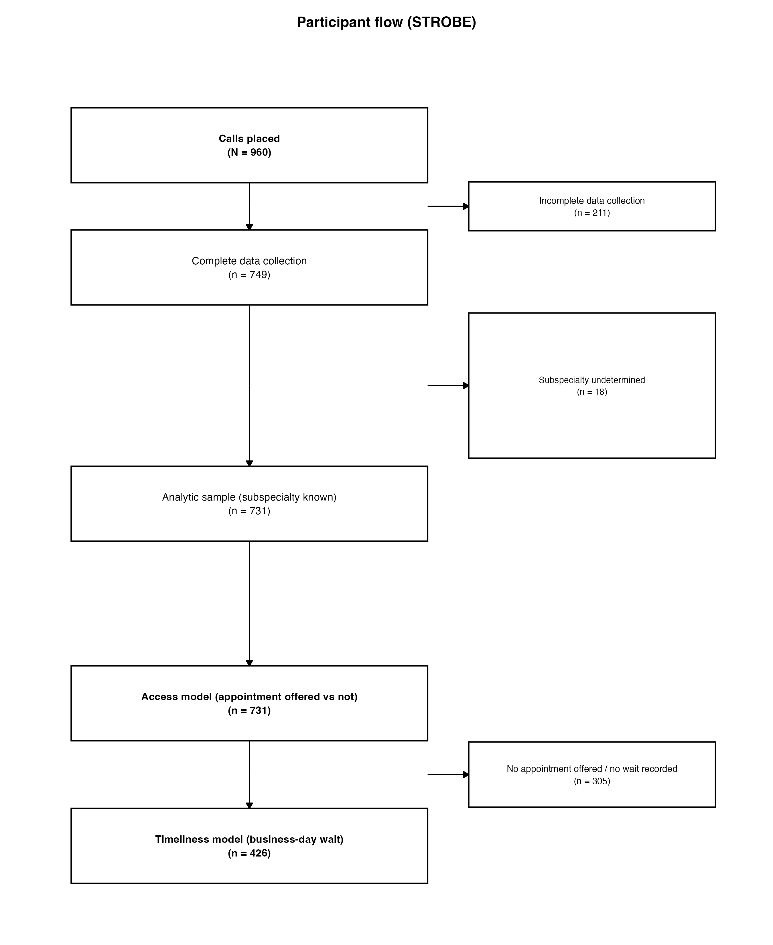
Figure 1. Participant flow from calls placed to the two analytic samples.
Figure 2. Access (odds ratios) and timeliness (incidence rate ratios).
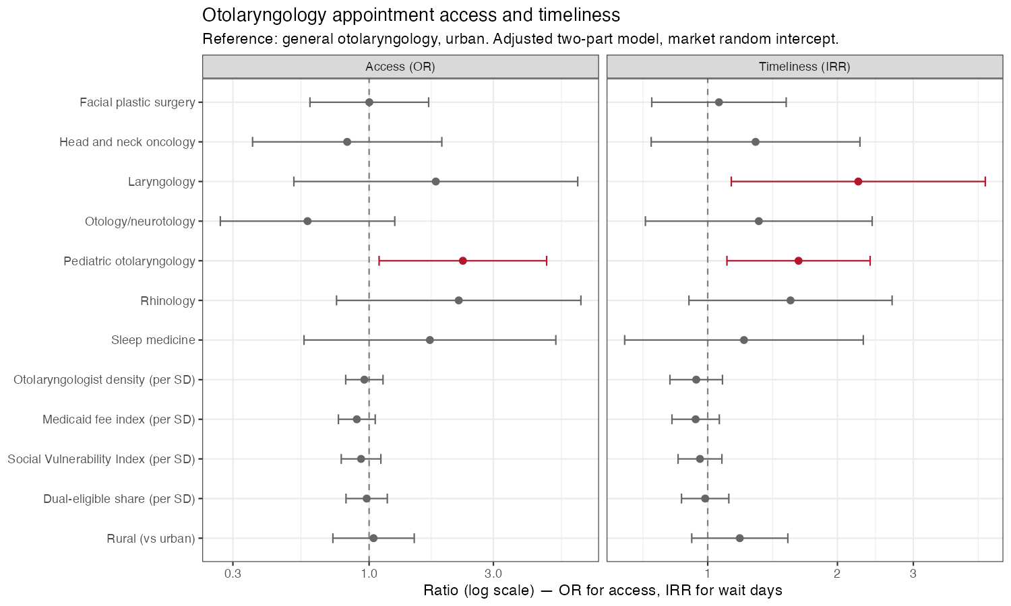
Figure 2. Adjusted access and timeliness effects.

Supplementary Material

Supplementary Tables
Table S1. Full access model (all odds ratios).
Term | estimate | se | z_value | p_value | p_value_fmt | or | ci_lower | ci_upper
Intercept | -0.238 | 0.191 | -1.250 | 0.211 | 0.211 | 0.788 | 0.542 | 1.145
Facial plastic surgery | 0.002 | 0.268 | 0.007 | 0.995 | 0.995 | 1.002 | 0.593 | 1.693
Head and neck oncology | -0.194 | 0.427 | -0.454 | 0.650 | 0.650 | 0.824 | 0.357 | 1.902
Laryngology | 0.590 | 0.640 | 0.921 | 0.357 | 0.357 | 1.803 | 0.514 | 6.322
Otology/neurotology | -0.544 | 0.393 | -1.383 | 0.167 | 0.167 | 0.580 | 0.268 | 1.255
Pediatric otolaryngology | 0.829 | 0.378 | 2.194 | 0.028 | 0.028 | 2.291 | 1.093 | 4.804
Rhinology | 0.792 | 0.551 | 1.437 | 0.151 | 0.151 | 2.208 | 0.750 | 6.503
Sleep medicine | 0.538 | 0.568 | 0.947 | 0.344 | 0.344 | 1.712 | 0.562 | 5.210
Otolaryngologist density (per SD) | -0.042 | 0.084 | -0.500 | 0.617 | 0.617 | 0.959 | 0.813 | 1.131
Medicaid fee index (per SD) | -0.109 | 0.083 | -1.308 | 0.191 | 0.191 | 0.897 | 0.762 | 1.056
Social Vulnerability Index (per SD) | -0.071 | 0.089 | -0.797 | 0.425 | 0.425 | 0.931 | 0.782 | 1.110
Dual-eligible share (per SD) | -0.022 | 0.093 | -0.233 | 0.816 | 0.816 | 0.979 | 0.815 | 1.175
Rural (vs urban) | 0.039 | 0.183 | 0.214 | 0.830 | 0.830 | 1.040 | 0.726 | 1.490
Caller: Deol | 0.812 | 0.255 | 3.190 | 0.001 | 0.001 | 2.253 | 1.368 | 3.711
Caller: Falk | 0.632 | 0.289 | 2.190 | 0.029 | 0.029 | 1.882 | 1.069 | 3.314
Caller: Gregg | 0.634 | 0.255 | 2.487 | 0.013 | 0.013 | 1.886 | 1.144 | 3.109
Caller: Kim | 0.725 | 0.256 | 2.830 | 0.005 | 0.005 | 2.065 | 1.250 | 3.412
Caller: Other | 0.271 | 0.595 | 0.456 | 0.648 | 0.648 | 1.312 | 0.409 | 4.211
Caller: Walsh | 0.842 | 0.252 | 3.344 | 0.001 | < 0.001 | 2.320 | 1.417 | 3.800

Table S2. Full timeliness model (all rate ratios).
Term | IRR (95% CI) | p-value
Facial plastic surgery | 1.06 (0.74-1.52) | 0.743
Head and neck oncology | 1.29 (0.74-2.26) | 0.369
Laryngology | 2.24 (1.13-4.41) | 0.020
Otology/neurotology | 1.31 (0.72-2.41) | 0.377
Pediatric otolaryngology | 1.62 (1.11-2.38) | 0.013
Rhinology | 1.56 (0.90-2.68) | 0.110
Sleep medicine | 1.21 (0.64-2.30) | 0.551
Otolaryngologist density (per SD) | 0.94 (0.82-1.08) | 0.391
Medicaid fee index (per SD) | 0.94 (0.83-1.06) | 0.318
Social Vulnerability Index (per SD) | 0.96 (0.85-1.08) | 0.489
Dual-eligible share (per SD) | 0.99 (0.87-1.12) | 0.832
Rural (vs urban) | 1.19 (0.92-1.53) | 0.191
Caller: Deol | 0.83 (0.60-1.14) | 0.258
Caller: Falk | 0.64 (0.43-0.93) | 0.020
Caller: Gregg | 0.90 (0.65-1.25) | 0.528
Caller: Kim | 0.98 (0.70-1.37) | 0.896
Caller: Other | 0.66 (0.23-1.87) | 0.436
Caller: Walsh | 0.89 (0.64-1.23) | 0.465

Table S3. Business-day wait by subspecialty.
Subspecialty | median_days | q1 | q3 | n
General otolaryngology | 14.0 | 5 | 26 | 286
Facial plastic surgery | 11.5 | 5 | 22 | 44
Head and neck oncology | 11.0 | 6 | 22 | 15
Laryngology | 32.0 | 13 | 41 | 9
Otology/neurotology | 22.0 | 5 | 42 | 13
Pediatric otolaryngology | 25.5 | 7 | 46 | 34
Rhinology | 15.5 | 10 | 39 | 14
Sleep medicine | 15.0 | 6 | 34 | 11

Table S4. Business-day wait by rurality.
rural | median_days | q1 | q3 | n
Urban | 13 | 5 | 30 | 217
Rural | 15 | 6 | 30 | 209

Table S5. Business-day wait by AAO-HNS region.
aao_hns_region | median_days | q1 | q3 | n
Central | 14.0 | 5 | 33 | 73
Mid-Atlantic/Southeast | 12.0 | 5 | 24 | 38
Middle Atlantic | 14.0 | 5 | 32 | 43
Midwest | 16.5 | 10 | 32 | 96
Mountain/Southwest | 14.0 | 12 | 20 | 21
New England | 29.5 | 14 | 51 | 26
Pacific | 14.0 | 5 | 30 | 48
Southeast | 9.0 | 4 | 20 | 81

Table S6. Appointment offer-rate disparities by region.
group | n | n_accepted | rate | lower_ci | upper_ci | abs_diff | rel_risk | rr_lower | rr_upper | p_value | p_value_fmt
New England | 48 | 26 | 0.542 | 0.403 | 0.674 | 0.000 | 1.000 | NA | NA | NA | NA
Central | 109 | 74 | 0.679 | 0.586 | 0.759 | 13.723 | 1.253 | 0.937 | 1.676 | 0.099 | p = 0.099
Midwest | 154 | 100 | 0.649 | 0.571 | 0.720 | 10.768 | 1.199 | 0.902 | 1.594 | 0.179 | p = 0.179
Southeast | 129 | 81 | 0.628 | 0.542 | 0.706 | 8.624 | 1.159 | 0.866 | 1.553 | 0.297 | p = 0.297
Mid-Atlantic/Southeast | 67 | 39 | 0.582 | 0.463 | 0.693 | 4.042 | 1.075 | 0.773 | 1.495 | 0.666 | p = 0.666
Pacific | 88 | 50 | 0.568 | 0.464 | 0.667 | 2.652 | 1.049 | 0.763 | 1.441 | 0.766 | p = 0.766
Middle Atlantic | 91 | 45 | 0.495 | 0.394 | 0.595 | -4.716 | 0.913 | 0.654 | 1.274 | 0.597 | p = 0.597
Mountain/Southwest | 45 | 21 | 0.467 | 0.329 | 0.609 | -7.500 | 0.862 | 0.574 | 1.294 | 0.470 | p = 0.470

Table S7. Access vs. timeliness models, side by side.
Term | Access [Logistic] | Timeliness [NB]
General otolaryngology (reference) | Ref. | Ref.
Facial plastic surgery | 1.00 (0.59-1.69), p=0.995 | 1.06 (0.74-1.52), p=0.743
Head and neck oncology | 0.82 (0.36-1.90), p=0.650 | 1.29 (0.74-2.26), p=0.369
Laryngology | 1.80 (0.51-6.32), p=0.357 | 2.24 (1.13-4.41), p=0.020
Otology/neurotology | 0.58 (0.27-1.25), p=0.167 | 1.31 (0.72-2.41), p=0.377
Pediatric otolaryngology | 2.29 (1.09-4.80), p=0.028 | 1.62 (1.11-2.38), p=0.013
Rhinology | 2.21 (0.75-6.50), p=0.151 | 1.56 (0.90-2.68), p=0.110
Sleep medicine | 1.71 (0.56-5.21), p=0.344 | 1.21 (0.64-2.30), p=0.551
Otolaryngologist density (per SD) | 0.96 (0.81-1.13), p=0.617 | 0.94 (0.82-1.08), p=0.391
Medicaid fee index (per SD) | 0.90 (0.76-1.06), p=0.191 | 0.94 (0.83-1.06), p=0.318
Social Vulnerability Index (per SD) | 0.93 (0.78-1.11), p=0.425 | 0.96 (0.85-1.08), p=0.489
Dual-eligible share (per SD) | 0.98 (0.82-1.17), p=0.816 | 0.99 (0.87-1.12), p=0.832
ruralUrban | Ref. | Ref.
Rural (vs urban) | 1.04 (0.73-1.49), p=0.830 | 1.19 (0.92-1.53), p=0.191
Caller: Roesch | Ref. | Ref.
Caller: Deol | 2.25 (1.37-3.71), p=0.001 | 0.83 (0.60-1.14), p=0.258
Caller: Falk | 1.88 (1.07-3.31), p=0.029 | 0.64 (0.43-0.93), p=0.020
Caller: Gregg | 1.89 (1.14-3.11), p=0.013 | 0.90 (0.65-1.25), p=0.528
Caller: Kim | 2.06 (1.25-3.41), p=0.005 | 0.98 (0.70-1.37), p=0.896
Caller: Other | 1.31 (0.41-4.21), p=0.648 | 0.66 (0.23-1.87), p=0.436
Caller: Walsh | 2.32 (1.42-3.80), p=< 0.001 | 0.89 (0.64-1.23), p=0.465
N | 731 | 426
AIC | 991.4 | 3514.6

Table S8. Sensitivity analyses: three-level RUCA and complete-case (key coefficients vs primary model).
spec | part | term | estimate | ci | p | n_access | n_timeliness
Primary (binary RUCA, imputed) | Access (OR) | Laryngology | 1.80 | 0.51-6.32 | 0.357 | 731 | 426
Primary (binary RUCA, imputed) | Access (OR) | Pediatric otolaryngology | 2.29 | 1.09-4.80 | 0.028 | 731 | 426
Primary (binary RUCA, imputed) | Access (OR) | Rural (vs urban) | 1.04 | 0.73-1.49 | 0.830 | 731 | 426
Primary (binary RUCA, imputed) | Timeliness (IRR) | Laryngology | 2.24 | 1.13-4.41 | 0.020 | 731 | 426
Primary (binary RUCA, imputed) | Timeliness (IRR) | Pediatric otolaryngology | 1.62 | 1.11-2.38 | 0.013 | 731 | 426
Primary (binary RUCA, imputed) | Timeliness (IRR) | Rural (vs urban) | 1.19 | 0.92-1.53 | 0.191 | 731 | 426
S-A: 3-level RUCA | Access (OR) | Laryngology | 1.81 | 0.52-6.34 | 0.355 | 731 | 426
S-A: 3-level RUCA | Access (OR) | Pediatric otolaryngology | 2.28 | 1.09-4.79 | 0.029 | 731 | 426
S-A: 3-level RUCA | Access (OR) | Suburban, RUCA 4-6 (vs urban) | 1.06 | 0.73-1.54 | 0.754 | 731 | 426
S-A: 3-level RUCA | Access (OR) | Rural, RUCA 7-10 (vs urban) | 0.93 | 0.49-1.75 | 0.822 | 731 | 426
S-A: 3-level RUCA | Timeliness (IRR) | Laryngology | 2.23 | 1.13-4.40 | 0.021 | 731 | 426
S-A: 3-level RUCA | Timeliness (IRR) | Pediatric otolaryngology | 1.64 | 1.12-2.40 | 0.012 | 731 | 426
S-A: 3-level RUCA | Timeliness (IRR) | Suburban, RUCA 4-6 (vs urban) | 1.16 | 0.89-1.51 | 0.276 | 731 | 426
S-A: 3-level RUCA | Timeliness (IRR) | Rural, RUCA 7-10 (vs urban) | 1.36 | 0.87-2.12 | 0.180 | 731 | 426
S-B: Complete-case | Access (OR) | Laryngology | 1.59 | 0.44-5.75 | 0.482 | 701 | 409
S-B: Complete-case | Access (OR) | Pediatric otolaryngology | 2.35 | 1.08-5.10 | 0.031 | 701 | 409
S-B: Complete-case | Access (OR) | Rural (vs urban) | 1.03 | 0.71-1.49 | 0.872 | 701 | 409
S-B: Complete-case | Timeliness (IRR) | Laryngology | 2.49 | 1.22-5.10 | 0.012 | 701 | 409
S-B: Complete-case | Timeliness (IRR) | Pediatric otolaryngology | 1.52 | 1.02-2.27 | 0.040 | 701 | 409
S-B: Complete-case | Timeliness (IRR) | Rural (vs urban) | 1.16 | 0.89-1.51 | 0.275 | 701 | 409

Table S10. Secondary access measures (access cascade), reasons for non-acceptance, and whom the appointment was with.
Group | Measure | n | Denominator | %
Access cascade (% of analytic sample) | Reached a live office (office answered) | 569 | 731 | 77.8
Access cascade (% of analytic sample) | Practice accepting new patients | 432 | 731 | 59.1
Access cascade (% of analytic sample) | Practice sees the presented complaint | 415 | 731 | 56.8
Access cascade (% of analytic sample) | New-patient appointment offered | 436 | 731 | 59.6
Access cascade (% of analytic sample) | Appointment with the sampled physician | 370 | 731 | 50.6
Reasons not accepting new patients (% of non-accepting) | changed practice | 44 | 240 | 18.3
Reasons not accepting new patients (% of non-accepting) | on leave | 4 | 240 | 1.7
Reasons not accepting new patients (% of non-accepting) | practice full | 7 | 240 | 2.9
Reasons not accepting new patients (% of non-accepting) | retired/left | 81 | 240 | 33.8
Reasons not accepting new patients (% of non-accepting) | unspecified | 104 | 240 | 43.3
Whom the appointment was with (% of offers) | Sampled physician | 370 | 436 | 84.9
Whom the appointment was with (% of offers) | A different physician | 58 | 436 | 13.3
Whom the appointment was with (% of offers) | Advanced practice provider only | 9 | 436 | 2.1

Supplementary Figures
Figure S1. Kaplan–Meier time to secured appointment, by subspecialty.
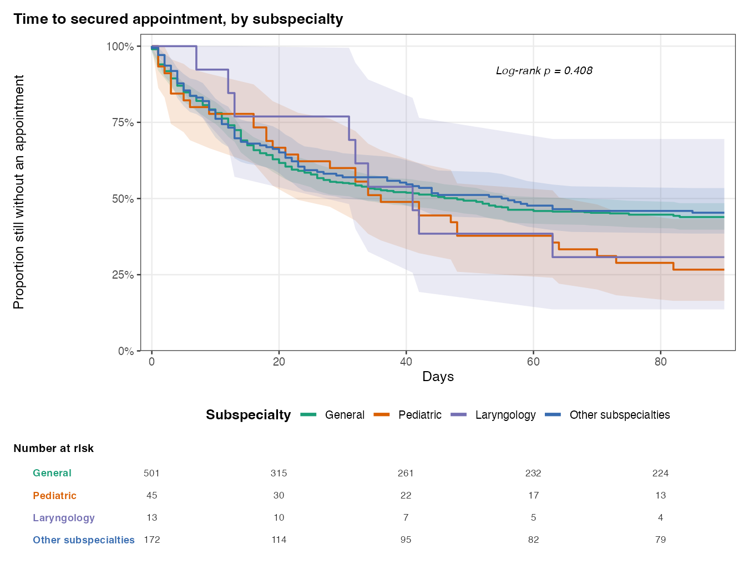
Figure S2. Business-day wait-time distribution by subspecialty.
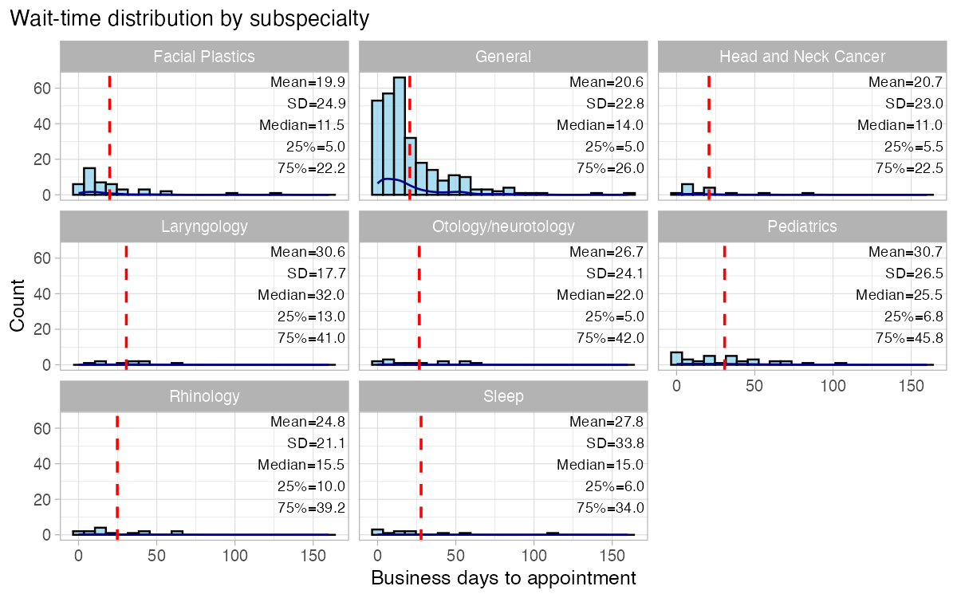
Figure S3. Negative binomial model diagnostics (DHARMa).
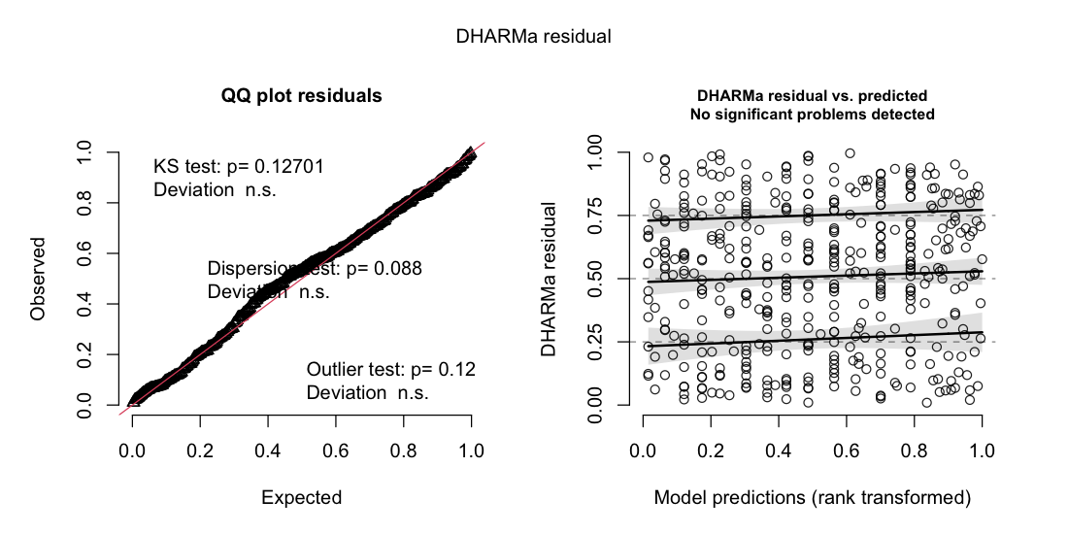
Figure S4a. Appointment offer rate by AAO-HNS region.
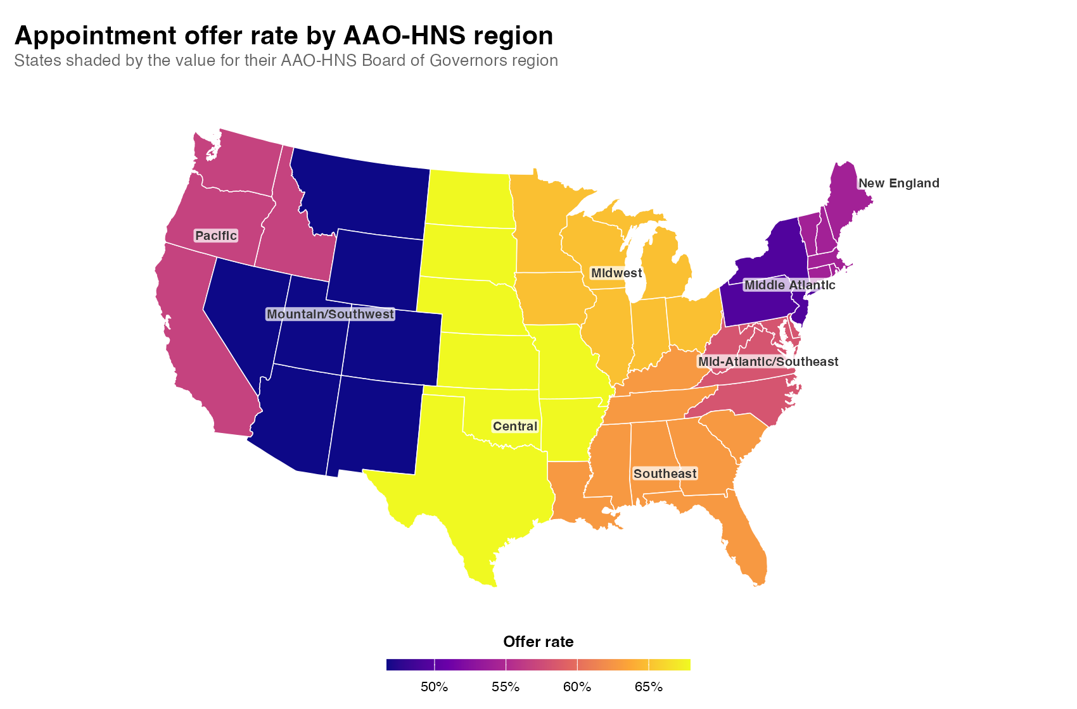
Figure S4b. Median business-day wait by AAO-HNS region.
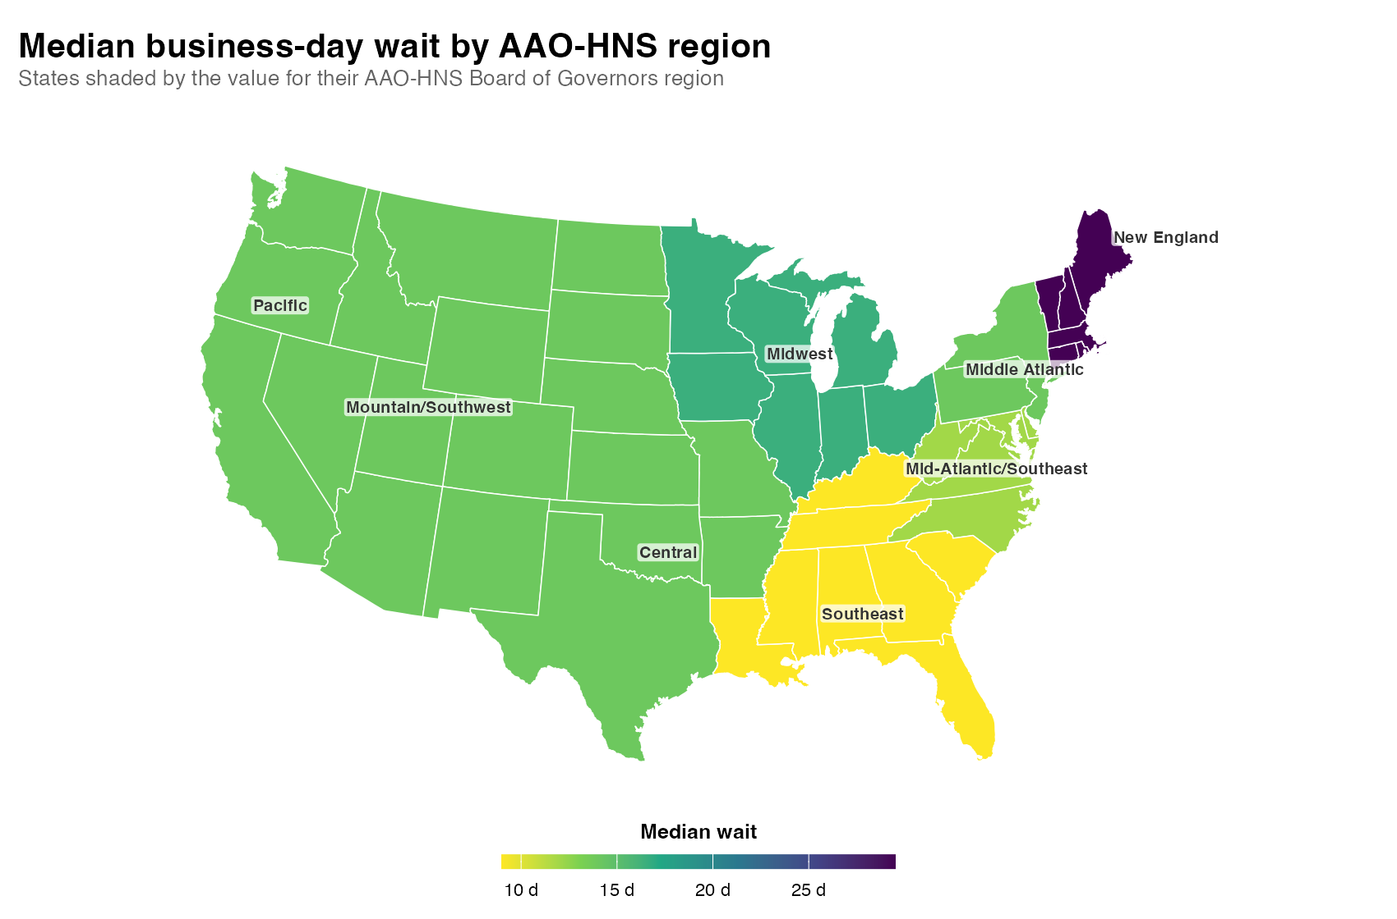
Figure S5. Appointment offer rate by state (mysterymaps).
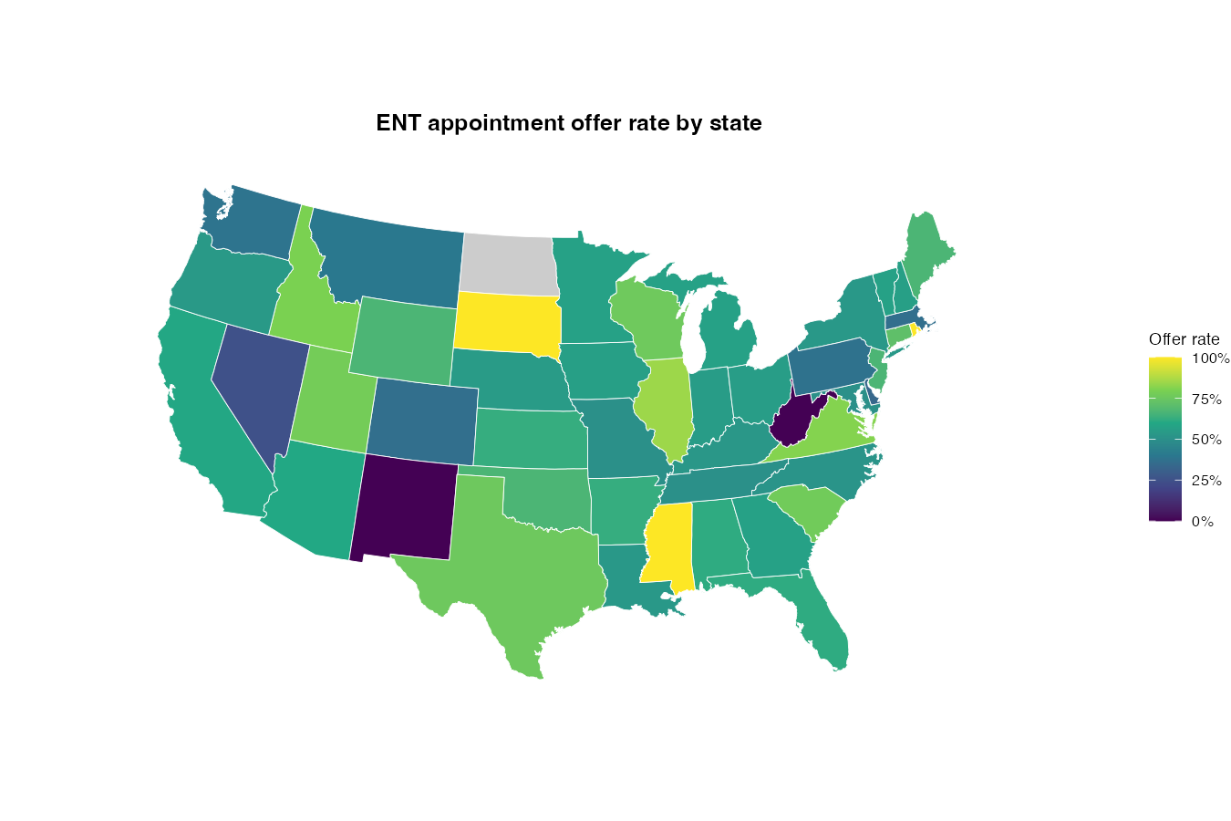
Figure S7. New-patient access cascade.
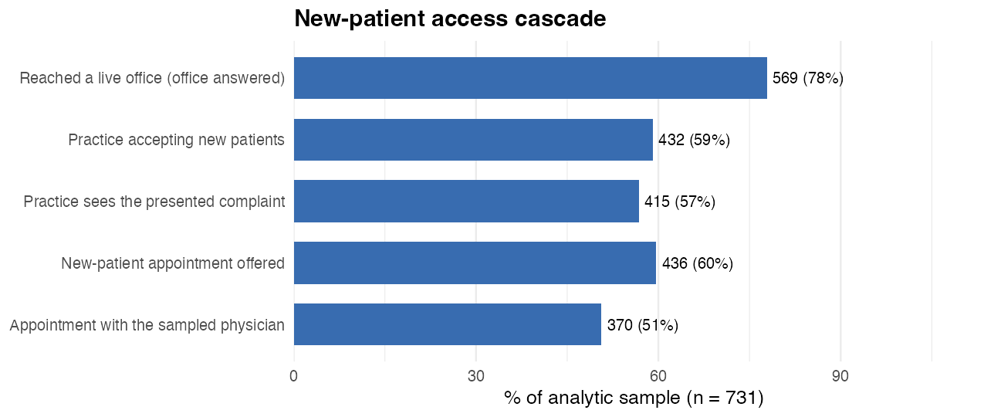
Full legends for all supplementary items are in docs/supplementary_legends.md. A completed STROBE checklist is provided in manuscript/STROBE_checklist.md.

Supplementary Appendix: Standardized call script
Callers followed a standardized telephone script, presenting as a new patient (or a family member calling on a patient’s behalf) with a referral-based, subspecialty-matched chief complaint, and recorded responses in a structured data-capture form.
Pre-call procedure. Before each call, the caller searched the sampled physician’s name and state of practice online and identified the matching practice website (typically among the first results, in under one minute). From the website, the caller determined whether the physician was fellowship-trained and selected the correspondingly matched subspecialty script; if the physician was not fellowship-trained, or fellowship status was unclear, the general otolaryngology script was used. Board certification was verified using the American Board of Otolaryngology–Head and Neck Surgery certification tool (abohns.org/verify-certification); if the physician was not listed as certified, the caller asked whether the physician was board certified after an appointment was offered. Calls used the phone number listed on the practice website (to avoid inadvertently reaching a personal number listed in NPI/CMS/Academy records); when no website could be found, the caller used the NPI/CMS-listed number with the general script and noted the absence of a website. The practice city and 2020 RUCA code were recorded before the call (via the Rural Health Information Hub “Am I Rural?” tool), along with any additional practice cities and their RUCA codes.
During the call. The caller delivered the selected script (Table S9). If asked for identifying details, the caller gave a standardized identity—“John” or “Jessica Smith,” date of birth June 1 of a script-appropriate year. No appointment was ever booked: when an appointment was offered, the caller requested the next-available date (“I want to make sure I can find an appointment that works with my schedule before moving forward with scheduling”) to compute the business-day wait, then stated they would check their schedule and call back. Structured response handling captured whether the physician sees the presented complaint (and, if not, what they do see), whether another provider could be seen for the concern and whether that provider was a physician or advanced practice provider and the time to that appointment, whether the physician was not accepting new patients, redirection to a different provider, and whether the physician was no longer practicing (retired vs moved). [Not specified in the script draft: the number and timing of call attempts before an office was recorded as unreachable—to confirm from the protocol.]
Table S9. Subspecialty-matched chief-complaint scripts (verbatim caller wording).
Subspecialty | Clinical scenario | Verbatim opening script
General otolaryngology | Nasal obstruction; suspected deviated septum after failed medical therapy | “I was worked up by my primary care doctor for difficulty breathing through my nose. I have tried multiple nasal sprays but none of them have helped. My primary care doctor said they think I have a deviated septum and referred me to Dr. ___.”
Pediatric otolaryngology | 12-year-old with recurrent tonsillitis and snoring; tonsillectomy discussion | “My twelve-year-old son has been worked up for recurrent tonsillitis and snoring by our pediatrician. He has had seven episodes of tonsillitis in the last year. He is also now snoring loudly and seems very tired during the day. Our pediatrician referred us to Dr. ___ to discuss possible tonsillectomy.”
Rhinology | Recurrent chronic sinusitis after prior sinus surgery; revision considered | “I have been evaluated and treated for chronic sinusitis by my primary care doctor and a general ENT. I have had one prior sinus surgery ten years ago, but my symptoms are back. I was referred to see Dr. ___ to discuss possible revision sinus surgery.”
Otology/neurotology | 70-year-old parent with progressive hearing loss; cochlear-implant candidate | “My 70-year-old mother has been worked up for hearing loss by our audiologist and a general ENT. She has had progressive hearing loss and is no longer getting benefit from hearing aids. After her most recent hearing test, she was referred to Dr. ___ to discuss possible cochlear implantation.”
Laryngology | 70-year-old parent with dysphonia; paralyzed vocal cord after cardiac surgery | “My 70-year-old father has been evaluated and treated for a hoarse voice by a general ENT and speech pathologist. He was told he has a paralyzed vocal cord after open heart surgery two years ago. He has completed a variety of treatments, but his voice has not improved. He is being referred to Dr. ___ to discuss possible surgical options for his voice.”
Facial plastic surgery | Post-traumatic nasal deformity and obstruction; rhinoplasty evaluation | “I have been worked up for difficulty breathing through my nose and a change in the appearance of my nose after a car accident one year ago by my primary care doctor. I was referred to Dr. ___ to discuss possible surgical options to improve my breathing and shape of my nose.”
Head and neck oncology | Thyroid nodule with biopsy showing high malignancy risk; thyroidectomy discussion | “I have been worked up for a thyroid nodule by my primary care provider. I had a biopsy done by an endocrinologist that showed a 70% chance of thyroid cancer. I was referred to Dr. ___ to discuss possible thyroidectomy.”
Sleep medicine | No dedicated script | Because script selection followed fellowship training and no sleep-specific vignette existed, physicians classified as sleep medicine received the general otolaryngology script above.

References
1. Graboyes EM, Kompelli AR, Neskey DM, et al. Association of treatment delays with survival for patients with head and neck cancer: A systematic review. JAMA Otolaryngology–Head & Neck Surgery. 2019;145(2):166-177. doi:10.1001/jamaoto.2018.2716
2. Bisgaier J, Rhodes KV. Auditing access to specialty care for children with public insurance. New England Journal of Medicine. 2011;364(24):2324-2333. doi:10.1056/NEJMsa1013285
3. Vickery TW, Weterings R, Cabrera-Muffly C. Geographic distribution of otolaryngologists in the United States. Ear, Nose & Throat Journal. 2016;95(6):218-223. doi:10.1177/014556131609500607
4. Rankin KA, Mosier-Mills A, Hsiang W, Wiznia DH. Secret shopper studies: An unorthodox design that measures inequities in healthcare access. Archives of Public Health. 2022;80:226. doi:10.1186/s13690-022-00979-z
5. Rhodes KV. Taking the mystery out of “mystery shopper” studies. New England Journal of Medicine. 2011;365(6):484-486. doi:10.1056/NEJMp1107779
6. Blinkhorn L. Secret shoppers and conflicts of interest. AMA Journal of Ethics (Virtual Mentor). 2013;15(2):119-124. doi:10.1001/virtualmentor.2013.15.2.bndr1-1302
7. Rhodes KV, Miller FG. Simulated patient studies: An ethical analysis. The Milbank Quarterly. 2012;90(4):706-724. doi:10.1111/j.1468-0009.2012.00680.x
8. Moriarty H, McLeod D, Dowell A. Mystery shopping in health service evaluation. British Journal of General Practice. 2003;53(497):942-946.
9. Hodson N, Onyeaso OO, Mills S, Sunstein CR, Bruine de Bruin W. Evaluating adherence to patient registration paperwork guidelines: A mystery shopper study in English primary care. BMJ Open. 2025;15:e100719. doi:10.1136/bmjopen-2025-100719
10. Lungfiel G, Mandlmeier F, Kunow C, Langer B. Oral emergency contraception practices of community pharmacies: A mystery caller study in the capital of Germany, Berlin. Journal of Pharmaceutical Policy and Practice. 2023;16(1):68. doi:10.1186/s40545-023-00565-w
11. Campbell JL, Carter M, Davey A, Roberts MJ, Elliott MN, Roland M. Accessing primary care: A simulated patient study. British Journal of General Practice. 2013;63(608):e171-e176. doi:10.3399/bjgp13X664216
12. Kaiser Family Foundation. Medicaid-to-medicare fee index. Published online 2024.
13. Agency for Toxic Substances and Disease Registry. CDC/ATSDR social vulnerability index (2022 database). Published online 2022.
14. Lenth RV. Emmeans: Estimated Marginal Means, Aka Least-Squares Means. 2024. https://CRAN.R-project.org/package=emmeans
15. R Core Team. R: A Language and Environment for Statistical Computing. R Foundation for Statistical Computing; 2024. https://www.R-project.org/
16. Brooks ME, Kristensen K, Benthem KJ van, et al. glmmTMB balances speed and flexibility among packages for zero-inflated generalized linear mixed models. The R Journal. 2017;9(2):378-400. doi:10.32614/RJ-2017-066
17. Elm E von, Altman DG, Egger M, Pocock SJ, Gøtzsche PC, Vandenbroucke JP. The Strengthening the Reporting of Observational Studies in Epidemiology (STROBE) statement: Guidelines for reporting observational studies. Annals of Internal Medicine. 2007;147(8):573-577. doi:10.7326/0003-4819-147-8-200710160-00010
18. Amaratunge S, Harrison M, Clifford R, Seubert L, Page A, Bond C. Developing a checklist for reporting research using simulated patient methodology (CRiSP): A consensus study. International Journal of Pharmacy Practice. 2021;29(3):218-227. doi:10.1093/ijpp/riaa002
19. Park JS, Page A, Clifford R, Bond C, Seubert L. Refining the CRiSPHe (checklist for reporting research using a simulated patient methodology in health): A Delphi study. International Journal of Pharmacy Practice. 2024;32(4):322-328. doi:10.1093/ijpp/riae019
20. Corbisiero MF, Muffly TM, Gottman DC, et al. Insurance status and access to otolaryngology care: National mystery caller study in the United States. Otolaryngology–Head and Neck Surgery. 2024;171(1):98-108. doi:10.1002/ohn.752
21. Saeedi A, Muffly T, Corbisiero MF, et al. Referral conundrum: Wait times for subspecialists versus comprehensive otolaryngologists in the United States. Cureus. 2025;17(9):e91744. doi:10.7759/cureus.91744
22. Pollack CE, Ross ME, Armstrong K, et al. Using a mystery-caller approach to examine access to prostate cancer care in Philadelphia. PLOS ONE. 2016;11(10):e0164411. doi:10.1371/journal.pone.0164411
23. Wilkinson TA, Rafie S, Clark PD, Carroll AE, Miller E. Evaluating community pharmacy responses about levonorgestrel emergency contraception by mystery caller characteristics. Journal of Adolescent Health. 2018;63(1):32-36. doi:10.1016/j.jadohealth.2017.11.303

