Validity of National Otolaryngology Workforce Listings: A Stratified Mystery-Caller Study
Grace E. Falk, PhD
Tyler M. Muffly, MD
Cristina Cabrera-Muffly, MD
Eric Dobratz, MD
Cristina Baldassari, MD
Andrew Tompkins, MD, MBA
Abstract
Objective. To estimate the validity of otolaryngology physician-location listings across strata defined by corroboration among three independent national registries.
Study Design. Stratified mystery-caller telephone audit.
Setting. National sample of U.S. otolaryngology practices, May 2026 to July 2026.
Methods. NPPES (207Y* taxonomy), ABOto active certification, and ENTHealth directory records were cross-linked by NPI to produce four analytic strata. Trained mystery callers contacted a stratified random sample of 960 NPPES-listed physicians using standardized scripts and recorded whether the physician was confirmed at the listed location and whether the physician remained an active otolaryngologist. A supplemental NPPES-only sample is being called to characterize that stratum.
Results. [TO BE COMPLETED AFTER NPPES-ONLY CALLS]
Conclusion. [TO BE COMPLETED]

Introduction
Provider directories are the infrastructure through which patients, insurers, and workforce analysts locate physicians. When a directory listing is inaccurate, the consequences are concrete: a patient cannot reach the specialist to whom they were referred, an insurer misrepresents network adequacy, and a workforce planner counts a clinician who is no longer in active practice at that location. National estimates suggest that 6–28% of NPPES physician addresses are inaccurate,(1) directory concordance across major commercial insurers reaches only 16–28%,(2) and errors persist even after the No Surprises Act imposed directory-update requirements.(3,4) Phantom listings impose measurable patient costs through unexpected out-of-network bills and failed referrals.(5)
Telephone audit methods directly measure listing validity by attempting to confirm physician presence at the recorded address. Prior mystery-caller studies have documented substantial error rates across specialties and payer types,(6–9) yet no published study has audited otolaryngology workforce listings. Otolaryngology is well-suited to this question because three independent national registries enumerate its practitioners: the National Plan and Provider Enumeration System (NPPES, administrative, mandatory for Medicare participation), the American Board of Otolaryngology–Head and Neck Surgery (ABOto) active-certification roster, and the AAO-HNS ENTHealth membership directory (voluntary). Cross-linking the three registries by National Provider Identifier (NPI) produces four mutually exclusive corroboration strata. We hypothesized that corroboration by more independent sources would be associated with higher listing validity. The primary outcome was confirmed physician presence at the NPPES-listed practice address; the secondary outcome was confirmed active practice anywhere.

Methods
Study Design and Data Sources
This cross-sectional telephone audit validated NPPES physician-location listings for clinicians identified as otolaryngologists (taxonomy 207Y) by calling a stratified random sample and recording physician presence at the listed address. NPPES records were extracted in February 2026; ABOto and ENTHealth files were accessed in May 2026. Each record was additionally linked to Medicare Part B billing indicators (2022–2023) from the Euler zone demographics file. Individual Type 1 NPIs with at least one 207Y taxonomy code were included; records with non-US, military, or diplomatic addresses were excluded from geographic analyses. For physicians with multiple NPPES practice locations, the primary (or first listed) location was used. The unit of analysis was one physician-location listing per NPI. This study was determined to be non-human-subjects research by the Old Dominion University IRB (protocol 24-12-NH-0285; approved December 20, 2024; updated March 2026).
Registry Overlap and Sampling
Cross-linking NPPES, ABOto, and ENTHealth by NPI produced four mutually exclusive analytic strata: NPPES only (N = 2,756), NPPES+ABOto (N = 6,748), NPPES+ENTHealth (N = 711), and triple-match (N = 4,573). The current mystery-caller cohort comprises 960 physician-location listings drawn from the NPPES+ABOto (498 listings) and triple-match (462 listings) strata via stratified random sampling. To characterize the NPPES-only stratum, a supplemental sample is planned: all eligible rural listings (RUCA ≥7) will be included as a census, and approximately 325 nonrural listings will be selected by stratified random sampling across AAO-HNS Board of Governors region and credential class. The sampling probability for each stratum equals the number of selected listings divided by the eligible population count; inverse-probability weights are used for all population-level estimates.
Mystery-Caller Protocol
Nine trained medical student callers placed calls under principal-investigator supervision. All callers completed standardized orientation covering scripts, REDCap entry, and call-attempt procedures before placing study calls; callers were blind to study hypotheses. Before each call, the caller identified the practice telephone number from the physician’s website, determined subspecialty fellowship from the website to select the appropriate script, and recorded the 2020 RUCA code. Eight subspecialty-specific scripts were developed (General, Pediatrics, Rhinology, Otology/Neurotology, Laryngology, Facial Plastics, Head and Neck Cancer, Sleep), each presenting a simulated new-patient scenario. The General script was used when fellowship training could not be confirmed. Per protocol, listings without a definitive disposition were to receive at least three call attempts on different days and times before being classified as unresolved; voicemail without a returned call did not constitute a definitive disposition. Call outcomes were entered into REDCap immediately after each contact.(10)
Outcomes
The primary outcome was a confirmed location-valid listing: the named physician was confirmed to be actively practicing otolaryngology at the NPPES-listed practice address. The secondary outcome was a workforce-valid listing: the individual was confirmed to be an active otolaryngologist regardless of practice location (a physician who had relocated was location-invalid but workforce-valid).
Every attempted listing was assigned to one of four mutually exclusive final categories: confirmed valid (practice reached and physician confirmed present at the NPPES address); confirmed invalid (definitive evidence that the physician had relocated to a different practice, had retired or was no longer practicing medicine, or the recorded telephone number was invalid or disconnected); unresolved (call protocol completed without a definitive physician-at-location determination); or not attempted (no call disposition recorded). A hierarchical validation cascade was evaluated: (1) practice reached, (2) physician confirmed present at the listed location, (3) physician confirmed active in practice, (4) accepting new patients. Accepting new patients is a secondary scheduling characteristic and was not used to determine listing validity. Sensitivity analyses assigned all unresolved listings first to confirmed valid (best case) then to confirmed invalid (worst case).
Statistical Analysis
Listing validity proportions and 95% confidence intervals were computed at each cascade stage overall and within each registry-overlap stratum. Bootstrap confidence intervals (2,000 replicates) were generated by stratum and by rurality. Because rural physicians are planned to be oversampled in the NPPES-only supplemental sample, sampling weights (inverse of the within-stratum sampling fraction) were applied to the current two-stratum cohort using the survey package in R.(11) Once NPPES-only calls are complete, absolute percentage-point differences between strata will use NPPES-only as the reference group. The primary adjusted analysis will use survey-weighted logistic regression (quasibinomial family) with location-valid listing as the dependent variable; prespecified predictors are registry-overlap stratum, years since NPI enumeration, credential class, rurality, and AAO-HNS Board of Governors region. All tests will be two-sided; P < .05 will be considered statistically significant. Analyses were performed in R (version 4.6.0).

Results
Source Population and Study Sample
The linked source population contained 15,048 NPPES physician-location listings with an otolaryngology taxonomy code distributed across four strata: NPPES only (2,756), NPPES+ABOto (6,748), NPPES+ENTHealth (711), and triple-match (4,573). The current audited cohort comprises 960 physician-location listings drawn from the NPPES+ABOto (498) and triple-match (462) strata; the supplemental NPPES-only sample is pending. Calls were placed from May 2026 through July 2026 across 48 states. Recent Medicare Part B billing was identified for 70.3% of listings (674/959). Listing-status distribution by stratum (current unweighted sample) is shown below.
Listing status by overlap zone, current sample only, unweighted.
overlap_zone | confirmed_valid | confirmed_invalid | unresolved | not_attempted
NPPES+ABOto | 128 | 103 | 111 | 156
NPPES+ABOto+ENTHealth | 317 | 35 | 58 | 52
Validation Cascade
Of 960 sampled listings, 208 (21.7%) had no call disposition recorded and were classified as not attempted. Among the 724 listings with a recorded office-answered disposition, a clinical practice was reached for 577 (79.7%). Among reached practices, staff confirmed the named physician at the listed location for 445 (77.1% of reached; 46.4% of all sampled). An additional 45 physicians were confirmed to be practicing medicine at a different location (workforce-valid but location-invalid). Of the 689 listings with a new-patient disposition recorded, 434 (63.0%) were accepting new patients; this reflects current scheduling capacity and is not a listing-validity measure.
Listing Status
Of 960 sampled listings, 445 (46.4%) were confirmed valid, 138 (14.4%) confirmed invalid, 169 (17.6%) unresolved after completing the call protocol, and 208 (21.7%) not attempted. Among the 138 confirmed-invalid listings, the reason was physician retirement or cessation of practice in 93 (67.4%) and physician relocation to a different practice in 45 (32.6%).
Listing Validity by Registry-Overlap Stratum
Unweighted location validity differed substantially between the two currently audited strata (Table 2). Among NPPES+ABOto listings, 128 of 498 (25.7%, 95% CI 22.1%–29.7%) were confirmed valid. Among triple-match listings, 317 of 462 (68.6%, 95% CI 64.2%–72.7%) were confirmed valid, a 42.9-percentage-point difference. NPPES-only and NPPES+ENTHealth stratum estimates are pending completion of supplemental calls. Sensitivity analyses restricted to the 752 attempted listings: when all 169 unresolved listings were classified as valid, the location-valid rate was 81.6%; when all were classified as invalid, 59.2%. Among the 583 listings with a definitive disposition, the observed valid rate was 76.3%. The adjusted survey-weighted logistic regression will be estimated on the full four-stratum dataset once supplemental calls are complete [PENDING].

Discussion
Among 960 otolaryngology physician-location listings audited by telephone, 46.4% were confirmed valid overall. Validity differed markedly by registry-overlap stratum: 25.7% of NPPES+ABOto listings were confirmed valid compared with 68.6% of triple-match listings, a 42.9-percentage-point difference. Among confirmed-invalid listings, physician retirement or permanent departure from medicine accounted for 67.4% and relocation to a different practice for 32.6%. These rates are broadly consistent with prior mystery-caller studies: Burman and colleagues confirmed physicians at 59–76% of listings across specialties(8) and Zhu and colleagues found 58.2% of Medicaid mental health listings unreachable or phantom.(7)
NPPES, ABOto, and ENTHealth were created for distinct administrative purposes and therefore capture different physician populations. NPPES enrollment is mandatory for Medicare billing but does not require active specialty practice; ABOto certification requires completion of an accredited residency and passing examinations but excludes osteopathic-pathway surgeons and those who have allowed certification to lapse; ENTHealth membership is voluntary. The 32% gap between NPPES (15,048) and ABOto (11,350) counts does not constitute a supply overestimate; it reflects the different eligibility criteria and incentives of each registry. Agreement across sources, rather than any single registry, provides a more reliable validity signal. Records identified in only one source warrant additional verification before use in patient-facing directories or geographic workforce analyses.
Several limitations warrant acknowledgment. Telephone numbers were obtained from practice websites rather than the NPPES flat file to avoid contacting personal mobile numbers; reach rates therefore cannot be directly attributed to NPPES phone-number accuracy. Of 960 sampled listings, 208 (21.7%) had no call disposition recorded and 169 (17.6%) remained unresolved after completing the call protocol; sensitivity analyses establish the plausible validity range (59.2% to 81.6%). The NPPES-only and NPPES+ENTHealth strata have not yet been called; stratum comparisons and the adjusted regression model will be estimated on the full dataset. The cross-sectional design cannot establish when a listing became inaccurate. Registry corroboration is a proxy for validity, not a gold standard; a physician absent from ABOto may be an active osteopathic-pathway surgeon or a resident in the pre-certification window.(12,13)

Conclusions
Listing validity was substantially higher among NPPES records corroborated by ABOto board-certification than among those with NPPES enrollment alone. Multi-registry cross-linkage using NPI as the matching key provides a low-cost validity signal and should be adopted as a routine pre-processing step in workforce analyses, network-adequacy assessments, and provider directory construction.

Author Contributions
Grace E. Falk, conception and design, data acquisition, drafting the article, final approval, accountability; Tyler Muffly, conception and design, statistical analysis, drafting the article, final approval, accountability; Cristina Cabrera-Muffly, conception and design, revision of the article, final approval, accountability; Eric Dobratz, conception and design, revision of the article, final approval, accountability; Cristina Baldassari, conception and design, revision of the article, final approval, accountability; Andrew Tompkins, conception and design, revision of the article, final approval, accountability.

Disclosures
Competing interests: None.
Sponsorship: None.
Funding source: None.

References
1. DesRoches CM, Barrett K, Harvey BE, Wintfeld N, Krol M, Landon BE. Assessing the accuracy of three national physician sampling frames. Journal of General Internal Medicine. 2015;30:S595–S601. doi: 10.1007/s11606-015-3379-5
2. Butala NM, Jiwani K, Bucholz EM. Characterizing physician directory data quality: Variation by specialty, state, and insurer. BMC Health Services Research. 2024;24:808. doi: 10.1186/s12913-024-11269-5
3. Haeder SF, Zhu JM. Inaccuracies in provider directories persist for long periods of time. Health Affairs Scholar. 2024;2:qxae079. doi: 10.1093/haschl/qxae079
4. Haeder SF, Zhu JM. Persistence of provider directory inaccuracies after the No Surprises Act. American Journal of Managed Care. 2025;30:584–588
5. Busch SH, Ndumele CD, Loveridge P, Lobo C, Kim H, Melnick G. Inaccurate provider directories may cost consumers seeking out-of-network care. Health Affairs. 2020;39:984–990. doi: 10.1377/hlthaff.2019.01543
6. Haeder SF, Weimer DL, Mukamel DB. Secret shoppers find access to providers and network accuracy lacking for those in marketplace and Medicaid plans. Health Affairs. 2016;35:1160–1166. doi: 10.1377/hlthaff.2015.1554
7. Zhu JM, Myers R, McConnell KJ, Colla C, Mehrotra A. Tracking Medicaid managed care behavioral health access from 2013 to 2018. Health Affairs. 2022;41:368–376. doi: 10.1377/hlthaff.2021.01284
8. Burman ME, Penfold RB, Horrigan-Maurer M, Kelleher KJ. Phantom providers: Medicaid directories and the reality of behavioral health access. Psychiatric Services. 2022;73:374–380. doi: 10.1176/appi.ps.202100117
9. Beltrami EJ, Nguyen BV, Hughes OB, Linden KG, Kimball AB. Accessibility of Mohs micrographic surgery for skin cancer: A secret shopper study. JAMA Dermatology. 2022;158:554–561. doi: 10.1001/jamadermatol.2022.0299
10. Harris PA, Taylor R, Thielke R, Payne J, Gonzalez N, Conde JG. Research Electronic Data Capture (REDCap): A metadata-driven methodology and workflow process for providing translational research informatics support. Journal of Biomedical Informatics. 2009;42:377–381. doi: 10.1016/j.jbi.2008.08.010
11. Lumley T. Analysis of complex survey samples. Journal of Statistical Software. 2004;9:1–19. doi: 10.18637/jss.v009.i08
12. Tessier-Kay LA et al. Mystery caller audit of pediatric dermatology appointment availability. Pediatric Dermatology. 2025
13. Falk GE, Muffly T, Cabrera-Muffly C. Rural access to otolaryngology care: A mystery caller study. Otolaryngology–Head and Neck Surgery. 2024

Tables
Table 1. Source population, sampling design, and audited sample by analytic stratum.
Stratum | Population N | Audited n | Sampling fraction | Median years since update
NPPES only | 2,756 | 54 rural (census) + ~325 nonrural (pending) | Pending | Pending
NPPES+ABOto | 6,748 | 498 | 7.4% | N/A
NPPES+ENTHealth | 711 | Not sampled | N/A | N/A
Triple-match | 4,573 | 462 | 10.1% | N/A
Abbreviations: ABOto, American Board of Otolaryngology–Head and Neck Surgery; CI, confidence interval; NPI, National Provider Identifier; NPPES, National Plan and Provider Enumeration System; OR, odds ratio; RUCA, Rural-Urban Commuting Area.
Table 2. Unweighted listing-status outcomes by registry-overlap stratum (NPPES-only and NPPES+ENTHealth strata pending).
Stratum | Audited n | Confirmed valid, n (%) | Confirmed invalid, n (%) | Unresolved, n (%)
NPPES+ABOto | 498 | 128 (25.7%) | 103 (20.7%) | 111 (22.3%)
Triple-match (all three) | 462 | 317 (68.6%) | 35 (7.6%) | 58 (12.6%)
Abbreviations: ABOto, American Board of Otolaryngology–Head and Neck Surgery; CI, confidence interval; NPI, National Provider Identifier; NPPES, National Plan and Provider Enumeration System; OR, odds ratio; RUCA, Rural-Urban Commuting Area.
Table 3. Adjusted associations with confirmed-valid listing (pending full dataset).
Note
Survey-weighted logistic regression will be estimated on the full four-stratum dataset once NPPES-only calls are complete. Prespecified predictors: registry-overlap stratum, years since NPI enumeration, credential class, rurality, AAO-HNS Board of Governors region.
Abbreviations: ABOto, American Board of Otolaryngology–Head and Neck Surgery; CI, confidence interval; NPI, National Provider Identifier; NPPES, National Plan and Provider Enumeration System; OR, odds ratio; RUCA, Rural-Urban Commuting Area.

Figures
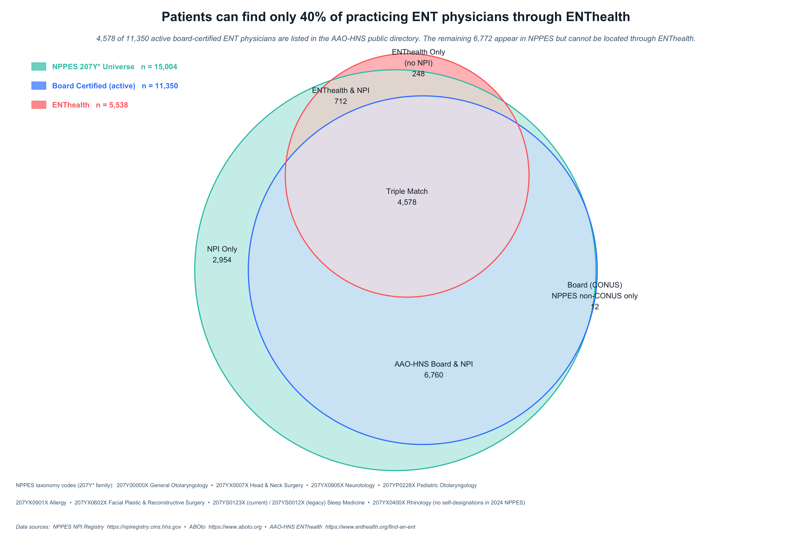
Figure 1. Euler diagram showing overlap among NPPES (207Y* taxonomy), ABOto active board-certification, and ENTHealth physician directory. Numbers represent unique physicians per zone.
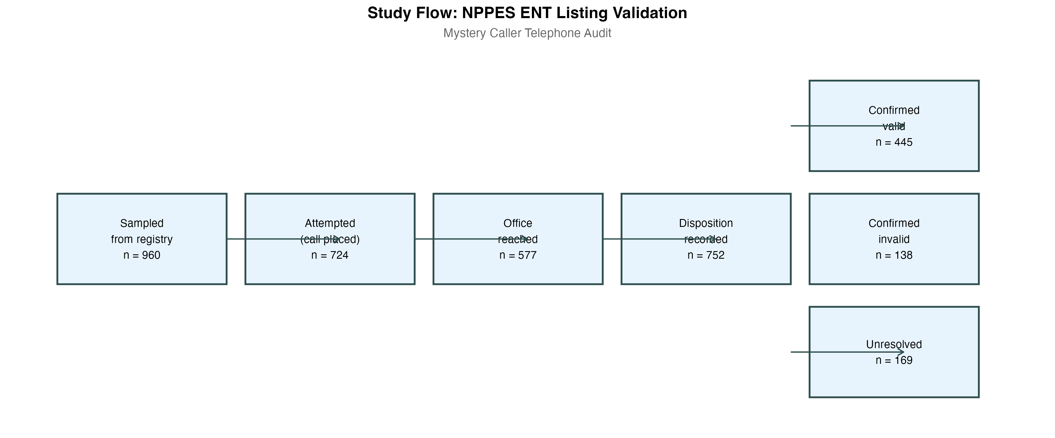
Figure 2. Study flow from registry sampling to listing adjudication.

Supplementary Material
Supplementary Table S1. Euler overlap zones, population counts, and sampling design.
Euler Zone | Definition | Population N | Audited (n)
NPPES only | 207Y* in NPPES; NOT ABOto; NOT ENTHealth | 2,756 | 54 rural (census) + ~325 non-rural (pending)
NPPES + ABOto | NPPES + ABOto board-cert; NOT ENTHealth | 6,748 | 498
NPPES + ENTHealth | NPPES + ENTHealth; NOT ABOto | 711 | Not sampled
Triple-match (all three) | Present in all three registries | 4,573 | 462
ABOto only (state conflict) | ABOto only; NPPES non-CONUS | 12 | Not sampled
ENTHealth only (with NPI) | ENTHealth; NPI not in NPPES 207Y* | 1 | Not sampled
ENTHealth only (no NPI) | ENTHealth; no NPI recorded | 247 | Not sampled
Total |  | 15,048 | 960
Abbreviations: ABOto, American Board of Otolaryngology–Head and Neck Surgery; CI, confidence interval; NPI, National Provider Identifier; NPPES, National Plan and Provider Enumeration System; OR, odds ratio; RUCA, Rural-Urban Commuting Area.
Supplementary Table S2. Sampling design and inverse-probability weights.
Stratum | Population N | Sampled n | Sampling fraction | Weight
NPPES+ABOto | 6,748 | 498 | 7.4% | 13.55
NPPES+ABOto+ENTHealth | 4,573 | 462 | 10.1% | 9.90
NPPES-only (pending) | 2,756 | NA | Pending | Pending
Abbreviations: ABOto, American Board of Otolaryngology–Head and Neck Surgery; CI, confidence interval; NPI, National Provider Identifier; NPPES, National Plan and Provider Enumeration System; OR, odds ratio; RUCA, Rural-Urban Commuting Area.
Supplementary Table S3a. Listing-status distribution (unweighted; NPPES-only calls pending).
Listing status | n | %
confirmed_valid | 445 | 46.4
confirmed_invalid | 138 | 14.4
unresolved | 169 | 17.6
not_attempted | 208 | 21.7

Supplementary Table S3b. Reasons for confirmed-invalid listings.
Reason | n | % of invalid
Retired or no longer practicing medicine | 93 | 67.4
Changed practices / relocated | 45 | 32.6
Abbreviations: ABOto, American Board of Otolaryngology–Head and Neck Surgery; CI, confidence interval; NPI, National Provider Identifier; NPPES, National Plan and Provider Enumeration System; OR, odds ratio; RUCA, Rural-Urban Commuting Area.
Supplementary Table S4. Characteristics of NPPES-only ENT physicians (not in ABOto or ENTHealth).
Characteristic | n (%)
Total (US addresses) | 2,932
Rural (RUCA ≥7) | 56 (1.9%)
Non-Rural (RUCA 1–6) | 2871 (98.1%)
MD credential | 1723 (58.8%)
DO credential | 536 (18.3%)
Other/non-physician | See note
Missing credential | 298 (10.2%)
Enumeration ≤5 years ago | 594 (20.3%)
Enumeration 6–10 years ago | 810 (27.6%)
Enumeration >10 years ago | 1528 (52.1%)
NPI deactivated | 0 (NaN%)
Abbreviations: ABOto, American Board of Otolaryngology–Head and Neck Surgery; CI, confidence interval; NPI, National Provider Identifier; NPPES, National Plan and Provider Enumeration System; OR, odds ratio; RUCA, Rural-Urban Commuting Area.
[TO BE COMPLETED: will include weighted validity estimates under best-case (all unresolved → valid) and worst-case (all unresolved → invalid) scenarios by stratum.]
Abbreviations: ABOto, American Board of Otolaryngology–Head and Neck Surgery; CI, confidence interval; NPI, National Provider Identifier; NPPES, National Plan and Provider Enumeration System; OR, odds ratio; RUCA, Rural-Urban Commuting Area.
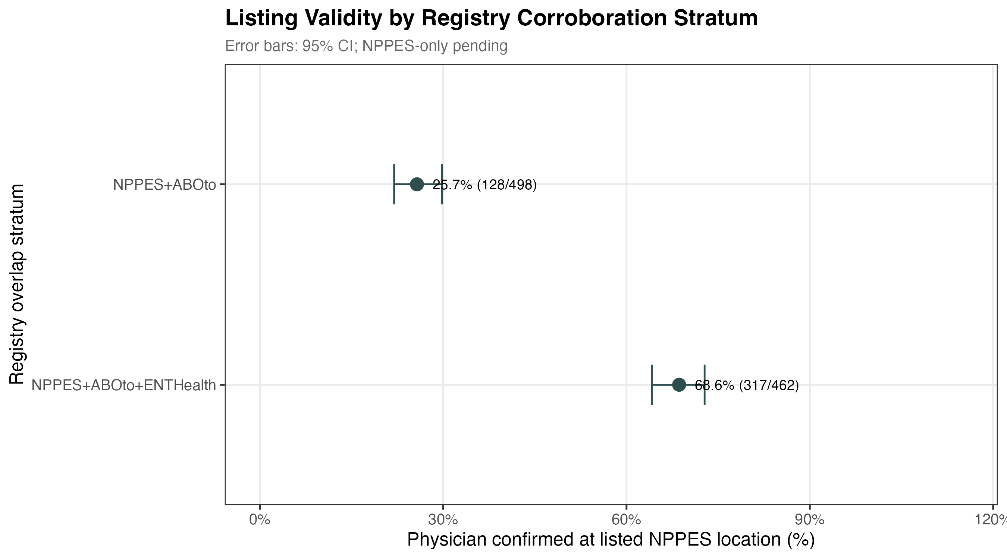
Supplementary Figure S1. Two-panel forest plot of weighted listing-validity estimates by registry-overlap stratum. Panel A: proportion of listings confirmed location-valid (physician at listed NPPES address). Panel B: proportion confirmed workforce-valid (physician an active otolaryngologist anywhere). Strata ordered from lowest to highest corroboration. Error bars represent 95% confidence intervals; vertical line indicates weighted overall estimate. Rural and nonrural subgroup rows shown where precision is sufficient. NPPES-only stratum pending completion of calls.
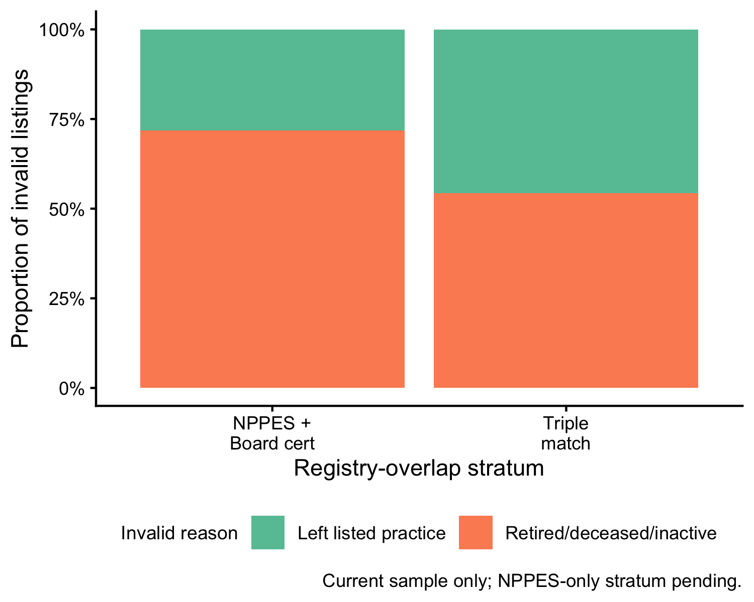
Supplementary Figure S2. Distribution of confirmed-invalid listing reasons within each registry-overlap stratum. Stacked bars show the proportion of invalid listings attributable to each reason category. The distribution of confirmed-invalid reasons differs across strata; results for NPPES-only stratum pending completion of calls.

Corresponding author: Grace E. Falk, PhD, Department of Communication Disorders and Special Education, Old Dominion University, Norfolk, VA 23529. Email: falkge@odu.edu.
Conflict of interest: None declared.
Funding: None declared.
Data availability: Analysis code is available at [GitHub repository URL to be added].
Word count: [TO BE ADDED]

Department of Otolaryngology–Head and Neck Surgery, Eastern Virginia Medical School, Norfolk, VA. falkge@odu.edu
Department of Obstetrics and Gynecology, Denver Health Medical Center and University of Colorado School of Medicine, Denver, CO. tyler.muffly@dhha.org
Department of Otolaryngology–Head and Neck Surgery, University of Colorado Anschutz Medical Campus, Aurora, CO
Department of Otolaryngology–Head and Neck Surgery, Eastern Virginia Medical School, Norfolk, VA
Department of Otolaryngology–Head and Neck Surgery, Eastern Virginia Medical School, Norfolk, VA
Ohio ENT & Allergy Physicians, Columbus, OH

