National travel-time accessibility to obstetrics-gynecology subspecialists, 2013-2023
Tyler M. Muffly, MD, and co-authors

National travel-time accessibility to obstetrics-gynecology subspecialists, 2013-2023

Enhanced two-step floating catchment area (E2SFCA) analysis

Tyler M. Muffly, MD, and co-authors

Draft, internal co-author review

Title Page
Full title. National travel-time accessibility to board-certified obstetrics-gynecology subspecialists in the contiguous United States, 2013-2023
Short title (running head). Access to board-certified obstetrics-gynecology subspecialists
Authors. [Author names and academic degrees, to be completed by the authors.]
Affiliations. [Departments and institutions, to be completed.]
Corresponding author. [Name; mailing address; telephone; email, to be completed.]
Financial Disclosure. [Conflict-of-interest disclosure for each author, to be completed.]
Funding. [Funding source(s), or a statement that the study received no external funding, to be completed.]
Institutional Review Board. This analysis used only publicly available, de-identified board-certification and U.S. Census data; [confirm the IRB exemption determination, to be completed].
Précis. Potential travel-time accessibility to board-certified obstetrics-gynecology subspecialists shows large, persistent rural and racial disparities, worst for American Indian or Alaska Native and rural women. (24 words; O&G limit 25.)
Word count. Abstract, 300 words (O&G limit 300); main text, approximately 3,912 words, above the Obstetrics & Gynecology Original Research target of roughly 2,500 to 3,000 words. Method and result detail has been moved to the Supplemental Digital Content (about 4,109 words across nine appendices); the residual excess is concentrated in the Discussion and can be trimmed further at the editor’s request.
Data source. Validated production run e2sfca_20260712_190734 (mass-conserving area-overlap allocator; 7 subspecialties × 11 years = 77 population-weighted national cells).

Abstract
Précis. Potential travel-time accessibility to board-certified obstetrics-gynecology subspecialists shows large, persistent rural and racial disparities, worst for American Indian or Alaska Native and rural women.
Objective. To measure geographic access to the seven obstetrics-gynecology subspecialties across the contiguous United States, 2013 to 2023, and its disparities by rurality and by race and ethnicity.
Methods. We located every board-certified subspecialist active in each year and used real road driving times (30 to 180 minutes) to measure how reachable each subspecialty was for the 2020 female population (164,690,617 women; American Community Survey). Access was scored with an enhanced two-step floating catchment area model, which rewards shorter drives and accounts for competing demand for the same subspecialists. We compared access by urban versus rural location and by race and ethnicity, and described change from 2013 to 2022 (2023 provisional).
Results. In 2020, geographic access was highly uneven. About one in five women lived more than a 60-minute drive from the nearest gynecologic oncology (19.2%) or maternal-fetal medicine (19.3%) subspecialist, rising to 59.8% for complex family planning; even within a three-hour drive, 21.7% remained outside any complex-family-planning catchment. Metropolitan women had more than twice the access of rural women (gynecologic oncology, 2.27 times as much), and rural women were about six times as likely to live where no subspecialist was reachable (4.1% vs 0.6%). American Indian or Alaska Native women had the highest zero-access share (9.4%), 8.2 points higher than non-Hispanic White women. From 2013 to 2022, minimally invasive gynecologic surgery increased most (50.1%) and maternal-fetal medicine alone declined (-30.2%). Disparities held across sensitivity analyses varying decay, catchment, and resolution.
Conclusion. Access to obstetrics-gynecology subspecialists shows large, persistent rural and racial disparities, greatest for the rarest subspecialties and for American Indian or Alaska Native and rural women, that narrowed little over the decade.

Introduction
Access to advanced obstetric and gynecologic care depends not only on the size of the workforce but also on where clinicians practice relative to the populations they serve. The present study evaluates five subspecialties for which the American Board of Obstetrics and Gynecology (ABOG) administers subspecialty certification, complex family planning, gynecologic oncology, maternal-fetal medicine, reproductive endocrinology and infertility, and urogynecology and reconstructive pelvic surgery, and two areas with focused-practice designations, minimally invasive gynecologic surgery and pediatric and adolescent gynecology. Prior studies suggest substantial geographic concentration within individual fields: in 2020, 98.3% of gynecologic oncologists practiced in urban areas [1]; nearly 40% of reproductive-aged women lived in areas with limited or no nearby access to assisted reproductive technology services [2]; and a national study of Indian Health Service locations found a median drive time of 214 minutes to the nearest obstetric-gynecologic subspecialist [3]. No previous study, however, has compared potential travel-time accessibility across all seven fields using a common national framework.
Although geographic proximity is only one of the five dimensions of health care access [4,5], travel burden can influence whether and when patients obtain care. Across reproductive health services, longer travel has been associated with a lower likelihood of timely prenatal-care initiation and fewer prenatal visits [6], with delays or inability to obtain desired abortion care [7], and with limited access to fertility treatment [2]. In oncology, greater distance has also been associated with delayed diagnosis, reduced receipt of appropriate treatment, and worse outcomes [8]. Together these findings establish travel time as a relevant barrier across both oncologic and nononcologic obstetric and gynecologic care [9], while affordability, referral pathways, insurance coverage, appointment availability, and patient preferences also shape realized access.
Prior geographic-access research in this area has focused largely on single subspecialties and on straight-line or county-level distance. Desjardins and colleagues described county-level, distance-based disparities in potential access to gynecologic oncologists over 2001-2020 and reported that access did not improve for rural or American Indian or Alaska Native populations despite a doubling of the workforce and of fellowship programs [1]; Ackroyd and colleagues, using National Provider Identifier records, found that approximately 91% of U.S. counties had no practicing gynecologic oncologist [10]. More broadly, nearly half of U.S. counties, home to roughly 20 million people, lack any obstetrician-gynecologist [11], and travel-time analyses of individual OB/GYN subspecialty services have found substantial travel burdens: several million reproductive-aged women live beyond a two-hour drive of an oncofertility center [12], and a nearest-provider drive-time analysis of urogynecology access found that barely 1% of U.S. ZIP codes contain a urogynecologist, with American Indian or Alaska Native women bearing the greatest travel burden [13]. These studies, however, characterize access as county-level presence, a single travel-time threshold, or nearest-provider distance for one service at a time, none of which accounts for the population competing for a given subspecialist’s time; the authors of the county-level work note that they cannot distinguish true care deserts from access in an adjacent county [11]. Less is known about how potential accessibility compares across the full set of OB/GYN subspecialties, how it has changed as the workforce has entered, retired, and relocated, and how it is distributed by rurality and by race and ethnicity at a fine geographic scale. The present study advances this literature in four ways: it spans all seven ABOG subspecialties on one framework; it measures accessibility as travel time along the actual road network rather than straight-line or county-centroid distance; it resolves demand at the census-tract level on a mass-conserving 500-m grid rather than the county; and it uses a near-census of board-certified subspecialists, the certification standard used to define subspecialty, rather than society rosters or provider registries, computed annually across more than a decade.
We therefore estimated potential spatial accessibility to each of the seven ABOG subspecialties across the contiguous United States from 2013 to 2023, using an enhanced two-step floating catchment area model on road-network travel-time isochrones with a mass-conserving demand allocation. Our objectives were to characterize national accessibility levels and their temporal trends by subspecialty and to quantify disparities by rurality and by race and ethnicity. Gynecologic oncology was designated a priori as the detailed exemplar for the stratified disparity analyses, both because it is an oncologic subspecialty for which timely access is prognostically important and to permit direct comparison with existing distance-based estimates [1].

Materials and Methods

Study design and data sources
This was a retrospective, population-based geospatial analysis of potential spatial accessibility to the seven American Board of Obstetrics and Gynecology (ABOG)-certified subspecialties across the 48 contiguous United States and the District of Columbia, 2013 through 2023. Subspecialist identity and board certification were ascertained from ABOG certification data. Population (demand) came from the U.S. Census Bureau American Community Survey (ACS) 5-year estimates [14]; census-tract geometry and demographic tables were retrieved with the tidycensus interface [15], and spatial operations used the sf and terra frameworks [16]. Only publicly available, de-identified aggregate data were used; the study did not involve human participants and was determined to be exempt from institutional review board review. [Author to confirm the reviewing IRB and determination number.]

Subspecialist cohort
For each calendar year, the analytic cohort comprised board-certified subspecialists who were clinically active in that year. Subspecialty was assigned from American Board of Obstetrics and Gynecology (ABOG) board-certification records, the certification standard used to define each subspecialty, rather than from self-reported specialty codes, under which all obstetrics-gynecology subspecialists are classified as generic obstetrics-gynecology. A physician was counted as clinically active in year Y when their estimated retirement year exceeded Y (strict inequality; retirement was estimated from a multi-source consensus of practice-activity signals, and certification dated the physician’s entry to the subspecialty), so a physician contributed to a subspecialty’s accessibility surface only in the years in which they were active, and relocations were tracked so that each physician was placed at their practice location for the year in question. A physician practicing at multiple locations contributed fully at each location (no fractional allocation; Limitations). Physicians were included only if their practice address geocoded successfully to a contiguous-U.S. location; unmatched, ungeocoded, or non-contiguous records were excluded. In 2020, 4,322 subspecialists were active across the seven subspecialties (Table 1), and the panel comprises 77 subspecialty-year cells (7 subspecialties × 11 years). [Authors to add a cohort-flow diagram reporting: total certified physicians identified, the National Provider Identifier match rate, the geocoding success rate, the annual activity-classification counts, the number of unique physicians and physician-years, frequency of multiple practice locations, and validation against an independent roster or claims-based activity measure.]

Population, denominators, and geographic units
The demand denominator was the total female population by census tract (ACS table B01001). The same total-female-population denominator was applied to all seven subspecialties to yield a reproducible, standardized index; because the subspecialties serve different age ranges (for example, pediatric and adolescent gynecology serves children and adolescents, whereas female pelvic medicine and reconstructive surgery serves a predominantly older population), across-subspecialty rate comparisons reflect workforce size and clinical scope in addition to access, and are interpreted accordingly (Discussion). For race and ethnicity, non-Hispanic White (ACS table B01001H) and Hispanic-origin (any race; B01001I) women were analyzed alongside race-alone groups (Black, Asian, American Indian or Alaska Native, and Native Hawaiian or Other Pacific Islander; B01001B-E); these do not form a single mutually exclusive partition, because race-alone counts can include persons of Hispanic origin, so comparisons are among separately defined groups rather than across a complete classification. Rurality was classified with U.S. Department of Agriculture Rural-Urban Commuting Area (RUCA) codes [17], grouping primary codes 1-3 as metropolitan and 4-10 as rural. Census tract vintage changed between 2019 and 2020; 2013-2019 used 2010-vintage tracts and 2020-2023 used 2020-vintage tracts, each with its contemporaneous ACS estimates, and a prespecified seam analysis showed that this vintage change had negligible effects on the national population-weighted estimates under the mass-conserving production allocator. Because the stratified trends span the boundary, we also ran a subgroup-specific seam test: holding the 2020 cohort fixed, we recomputed each subgroup’s mean access and zero-access share under the 2010-vintage (2019 ACS) and 2020-vintage (2020 ACS) frameworks; the pure vintage-induced shift was small for every reported group (median 0.05 percentage point in the zero-access share, at most 0.5 for rural or American Indian or Alaska Native women, and 1.3 at most across all groups, in the small Nat. Hawaiian/Pac. Isl. group; mean-access shift ≤0.018 per 100,000), indicating the subgroup trends are not artifacts of the tract-vintage change (Discussion). The analysis was restricted to the 48 contiguous states and the District of Columbia; Alaska was therefore excluded, which is relevant to interpretation of the American Indian or Alaska Native findings (Discussion). The 2020 analysis represented 164,690,617 women.

Travel-time isochrones
Drive-time isochrones of 30, 60, 120, and 180 minutes were generated around each physician practice location with the Valhalla routing engine on OpenStreetMap road networks [18]. We deliberately held the routing network constant across all study years, rather than re-routing on a per-year network, so that year-to-year change in the accessible footprint reflects only the change in the active physician cohort and not incidental differences in the road extract; the OpenStreetMap extract and Valhalla tiles were built from a single snapshot ([extract date to be confirmed by the authors]). Holding the network fixed is a design choice to isolate the cohort effect, not a claim that road travel conditions were unchanged over the study period.

Enhanced two-step floating catchment area accessibility
Potential spatial accessibility was estimated with the enhanced two-step floating catchment area (E2SFCA) method [19,20], using road-network travel time and a Gaussian distance-decay across the four bands (weights 1, 0.68, 0.22, and 0.09 for 30/60/120/180 minutes). Supply is the count of distinct active subspecialists at each location; accessibility is a relative index (subspecialists per 100,000 women) and, equivalently, a Spatial Access Ratio normalized to the national mean of 1.00 [21], the absolute per-100,000 value retained alongside it. Because the same weights enter both steps, the national population-weighted mean reduces algebraically to supply per population (a conservation property) and is reported only as a standardized workforce index; spatial variation resides in the distribution of the surface (rurality and race/ethnicity contrasts, the share outside the catchment, and geographic inequality), which we treat as the primary spatial outcomes. The full algorithm, the incremental-band derivation and provider-to-population and accessibility equations, the weight rationale, and the alternative-specification sensitivity framework (Gaussian-derived zonal reparameterization, variable urban/rural catchments, and an M2SFCA maldistribution penalty) are in eMethods S4.

Mass-conserving demand allocation
Demand was allocated from census tracts to a 500-m equal-area grid (EPSG:5070) by polygon-cell area overlap, conserving every tract’s population (0.00% loss vs 1.06% under centroid allocation); the 500-m and 1,000-m surfaces gave near-identical results. The method assumes uniform within-tract density, least tenable in large rural and tribal tracts; detail is in eMethods S2.

Temporal comparison
National accessibility was computed for every subspecialty-year cell; the 2013-2023 comparison surfaces were computed on a single common grid and denominator (2020 vintage; ACS 2020) so the difference reflects only the change in the active cohort (eMethods S3).

Statistical analysis
National accessibility was summarized as the population-weighted mean at the raster-cell level, with intervals reflecting only ACS sampling error; because the physician catchments are deterministic and tracts were treated as independent, pooled intervals are near-zero-width and are reported as point estimates whose honest uncertainty envelope is the sensitivity range. Temporal change was summarized by ordinary least-squares slopes with Newey-West HAC P values, excluding the most recent (right-censored) year; stratified trend analyses are exploratory. Full detail on the uncertainty model, the zero-access estimators, the trend specification, and the robustness analyses is in eMethods S1. Analyses used R version 4.5.1.

Results

Subspecialist workforce and study population
We identified board-certified obstetrics-gynecology subspecialists active in each year from 2013 through 2023 and modeled potential spatial accessibility with an enhanced two-step floating catchment area method [19,20] for the 164,690,617 women represented by the 2020 American Community Survey [14] across the 48 contiguous United States and the District of Columbia. In 2020, the active workforce comprised 1,244 maternal-fetal medicine (MFM), 890 gynecologic oncology (GO), 848 reproductive endocrinology and infertility (REI), 783 female pelvic medicine and reconstructive surgery (FPMRS; urogynecology), 372 minimally invasive gynecologic surgery (MIGS), 113 pediatric and adolescent gynecology (PAG), and 72 complex family planning (CFP) physicians. Because the area-weighted demand allocation conserved the full at-risk population (0.00% loss, vs 1.06% under conventional centroid allocation), the full modeled female population was represented in the accessibility estimates (Table 1).
Table 1. Active Workforce and Standardized Supply per Population by Obstetrics-Gynecology Subspecialty, 2020
Subspecialty | Active physicians, 2020 | Supply per 100,000, 2020 | Change, 2013-2022
MFM | 1,244 | 0.755 | -30.2%
GO | 890 | 0.540 | +13.3%
REI | 848 | 0.515 | -7.0%
FPMRS | 783 | 0.476 | +10.4%
MIGS | 372 | 0.226 | +50.1%
PAG | 113 | 0.069 | -0.5%
CFP | 72 | 0.044 | +28.4%
Active physicians are the 2020 board-certified, contiguous-U.S., geocoded provider counts. The supply-per-population column is the national population-weighted mean of the enhanced two-step floating catchment area surface, which by a conservation property of the method equals subspecialist supply per 100,000 women (Methods); it is a standardized workforce-distribution index, not a spatial-accessibility measure, and its ranking is the workforce-size ranking. Spatial distribution and disparities are reported in Tables 2-3 and Figures 3-6. Change is the descriptive relative change from 2013 to 2022; 2023 is right-censored and reported provisionally. Trend inference is given in Appendix Table S1. AIAN, American Indian or Alaska Native; CFP, complex family planning; FPMRS, female pelvic medicine and reconstructive surgery; GO, gynecologic oncology; MFM, maternal-fetal medicine; MIGS, minimally invasive gynecologic surgery; PAG, pediatric and adolescent gynecology; REI, reproductive endocrinology and infertility.

Spatial distribution and inequality of access
Because the national population-weighted mean is algebraically a supply-per-population index and carries no spatial information (Methods), we report the geographic distribution of access as the primary description. Potential accessibility in 2020 was strongly concentrated in metropolitan areas of the eastern and midwestern United States, with large contiguous regions of the Mountain West and Great Plains lying outside the catchment of any subspecialist; the scarcest subspecialties, complex family planning and pediatric and adolescent gynecology, showed geographically extensive areas of zero modeled access, covering most of the land area outside major metropolitan regions (Figure 1).
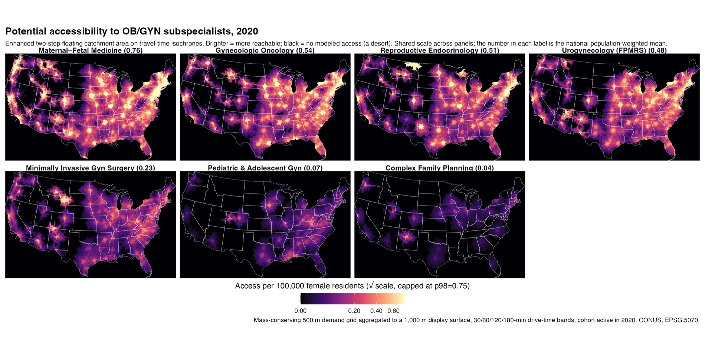 Figure 1. Potential spatial accessibility to each obstetrics-gynecology subspecialty, 2020, per 100,000 women, estimated with an enhanced two-step floating catchment area model on 30-, 60-, 120-, and 180-minute travel-time isochrones. Brighter shading indicates greater potential accessibility; black indicates no modeled access (a desert). One panel per subspecialty on a shared square-root color scale (capped at the 98th percentile); the number in each label is the national population-weighted mean. Mass-conserving 500-m demand grid aggregated to a 1,000-m display surface; contiguous United States.
Quantifying that distribution, in 2020 roughly one in five women lived outside a 60-minute drive of the nearest subspecialist for the more common fields, 19.2% for gynecologic oncology, 19.3% for maternal-fetal medicine, and 17.8% for female pelvic medicine, rising to 43.9% for pediatric and adolescent gynecology and 59.8% for complex family planning (Table 2). Even within a three-hour drive, 21.7% of women remained outside any complex-family-planning catchment and 9.7% outside any pediatric and adolescent gynecology catchment, versus 1.9% for gynecologic oncology. The spatial concentration of access, summarized by the population-weighted Gini index, was lowest for female pelvic medicine and reconstructive surgery (0.29) and highest for complex family planning (0.64), indicating that the scarcest fields are not only smaller but far more unevenly distributed (Table 2).
Table 2. Spatial Distribution and Inequality of Potential Accessibility by Subspecialty, 2020
Subspecialty | % outside 60 min | % outside 120 min | % outside 180 min | Gini
MFM | 19.3 | 4.0 | 1.0 | 0.39
GO | 19.2 | 5.7 | 1.9 | 0.30
REI | 23.1 | 7.1 | 2.2 | 0.39
FPMRS | 17.8 | 4.9 | 2.1 | 0.29
MIGS | 25.6 | 9.0 | 3.3 | 0.35
PAG | 43.9 | 20.3 | 9.7 | 0.50
CFP | 59.8 | 37.2 | 21.7 | 0.64
“% outside t min” is the share of women with no subspecialist reachable within a t-minute drive (population-weighted, road-network travel time). Gini is the population-weighted Gini index of the accessibility surface (0 = perfectly even; higher = more spatially concentrated). These are spatial-distribution measures and, unlike the standardized supply index in Table 1, depend on provider geography. Computed on a 1-km demand grid. AIAN, American Indian or Alaska Native; CFP, complex family planning; FPMRS, female pelvic medicine and reconstructive surgery; GO, gynecologic oncology; MFM, maternal-fetal medicine; MIGS, minimally invasive gynecologic surgery; PAG, pediatric and adolescent gynecology; REI, reproductive endocrinology and infertility.
On the common denominator, the standardized supply index (Table 1) was highest for maternal-fetal medicine and lowest for complex family planning (Figure 2A); because this index equals workforce supply per population (Methods), it reflects workforce size and clinical scope rather than spatial access and is not comparable across subspecialties.
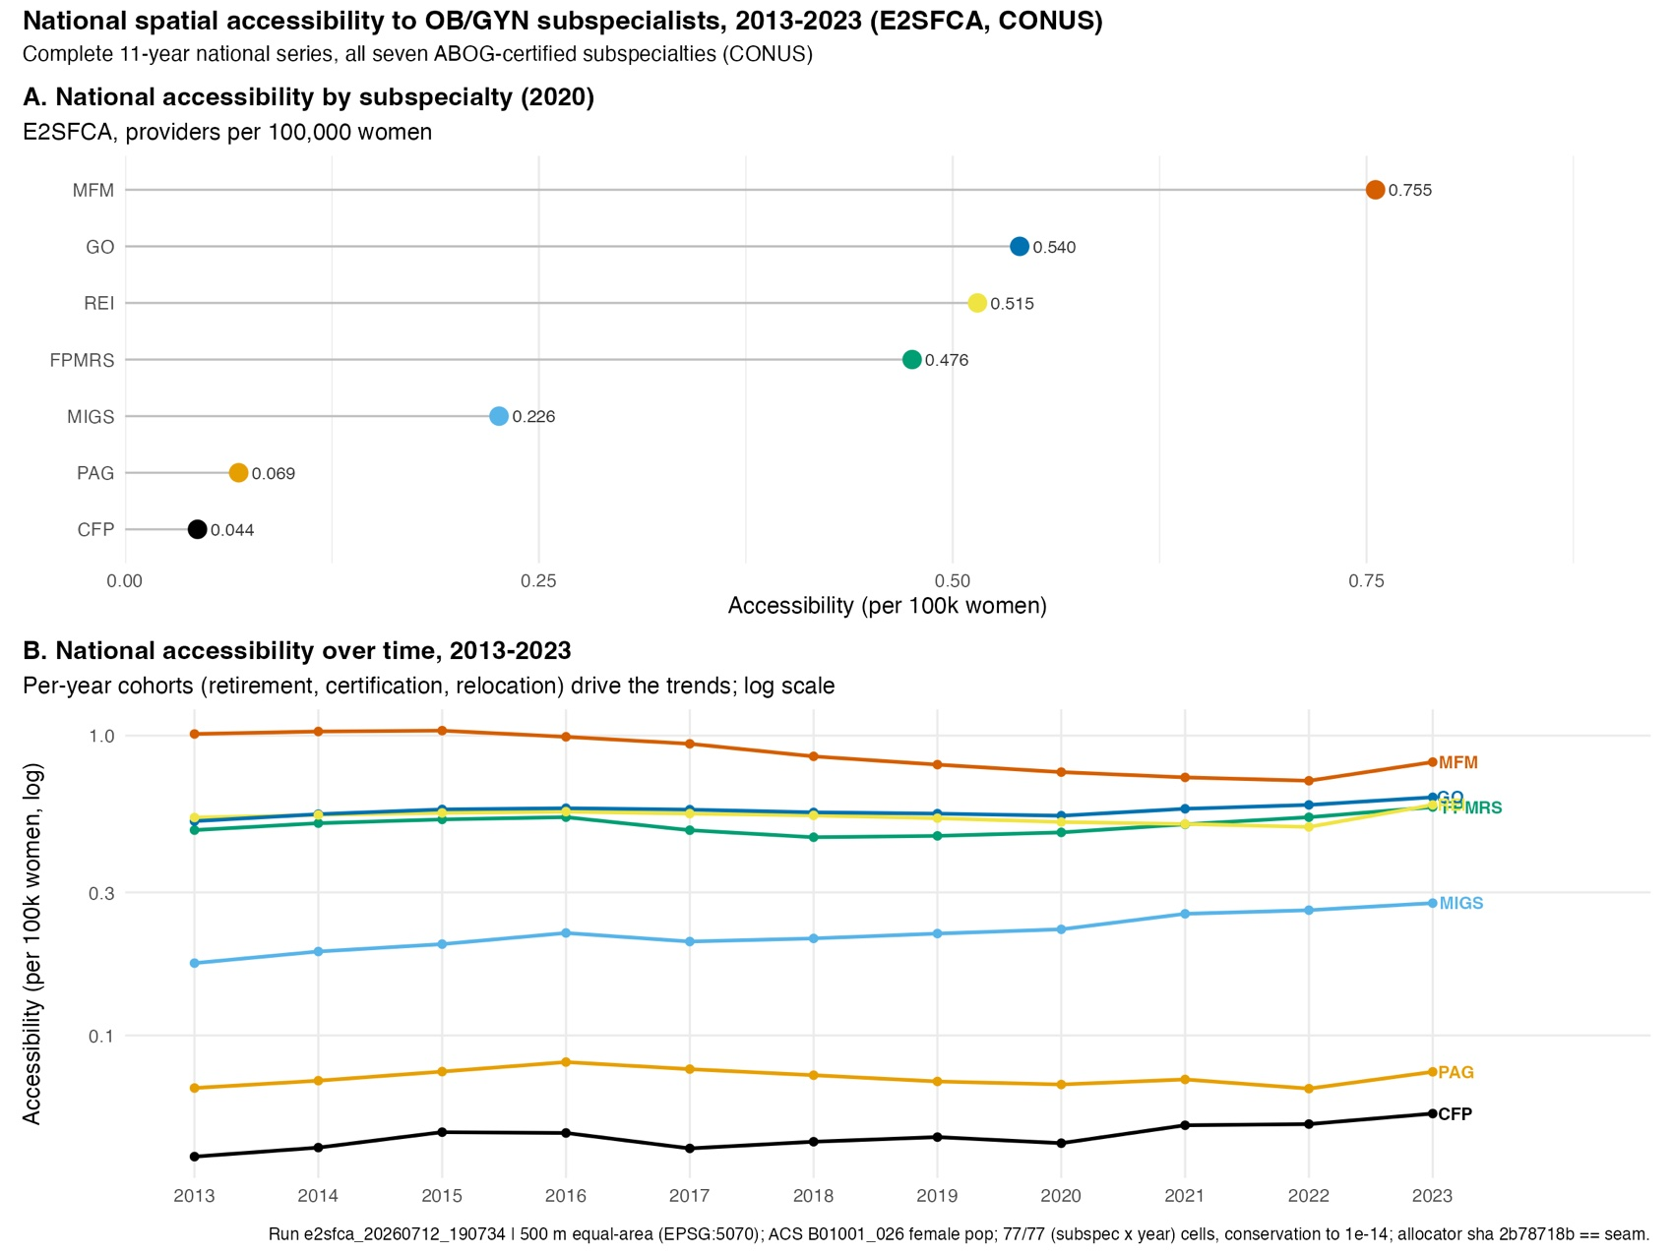 Figure 2. National potential accessibility to OB/GYN subspecialists, 2013-2023 (E2SFCA on travel-time isochrones). (A) Population-weighted accessibility by subspecialty, 2020. (B) By subspecialty, 2013-2023 (log scale). Cell-level population-weighted; per 100,000 women.

Temporal trends
From 2013 to 2022 (the primary period; 2023 was right-censored and is reported provisionally), minimally invasive gynecologic surgery increased from 0.174 to 0.262 per 100,000 women (a 50.1% relative change), the largest relative increase among the subspecialties, and maternal-fetal medicine was the only subspecialty to decline (1.013 to 0.707; -30.2%), reaching a mid-series low of 0.707 in 2022. Gynecologic oncology increased from 0.518 to 0.587 (13.3%). Each annual estimate used only physicians active in that year, reflecting retirement, new board certification, and relocation (Figure 2B). On a provisional basis, minimally invasive gynecologic surgery reached 0.276 and maternal-fetal medicine 0.816 per 100,000 women in 2023.

Disparities by rurality
For gynecologic oncology in 2020, population-weighted accessibility was 0.60 per 100,000 women in metropolitan areas versus 0.26 in rural areas, a metropolitan-to-rural ratio of 2.27 (Figure 3A; ACS uncertainty intervals for all estimates appear in Table 3). At the extreme of no access, 4.1% of rural women lived in a census tract whose mean modeled access to a gynecologic oncologist was zero, versus 0.6% of metropolitan women, an approximately sixfold higher rate.

Disparities by race and ethnicity
American Indian or Alaska Native women had the lowest gynecologic oncology accessibility (0.379 per 100,000) and the highest share living in census tracts with zero mean modeled access (9.4%); the zero-access share was 8.2 percentage points higher than for non-Hispanic White women (ACS uncertainty interval excluding zero). Asian women had the highest modeled accessibility (Figure 3B). Because race-alone and Hispanic-origin groups do not form a mutually exclusive classification (Methods), these are comparisons among separately defined groups.
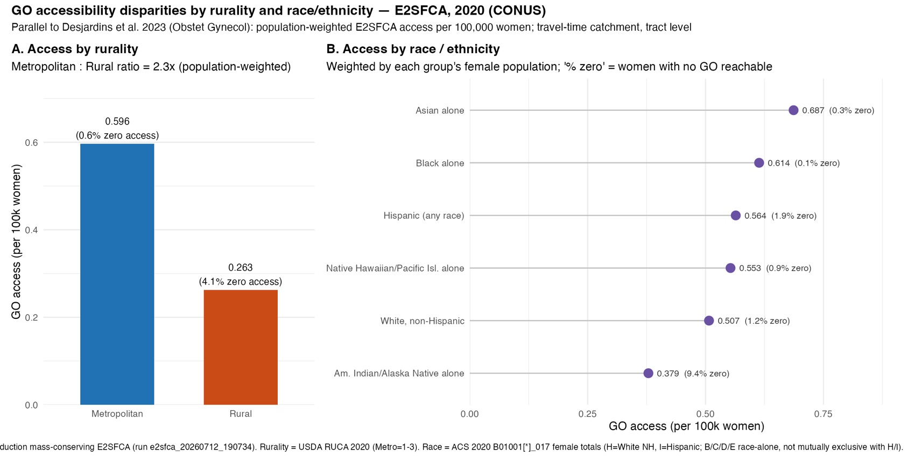 Figure 3. Gynecologic oncology accessibility in 2020 by (A) rurality and (B) race and ethnicity, population-weighted per 100,000 women. “% zero” = share of the group’s population living in census tracts whose mean modeled access to a gynecologic oncologist is zero (a tract-level, not individual-level, measure).

Disparities across all subspecialties
The rurality and race/ethnicity disparities were directionally consistent across all seven subspecialties; per-subspecialty estimates are reported in eResults S5.

Persistence of disparities over time
The rural and racial disparities persisted with little narrowing across 2013-2023; the year-by-year detail is in eResults S6.

Access deserts across subspecialties
The share of women outside any modeled catchment (“access deserts”) varied widely by subspecialty; per-subspecialty values are in eResults S7.

Change in accessibility by subspecialty
Decade-scale change differed by subspecialty, minimally invasive gynecologic surgery increased most and maternal-fetal medicine alone declined; the per-subspecialty change is in eResults S8.

Discussion
In this national analysis of potential spatial accessibility to the seven ABOG-certified obstetric and gynecologic subspecialties, accessibility was consistently concentrated in metropolitan areas and lowest for rural women and for American Indian or Alaska Native women, and these disparities changed little across the study period. The subspecialties differed markedly in absolute accessibility and in their temporal trajectories.
These findings extend prior geographic-access research, which has largely examined single subspecialties or straight-line, county-level distance. For gynecologic oncology, our results reproduce and refine the county-level, straight-line two-step floating catchment model of Desjardins and colleagues, who found most gynecologic oncologists in urban counties, 95.2% of counties (roughly 54.7 million at-risk women) with none, and, critically, no improvement over two decades in the share of American Indian or Alaska Native women beyond 100 miles (25.6% to 23.7%; P=.866) [1]. Our year-specific, board-certified cohort is smaller by design, so the counts are not directly comparable, but our travel-time, tract-level surface independently corroborates the same inequities at finer resolution and across all seven subspecialties. A state-level E2SFCA analysis similarly found 18.4% of Georgia tracts with zero access and, by combining spatial access with social vulnerability, doubly disadvantaged communities invisible to either measure alone [22], the logic behind our stratified, group-versus-reference synthesis (Figure 4).
A complementary, provider-referenced metric reinforces this for female pelvic medicine and reconstructive surgery. Using differential distance, the extra travel to the nearest urogynecologist beyond the nearest general obstetrician-gynecologist, against more than 40,000 geocoded general obstetrician-gynecologists [23], women 65 or older in the median county faced roughly 29 additional miles, and 17% lived where this marginal burden exceeded 30 miles, concentrated in the rural Plains and Mountain West. By isolating the incremental cost of needing a subspecialist, it shows that subspecialty maldistribution, rather than an absence of gynecologic care, drives the rural access gap.
Our other-subspecialty findings are likewise consistent with the literature. The extensive reproductive endocrinology and infertility zero-access areas echo estimates that roughly 29% of reproductive-aged U.S. women live without an assisted reproductive technology clinic, with well-documented racial and ethnic disparities [24], and an oncofertility travel-time analysis found the share beyond a two-hour drive nearly doubled from general to subspecialized fertility care (3.4% to 5.7%), paralleling our deeper deserts in narrower subspecialties [12]. These literatures emphasize that such disparities are multifactorial, the Disparities in Assisted Reproductive Technology framework attributes them to delayed presentation, discontinuation, provider, and patient-level factors beyond structural access [25], framing how our geographic measure should be read.
The persistence of these disparities is consistent with access gradients documented across many specialized services, including cardiac rehabilitation, transplantation, pediatric and specialized cancer care, lung-cancer screening, mental health, and rehabilitation therapy, where rural and American Indian or Alaska Native populations are consistently farther from care [26-34]. The most comparable prior work, a national E2SFCA analysis of six dental specialties, reproduced our central patterns: more than 98% of specialists urban and rural people in rural areas driving roughly three times as far [35]. Subspecialists cluster in metropolitan academic and referral centers, and many rural regions, and areas with large American Indian or Alaska Native populations, lie beyond even a 180-minute drive of any, so incremental workforce growth need not reach them; indeed the workforce grew over the study period even as rural and American Indian or Alaska Native access held nearly constant. The core inequity is thus a mismatch of supply relative to population, and because the denominator is total population rather than disease or procedure demand, these estimates locate where the geographic component of access is most deficient, not where clinical need is greatest. Narrowing the gaps therefore likely requires strategies that decouple access from physician relocation, such as hub-and-spoke models, telehealth, provider knowledge-sharing networks like Project ECHO [36], placement incentives such as the National Health Service Corps, and visiting-specialist clinics, each warranting formal evaluation rather than presumed benefit. Because our measure captures potential rather than realized access, its value is in identifying where such strategies are most needed.
Potential accessibility is not a surrogate for realized use or outcomes: of the five dimensions of access, the model captures only availability and geographic accessibility [4,5], not affordability, accommodation, or acceptability. Populations with high modeled proximity can still fare poorly, as groups near referral centers may register favorable access yet face systemic racism, insurance and scheduling barriers, and higher disease burden [37]. This metropolitan concentration, and its reversal outside metros where minority populations fare worse, mirrors the race-by-rurality intersection reported for emergency surgical services [38] and mammography access [39]; and because racial outcome disparities attenuate after adjustment for structural factors such as insurance, income, and education [40], a geographic access difference becomes an inequity when patterned by unequally distributed social factors, most pronounced where low socioeconomic status and isolation coincide [41]. Modeled proximity should therefore be read as one necessary but insufficient condition for equitable care, its use being to localize where the geographic gap is deepest rather than to certify adequacy where proximity is high.
The study has several strengths: a near-census of board-certified subspecialists rather than a sample; road-network travel times rather than straight-line distance; a mass-conserving demand allocation that represented the full female population rather than discarding population near tract centroids, mitigating the distance-type and population-aggregation errors documented for potential-access measures [42]; year-specific active cohorts that reflect real workforce entry, exit, and relocation; and fully reproducible, canonical-source computation of every reported value. Unlike nearest-provider travel time or administrative-area provider ratios, the floating-catchment design jointly incorporates provider availability, competing population demand, and travel impedance, and flags low-access areas that those simpler measures do not [43].
Several limitations temper interpretation. The same total-female-population denominator was applied to all seven subspecialties, so across-subspecialty comparisons reflect workforce size and clinical scope as well as access; the index measures potential rather than realized access and omits practice capacity, appointment availability, insurance, and patient travel behavior; the reported intervals capture only ACS sampling error and are therefore not comprehensive confidence intervals; the zero-access metric is defined at the tract level; race-alone and Hispanic-origin groups do not form a mutually exclusive partition; and Alaska’s exclusion, by omitting Alaska-resident Alaska Natives, likely renders the American Indian or Alaska Native findings conservative. These points, together with international-border edge effects, the uniform-within-tract density assumption of the area-weighted allocation, and directions for empirical patient-flow calibration, are detailed in eDiscussion S9.

Conclusion
Across the contiguous United States, potential accessibility to board-certified obstetric and gynecologic subspecialists was persistently lower for rural women and for American Indian or Alaska Native women, and these disparities narrowed little over more than a decade. Interpreted as a measure of where specialized care is potentially reachable, rather than of realized or clinically sufficient access, these findings identify the populations and regions that may benefit most from regionalized care, outreach, telehealth, and targeted workforce strategies.

Supplemental Digital Content

eMethods S1: Statistical analysis
National accessibility was summarized as the population-weighted mean at the raster-cell level. Uncertainty intervals reflect only sampling error in the ACS population weights: because the physician catchments and cell-level accessibility values are deterministic (a near-census of active physicians on fixed isochrones), we propagated the ACS margins of error by Monte-Carlo simulation (2,000 draws; each tract’s female population drawn from a Normal distribution with SD = margin of error ÷ 1.645) and summarized each estimate by the 2.5th and 97.5th percentiles. Draws were not truncated at zero: because they enter only aggregate weighted sums (where the expectation equals the sum of the tract estimates), clamping would inject spurious positive weight into the many zero-population tracts and bias sparse groups (for example, American Indian or Alaska Native) upward. Tracts were treated as independent, so the variance of an aggregate is the sum of tract variances; this does not use the ACS covariance structure or replicate weights, and because errors average out across the tens of thousands of tracts, the intervals for pooled quantities, especially aggregate ratios such as the metropolitan-to-rural ratio, collapse to implausibly narrow ranges. Such intervals should be read as point estimates whose honest uncertainty envelope is the sensitivity range (Appendix Table S2) rather than as informative confidence intervals; we accordingly report a point estimate alone where the interval is narrower than the reported precision. We refer to these as ACS uncertainty intervals; they do not incorporate uncertainty from physician ascertainment, clinical-activity classification, geocoding, multiple practice locations, practice capacity, travel-time modeling, catchment thresholds, or distance-decay weights, and are therefore narrower than a comprehensive confidence interval would be. Rurality- and race/ethnicity-stratified estimates were computed at the tract level (required to attach RUCA rurality and race-specific denominators) and reconcile with the cell-level national summary to within 0.001 per 100,000 women. The zero-access metric (“% zero”) is the share of a group’s population living in census tracts whose mean modeled access is zero. As a sensitivity comparison, we also computed a cell-level estimator for 2020, the area-weighted share of each tract lying in grid cells with zero access, weighted by the tract’s group population, which was stable between the 500-m and 1,000-m grids (agreement within 0.1 percentage point for the subspecialties checked) and gave higher zero-access shares than the tract-mean definition (Appendix Table S3). Because both estimators rest on the same area-weighted (uniform within-tract density) allocation, this difference reflects the choice of definition, not independent evidence that either value is more accurate; a dasymetric or block-level allocation would be required to establish that (Discussion). A subspecialist was considered reachable if the practice location fell within the 180-minute maximum travel-time catchment. Temporal change was summarized by ordinary least-squares slopes of the annual estimate on calendar year over 2013-2022. Because successive ACS 5-year estimates overlap and provider cohorts are serially correlated, we also computed Newey-West heteroskedasticity- and autocorrelation-consistent (HAC) P values, with the lag prespecified at 4 to reflect the overlap of the 5-year ACS window (Appendix Table S1); because only 10 annual estimates were available, these trend tests are imprecise and are interpreted descriptively. The stratified trend analyses across the seven subspecialties and multiple groups are exploratory: we prespecified no primary comparison and applied no multiple-comparisons correction, and we therefore emphasize the direction and magnitude of change over statistical significance. The most recent year (2023) was excluded from trend estimation and is reported as a provisional observation because its workforce panel is subject to right-censoring. To assess robustness to modeling choices, we recomputed the 2020 accessibility surface for every subspecialty under alternative distance-decay weights (sharper and slower falloff), a reduced catchment (dropping the 180-minute band), and a finer 500-m grid, and compared the national ranking and the rurality and race contrasts with the base specification (Appendix Table S2). Analyses used R version 4.5.1.

eMethods S2: Mass-conserving demand allocation
Demand was allocated from census tracts to a 500-m equal-area analysis grid (EPSG:5070) by polygon-cell area overlap, conserving every tract’s population (mass-conserving area-weighted allocation). This recovered the full at-risk population (0.00% loss) versus a 1.06% loss under conventional centroid-based allocation; per-year national totals were conserved to within 10⁻⁶. Conserving population prevents the loss that centroid allocation incurs and reduces the display-scale aggregation that coarser zone centroids impose [44]; it does not, however, improve the underlying spatial precision, because population is distributed by land-area overlap and the method therefore assumes uniform population density within each tract. This assumption is least tenable in large rural and tribal tracts, where women occupy a small fraction of the land area, so the 500-m surface can appear more spatially precise than the tract-level input justifies (see Limitations). The 500-m and 1,000-m surfaces nonetheless gave near-identical results (Appendix Table S2).

eMethods S3: Temporal comparison, 2013-2023
National accessibility was computed for every subspecialty-year cell. To visualize decade-scale change while isolating the cohort effect, the 2013 and 2023 accessibility surfaces for each subspecialty were computed on a single common grid and demand denominator (2020 tract vintage; ACS 2020), so the difference reflects only the change in the active physician cohort.
Appendix 1. Accessibility change by subspecialty, 2013-2023 (to be posted online as Supplemental Digital Content).
Level maps look similar year-to-year because the workforce is ~85-95% persistent between consecutive years; the change accumulates. To isolate the cohort signal, each figure below computes the 2013 and 2023 surfaces on one common grid (2020 tract vintage; ACS 2020), so the difference (panel C) reflects only the change in the active physician cohort. Red = access grew; blue = shrank. Because both years are placed on the 2020 grid, the national means and percentage changes annotated on these figures are computed on that common (cohort-isolated) basis and differ by up to about 5 percentage points from the vintage-matched canonical national changes reported in the Results, Table 1, and Figure 7; those canonical values (e.g., minimally invasive gynecologic surgery +59%, maternal-fetal medicine -19%) are the authoritative national estimates, and these appendix figures are provided to show the underlying spatial pattern and the 2013 baseline versus 2023 endpoint.
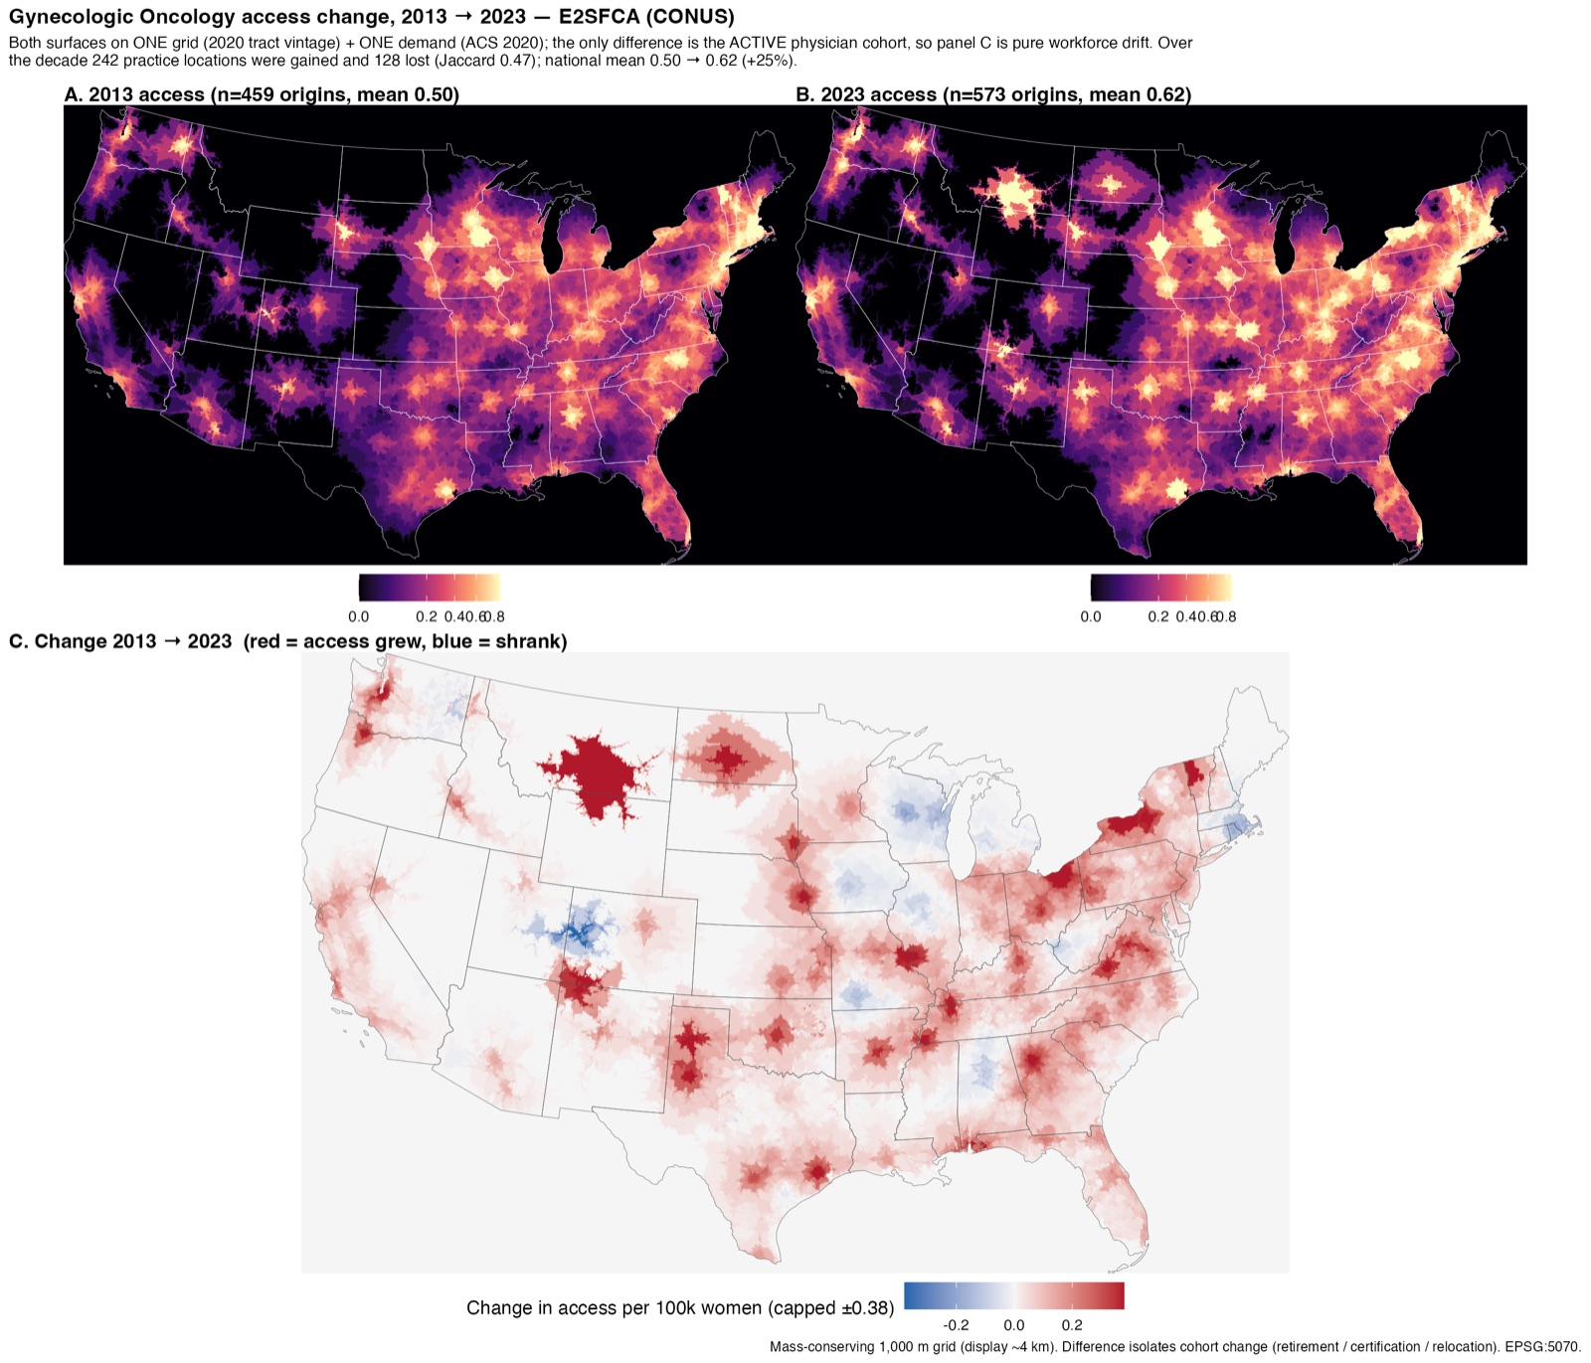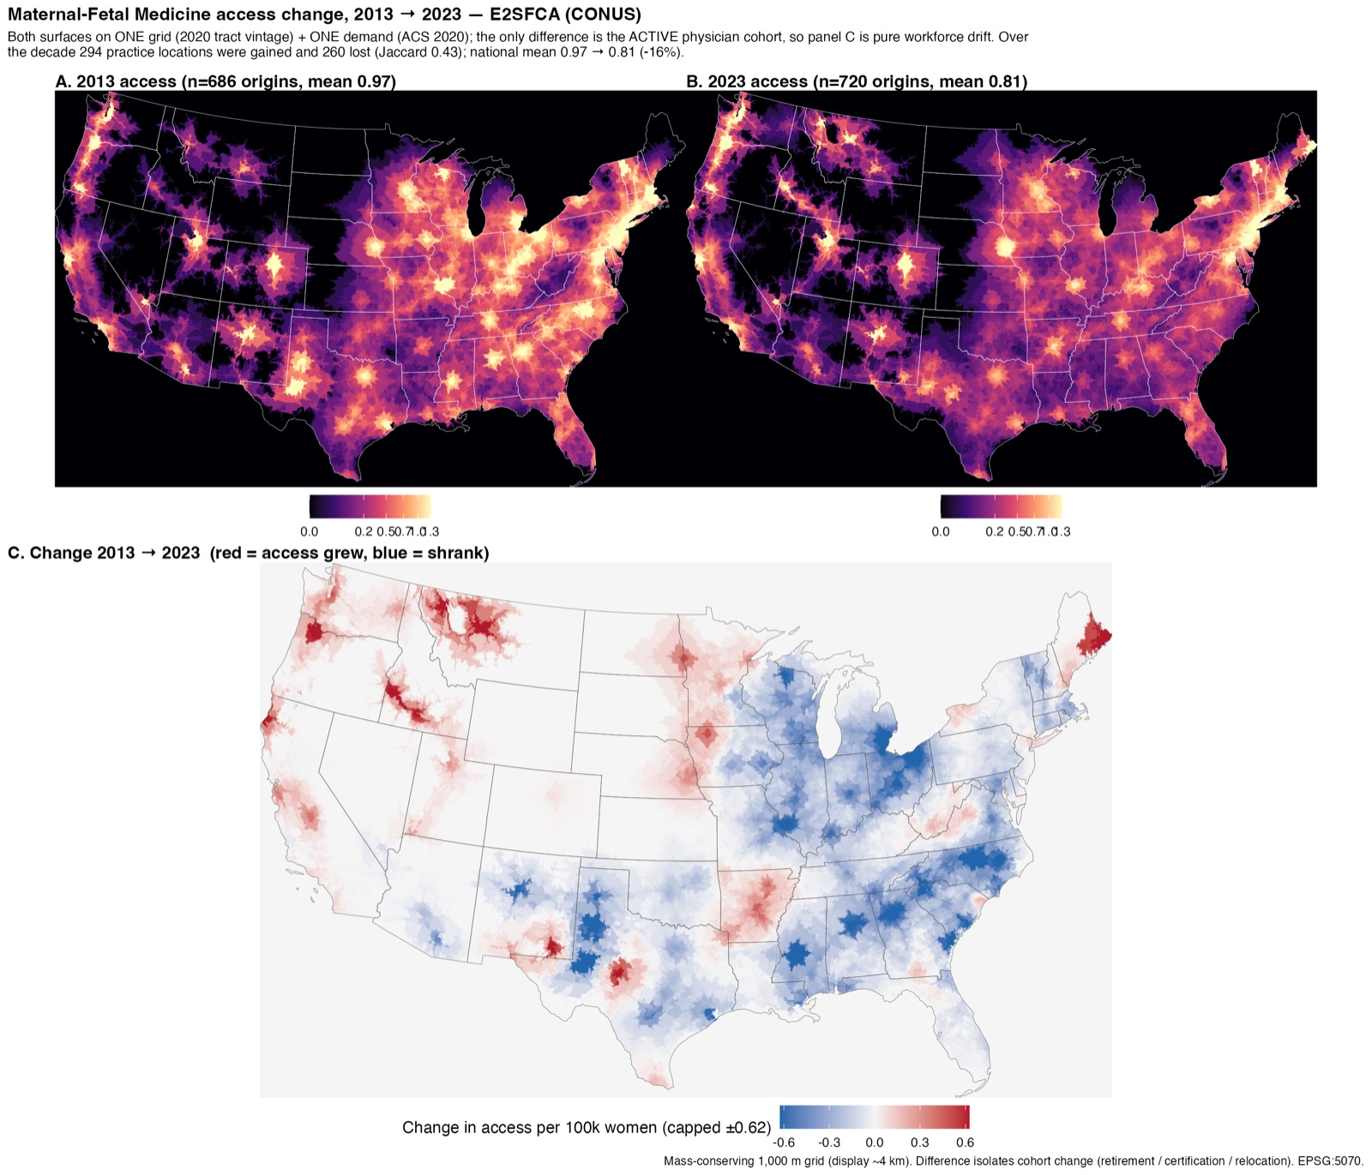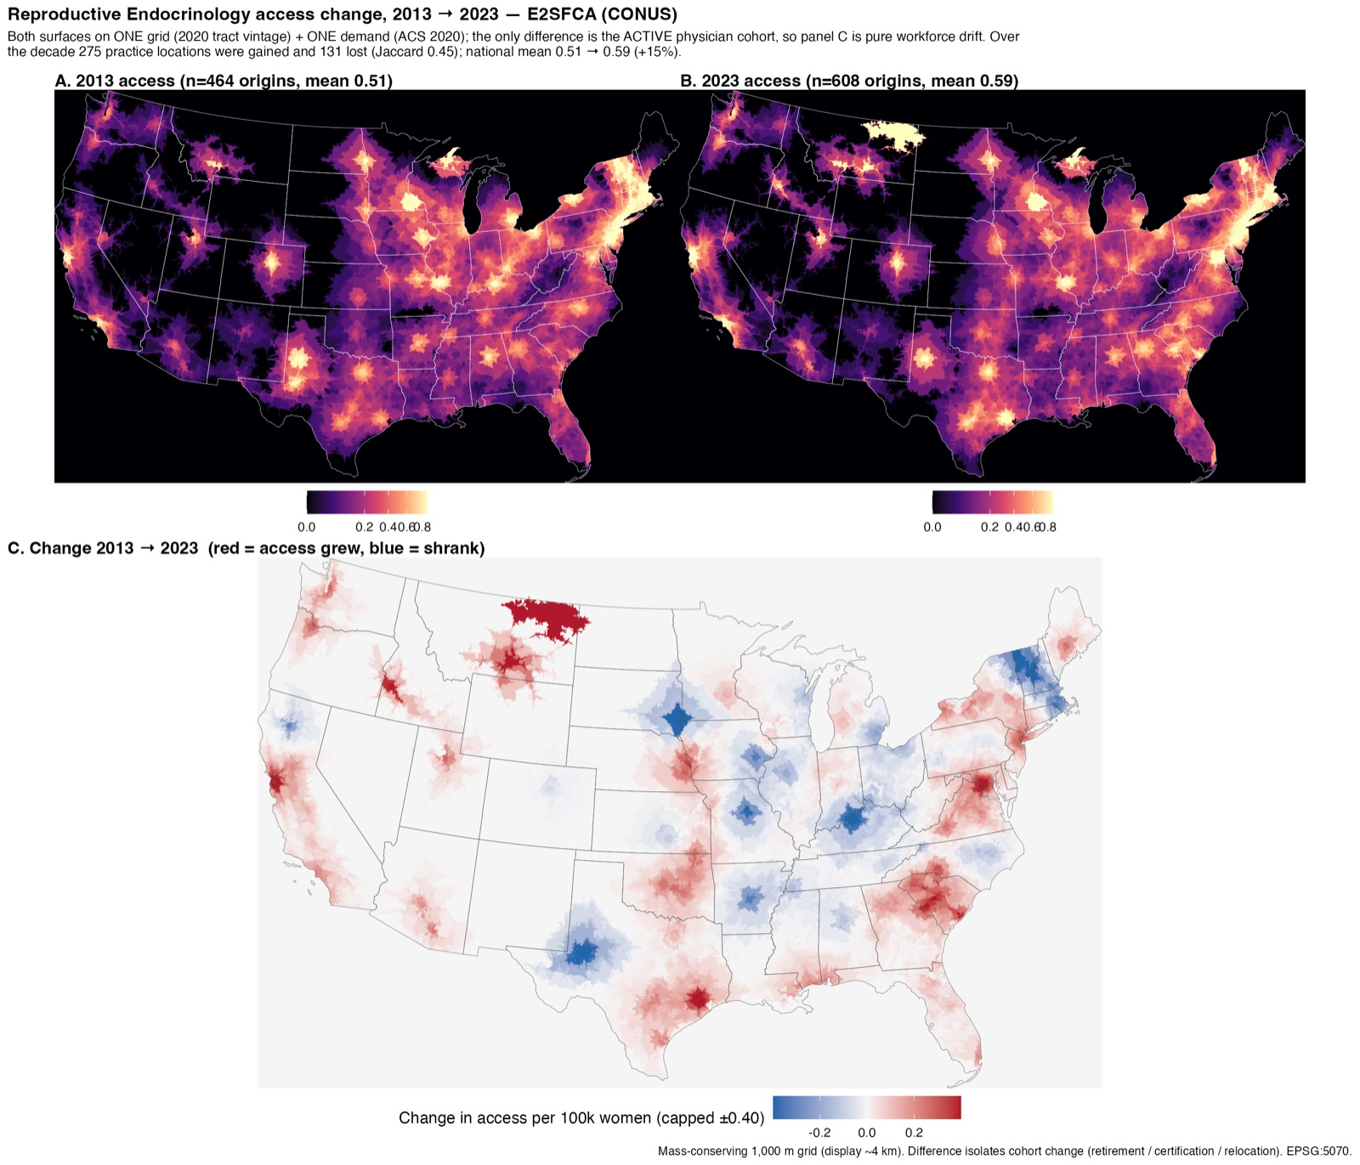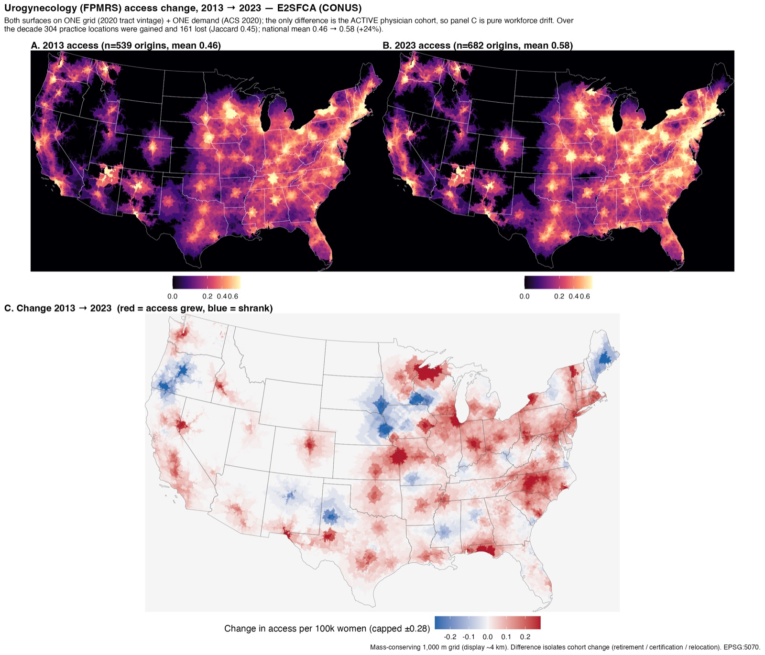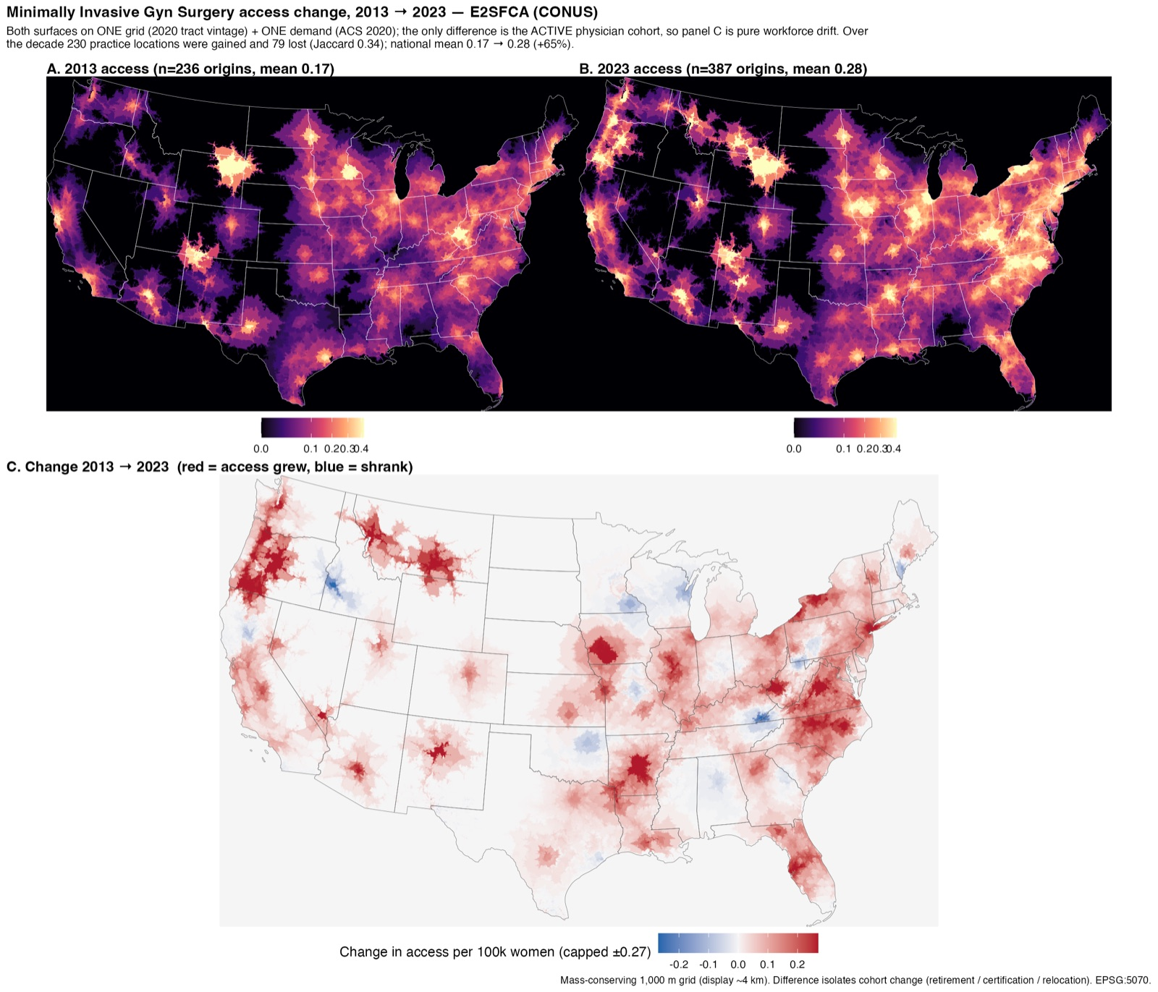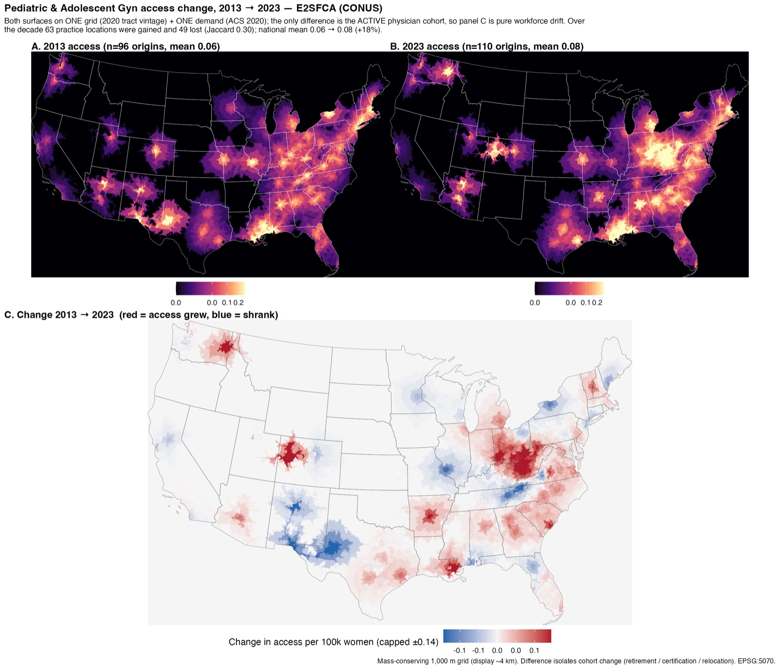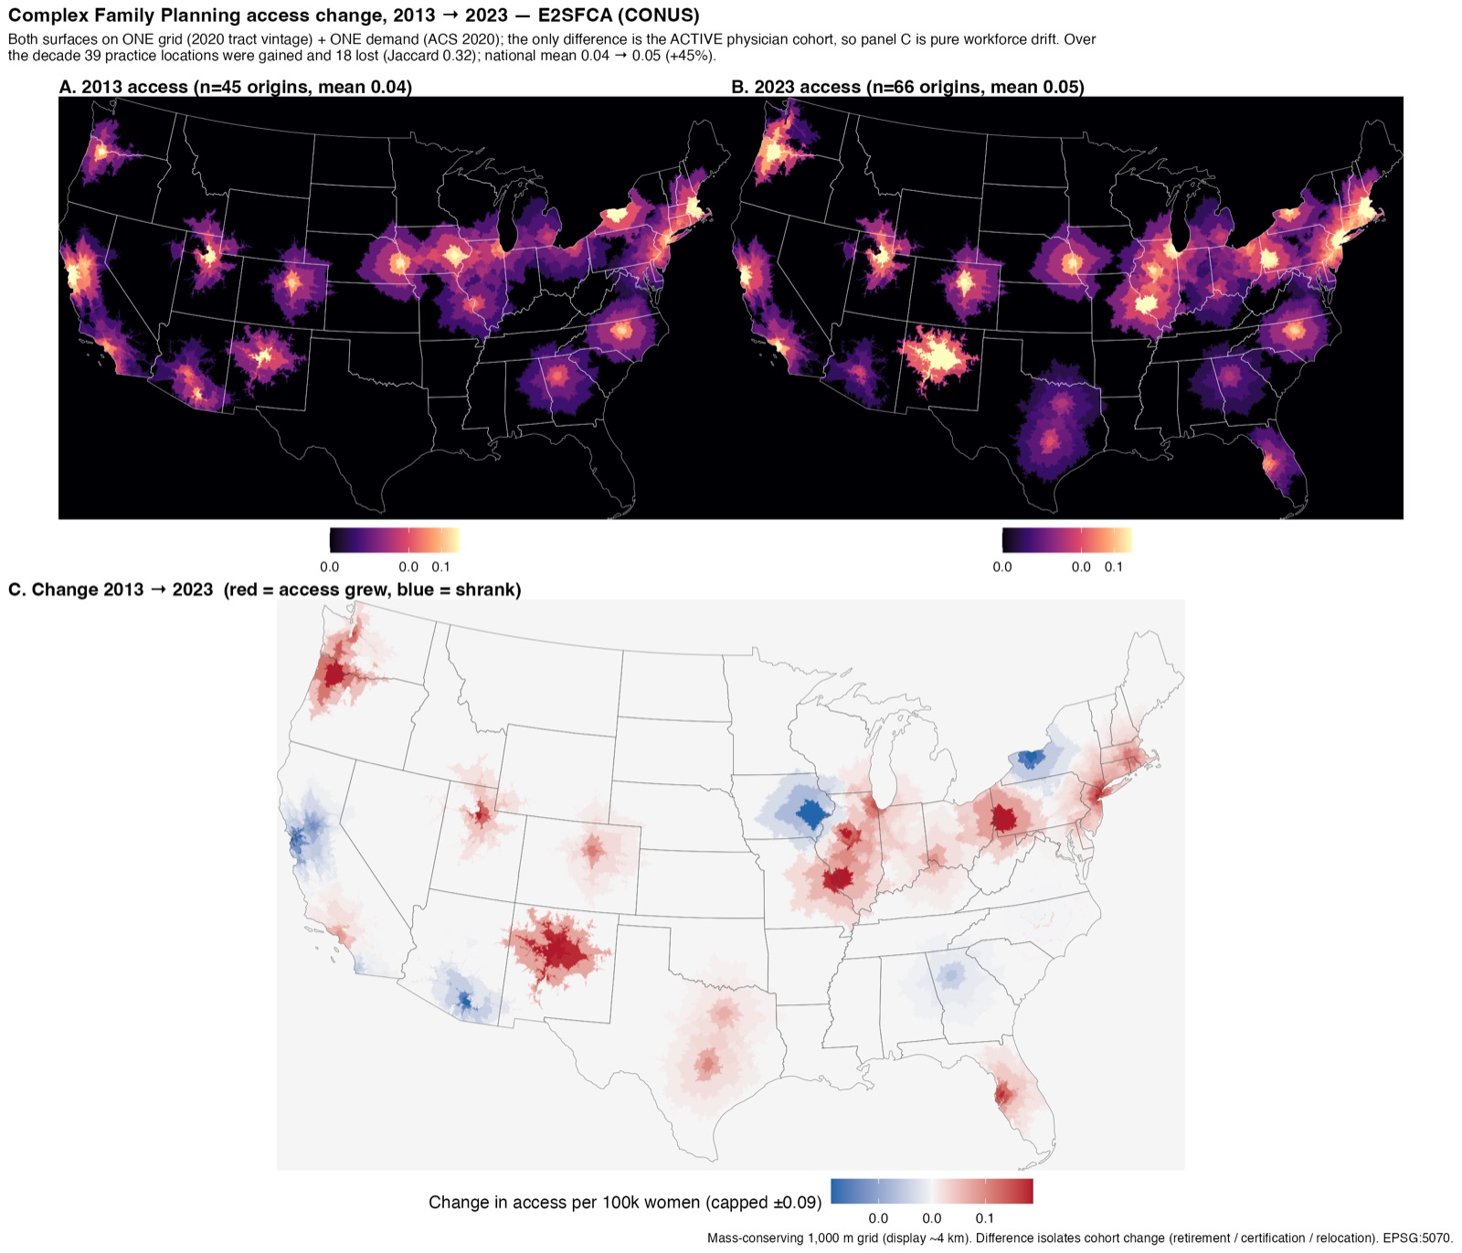 Figures S1-S7. Access change 2013 → 2023 for gynecologic oncology, maternal-fetal medicine, reproductive endocrinology and infertility, urogynecology (FPMRS), minimally invasive gynecologic surgery, pediatric and adolescent gynecology, and complex family planning. Both years computed on one 2020 grid and demand so panel C isolates workforce change.
Appendix Table S1. Trends in the Zero-Access Share by Subspecialty, 2013-2022
Subspecialty | Group | Slope (pp/y) | P, OLS | P, HAC
GO | Rural | -0.058 | .085 | .008
GO | AIAN | -0.202 | <.001 | <.001
MFM | Rural | -0.075 | .028 | .004
MFM | AIAN | -0.201 | <.001 | <.001
REI | Rural | +0.012 | .667 | .688
REI | AIAN | -0.021 | .608 | .658
FPMRS | Rural | +0.010 | .842 | .833
FPMRS | AIAN | -0.031 | .491 | .357
MIGS | Rural | -0.017 | .898 | .895
MIGS | AIAN | +0.034 | .915 | .914
PAG | Rural | +0.172 | .609 | .577
PAG | AIAN | +1.158 | .015 | .002
CFP | Rural | -2.057 | .004 | <.001
CFP | AIAN | -1.528 | .002 | <.001
Slope is the ordinary least-squares change per year in the percentage of a group’s population living in census tracts with zero mean modeled access, over 2013-2022 (10 annual estimates; 2023 excluded as right-censored). P, OLS is the naive ordinary least-squares P value; P, HAC is a Newey-West heteroskedasticity- and autocorrelation-consistent P value with the lag prespecified at 4 to reflect the overlap of American Community Survey 5-year estimates. With only 10 observations these trend tests are imprecise and are interpreted descriptively. HAC, heteroskedasticity- and autocorrelation-consistent; OLS, ordinary least squares; AIAN, American Indian or Alaska Native; CFP, complex family planning; FPMRS, female pelvic medicine and reconstructive surgery; GO, gynecologic oncology; MFM, maternal-fetal medicine; MIGS, minimally invasive gynecologic surgery; PAG, pediatric and adolescent gynecology; REI, reproductive endocrinology and infertility.
Appendix 2. Sensitivity of the 2020 findings to modeling assumptions.
The 2020 accessibility surface for each subspecialty was recomputed under alternative distance-decay weights (sharper and slower falloff than the base Gaussian weights), a reduced catchment that dropped the 180-minute band, and the production 500-m grid (the sensitivity was computed on a 1,000-m reference grid for efficiency; the 500-m specification reproduces the resolution that generated the production national values). The national population-weighted mean and its induced subspecialty ranking were identical across every specification (Spearman ρ = 1.00); this is not evidence of spatial robustness but a direct consequence of the conservation property (Methods), the national mean equals supply divided by population and does not depend on the decay weights, catchment bands, or grid resolution. The meaningful sensitivity is therefore in the spatial quantities. Rural women had lower accessibility than metropolitan women for all 7 subspecialties under every specification. American Indian or Alaska Native women had lower accessibility than non-Hispanic White women for all 7 subspecialties under the base, sharper-decay, dropped-band, and production-resolution specifications, and for 6 of 7 under the slowest decay (complex family planning, already near parity, crossed to a slight advantage). Magnitudes did move, and Table S2 reports them: the median rural:metro accessibility ratio was 0.44 at the reference specification and ranged from 0.22 (sharper decay; deeper rural gap) to 0.56 (slower decay; shallower gap), while the median AIAN:White ratio moved only within 0.77-0.83 (reference 0.78); direction never reversed, and the production-resolution (500-m) grid reproduced the reference results almost exactly. This insensitivity of direction to the distance-decay weights is consistent with prior enhanced two-step floating catchment area analyses, including studies of mental health and of maternal-health services, in which access estimates were likewise robust to varying the decay parameter [34,45].
Appendix Table S2. Sensitivity of 2020 Findings to Modeling Assumptions (Seven Subspecialties)
Specification | Rank ρ | Rural:metro ratio (median) | AIAN:White ratio (median) | Rural < metro | AIAN < White
Sharper distance decay | 1.00 | 0.31 | 0.78 | 7/7 | 7/7
Slower distance decay | 1.00 | 0.56 | 0.81 | 7/7 | 6/7
Drop 180-min band (30/60/120) | 1.00 | 0.40 | 0.78 | 7/7 | 7/7
Production resolution (500-m grid) | 1.00 | 0.44 | 0.78 | 7/7 | 7/7
NA | 1.00 | 0.37 | 0.77 | 7/7 | 7/7
NA | 1.00 | 0.22 | 0.83 | 7/7 | 6/7
Each 2020 accessibility surface was recomputed under the listed specification and compared with the reference specification (Gaussian band weights 1/0.68/0.22/0.09 for the 30/60/120/180-minute bands). The sensitivity was computed on a 1,000-m reference grid for efficiency; the production/authoritative national values use a 500-m grid (Methods), reproduced by the ‘Production resolution’ row. Rank ρ is the Spearman correlation of the seven subspecialties’ national population-weighted mean accessibility with the reference ranking (reference median rural:metro ratio 0.44, AIAN:White ratio 0.78). The ratio columns are the median across the seven subspecialties; a ratio below 1 means the disadvantaged group had lower accessibility. “Rural < metro” and “AIAN < White” count the subspecialties in which that held. AIAN, American Indian or Alaska Native; CFP, complex family planning; FPMRS, female pelvic medicine and reconstructive surgery; GO, gynecologic oncology; MFM, maternal-fetal medicine; MIGS, minimally invasive gynecologic surgery; PAG, pediatric and adolescent gynecology; REI, reproductive endocrinology and infertility.
Appendix 3. Cell-level versus tract-level zero-access, 2020.
The zero-access share reported throughout is defined at the census-tract level (the share of a group’s population in tracts whose mean modeled access is zero). As a sensitivity comparison, a cell-level estimator was computed for 2020: for each tract, the area-weighted fraction lying in 500-m grid cells with zero access, aggregated by the tract’s group population. The cell-level estimate exceeded the tract-mean estimate for every group and subspecialty (median +0.7 percentage points; maximum +7.3), and the divergence was largest for the most disadvantaged groups. Because both estimators assume uniform population density within each tract, this comparison shows only that the two definitions differ, not that either is the more accurate estimate of the true burden; a dasymetric or block-level allocation would be needed to adjudicate. Values agreed between the 500-m and 1,000-m grids to within 0.1 percentage point.
Appendix Table S3. Cell-Level vs Tract-Level Zero-Access Share (%), 2020 (cell / tract)
Subspecialty | Metro | Rural | White | AIAN
MFM | 0.3 / 0.1 | 5.0 / 2.5 | 1.3 / 0.6 | 11.6 / 6.5
GO | 0.9 / 0.6 | 7.2 / 4.1 | 2.0 / 1.2 | 15.6 / 9.4
REI | 1.1 / 0.8 | 8.2 / 4.7 | 2.4 / 1.3 | 16.2 / 10.5
FPMRS | 1.1 / 0.9 | 7.2 / 4.3 | 2.3 / 1.5 | 13.0 / 7.8
MIGS | 1.9 / 1.5 | 10.6 / 7.1 | 3.8 / 2.8 | 21.7 / 14.4
PAG | 7.2 / 6.5 | 22.6 / 18.2 | 10.2 / 8.6 | 39.8 / 35.1
CFP | 18.0 / 17.0 | 40.2 / 34.5 | 22.7 / 20.5 | 43.0 / 37.4
Each cell shows the cell-level zero-access share / the tract-level share (%). Cell-level is the group-population-weighted mean of each tract’s area fraction in 500-m grid cells with zero modeled access; tract-level is the share in tracts whose mean access is zero. Both estimators assume uniform within-tract density, so the higher cell-level values reflect the definition, not evidence that either is more accurate. AIAN, American Indian or Alaska Native; CFP, complex family planning; FPMRS, female pelvic medicine and reconstructive surgery; GO, gynecologic oncology; MFM, maternal-fetal medicine; MIGS, minimally invasive gynecologic surgery; PAG, pediatric and adolescent gynecology; REI, reproductive endocrinology and infertility.

eMethods S4: Enhanced two-step floating catchment area, algorithm, weights, and sensitivity
Potential spatial accessibility was estimated with the enhanced two-step floating catchment area (E2SFCA) method [19], an extension of the two-step floating catchment area approach [20] that is now widely applied to physician, screening, surgical, and other health-service access [32-34,46-50], and a recent systematic review situates them within the broader gravity-model family of potential spatial-access measures [51]. Floating catchment methods were chosen over crude provider-to-population ratios, which ignore where supply sits relative to demand and capture a distinct dimension of access that binary distance or travel-time thresholds undercount [38,52,53], and travel time along the road network was used rather than straight-line distance, which overstates reachability where terrain or road structure lengthens the true trip [26]. Demand within each catchment was weighted by a Gaussian distance-decay across the four travel-time bands (weights 1, 0.68, 0.22, and 0.09 for the 30-, 60-, 120-, and 180-minute zones); these Gaussian band weights follow the published E2SFCA formulation and match values in common use (the inner-band weights are identical to those applied in recent screening-access studies), and a slower distance decay with a wider catchment is appropriate for specialized care that patients travel farther to reach than primary care [19,33]; studies contrasting generalist and subspecialty access likewise assign subspecialists materially wider catchments than primary care providers [54]. No single distance-decay function is empirically established as correct, and the floating-catchment literature has called for finer spatial demand units and refined decay functions than the coarse zone centroids and step weights used in most prior work [55,56]; we therefore resolved demand on a fine grid, adopted the conventional Gaussian weights, and confirmed that the findings were insensitive to this choice, to the catchment bands, and to the grid resolution in a sensitivity analysis (Appendix Table S2). That sensitivity framework additionally supports a Gaussian-derived versus purely zonal band-weight parameterization (a four-band approximation, not a continuous distance function) [57], variable urban and rural catchments that widen the effective catchment for rural populations [58], and a modified two-step specification that penalizes suboptimally configured supply (M2SFCA) [59]. The M2SFCA second application of the distance weight is intentional and method-specific, not the inadvertent reuse of the same weights in both steps cautioned against elsewhere [60]; a fully dynamic variable-catchment implementation would expand each catchment until a population and provider criterion is met rather than compositing separate fixed urban and rural surfaces [61]. The four listed values are cumulative-band weights \(W_b\) (applied to the population reachable within band \(b\)); they enter the computation as incremental band weights \(w'_b = W_b - W_{b+1}\) (with \(W\) beyond the outermost band set to 0), which makes the cumulative-isochrone implementation equivalent to a ring-based E2SFCA. In the first step, each physician location \(j\) receives a provider-to-population ratio \[R_j = \frac{S_j}{\sum_b w'_b\, P_{jb}},\] where \(S_j\) is the subspecialist supply at \(j\) and \(P_{jb}\) is the female population reachable from \(j\) within band \(b\). In the second step, the accessibility at demand cell \(i\) is the band-weighted sum of the ratios of all physician locations whose band-\(b\) catchment contains \(i\), \[A_i = \sum_{j}\sum_{b} w'_b\, R_j .\] Supply \(S_j\) is the count of distinct active subspecialists (unique National Provider Identifiers) whose practice location maps to \(j\). A quality-control check confirmed that every physician had exactly one active practice location in each study year, so supply reflects one physician-equivalent per physician and no multisite duplication occurred; had a physician held multiple locations the estimator would have counted them fully at each, so fractional (1/\(k\)) allocation would be required only for an extension of the cohort to multisite practice (Limitations). Accessibility is a relative index expressed as subspecialists per 100,000 women; it is not a raw physician-to-population density and is not directly numerically comparable with distance-based accessibility scores [1]. We also express it as a Spatial Access Ratio normalized to the national population-weighted mean of 1.00, with values above 1 indicating better-than-average spatial access [21]; the absolute per-100,000 index is retained alongside it so that normalization cannot conceal changes in the absolute national supply-demand balance.
A structural property of the two-step method is important for interpretation. Because the same band weights enter both steps, the population-weighted mean of the accessibility surface over all demand reduces algebraically to the total supply divided by the total population, \[\frac{\sum_i P_i A_i}{\sum_i P_i}=\frac{\sum_j R_j\sum_i w'_{ij}P_i}{\sum_i P_i}=\frac{\sum_j S_j}{\sum_i P_i},\] which we verified numerically (the national means in Table 1 equal subspecialist counts per 100,000 women to within 0.02%). The national mean is therefore a standardized supply-per-population index and carries no spatial information; the across-subspecialty ranking it induces is the workforce-size ranking. Spatial variation is expressed only in the distribution of the surface, the rurality and race/ethnicity contrasts, the share of the population outside the modeled catchment, and geographic inequality, which we accordingly treat as the primary spatial outcomes. National means and their ranking are reported as standardized workforce measures, not as spatial accessibility.

eResults S5: Disparities across all subspecialties
Viewed across all seven subspecialties, the disparity pattern was consistent (Figure 4). In 2020, rural women had lower potential accessibility than metropolitan women for every subspecialty, by as much as 74.3% for complex family planning and by at least 46.3% even for the least affected subspecialty. American Indian or Alaska Native women had lower accessibility than non-Hispanic White women for 6 of the seven subspecialties. By contrast, Black, Hispanic, Asian, and Native Hawaiian or Other Pacific Islander women generally had higher modeled accessibility than non-Hispanic White women, reflecting their greater concentration in metropolitan areas where subspecialists practice, a pattern of potential proximity that, as discussed below, does not imply equivalent realized access or outcomes. These spatial patterns were robust to the modeling assumptions: in a sensitivity analysis that varied the distance-decay weights, the catchment bands, and the grid resolution, the rural disadvantage held for all 7 subspecialties under every specification, and the rural and race contrasts moved in magnitude but never reversed in direction (Appendix Table S2).
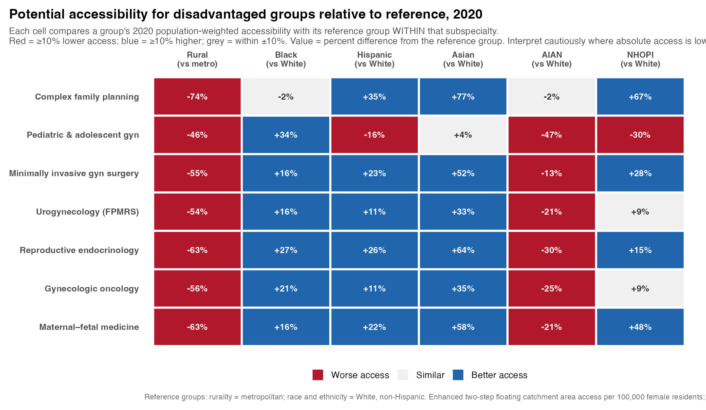 Figure 4. Potential accessibility for disadvantaged groups relative to their reference group in 2020, across all seven subspecialties. Each cell is the percent difference in 2020 population-weighted accessibility between a group and its reference group within that subspecialty: red = at least 10% lower access, blue = at least 10% higher, gray = within ±10%. Reference groups: rurality, metropolitan; race and ethnicity, non-Hispanic White. Within-subspecialty relative contrasts facilitate comparison across subspecialties of differing scarcity, but should be interpreted cautiously where absolute accessibility is low (for example, complex family planning and pediatric and adolescent gynecology), because relative differences become unstable at very small baseline values. Enhanced two-step floating catchment area access per 100,000 women; tract-level population-weighted; contiguous United States. AIAN, American Indian or Alaska Native; NHOPI, Native Hawaiian or Other Pacific Islander.

eResults S6: Persistence of disparities over time
Rural and racial disparities persisted across the decade (Figure 5; Appendix Table S1). Over 2013-2022, the metropolitan-to-rural gynecologic oncology accessibility ratio narrowed by 0.008 per year (P=.007; Newey-West P<.001), and the American Indian or Alaska Native zero-access share for gynecologic oncology declined by 0.20 percentage points per year (P<.001; Newey-West P<.001) while remaining the highest of any group in every year. Directions were unchanged under autocorrelation-robust inference, although with only 10 annual estimates the trend tests are imprecise (Appendix Table S1).
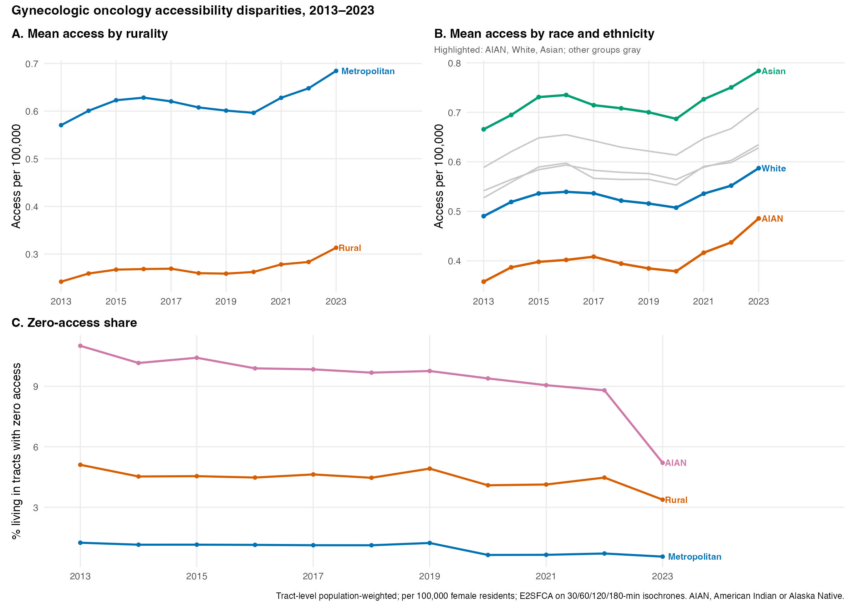 Figure 5. Trends in gynecologic oncology potential accessibility disparities, 2013-2023, tract-level population-weighted (per 100,000 women; enhanced two-step floating catchment area on 30/60/120/180-minute isochrones). (A) Mean accessibility by rurality. (B) Mean accessibility by race and ethnicity, with American Indian or Alaska Native (AIAN), non-Hispanic White, and Asian groups highlighted and the remaining groups in gray. (C) Share of each group’s population living in census tracts with zero mean modeled access.

eResults S7: Access deserts across subspecialties
The magnitude of inaccessibility depended strongly on subspecialty scarcity (Figure 6; Table 3). The rural zero-access share ranged from about 2.5% for MFM to about 34.5% for CFP, and was consistently highest for American Indian or Alaska Native women (Table 3). These tract-level, travel-time patterns parallel the county-level, distance-based gynecologic oncology access disparities reported by Desjardins and colleagues [1].
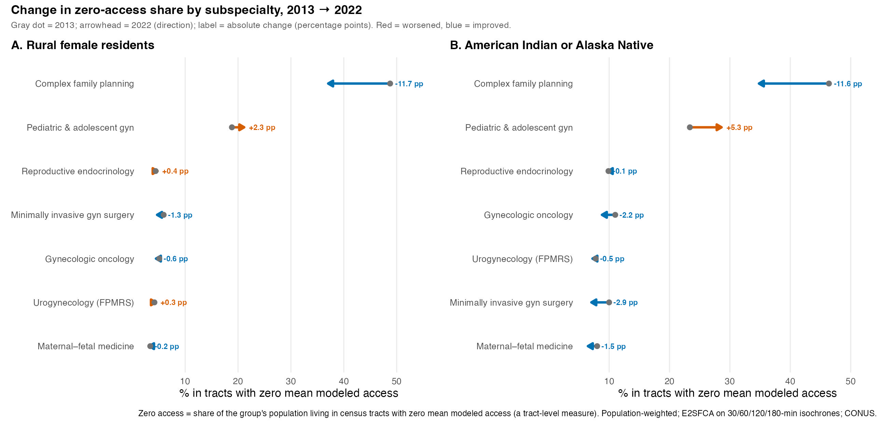 Figure 6. Change in the share of (A) rural and (B) American Indian or Alaska Native women living in census tracts with zero mean modeled access, by subspecialty, 2013→2022. The gray dot marks the 2013 value and the arrowhead the 2022 value, so the arrow’s length is the absolute change and its head shows the direction; blue arrows indicate an improvement (falling zero-access share) and red arrows a worsening, with the absolute change (percentage points) labeled. Tract-level population-weighted; enhanced two-step floating catchment area on 30/60/120/180-minute isochrones; contiguous United States.
Table 3. Rural and Racial/Ethnic Disparities in Potential Accessibility, 2020
Subspecialty | Metro:rural ratio | Rural, % zero | AIAN, access | AIAN, % zero | AIAN − White, % zero
GO | 2.27 | 4.09 (4.06-4.12) | 0.379 (0.376-0.382) | 9.39 (9.16-9.60) | 8.18 (7.95-8.39)
MFM | 2.69 | 2.49 (2.47-2.51) | 0.543 (0.537-0.549) | 6.49 (6.32-6.68) | 5.88 (5.70-6.06)
REI | 2.74 | 4.67 (4.64-4.71) | 0.322 (0.318-0.326) | 10.46 (10.22-10.71) | 9.12 (8.88-9.37)
FPMRS | 2.15 | 4.27 (4.24-4.30) | 0.355 (0.352-0.358) | 7.81 (7.61-8.02) | 6.35 (6.15-6.56)
MIGS | 2.23 | 7.06 (7.02-7.10) | 0.180 (0.177-0.182) | 14.45 (14.18-14.74) | 11.66 (11.40-11.95)
PAG | 1.86 | 18.15 (18.09-18.21) | 0.036 (0.035-0.036) | 35.13 (34.69-35.56) | 26.48 (26.04-26.91)
CFP | 3.89 | 34.48 (34.41-34.56) | 0.039 (0.038-0.040) | 37.39 (36.95-37.86) | 16.93 (16.49-17.39)
Values are point estimate (95% ACS uncertainty interval). Access is per 100,000 women. Stratified estimates are tract-level population-weighted (required to attach rurality and race-specific denominators) and reconcile with the cell-level national means (Table 1) to within 0.001. “% zero” is the share of a group’s population living in census tracts with zero mean modeled access. Intervals quantify ACS sampling uncertainty only and are narrower than comprehensive confidence intervals; the metropolitan-to-rural ratio pools over tens of thousands of tracts, so its ACS interval is narrower than the reported precision and it is shown as a point estimate (its honest uncertainty envelope is the sensitivity range, Appendix Table S2; Methods). Race-alone and Hispanic-origin groups are not mutually exclusive. AIAN, American Indian or Alaska Native; CFP, complex family planning; FPMRS, female pelvic medicine and reconstructive surgery; GO, gynecologic oncology; MFM, maternal-fetal medicine; MIGS, minimally invasive gynecologic surgery; PAG, pediatric and adolescent gynecology; REI, reproductive endocrinology and infertility.

eResults S8: Change in accessibility by subspecialty
Descriptive changes in potential accessibility from 2013 to 2023 were geographically heterogeneous across subspecialties (Figure 7). This 2013-2023 endpoint comparison, in which 2023 is provisional, is distinct from the 2013-2022 modeled trends reported above. Nationally, population-weighted accessibility increased most for minimally invasive gynecologic surgery (58.5%), and maternal-fetal medicine was the only subspecialty to decline (-19.4%); however, both gains and losses were spatially concentrated rather than uniform across the country. Figure 7 shows the absolute cell-level change, while the facet labels report the national relative change (Table 1).
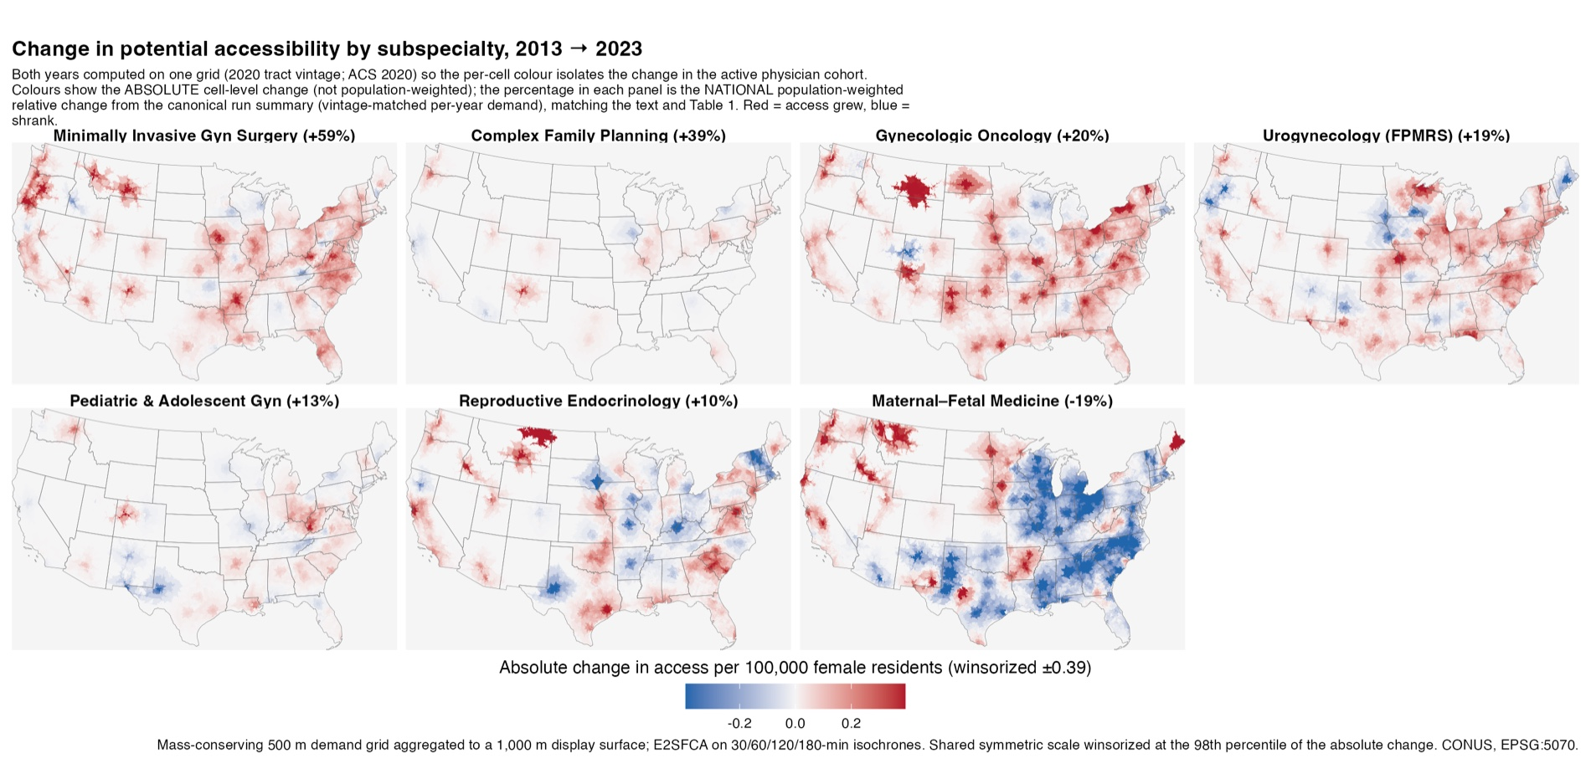 Figure 7. Change in potential accessibility by subspecialty, 2013 → 2023. This figure combines two distinct quantities: the map colors show the absolute cell-level change in access (per 100,000 women; not population-weighted), computed with both years on a common 2020 grid so the spatial pattern isolates the change in the active physician cohort, whereas the percentage in each panel is the national population-weighted relative change over the full 2013→2023 endpoint. Because 2023 is provisional, this endpoint differs from the 2013-2022 primary period reported in Table 1, and the panel percentages should not be read against Table 1. Red indicates access grew, blue that it shrank. Mass-conserving 500-m demand grid aggregated to a 1,000-m display surface; the shared symmetric color scale is winsorized at ±0.39 per 100,000 women (the 98th percentile of the absolute cell-level change), which clipped 0.7% of cells.

eDiscussion S9: Limitations
Several limitations temper interpretation. First, and most important, the same total-female-population denominator was applied to all seven subspecialties. Because the subspecialties serve different populations, pediatric and adolescent gynecology serves children and adolescents; maternal-fetal medicine, reproductive endocrinology, and complex family planning serve predominantly reproductive-aged patients; and female pelvic medicine and reconstructive surgery serves an older population, the large across-subspecialty differences in the standardized index reflect workforce size and clinical scope as well as access, and the rates should not be read as directly comparable measures of clinical adequacy; age-specific, within-specialty denominators are a priority for future work, alongside supply- and demand-adjusted catchments that model service-specific capacity and age-specific need [62] and distance-decay functions empirically calibrated from observed patient-flow data rather than prespecified [63,64]. Second, the measure reflects potential (modeled) rather than realized access and does not capture practice capacity, appointment availability, insurance acceptance, or patient travel behavior; in particular, because higher-socioeconomic-status patients more readily overcome distance by traveling to distant centers, a spatially uniform potential-access measure may understate realized disadvantage for lower-income and rural populations [27]. Third, the reported intervals quantify only ACS sampling uncertainty and omit uncertainty from physician ascertainment and activity classification, geocoding, multiple practice locations, and the travel-time, catchment, and distance-decay assumptions of the model and are therefore not comprehensive confidence intervals; Monte Carlo propagation of supply, activity, geocoding, and parameter uncertainty through the model is a natural extension [65], and potential edge effects at the international borders and coastlines (providers and population outside the United States were unavailable) could not be captured [66]; however, a sensitivity analysis varying the distance-decay weights, the catchment bands, and the grid resolution left the direction of the rurality and race disparities unchanged (Appendix Table S2; the national mean and its ranking are invariant to these choices by the conservation property and are not a robustness result). Fourth, the zero-access metric is defined at the tract level (the share of a group living in tracts with zero mean modeled access) and may undercount people in zero-access locations within partially served tracts. A cell-level estimator for 2020 (the area-weighted share of each tract that lies in grid cells with zero access, weighted by the tract’s group population) gave higher zero-access shares than the tract-mean metric (median +0.7 percentage points across groups and subspecialties, and up to +7.3 for American Indian or Alaska Native and +5.8 for rural women; Appendix Table S3). However, both estimators assume uniform population density within each tract, so this difference does not establish that the tract-mean metric understates the true burden; it shows only that the two definitions diverge, and resolving which is more accurate would require a dasymetric or block-level population allocation, which we did not perform. Relatedly, spatial associations can depend on the choice of areal unit (the modifiable areal unit problem); we resolved demand at a fine scale (census tract allocated to a 500-m grid) to limit this, but stratified estimates could differ under coarser units [30]. The area-weighted allocation also conserves population without validating its within-tract placement: it assumes uniform density within each tract, which is least tenable in large rural and tribal tracts, and a dasymetric or block-level allocation would better locate women; mass conservation prevents loss but does not by itself certify spatial precision. Fifth, race-alone and Hispanic-origin groups do not form a mutually exclusive classification, so between-group contrasts are among separately defined groups; moreover, the broad American Community Survey categories mask substantial within-group heterogeneity (for example, across Asian-origin subgroups), and finer disaggregation, shown elsewhere to reveal disparities that pooled categories conceal, is a priority for future work [40]. These stratified estimates are ecological: they are computed at the census-tract level from group-specific population denominators and describe the accessibility of the areas where each group lives, not the realized access of individual patients, and within-tract residential patterns may differ by group. Sixth, overlapping ACS 5-year estimates and serially correlated cohorts make ordinary least-squares trend inference optimistic; we therefore report Newey-West autocorrelation-consistent P values alongside the ordinary least-squares values (Appendix Table S1), although with only 10 annual estimates these remain imprecise, and the maternal-fetal medicine trajectory is nonlinear (decline then rebound), which a single linear slope summarizes incompletely. Moreover, the 2019-2020 census-tract vintage change falls within the trend window; a subgroup-specific seam test (2020 cohort held fixed, each subgroup recomputed under the 2010- and 2020-vintage frameworks; Methods) found the pure vintage shift to be small (median 0.05 percentage point in the zero-access share, and at most 0.5 for the rural and American Indian or Alaska Native series), so the subgroup trends crossing the boundary are not attributable to the vintage change, with the exception of the Native Hawaiian or Other Pacific Islander series, whose smaller population produced the largest shift (1.3 percentage point) and which is already limited by the exclusion of Hawaii. Seventh, the most recent year (2023) is right-censored and is reported provisionally. Eighth, we summarized accessibility descriptively and did not model residual spatial autocorrelation, which spatially explicit approaches address directly [38]. Finally, the analysis was restricted to the contiguous United States because road-network routing cannot represent the air and water travel on which access in Alaska, and in much of Hawaii, depends; the closest prior urogynecology-access study likewise restricted its main analysis to the continental United States for the same reason [13]. Alaska is therefore a boundary of the modeling framework rather than an omission: quantifying access there would require an air- and maritime-inclusive travel model, not the road-network isochrones on which this entire study is built. This exclusion bears most on the American Indian or Alaska Native category, whose very name includes Alaska Natives: our estimates pertain to the contiguous-U.S. members of that group and omit Alaska-resident Alaska Natives, who face distinct and frequently non-road access barriers that are typically more severe. Because the excluded population is among the least geographically served, the American Indian or Alaska Native disadvantage reported here is, if anything, conservative with respect to the full national population. The exclusion of Hawaii is equally relevant to the Native Hawaiian or Other Pacific Islander results, which should likewise be read as pertaining only to the contiguous-U.S. members of that group.

Reproducibility record (supplement, not part of the typeset manuscript)
The following provenance metadata is provided for the reproducibility repository and peer review; it is not intended for the submitted/typeset article.
- Run: e2sfca_20260712_190734 (git ff3aac4a)
- Allocator: mass_conserving / allocate_pop_areaweighted (mode area; module sha256 2b78718bf65c2ecb)
- Headline source: e2sfca_national_summary.csv (cell-level population-weighted)
- Cells: 77 specialty-year national rows (7 specialties × 11 years)
All scientific values above are inline R expressions evaluated from the canonical run objects at render time; none are hardcoded in prose.

References
[1]
Desjardins MR, Desravines N, Fader AN, Wethington SL, Curriero FC. Geographic disparities in potential accessibility to OBGYN subspecialists in the United States from 2001 to 2020. Obstet Gynecol. 2023;142(3):688-97.
[2]
Harris JA, Menke MN, Haefner JK, Moniz MH, Perumalswami CR. Geographic access to assisted reproductive technology health care in the united states: A population-based cross-sectional study. Fertility and Sterility. 2017;107(4):1023-7. https://doi.org/10.1016/j.fertnstert.2017.02.101.
[3]
Akapo OO, Schultz C, Coelho D, Muffly TM. American indian and alaskan native access to obstetrics and gynecology subspecialists: Findings from a national mystery caller study in the united states. Cureus. 2023;15(12):e51403. https://doi.org/10.7759/cureus.51403.
[4]
Penchansky R, Thomas JW. The concept of access: Definition and relationship to consumer satisfaction. Medical Care. 1981;19(2):127-40. https://doi.org/10.1097/00005650-198102000-00001.
[5]
McLaughlin CG, Wyszewianski L. Access to care: Remembering old lessons. Health Services Research. 2002;37(6):1441-3. https://doi.org/10.1111/1475-6773.12171.
[6]
Deng S, Chen Y, Bennett KJ. The association of travel burden with prenatal care utilization: What happens after provider selection. BMC Health Services Research. 2024;24:781. https://doi.org/10.1186/s12913-024-11249-9.
[7]
Pleasants EA, Cartwright AF, Upadhyay UD. Association between distance to an abortion facility and abortion or pregnancy outcome among a prospective cohort of people seeking abortion online. JAMA Network Open. 2022;5(5):e2212065. https://doi.org/10.1001/jamanetworkopen.2022.12065.
[8]
Ambroggi M, Biasini C, Del Giovane C, Fornari F, Cavanna L. Distance as a barrier to cancer diagnosis and treatment: Review of the literature. The Oncologist. 2015;20(12):1378-85. https://doi.org/10.1634/theoncologist.2015-0110.
[9]
Syed ST, Gerber BS, Sharp LK. Traveling towards disease: Transportation barriers to health care access. Journal of Community Health. 2013;38(5):976-93. https://doi.org/10.1007/s10900-013-9681-1.
[10]
Ackroyd SA, Shih Y-CT, Kim B, Lee NK, Halpern MT. A look at the gynecologic oncologist workforce - are we meeting patient demand? Gynecologic Oncology. 2021;163(2):229-36. https://doi.org/10.1016/j.ygyno.2021.08.013.
[11]
Chen V, Ying X, Majdinasab E, Theiler R. Geographic disparities in obstetric care access in the United States. Obstetrics & Gynecology. 2026;147(3):422-4. https://doi.org/10.1097/AOG.0000000000006069.
[12]
Peipert BJ, Potapragada NR, Lantos PM, Harris BS, Reinecke J, Goldman KN. A geospatial analysis of disparities in access to oncofertility services. JAMA Oncology. 2023;9(10):1364-70. https://doi.org/10.1001/jamaoncol.2023.2780.
[13]
Schmidt EM, Ward L, Gregory WT, Cichowski SB. Geographic access to urogynecology care in the united states. Urogynecology. 2024;30(10):829-37. https://doi.org/10.1097/SPV.0000000000001547.
[14]
U.S. Census Bureau. American community survey (ACS) 5-year estimates [Internet]. Suitland (MD): U.S. Census Bureau; 2021. [cited 2026 Feb 28]. Available from: https://www.census.gov/programs-surveys/acs.
[15]
Walker K. Tidycensus: Load US census boundary and attribute data as tidyverse and sf-ready data frames [Internet]. Comprehensive R Archive Network; 2024. [cited 2026 Feb 28]. Available from: https://walker-data.com/tidycensus/.
[16]
Pebesma E. Simple features for R: Standardized support for spatial vector data. R J. 2018;10(1):439-46. Available from: https://journal.r-project.org/archive/2018/RJ-2018-009/.
[17]
U.S. Department of Agriculture, Economic Research Service. Rural-urban commuting area codes. USDA Economic Research Service; 2020.
[18]
Mapzen/Linux Foundation. Valhalla routing engine, version 3.4 [Internet]. San Francisco (CA): Linux Foundation; 2023. [cited 2026 Feb 28]. Available from: https://github.com/valhalla/valhalla.
[19]
Luo W, Qi Y. An enhanced two-step floating catchment area (E2SFCA) method for measuring spatial accessibility to primary care physicians. Health & Place. 2009;15(4):1100-7. https://doi.org/10.1016/j.healthplace.2009.06.002.
[20]
Luo W, Wang F. Measures of spatial accessibility to health care in a GIS environment: Synthesis and a case study in the Chicago region. Environment and Planning B: Planning and Design. 2003;30(6):865-84. https://doi.org/10.1068/b29120.
[21]
Wan N, Zhan FB, Zou B, Chow E. A relative spatial access assessment approach for analyzing potential spatial access to colorectal cancer services in texas. Applied Geography. 2012;32(2):291-9. https://doi.org/10.1016/j.apgeog.2011.05.001.
[22]
Graham S, Hallisey E, Wilt G, Flanagan B, Rodriguez JL, Peipins L. Sociodemographic disparities in access to ovarian cancer treatment. Annals of Cancer Epidemiology. 2019;3:3. https://doi.org/10.21037/ace.2019.10.02.
[23]
Herb J, Shell M, Carlson R, Stitzenberg K. Is long travel distance a barrier to surgical cancer care in the United States? A systematic review. Am J Surg. 2021;222(2):305-10. https://doi.org/10.1016/j.amjsurg.2020.12.005.
[24]
Beroukhim G, Seifer DB. Racial and ethnic disparities in access to and outcomes of infertility treatment and assisted reproductive technology in the United States. Endocrinology and Metabolism Clinics of North America. 2023;52(4):659-75. https://doi.org/10.1016/j.ecl.2023.05.005.
[25]
Seifer DB, Sharara FI, Jain T. The disparities in ART (DART) hypothesis of racial and ethnic disparities in access and outcomes of IVF treatment in the USA. Reproductive Sciences. 2022;29(7):2084-8. https://doi.org/10.1007/s43032-022-00888-0.
[26]
Ebinger JE, Lan R, Driver MP, Rushworth P, Luong E, Sun N, et al. Disparities in geographic access to cardiac rehabilitation in Los Angeles county. Journal of the American Heart Association. 2022;11(15):e026472. https://doi.org/10.1161/JAHA.121.026472.
[27]
Yilma M, Dalal N, Wadhwani SI, Hirose R, Mehta N. Geographic disparities in access to liver transplantation. Liver Transplantation. 2023;29(9):987-97. https://doi.org/10.1097/LVT.0000000000000182.
[28]
Liu X, Fluchel MN, Kirchhoff AC, Zhu H, Onega T. Geographic access to pediatric cancer care in the US. JAMA Network Open. 2023;6(1):e2251524. https://doi.org/10.1001/jamanetworkopen.2022.51524.
[29]
Towne SD, Smith ML, Ory MG. Geographic variations in access and utilization of cancer screening services: Examining disparities among American Indian and Alaska Native elders. International Journal of Health Geographics. 2014;13:18. https://doi.org/10.1186/1476-072X-13-18.
[30]
El Khoury CJ. Application of geographic information systems (GIS) in the study of prostate cancer disparities: A systematic review. Cancers. 2024;16(15):2715. https://doi.org/10.3390/cancers16152715.
[31]
Hecox EE, Boydstun AG, Talbot HG, Edwards SR, Anderson L, Benedict KC, et al. Geographic disparities in access to certified hand therapists in the United States. Journal of Hand Surgery (American Volume). 2026;51(3):322.e1-8. https://doi.org/10.1016/j.jhsa.2025.05.013.
[32]
Welch AC, Gorden JA, Mooney SJ, Wilshire CL, Zeliadt SB. Understanding Washington state’s low uptake of lung cancer screening in two steps: A geospatial analysis of patient travel time and health care availability of imaging sites. Chest. 2024;166(3):622-31. https://doi.org/10.1016/j.chest.2024.04.021.
[33]
Campbell JE, Sambo AB, St. James N, Willingham K, Warren H, Penaflor J, et al. Spatial accessibility for deploying mobile lung cancer screenings in a rural state using two-step floating catchment spatial analysis in Oklahoma, United States. Preventive Medicine Reports. 2025;60:103290. https://doi.org/10.1016/j.pmedr.2025.103290.
[34]
Charlesworth CJ, Nagy D, Drake C, Manibusan B, Zhu JM. Rural and frontier access to mental health prescribers and nonprescribers: A geospatial analysis in Oregon Medicaid. The Journal of Rural Health. 2024;40(1):16-25. https://doi.org/10.1111/jrh.12761.
[35]
Rahman MS, Martinez A, Elani HW. Geographic access to dental specialists in the United States. Journal of Dental Research. 2026;105(7):875-82. https://doi.org/10.1177/00220345251388919.
[36]
Arora S, Brakey HR, Jones JL, Hood N, Fuentes JE, Cirolia L. Project ECHO for cancer care: A scoping review of provider outcome evaluations. Journal of Cancer Education. 2023. https://doi.org/10.1007/s13187-023-02292-x.
[37]
Bassett MT, Galea S. Reparations as a public health priority - a strategy for ending Black-White health disparities. New England Journal of Medicine. 2020;383(22):2101-3. https://doi.org/10.1056/NEJMp2026170.
[38]
McCrum ML, Wan N, Han J, Lizotte SL, Horns JJ. Disparities in spatial access to emergency surgical services in the US. JAMA Health Forum. 2022;3(10):e223633. https://doi.org/10.1001/jamahealthforum.2022.3633.
[39]
Campbell JE, Janitz A, Sambo AB, St. James N, Pharr SF, Doescher MP. Optimizing mobile mammography deployment in Oklahoma 2024: A two-step floating catchment area approach. Geospatial Health. 2026;21(1). https://doi.org/10.4081/gh.2026.1426.
[40]
Greenberg AL, Brand NR, Zambeli-Ljepović A, Barnes KE, Chiou SH, Rhoads KF, et al. Exploring the complexity and spectrum of racial/ethnic disparities in colon cancer management. International Journal for Equity in Health. 2023;22(1):68. https://doi.org/10.1186/s12939-023-01883-w.
[41]
Hod T, Goldfarb-Rumyantzev AS. The role of disparities and socioeconomic factors in access to kidney transplantation and its outcome. Renal Failure. 2014;36(8):1193-9. https://doi.org/10.3109/0886022X.2014.934179.
[42]
Apparicio P, Gelb J, Dube A-S, Kingham S, Gauvin L, Robitaille E. The approaches to measuring the potential spatial access to urban health services revisited: Distance types and aggregation-error issues. International Journal of Health Geographics. 2017;16:32. https://doi.org/10.1186/s12942-017-0105-9.
[43]
Drake C, Cai C, Anderson D, Sabik LM. A comparison of methods for measuring spatial access to health care. Health Services Research. 2021;56(5):777-87. https://doi.org/10.1111/1475-6773.13700.
[44]
Bryant J, Delamater PL. Examination of spatial accessibility at micro- and macro-levels using the enhanced two-step floating catchment area (E2SFCA) method. Annals of GIS. 2019;25(3):219-29. https://doi.org/10.1080/19475683.2019.1641553.
[45]
Vadrevu L, Kanjilal B. Measuring spatial equity and access to maternal health services using enhanced two step floating catchment area method (E2SFCA): A case study of the Indian Sundarbans. International Journal for Equity in Health. 2016;15:87. https://doi.org/10.1186/s12939-016-0376-y.
[46]
Gilliland JA, Shah TI, Clark A, Sibbald S, Seabrook JA. A geospatial approach to understanding inequalities in accessibility to primary care among vulnerable populations. PLoS ONE. 2019;14(1):e0210113. https://doi.org/10.1371/journal.pone.0210113.
[47]
Wurdeman T, Torres Balarezo A, Borrero Vega A, Dey T, Falconi M, Garcia MJ, et al. Access to surgery in Ecuador using the enhanced 2-step floating catchment area approach. BMC Global and Public Health. 2026;4:14. https://doi.org/10.1186/s44263-026-00241-6.
[48]
Utaka EN, Yang X, Xia H, Wang S, Shi F, Li Q, et al. Geospatial accessibility factors influencing HIV care continuum outcomes in South Carolina. AIDS and Behavior. 2026. https://doi.org/10.1007/s10461-026-05161-y.
[49]
Petzold T, Nauck F, Banse C, Augustin J, Jansky M. Spatial access to palliative care units in Germany: Integrated analysis of availability and accessibility using the E2SFCA method. Bundesgesundheitsblatt Gesundheitsforschung Gesundheitsschutz. 2025;68(10):1128-37. https://doi.org/10.1007/s00103-025-04124-3.
[50]
Arora A, Kulkarni A, Srinivasa S. GeoHealth Karnataka: A geospatial framework for comprehensive healthcare accessibility analysis. Proceedings of the 19th international symposium on spatial and temporal data (SSTD ’25), ACM; 2025, p. 238-42. https://doi.org/10.1145/3748777.3748798.
[51]
Stacherl B, Sauzet O. Gravity models for potential spatial healthcare access measurement: A systematic methodological review. International Journal of Health Geographics. 2023;22:34. https://doi.org/10.1186/s12942-023-00358-z.
[52]
Nakamura T, Nakamura A, Mukuda K, Harada M, Kotani K. Potential accessibility scores for hospital care in a province of Japan: GIS-based ecological study of the two-step floating catchment area method and the number of neighborhood hospitals. BMC Health Services Research. 2017;17:438. https://doi.org/10.1186/s12913-017-2367-0.
[53]
Sánchez-Cárdenas MA, León MX, Rodríguez-Campos LF, Vargas-Escobar LM, Cabezas L, Tamayo-Díaz JP, et al. Accessibility to palliative care services in Colombia: An analysis of geographic disparities. BMC Public Health. 2024;24:1659. https://doi.org/10.1186/s12889-024-19132-2.
[54]
Liu X, Patel AB, Seidel JE, Mosher DP, Hagens J, Marshall DA. Geographic disparities in access to primary and rheumatology care: Potential versus realized access. Canadian Geographies / Géographies Canadiennes. 2026;70(1):e70063. https://doi.org/10.1111/cag.70063.
[55]
Hong I, Wilson B, Gross T, Conley J, Powers T. Challenging terrains: Socio-spatial analysis of primary health care access disparities in West Virginia. Applied Spatial Analysis and Policy. 2023;16(1):141-61. https://doi.org/10.1007/s12061-022-09472-0.
[56]
Weng Y-X, Hsieh C-C, Liao H-C, Tung Y-C. Impact of spatial accessibility to primary care physicians on health care outcomes and costs. International Journal of Health Geographics. 2025;24:38. https://doi.org/10.1186/s12942-025-00430-w.
[57]
McGrail MR. Spatial accessibility of primary health care utilising the two-step floating catchment area method: An assessment of recent improvements. International Journal of Health Geographics. 2012;11:50. https://doi.org/10.1186/1476-072X-11-50.
[58]
McGrail MR, Humphreys JS. Measuring spatial accessibility to primary care in rural areas: Improving the effectiveness of the two-step floating catchment area method. Applied Geography. 2009;29(4):533-41. https://doi.org/10.1016/j.apgeog.2008.12.003.
[59]
Delamater PL. Spatial accessibility in suboptimally configured health care systems: A modified two-step floating catchment area (M2SFCA) metric. Health & Place. 2013;24:30-43. https://doi.org/10.1016/j.healthplace.2013.07.012.
[60]
Zhang S, Wang F, Shi X. Trap of weights: The reuse of weights in the floating catchment area (FCA) methods to measuring accessibility. International Journal of Health Geographics. 2023;22:8. https://doi.org/10.1186/s12942-023-00330-x.
[61]
Luo J. Variable catchment sizes for the two-step floating catchment area (2SFCA) method. Health & Place. 2012;18(4):789-95. https://doi.org/10.1016/j.healthplace.2012.04.009.
[62]
Shao Y, Luo W. Supply-demand adjusted two-steps floating catchment area (SDA-2SFCA) model for measuring spatial access to health care. Social Science & Medicine. 2022;296:114727. https://doi.org/10.1016/j.socscimed.2022.114727.
[63]
Khosravi Kazazi A, Li Z. Bridging theory and behavior for healthcare accessibility modeling: A mobility-driven revision of the E2SFCA. PLOS ONE. 2026;21(4):e0346009. https://doi.org/10.1371/journal.pone.0346009.
[64]
Li H, Wang F, Zhang R, Qin A, Javan E, Reddy R, et al. Measuring maternal healthcare accessibility in florida by a data-driven extension of V2SFCA. Health & Place. 2026;98:103608. https://doi.org/10.1016/j.healthplace.2026.103608.
[65]
Park J, Goldberg DW. An examination of the stochastic distribution of spatial accessibility to intensive care unit beds during the COVID-19 pandemic. ISPRS International Journal of Geo-Information. 2022;12(8):326. https://doi.org/10.3390/ijgi11080326.
[66]
Gao F, Kihal W, Le Meur N, Souris M, Deguen S. Does the edge effect impact on the measure of spatial accessibility to healthcare providers? International Journal of Health Geographics. 2017;16:46. https://doi.org/10.1186/s12942-017-0119-3.

