population dynamics of hematopoetic progenitor cells

Mufteev Marat, Department of Physics, Goyals Lab

# Problem statement

Our blood regenerates from clones of hematopoetic stem cells. Each clone produces a pool of mature blood cells. Since bone marrow has limited resources, clones compete with each other. Interaction of different clones population results in complex dynamics of cells and clones numbers. The complexity of the interaction holds us from solving problem analytically. To grasp insights about dynamics we suggest performing computer simulations.

# Model description

Our model consists of a collection of clones. Each clone contains cells with the same genetic barcode. Number of cells in the clone changes in four ways:

* Increase by 1, if stem cell with given barcode differentiate
* Increase by 1, if progenitor cell renew itself
* Decrease by 1, if progenitor cell dies
* Decrease by 1, if progenitor cell differentiate to the mature blood cell

Location of artificially prepared DNA sequence in the cell genome determines the barcode.

# Methods

The Gillespie algorithm allows simulating stochastic dynamics of the populations of cells. On each step of the simulation algorithm chooses the clone for the update, based on probability of the event for given clone. As a result of the choice, number of cells will increase or decrease by 1. At the same time algorithm calculates timestep. The simulation proceeds until the time reaches specified beforehand limit.

# Results

The simulation should be fixed to work properly. We used two steps:

* Check qualitatively the dynamics behavior for different parameters
* Compare mean numbers in the equilibrium state to the steady-state calculation

First we study the behavior of cell and clone numbers by varying differentiation rates and cell death rates:

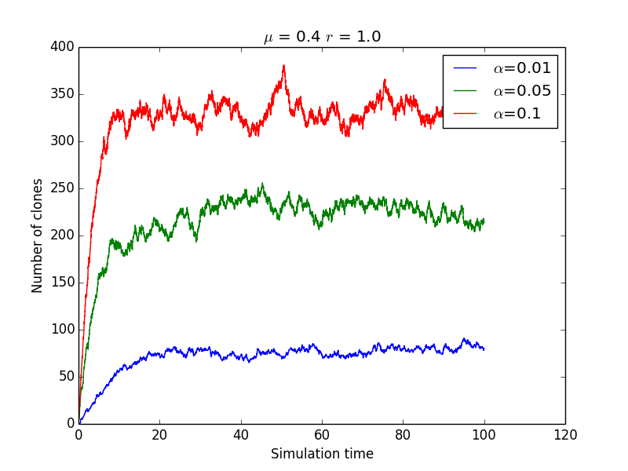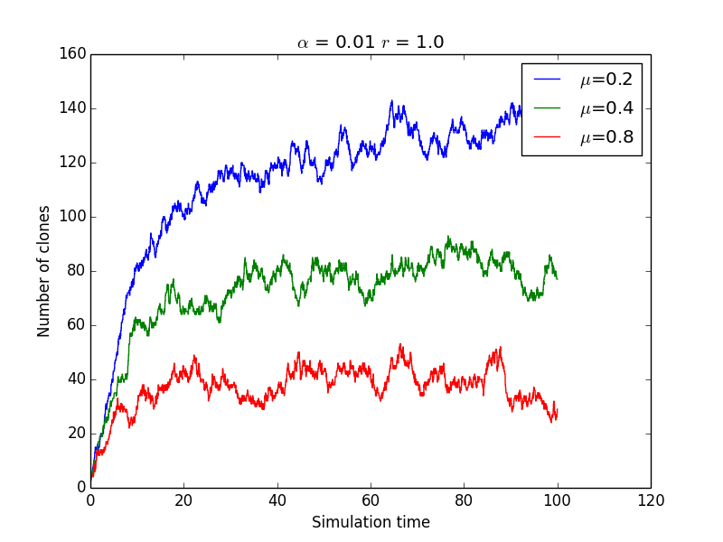

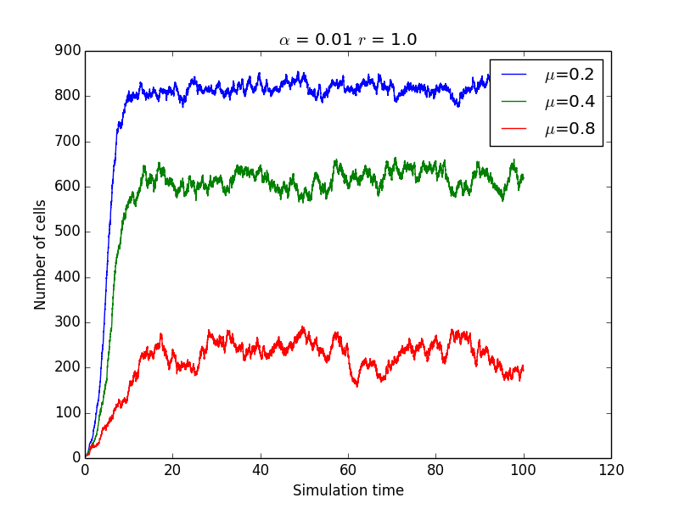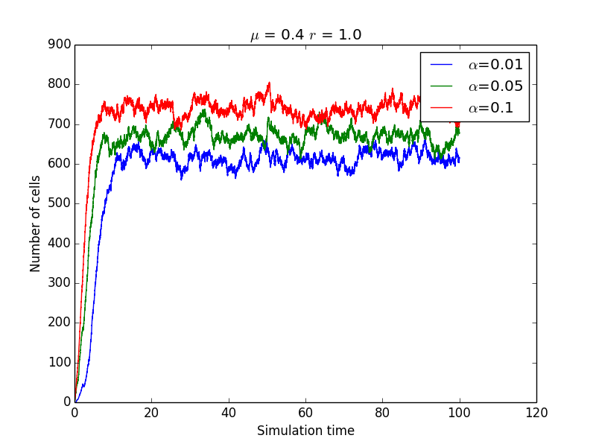

Then we compare results with steady state analytical calculations:

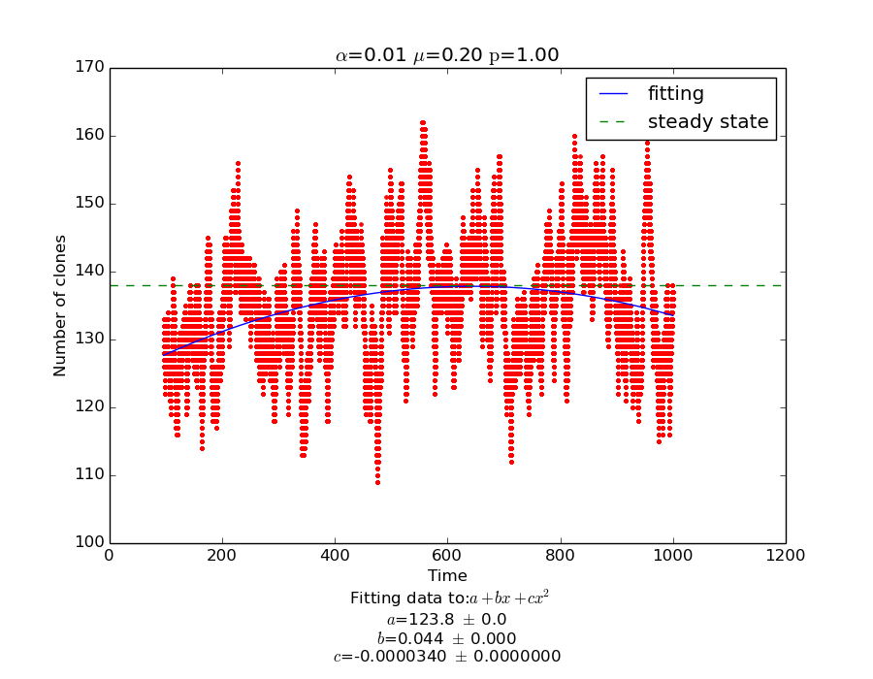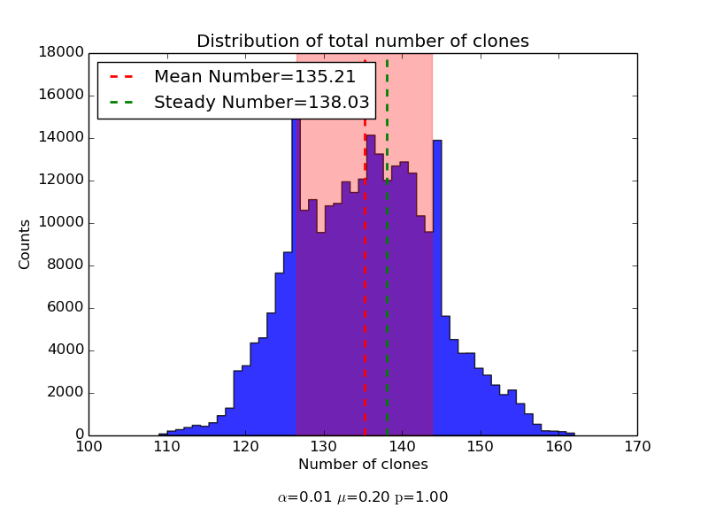

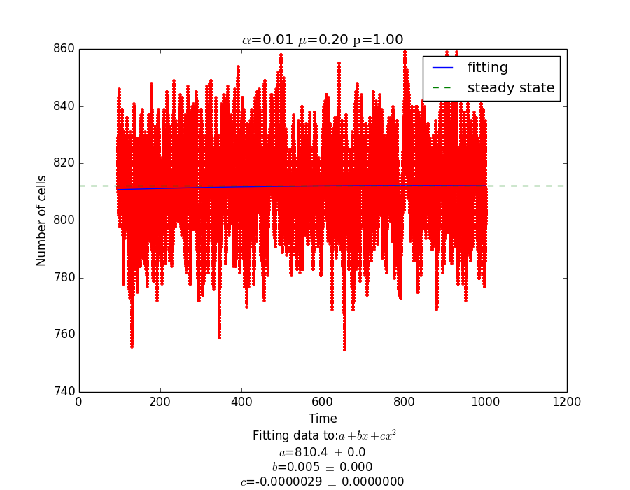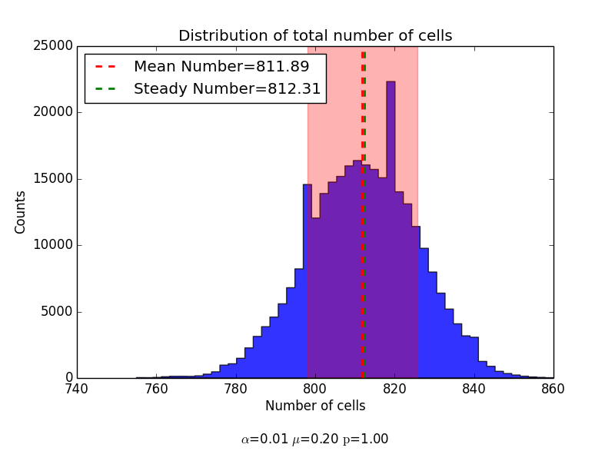

# Future directions

We suggest two possible ways to extend the project:

* Add the mature blood cells pool to study dynamics of the fully differentiated cells
* Study dynamics of the transient state, before system reaches the equilibrium