|  |  |  |  |
| --- | --- | --- | --- |
|  | Nama : | Mufqi Uwais Nastiar Salim | Sabtu, 17 Oktober 2020 |
| NIM : | 181524017 | Pengembangan Web |
| Kelas : | 3A/D4-Teknik Informatika | Screenshot Hasil Tugas MLM |

Screenshot data dummy di postgrasql

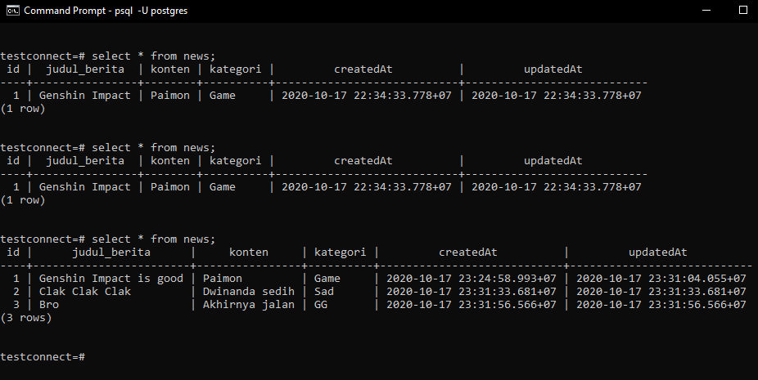

Screenshot data baru input

