Deore Mufrad Hendrady
1301223029
TP MOD 8

https://github.com/mufrad2004/TP-STD/tree/main/TP-8

header.h
https://github.com/mufrad2004/TP-STD/blob/main/TP-8/header.h
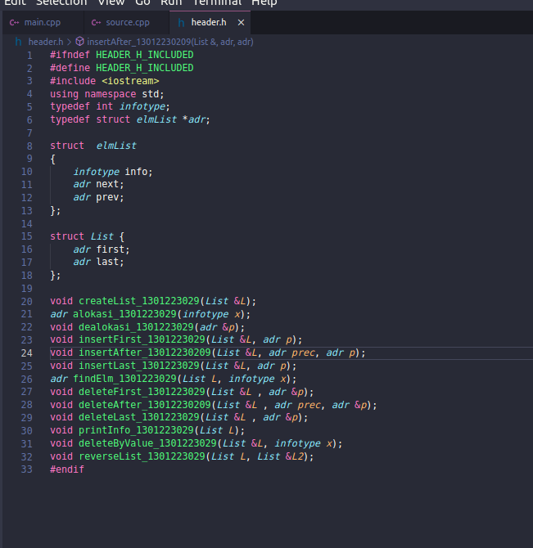

source.cpp
https://github.com/mufrad2004/TP-STD/blob/main/TP-8/source.cpp

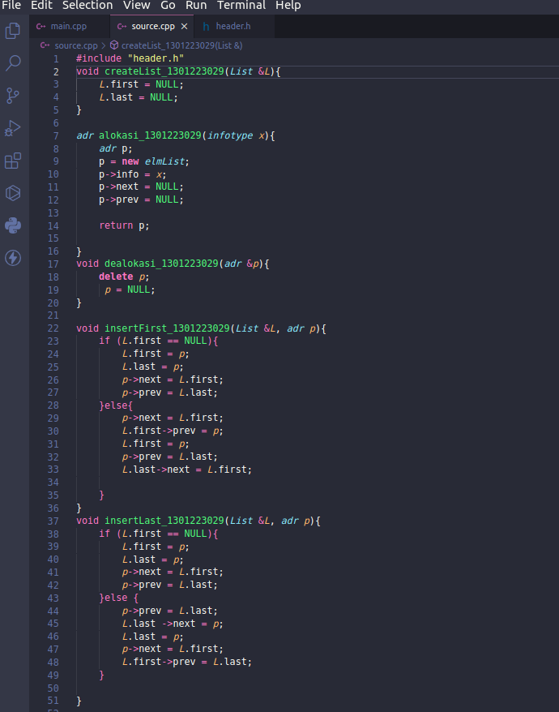

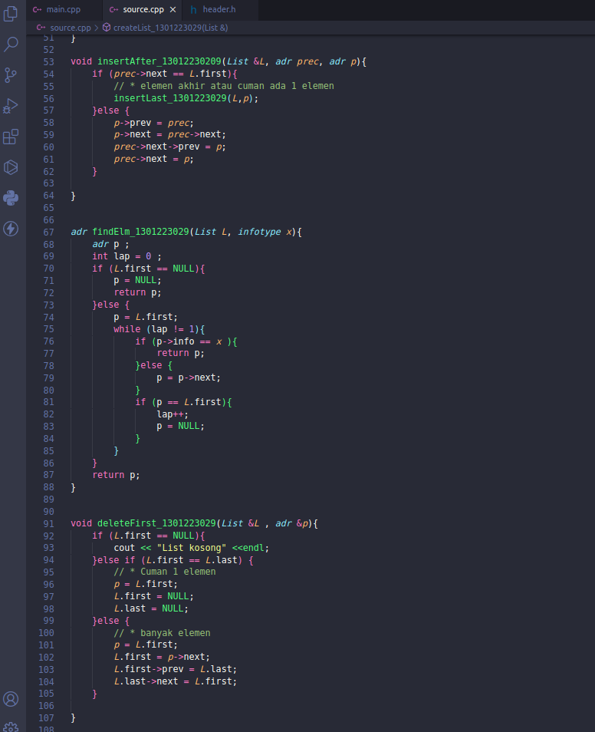

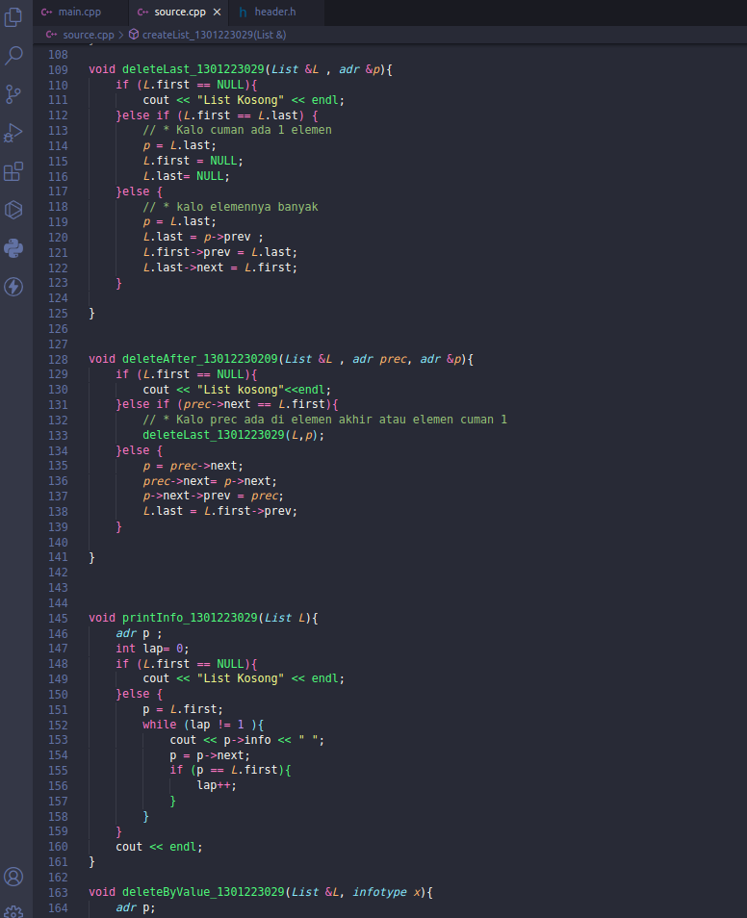

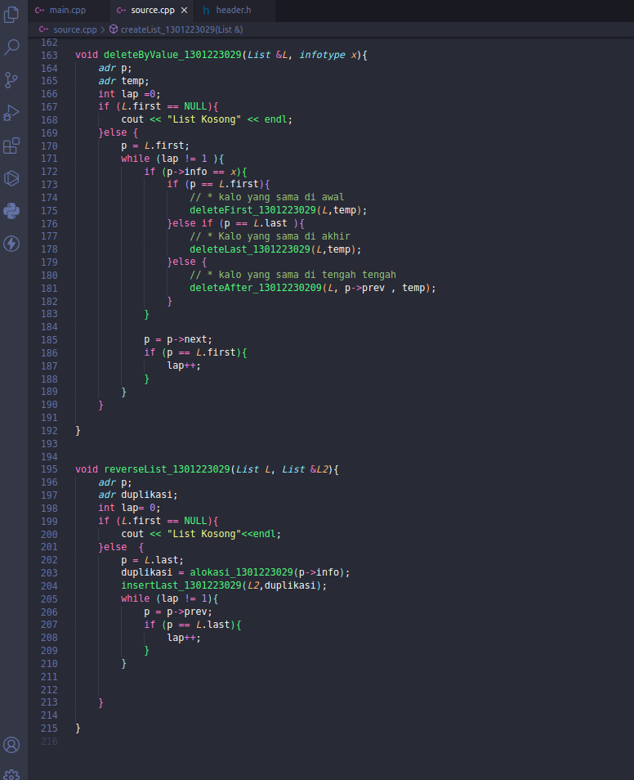

main.cpp
https://github.com/mufrad2004/TP-STD/blob/main/TP-8/main.cpp

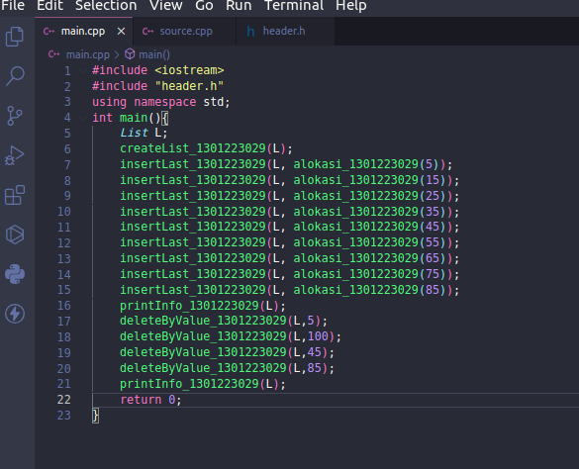

output
