**Task 1**

**Documents Management:**

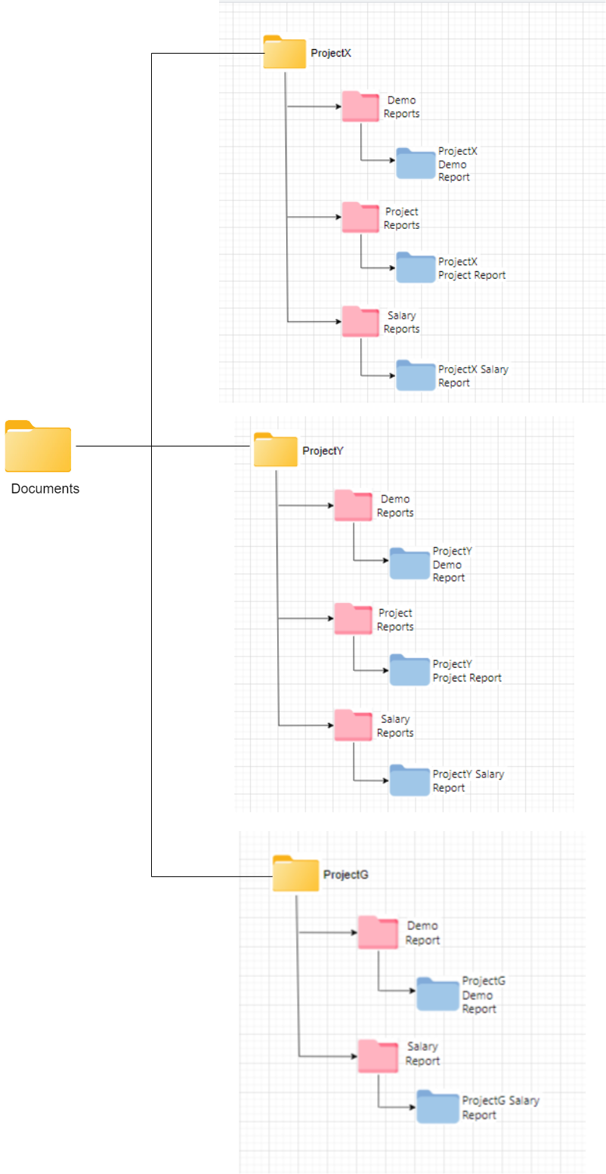

**Task 2**

Given that,

Total number of images = 100,000

3 Classes are Bounding Box, Polygon, Key-point

According to annotation benchmarks,

Bounding Box = 10 sec

Polygon = 15 sec

Key-point = 5 sec

According to quality Check benchmarks,

Bounding Box = 5 sec

Polygon = 7 sec

Key-point = 3 sec

Each image averages 1 object per class.

Effective Working Hours per Day (seconds) = 6 hours/day

= 6× 60 × 60 seconds/day

= 21,600 seconds/day

**1. Total effective working hours to finish the task including and excluding the Quality Check:**

Total Time for Annotation (excluding Quality Check) = ( Total Time for Bounding

Box Annotation + Total Time for Polygon Annotation + Total Time

for Key-point Annotation ) seconds

= (100,000 × 10) + (100,000 × 15) + (100,000 × 5) seconds

= ( 1000000 + 1500000 + 500000 ) seconds

= 3000000 seconds

Total time for Quality Check = 100,000×5 seconds×1 annotator

= 500000 seconds

Total Time including Quality Check = Total Time for Annotation (excluding Quality Check) + Total time for Quality Check

= ( 3000000 + 500000 ) seconds

= 3,500,000 seconds

Total effective working hours to finish the task (excluding Quality Check)

= 3000000 seconds / 21600 seconds/day

= 139 days (Approximately)

Total effective working hours to finish the task (including Quality Check)

= 3500000 seconds / 21600 seconds/day

= 162 days (Approximately)

1. **Total number of annotators required to accomplish the task in 10 days:**

Here,

Number of days to complete the task = 10 days

Total effective working hours required = 10 days × 21600 seconds/day

= 216000 seconds

Total time required for annotation (excluding Quality Check) = 3,000,000 seconds

Number of annotators required = 3000000 seconds / 216000 seconds/day

=13.89

Rounding up to the nearest whole number, 14 annotators would be required.

1. **Estimated date to deliver the project to the client with extra 5 annotators (exclude off-days):**

Total annotators = 1 (initial) + 5 (extra) = 6 annotators

Total effective working hours per day with 6 annotators = 6×21600 seconds/day

= 129,600 seconds/day

Total time required for annotation (including Quality Check) = 3,500,000 seconds

Number of days required = 3,500,000 seconds / 129,600 seconds/day

= 27 days

Starting from 02 February 2024,

The estimated delivery date = 02 February 2024 + 27 days = 01 March, 2024

**Task-3**

From: [naznin51-026@diu.edu.bd](mailto:naznin51-026@diu.edu.bd)

To: projectmanager@quantigo.ai

Subject: Update on Annotation Task Timeline

Sir,

Assalamu Alaikum. I wanted to update you on the annotation task's timeline.

We have 100,000 images to annotate with three different types of annotations. After calculating, it looks like we need about 162 days for one annotator to finish the task, or 10 days with a team of 14 annotators.

Good news: HR has provided us with 5 extra annotators! With their help, we're on track to finish by 01 March 2024.

Thanks for your understanding. If you have any questions, please let us know.

Best regards,

Naznin Nahar Jyoti,

Project Intern

**Task-4**

Here's the priority order for the mentioned tasks to ensure smooth execution of the task/project:

**1. You have missed a delivery deadline for an ongoing batch**

- Addressing a missed delivery deadline is the highest priority as it's time-sensitive and directly impacts client expectations and project timeline.

**2. A batch that you will have to deliver tonight**

- Delivering the batch due tonight is the next priority to ensure timely completion and maintain trust with the client.

**3. Feedback arrived on a particular batch you delivered earlier**

- While feedback is crucial for improvement, addressing it is of lower urgency compared to meeting current delivery deadlines and delivering batches due shortly.

**4. A new batch has arrived from the sales team and you need to do the DEMO**

- The DEMO for the new batch is of the lowest priority among the listed tasks. It's essential for showcasing capabilities and business development, but it can be scheduled without immediate urgency as it doesn't have a direct impact on ongoing deliverie**s** or client commitments.