pfSense Firewall Setup & Hardening
Hands-On Lab Guide
Network Security Unit | Practical Lab
Field | Details
Author | Mufthi Thanzeel
Institution | University of the Sunshine Coast
Unit | Network Security
Tools Used | pfSense 2.8.1, VirtualBox, Kali Linux, Ubuntu
Frameworks | NIST CSF, ASD Essential Eight, CyBOK
Difficulty | Intermediate

1. Lab Overview
In this lab you will deploy and configure a pfSense firewall in a virtualised environment. pfSense is a widely used open-source firewall and router platform built on FreeBSD, used in both enterprise networks and educational labs worldwide.
By the end of this lab you will be able to configure WAN and LAN interfaces, define firewall rules to control traffic, and enable Snort for intrusion detection.

Learning Objectives
- Access and navigate the pfSense web GUI
- Understand WAN and LAN interface configuration
- Create and interpret firewall rules
- Enable and verify Snort IDS on both interfaces
- Align lab activities to the ASD Essential Eight and NIST CSF

Lab Topology
VM | Role
pfSense 2.8.1 | Firewall / Gateway (192.168.1.1)
Ubuntu | LAN client — accesses pfSense web GUI
Kali Linux | Attacker machine for testing firewall rules
Windows 10 | Optional additional LAN client

2. Prerequisites
- VirtualBox installed with pfSense, Ubuntu, and Kali VMs
- pfSense VM has two network adapters: NAT (WAN) and Internal Network (LAN)
- Ubuntu VM is on the same Internal Network as pfSense LAN
- pfSense is booted and showing the console menu

Note: pfSense default login credentials are admin / pfsense. Change these immediately in a production environment.

3. Accessing the pfSense Web GUI
- Start your pfSense VM in VirtualBox and wait for the console menu to appear.
- Start your Ubuntu VM.
- Open Firefox in Ubuntu and navigate to https://192.168.1.1
- Accept the security warning by clicking Advanced > Accept the Risk and Continue.
- Log in with username admin and password pfsense.
- You will be taken to the Status / Dashboard page.

Tip: The dashboard shows system information including pfSense version, CPU type, and real-time firewall logs. Always check the version is up to date before beginning lab work.

4. WAN Interface Configuration
The WAN interface connects pfSense to the external network (simulated by VirtualBox NAT in this lab). Navigate to Interfaces > WAN to review the settings.

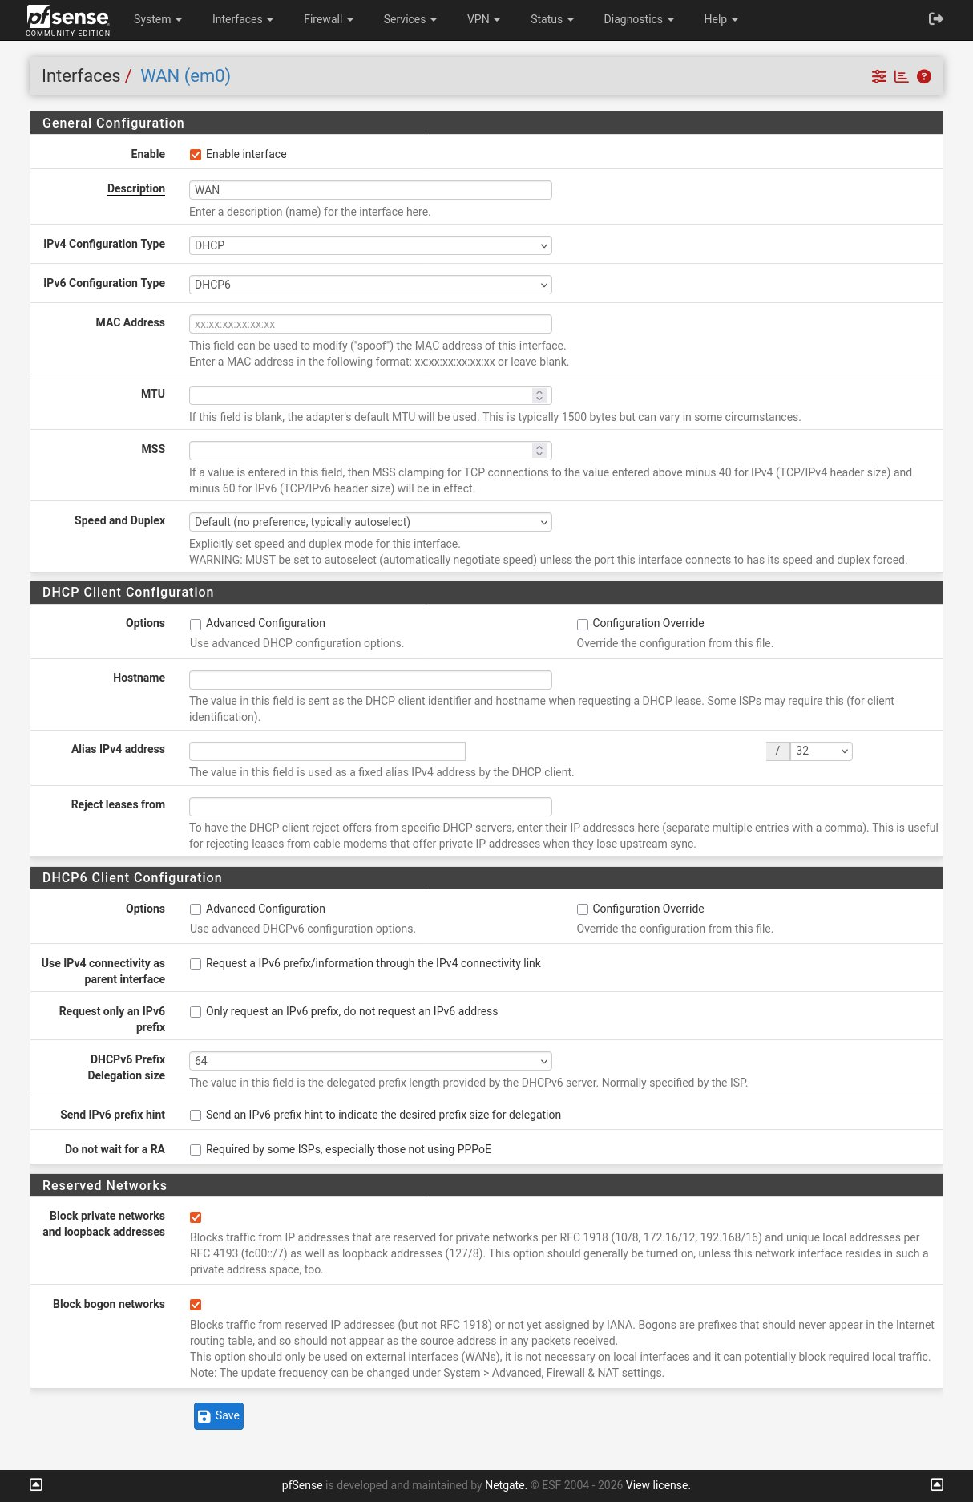
Figure 1: WAN Interface (em0) configuration page

Key Settings Explained
Setting | Value / Purpose
IPv4 Configuration Type | DHCP — pfSense automatically receives an IP from VirtualBox NAT
IPv6 Configuration Type | DHCP6 — IPv6 address also assigned automatically
Block private networks | Enabled — blocks RFC 1918 addresses arriving on WAN (security hardening)
Block bogon networks | Enabled — blocks reserved/unassigned IP ranges from entering the network

ASD Essential Eight alignment: Blocking private and bogon networks on the WAN interface reduces the attack surface and aligns to the 'Restrict Administrative Privileges' and 'Network Segmentation' controls.

5. Firewall Rules
Firewall rules define what traffic is allowed or denied on each interface. Navigate to Firewall > Rules to review the WAN and LAN rule sets.

5.1 WAN Rules
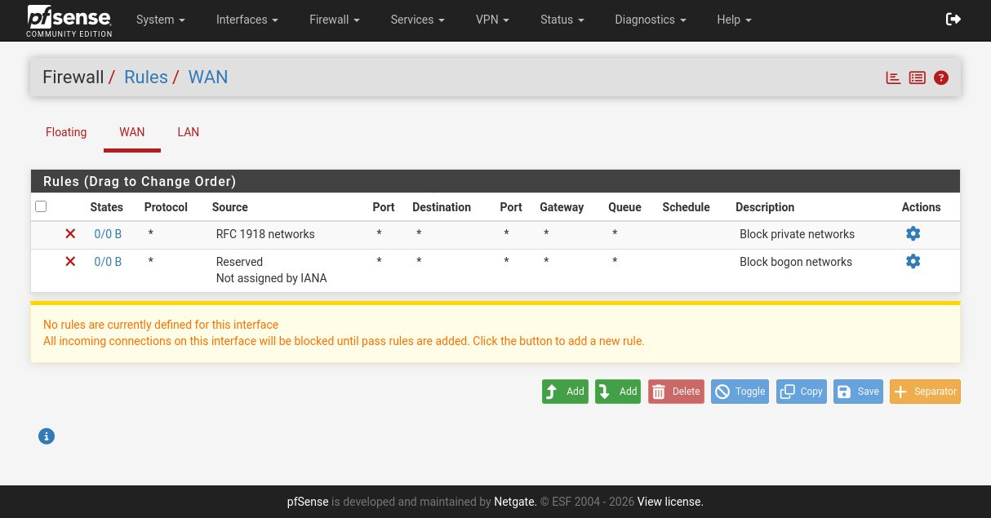
Figure 2: Firewall Rules — WAN interface

The WAN interface has two default deny rules:
- Block private networks — drops traffic sourced from RFC 1918 address space (10.x, 172.16.x, 192.168.x)
- Block bogon networks — drops traffic from reserved or unassigned IANA address ranges

Important: The yellow notice at the bottom of the WAN rules page states that all incoming connections are blocked by default until pass rules are added. This is the correct default security posture — deny all, permit by exception.

5.2 LAN Rules
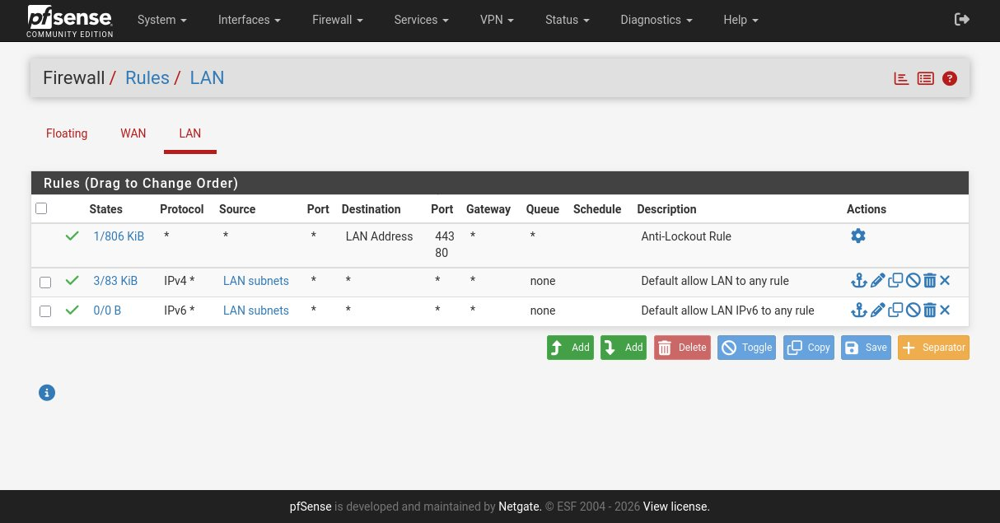
Figure 3: Firewall Rules — LAN interface

The LAN interface has three default rules:
- Allows access to the pfSense web GUI on port 443/80 — prevents administrators from accidentally locking themselves out: Anti-Lockout Rule
- Permits all outbound IPv4 traffic from LAN clients — this is the standard default for small networks: Default allow LAN to any (IPv4)
- Same as above for IPv6 traffic: Default allow LAN to any (IPv6)

Lab Exercise: Try adding a block rule above the default allow rule to deny ICMP (ping) from the LAN to the WAN. Test it from Ubuntu by pinging 8.8.8.8. Then remove the rule and confirm pings succeed again.

6. Snort Intrusion Detection System
Snort is an open-source IDS/IPS (Intrusion Detection/Prevention System) that analyses network traffic against a ruleset to detect malicious patterns. In this lab Snort is installed on pfSense and monitoring both WAN and LAN interfaces.

Navigate to Services > Snort to view the interface configuration.

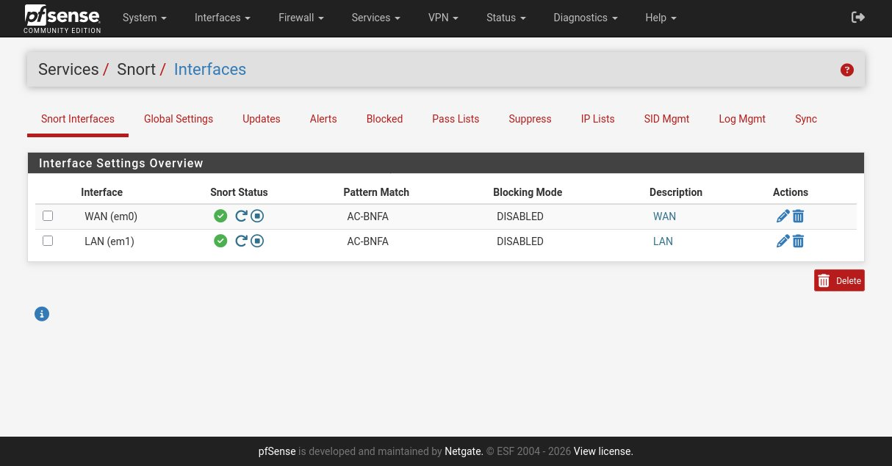
Figure 4: Snort Interfaces — WAN (em0) and LAN (em1) both active

What You Can See
Column | Meaning
Interface | Which network interface Snort is monitoring
Snort Status | Green tick = Snort is running on this interface
Pattern Match | AC-BNFA = Aho-Corasick pattern matching algorithm (efficient multi-pattern search)
Blocking Mode | DISABLED = detection only mode; enable to actively block threats

NIST CSF alignment: Snort supports the Detect function of the NIST Cybersecurity Framework. It provides continuous monitoring (DE.CM) and anomaly/event detection (DE.AE) capabilities.

Lab Exercise — Enable Blocking Mode
- Click the edit (pencil) icon next to the WAN interface in Snort.
- Scroll to the Blocking section and enable Block Offenders.
- Save and restart Snort.
- From Kali, run a port scan against pfSense: nmap -sS 192.168.1.1
- Check Services > Snort > Blocked to see if Kali's IP has been blocked.

7. Reflection Questions
Answer the following questions in your lab report:

- Why is it important to block private networks on the WAN interface? What attack does this mitigate?
- The LAN default rule allows all outbound traffic. Is this appropriate for an enterprise network? What would you change?
- Snort is currently in detection-only mode. What are the risks of enabling blocking mode in a production environment?
- Map each configuration step in this lab to one or more ASD Essential Eight controls. Justify your answer.
- How does pfSense support the NIST CSF Protect and Detect functions?

8. Summary
In this lab you have:
- Deployed pfSense 2.8.1 in VirtualBox and accessed the web GUI from an Ubuntu LAN client
- Reviewed and understood WAN interface settings including private and bogon network blocking
- Inspected default firewall rules on both WAN and LAN interfaces
- Verified Snort IDS is actively monitoring both interfaces
- Connected lab activities to NIST CSF and ASD Essential Eight frameworks

Framework Alignment Summary
Control / Framework | Covered in This Lab
ASD Essential Eight — Patch OS | pfSense 2.8.1 confirmed as latest version
ASD Essential Eight — Network Segmentation | WAN/LAN separation with firewall rules
NIST CSF — Protect (PR.AC) | Firewall rules restrict access by default
NIST CSF — Detect (DE.CM) | Snort IDS monitoring both interfaces
CyBOK — Network Security | Firewall rule logic, IDS deployment

Created by Mufthi Thanzeel | ICT Lecturer, University of the Sunshine Coast | mufthi.thanzeel@gmail.com

