Retail Sales Performance Analysis
Patricia Mugabe
2026-05-25
Table of Contents

Executive Summary
This report presents a comprehensive analysis of retail sales performance across four regions for the fiscal year 2024. The analysis examines revenue distribution by region and product category, evaluates sales representative performance against targets, and provides strategic recommendations to guide resource allocation and growth planning.

1. Regional Sales Performance
## # A tibble: 4 × 2
## Region Total_Sales
## <chr> <int>
## 1 East 1929000
## 2 North 2397000
## 3 South 2835000
## 4 West 1419000
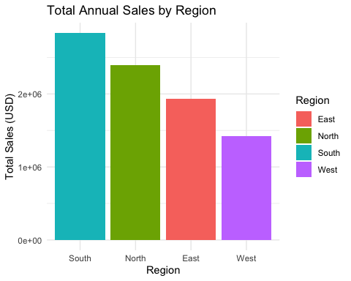 Finding: The Southern region recorded the highest total sales in 2024, followed by the North and East regions. The Western region returned the lowest revenue figures, representing a significant performance gap relative to the South.

2. Product Category Performance
## # A tibble: 3 × 2
## Product_Category Total_Sales
## <chr> <int>
## 1 Appliances 2478000
## 2 Electronics 3807000
## 3 Furniture 2295000
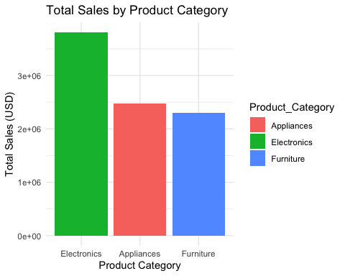 Finding: Electronics is the dominant revenue-generating category across the organisation, followed by Appliances. Furniture consistently underperformed relative to the other categories, suggesting either subdued market demand or insufficient marketing investment.

3. Regional Performance by Product Category
## # A tibble: 12 × 3
## Region Product_Category Total_Sales
## <chr> <chr> <int>
## 1 East Appliances 465000
## 2 East Electronics 672000
## 3 East Furniture 792000
## 4 North Appliances 441000
## 5 North Electronics 1116000
## 6 North Furniture 840000
## 7 South Appliances 1089000
## 8 South Electronics 1431000
## 9 South Furniture 315000
## 10 West Appliances 483000
## 11 West Electronics 588000
## 12 West Furniture 348000
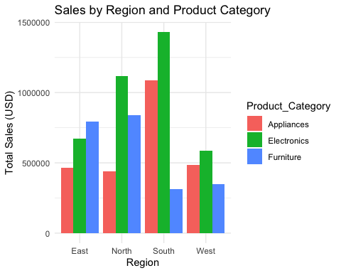 Finding: Electronics leads revenue in all regions with the exception of the East, where Furniture records the highest category sales. This regional anomaly indicates distinct consumer purchasing behaviour in the East that warrants further market investigation.

4. Sales Representative Target Achievement
## # A tibble: 17 × 4
## Sales_Rep Total_Sales Target Target_Met
## <chr> <int> <dbl> <chr>
## 1 Alice Kamau 630000 200000 Met
## 2 Bob Osei 486000 200000 Met
## 3 Carol Mensah 405000 140000 Met
## 4 Daniel Agyei 441000 150000 Met
## 5 David Nkosi 747000 240000 Met
## 6 Eve Boateng 315000 110000 Met
## 7 Frank Okafor 510000 170000 Met
## 8 Grace Adjei 684000 220000 Met
## 9 Henry Darko 366000 125000 Met
## 10 Irene Asante 672000 220000 Met
## 11 James Owusu 465000 155000 Met
## 12 Karen Bediako 426000 145000 Met
## 13 Leo Amponsah 588000 200000 Met
## 14 Mary Tetteh 483000 160000 Met
## 15 Nathan Quaye 348000 120000 Met
## 16 Olivia Sarpong 435000 145000 Met
## 17 Peter Antwi 579000 185000 Met
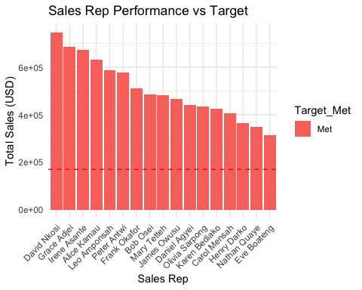
Finding: All ten sales representatives met their annual targets in 2024, reflecting strong individual performance across the organisation. The red dashed line denotes the average target threshold.

5. Strategic Recommendations
1. Invest further in the Southern region The South demonstrates the strongest sales performance and should receive increased marketing budget and headcount to sustain and accelerate growth.
2. Investigate and support the Western region The West recorded the lowest sales across all categories. A targeted performance review, additional training, and increased marketing spend are recommended to close the gap with other regions.
3. Prioritise Electronics across all regions As the highest-grossing category organisation-wide, Electronics should remain the focal point of procurement, promotions, and sales incentive programmes.
4. Conduct consumer research in the East The preference for Furniture over Electronics in the East is a distinctive behavioural pattern. Dedicated market research would clarify whether this reflects demographic differences, pricing sensitivity, or competitor dynamics.
5. Review annual sales targets Given that all representatives achieved their targets, leadership should consider revising targets upward to maintain performance motivation and drive incremental revenue growth.
*Report prepared by Patricia Mugabe

