

**ZETECH UNIVERSITY.**

**High School Result Management and**

**Registration System.**

**A PROJECT PROPOSAL SUBMITTED IN PARTIAL   
FULFILLMENT OF THE REQUIREMENTS FOR BACHELOR’S DEGREE IN INFORMATION TECHNOLOGY NOVEMBER 2021.**

**PRESENTED BY:**

**VICTOR MUGAMBI- BSCIT-01-0003/2020.**

**IAN ADEYA- BSCIT-01-0006/2020.**

# ACKNOWLEDGMENT

We would like to express our special thanks of gratitude to our teacher Madam

Josephine Magu who gave us the golden opportunity to do this wonderful project, which also helped us in doing a lot of Research and we came to know and practice and integrate many things we have been learning in class and we are really thankful to her.

Secondly we would also like to thank our parents and friends who helped us a lot with motivation to finalize this project within the limited time frame. We are overwhelmed in all humbleness and gratefulness to acknowledge in depth to all those who have helped us put these ideas, well above the level of simplicity and into something concrete.

# DEDICATION

We dedicate this project to our parents and family who have never failed to give us financial and moral support, during the time we developed our system and for teaching us that even the largest of tasks can be accomplished if it is done one step at a time. We dedicate this project to our friends and colleagues who have participated in helping us complete this project.

# ABSTRACT

For several years, efforts have been made to ease the difficulties faced by students at registration, result and transcript generation and the accompanying hardship faced by desk officers who are in charge of processing these applications. There are errors associated with the existing manual method of processing of students results in most Higher Intuitions in Kenya, this makes it not only desirable but imperative that students’ result processing be computerized.

Online registration emerged because of these problems associated with manual handling of registration and student records. Other problems include mismanagement of students’ academic records, mismanagement of courses registered for, among others. The solution to these problems, therefore, is to find a method of processing examination results that would be sufficiently accurate and reasonably timely. Online Result management and Registration is a system that could easily manage its student body while also providing added bonuses, with a main goal being to ease the transfer of information.

Table of Contents

ACKNOWLEDGMENT 2

DEDICATION 3

ABSTRACT 4

CHAPTER ONE 8

INTRODUCTION 8

BACKGROUND 8

PROBLEM STATEMENT 8

OBJECTIVES 9

SCOPE AND LIMITATION OF THE PROJECT 9

CHAPTER TWO 10

LITERATURE REVIEW 10

**Introduction** 10

My School for Management 10

My School for Administrator 10

My School for Parent 11

My School for Student 11

Technologies used in My School 11

Chapter 3 13

METHODOLOGY 13

Introduction 13

Methodology 13

Prototyping Model 14

Advantages of Prototyping 14

The Process of Prototyping 14

Phases in prototype Model 15

**Conclusion** 16

PROJECT TASKS AND TIMELINE 16

Conclusions. 17

CHAPTER FOUR 18

SYSTEM ANALYSIS AND REQUIREMENTS MODELLING 18

SYSTEM ANALYSIS 18

Introduction 18

New system requirements 20

THE CURRENT SYSTEM 20

Functional Requirements 20

Non-Functional Requirements 21

Performance Requirements 21

Hardware & Software requirements 22

Conclusion. 25

CHAPTER FIVE 26

SYSTEM DESIGN 26

Introduction 26

Analyze Phase 26

Build A Prototype. 26

Design Phase 26

Class Diagram 27

Database Tables. 27

CHAPTER SIX 31

SYSTEM IMPLEMENTATION 31

INTRODUCTION 31

Functionality testing 31

Security testing 31

Database testing 31

Proposed changeover 31

**CHAPTER SEVEN** 33

LIMITATIONS, CONCLUSIONS AND RECOMMEDATIONS. 33

RECOMMEDATIONS 33

Conclusions. 33

References 33

**APPENDIX** 34

Codes from the project. 34

**List of tables and figures**

Table 1: project timeline 18

Figure 1: prototyping model 13

Figure 2: phases in prototype model 14

Figure 3: Work Breakdown Structure 16

Figure 4: DFD 22

Figure 5: Admin Usecase 23

Figure 6: Student use Case 23

Figure 7:Parent Usecase 24

Figure 8 : class diagram 26

Figure 9: database tables 27

Figure 10: admin_dashboard 28

Figure 11: student_dashboard 28

Figure 12:posts.php 29

Figure 13: admin_dashboard.php 33

Figure 14: addmarks.php 34

Figure 15: add_student.php 34

# CHAPTER ONE

## INTRODUCTION

### BACKGROUND

Nowadays education plays a great role in development of any country. Many of education organizations try to increase education quality. One of the aspects of this improvement is managing of school resources. Our system is a major tool through which this managing process can be made easier for managing student results, registration and getting feedback from parents. In order to achieve that goal, we need a Website that covers the needs of all users at the same time.

For Students, they can view their subject's grades, contact the school for any complaint and they are also able to view important school updates published on the student portal. For the Administrator, they have a full control on the system, like they can add a new parent and students with their subjects and classes.

The administrator also adds student grades, edit results and He/she can also see feedback messages sent by parents or student. . All the system users can view whatever the Administrator publishes within the educational updates section, and these posts are visible for all the users.

Parents have access to their sons/daughters grades without any possibility to edit on it, and they can directly contact with the Administrator.

## PROBLEM STATEMENT

The academic achievement for many students has declined, because of lack of care from their parents, and this refers to that their parents do not have free time to come to school and see student progress. Head teachers and Teachers are facing problems at the start of every new academic year, because of distribution process for courses and classes, in addition to this , through and at the end of every year another problem is facing them, which is the complexities of the grades entry process for their students . Lack of a communication platform between the school Staff and parents has a bad reflection on the education process, since a school is a community and all stakeholders need to be updated of important projects going on in school.

The manual methods being employed suffer a number of set-backs which includes; computational miscalculation, others are high turnover time for processing, difficult retrieval of student results and so on making the process to be time consuming and prone to error. All these lead to examination results being published late, sometimes with wrong grades being entered and students’ grade point averages being wrongly computed as a result, and ultimately leading to wrong conclusions being arrived at on grades being awarded. Some students could end up with undeserved fail result, while others could be unfairly victimized, bringing about frustration.

## OBJECTIVES

The objectives of this project are:

To build a web application for managing the different school activities and help parents track student’s grades. This project will help build a virtual community between the members of educational process.

## SCOPE AND LIMITATION OF THE PROJECT

Highschool result management and registration system has been designed to provide an easy way for Kenyan students to get their grades, and for their parents to be familiar with the grades and the academic achievement for their kids .However this project is facing some obstacles which deny it from achievement it’s goals, like : lack of acceptance these idea from some teachers and Head teachers, because of their little knowledge about using that technology or they find that using computers in their works instead of the paper works so hard and difficult.

# CHAPTER TWO

## LITERATURE REVIEW

### **Introduction**

This chapter identify the concepts of High school result management and resistration system for management, administrator, students and parents. Also review the related works with it.

High school result management and resistration system is a complete school information management solution. Today's schools need to manage more information than ever before. Without a solid internal infrastructure for school staff and departments to share data, critical school and student information can be lost, or worse leading to a host of problems that can have effect of a school's image and endurance. To remain competitive, school needs a simple solution that can run individual function, connect their entire operation, use the web as a key communication tool and simplify day to day operational responsibilities, giving staff more time with students.

### My School for Management

- Single point school management software.

- Connect with Parents and other stakeholders effectively.

- Build and Manage community of parents, School(admin) and students.

- Manages all administrative records with zero redundancy.

- Achieve best possible resource optimization.

- Automate Exam Result Management.

### My School for Administrator

- Complete marks/grade management.

- create other users i.e parents and students.

- create classes and their subsequent subjects.

- add student Grades to the system.

- Interact with parents efficiently and effectively.

- create school announcements.

- Email messaging system.

### My School for Parent

- Get latest updates about school through image Gallery, News etc.

- Get connected with schools effectively and easily

- Interact with teachers through a messaging system.

- know academic status about his/her child.

### My School for Student

- Get latest updates about school through image Gallery, News etc.

- Get connected with schools effectively and easily

- know result status with ease.

## Technologies used in My School

**HTML:**

Is the standard markup language used to create web pages. Web browsers can read HTML files and render them into visible or audible web pages. HTML elements form the building blocks of all websites. HTML allows images and objects to be embedded and can be used to create interactive forms. It provides a means to create structured documents by denoting structural semantics for text such as headings, paragraphs, lists, links, quotes and other items.

**CSS:**

CSS stands for Cascading Style Sheets.CSS describes how HTML elements are to be displayed on screen, paper, or in other media CSS saves a lot of work. It can control the layout of multiple web pages all at once.External stylesheets are stored in CSS files

**PHP:**

Is an open source server-side language which is used for creating dynamic web pages. It can be embedded into HTML. PHP is usually used in conjunction with a MySQL database on Linux/UNIX web servers. It is probably the most popular scripting language. And it is a widely-used general purpose scripting language and interpreter that is freely available. A full explanation of all the PHP tags.

**MySQL Database:**

MySQL is the world's most popular open source database. With its proven performance, reliability and ease-of-use, MySQL has become the leading database choice for web-based applications, used by high profile web properties including Facebook, Twitter, YouTube, Yahoo! and many more.

**JavaScript**

JavaScript (js) is a light-weight object-oriented programming language which is used by several websites for scripting the Webpages. With JavaScript, users can build modern web applications to interact directly without reloading the page every time. The traditional website uses Js to provide several forms of interactivity and simplicity.

# Chapter 3

## METHODOLOGY

### Introduction

This chapter states the methodology used to reach the objectives of the project. The framework in which software is designed, developed, and maintained is known as the Software Development Life Cycle (SDLC). It shows the steps, phases, milestones, and evolution of the software development process. There are many types of models used in software design and development. Among them are the spiral models, rapid development model, Evolutionary model, waterfall model, prototyping model, etc.

### Methodology

Prototyping Model has been used to develop this application. The Prototyping model is a technique for quickly building a function but incomplete model of the information system. There are several kinds of prototypes but they all intend to reduce risk by building a quick and dirty replica or mockup of the intended system. It can be used to demonstrate technical feasibility when the technical risk is high. It can also be used to better understand and elicit user requirements. In either case, the goal is to reduce risk and limit costs by increasing understanding of proposed solutions before committing more resources, as shown in figure 1.

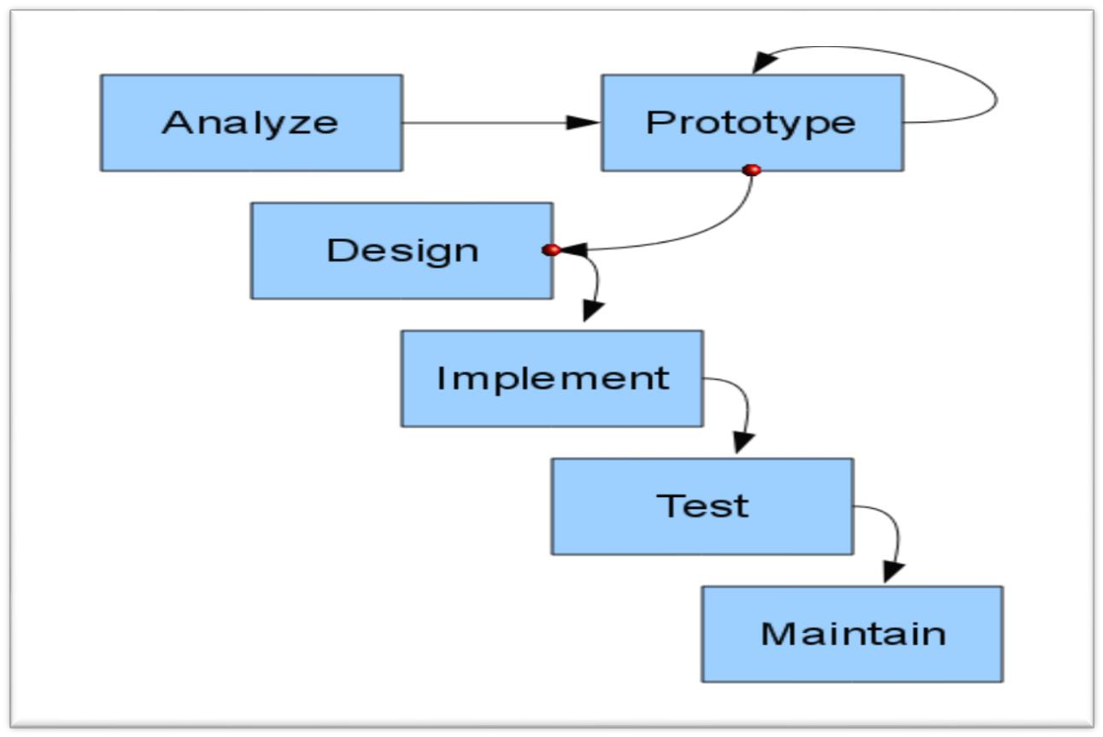

Figure : prototyping model

### Prototyping Model

### Advantages of Prototyping

- Reduces development time.

- Requires user involvement.

- Developers receive quantifiable user feedback.

- Facilitate system implementation since users know what to expect.

- Results in higher user satisfaction.

- Exposes developers to potential future system enhancements.

### The Process of Prototyping

- **Identify basic requirement:** Determine basic requirements including the input and output information desired. Details, such us security, can typically be ignored.

-**Develop initial prototype:** The initial prototype is developed that includes only user interfaces.

-**Review:** The customers, end-users, examine the prototype and provide feedback on additions or changes.

-**Revise and enhancing the prototype:** Using the feedback, both the specifications and the prototype can be improved.

This method involves a series of iterations and refinement until the prototype product is a fully working system, and the user is satisfied.

### Phases in prototype Model

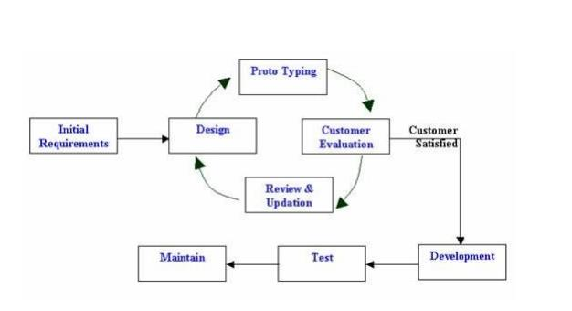

Figure : phases in prototype model

**Phase 1:**

Identify some requirements to begin with: Get lists of some major requirements which define the need for the new system including the main input output information.

**Phase 2:**

Develop initial prototype: Develop a basic initial prototype which only has UI screens.

**Phase 3:**

Review the prototype: End users and SME’s work and examine the prototype and

provide feedback for improvements/enhancements.

**Phase 4:**

Revise and enhance the prototype: Scope is changed based on feedback from end users and the prototype is enhanced and refined to accommodate user feedback.

### **Conclusion**

We used Prototyping Model as our methodology for developing this system, and we described the advantages of prototyping, it’s process, it’s phases and reasons for using this model.

## PROJECT TASKS AND TIMELINE

Table 1: project timeline

|  |  |  |  |
| --- | --- | --- | --- |
| INDEX | ACTIVITY | DEPENDENT ON.. | TIME |
| A | Create admin page and database |  | 3 DAYS |
| B | Create index page of the web app | A | 3 DAYS |
| C | Create student view of the system. | AB | 2 DAYS |
| D | Add functionality to Students view. | C | 1 WEEK |
| E | Add grading functionalities in the system | A | 1 WEEK |
| F | Create Parents view of the system. | C | 1 DAY |
| G | Add functionality to Parent’s view | F | 1 WEEK |
|  |  |  |  |

Figure 3: Work Breakdown Structure

## Conclusions.

In recent years, with the pace of technological development, people have become more and more demanding in terms of quality of life, and schools managers in recent years look to improve performance in their schools to get the highest rate of knowledge and experience in their student.

# CHAPTER FOUR

SYSTEM ANALYSIS AND REQUIREMENTS MODELLING.

### SYSTEM ANALYSIS

#### Introduction

Systems are created to solve problems. We can think of the systems approach as an organized way of dealing with a problem. System Analysis and Design mainly deals with the software development activities. System Analysis is the process of determining the information system’s user requirements through examination of the operations of a system. This can also be achieved by getting user attitudes as regards to the system. The analysis can be achieved through fact-finding techniques, which will help in generation of the information being sought.

A system, is a collection of components that work together to realize some objective. Basically there are three major components in every system, namely input, processing and output.

Tools used in analysis process:

1. *Observation*

It involved direct observation of handling results and school admissions. We observed how students are admitted, how results are handled. We conducted our observations at kanyakine High school.

Objectives

To get information about how student registration and results are handled in Kanyakine high school.

Findings

Noted that the operation of the school are both manually carried out and computerized. Registration information is maintained on both manual files and Ms excel work book. We also noted that documents and files retrieval took a lot of time thus delaying the whole operation.

1. *Interviews*

This is face to face interpersonal role in which the interviewer asks an interviewee questions relating to operations that take place in the business environment.

We had to ask questions to various teachers, students and parents so as to get the required data for the school operations.

Objectives

* To get to know which problems Teachers, students and parents experience when working with the current system/school’s procedures.
* To get to know the head teachers opinion about having a new system/about the current system.
* To know the policies of the school
* To know the activities carried out by the school.

Findings

* I found that there were delays in processing student results and registration due to poor file maintenance.
* Found that there had been a strain getting to communicate with parents.
* I found out that production of newsletters for all parents was a tedious and costly thing for the school.

1. *Questionnaires*

This method was used on the employees. It is fast and also efficient. They are asked a series of questions where they are required to strictly give yes or no answers.

* Is the current system user friendly?
* Does the current system meet ones requirements?
* What problems or difficulties do you encounter while using the current system?
* (list problems)
* Would you propose a new system?
* What would be the new features of the new system?

*Deliverables*

The current system had the following problems:

1. Data Insecurity information is stored on manual files it has been difficult to enforce data security.
2. Data unavailability: As same data is stored manually on manual files, records and files have been misplaced making data unavailable both to the employees and the management in general.
3. Difficult in information retrieval: With the current increase in customers and wide services whose information need to be maintained has resulted to maintenance of files/records. With this many records, it has be difficult to find individual record which has also resulted to delayed operation
4. Duplication: Due to the fact that many files are held separately it has led to duplication of data across records, data anomalies (update, deletion, addition anomalies) and duplication of efforts.
5. Lack of information integrity: Due to poor record keeping, loss of data and misplacement of files, it has resulted in lack of correct, accurate and up to date information that also has resulted to missing marks and misgradings.
6. Delayed report preparation :Report making also takes a lot of time as all the files have to be studied carefully before coming up with appropriate documentation
7. It is costly to run: This system (manual) strains the institution’s budget because of large students numbers in records related areas of entry
8. Current system is time wasting: The manual system is labor intensive in terms of data collection, entry, storage and reference.
9. Space wasting: Records are kept in cabinets which are ever on an increase with the increase of records with time hence taking more and more space which could otherwise be used for other institutional operations

### New system requirements

These requirements addresses the problems identified above:

-Reducing cost of human labor.

-Improve accuracy.

-Reduce the time taken to compute the operations and produce student results and transcripts.

-Ensure security in the system.

-Create more space in the school by eradicating the file system.

-Improve efficiency in the school.

The characteristics of the new system of the new system include:

* Faster retrieval of results or information.
* Ability of the system to update stored data.
* Faster communication throughout the school community.
* A system that have privacy i.e. ability to put passwords in some vital documents

Estimation

The estimation of the system after acquiring all the software and hardware recommended in the proposal will be roughly kshs. 85,000 exclusive of the developer’s payment.

#### THE CURRENT SYSTEM

We are trying to overcome the difficulty that comes with manual processing of student grading and admission processes in Kenyan High schools today. Our system encourages the school stakeholders i.e Teachers, students and Parents to use the High School Result Management and Registration System to make their work easier and also to cut cost associated with manual printing of newsletters and result transcripts. The proposed system enables one to track their grades with just a few clicks.

### Functional Requirements

This section describes the functional requirements of the system, these requirements which are expressed in the natural language style.

The Admin is the Administrator of the web application. He/she creates other users, through a User Interface in the Admin Dashboard. The Administrator creates classes, academic years, subjects and exams.

A student user logs in and is authenticated. The student is allowed to select his/her subjects for the year, done once every year. The student can view his/her results based on the exam year, the exam name and the class, the results only shows subjects the student only registered for.

The Administrator can then add grades of a student based on the year, the exam and the class of the student. The system automatically grades the student.

A parent user logs in and is authenticated. The parent can view his/her child’s results based on the exam year, the exam name and the class, the results only shows subjects the student only registered for.

### Non-Functional Requirements

1. Usability

This section includes all of those requirements that effect usability.

* We get the response within seconds.
* The software must have a simple, user-friendly interface so customers can save time and confusion.

1. Supportability

* The system is designed to be the cross platform supportable. The system is supported on a wide range of hardware and any software platforms. Hence it is extremely portable.

1. Implementation

* The system is implemented in web environment. The xampp server is used as the web server and windows 10pro is used as the platform.

1. Interface

* The user interface is based on the web browser. The application is developed using php and HTML along with CSS, bootstrap.
* The Interface design is aimed at a flexible front-end communication to provide the user with clear information, navigating the user-friendly interface.

##### Performance Requirements

The system exhibits high performance because it is well optimized. The business logic is clearly separate from the UI.

* We get the response within seconds.

#### Hardware & Software requirements

|  |  |
| --- | --- |
| **Property** | **Recommended** |
| Hardware | Processor Intel dual core and above |
| Operating System | Windows 7, Windows 8 , windows 10,linux |
| Browser | Google chrome latest version, IExplorer 10; |
| Database | MY SQL |
|  |  |

Software:

* MY SQL: It is a relational database management system. As a database it‘s a software product whose primary function is to store & retrieve data as requested by other software applications, be it those on the same computer or those running on another computer across a network (including the internet).

DataFlow diagram for the proposed system

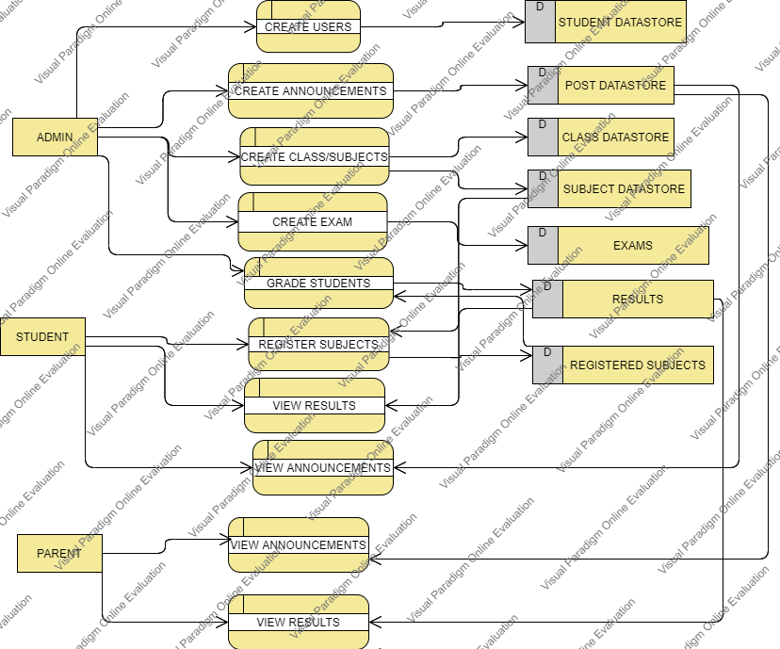

Figure 4: DFD

*System Analysis*

This part contains the analysis of the functional and non-functional requirements using use-case diagrams, and use-cases details.

Use case Diagram

This part contains the analysis of the functional and non-functional requirements using use-case diagrams, and use-cases details.

1. **Admin**

The functions that Admin can do after login, as shown in figure 7: -

Add Teacher include (view teacher).

- Add Student include (view student).

- Add Parent include (view parent).

- Add Class include (view classes).

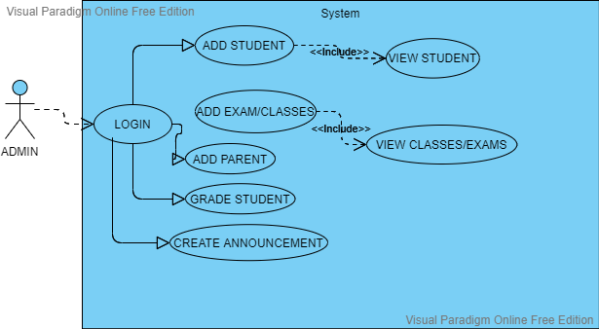

Figure 5: Admin Usecase

1. **Student**

The functions that Student can do after login, function as shown in figure 8:

- View Courses Marks.

- View Personal Details.

- Contact with teachers and headmaster

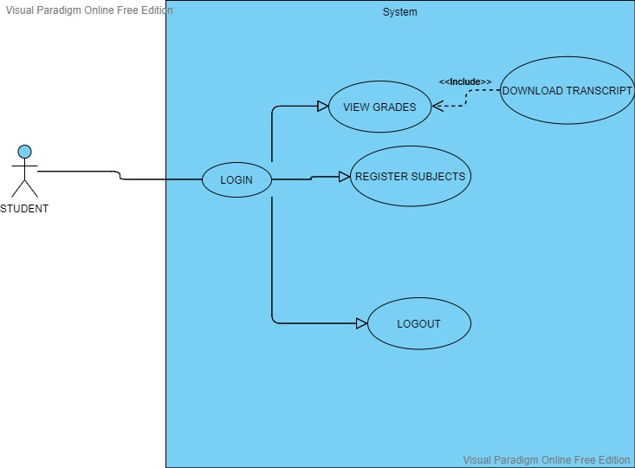

Figure 6: Student use Case

1. **Parent.**

The functions that Parent can do after login, as shown in figure 10:

- View their children’s grades.

- Contact with teachers and admin

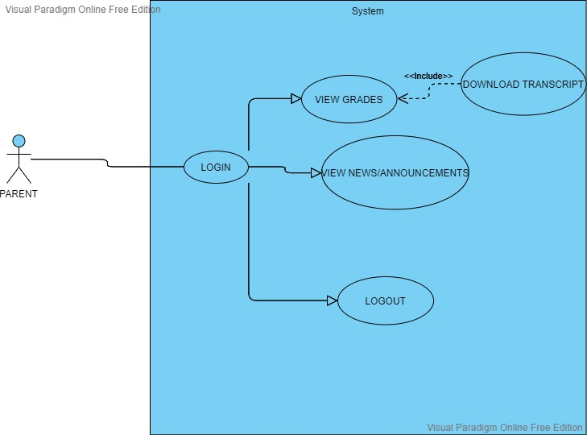

Figure 7:Parent Usecase

#### Conclusion.

We had a description for the system and its users, and the functional and non-functional, then we talked about several tools such as usecase diagrams and Dataflow diagram that have been used to analyze the interactive behavior of the activities.

# CHAPTER FIVE

## SYSTEM DESIGN

### Introduction

This chapter explains the design and implementation phases of the system. It depicts the class diagram, ER diagram and database schema the System. Moreover, the implementation phase combines the requirements, design phase outputs, and process them using the appropriate technologies.

#### Analyze Phase

During the analyze phase, we determined the requirement of the project and got in touch how we can improve the school's performance.

#### Build A Prototype.

In this phase, the tools used in developing the prototype and the developed system are described:

Programming Tool

The system are developed using web development techniques (HTML5, CSS3, JavaScript, JQuery, Bootstrap) that lets us design the system layout such as login form, tables, panels and colors, then implement UI/UX element's such as :

- Make the system ease to use.

- Make the system easy to learn.

- Choose the website color's carefully to enhance user interfaces

Then, make the system dynamic using programming tools (PHP v7, MYSQL DBMS) it let us store the user's information in database and view it through the WebPages using PHP v7 5.4

#### Design Phase

The design phase, the relationships between classes was designed and analyzed using the class diagram. After that, the database schema is developed to illustrate the mapping of the data.

#### Class Diagram

To illustrate the relationships and source code dependencies among classes, class diagram was developed. In this context, the class defines the methods and variables in an object, which is a specific entity in a program or the unit of code representing that entity.

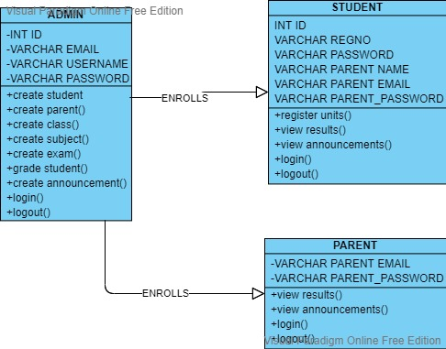

Figure 8 : class diagram

#### Database Tables.

The database of the system was implemented using mysql relational databases. Each table contains different attributes that aid in communication of the system components.

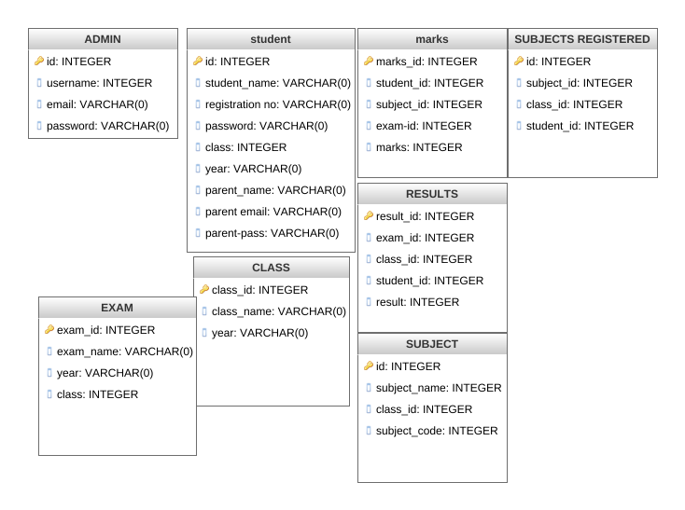

Figure 9: database tables

**INTERFACES**

Admin interface

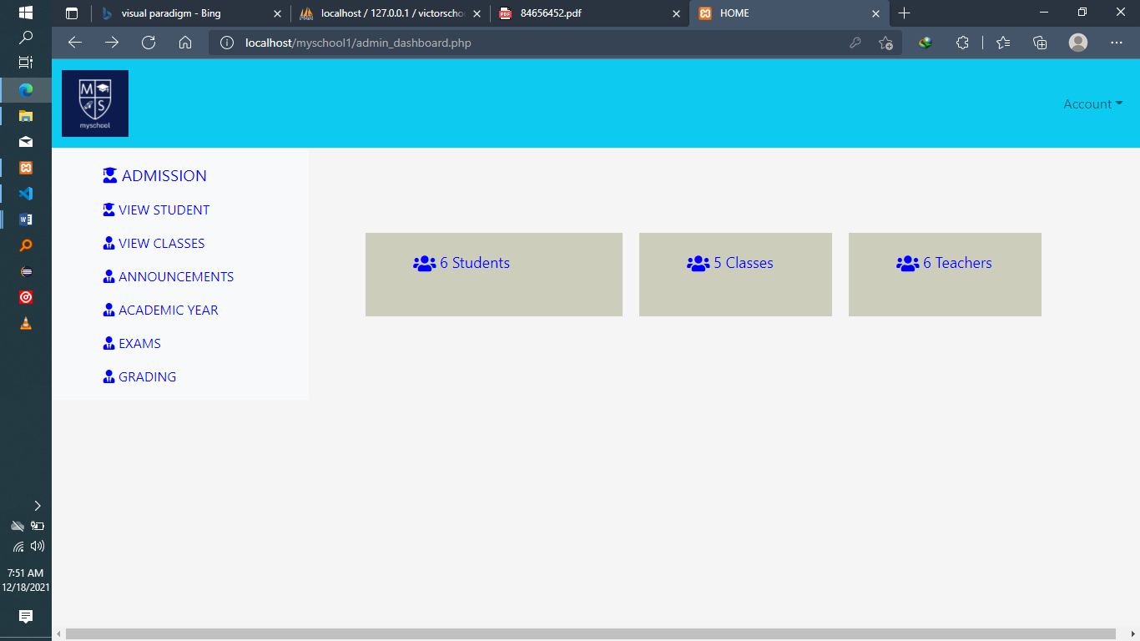

Figure 10: admin_dashboard

Student interface.

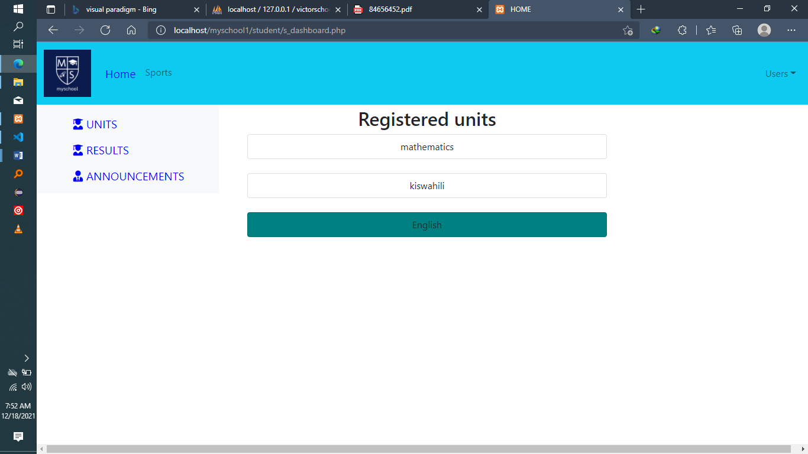

Figure 11: student_dashboard

**Parent interface**

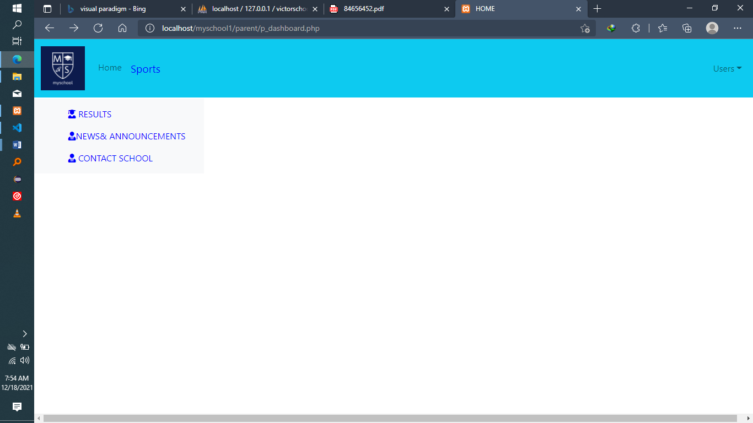

**Create announcement interface**

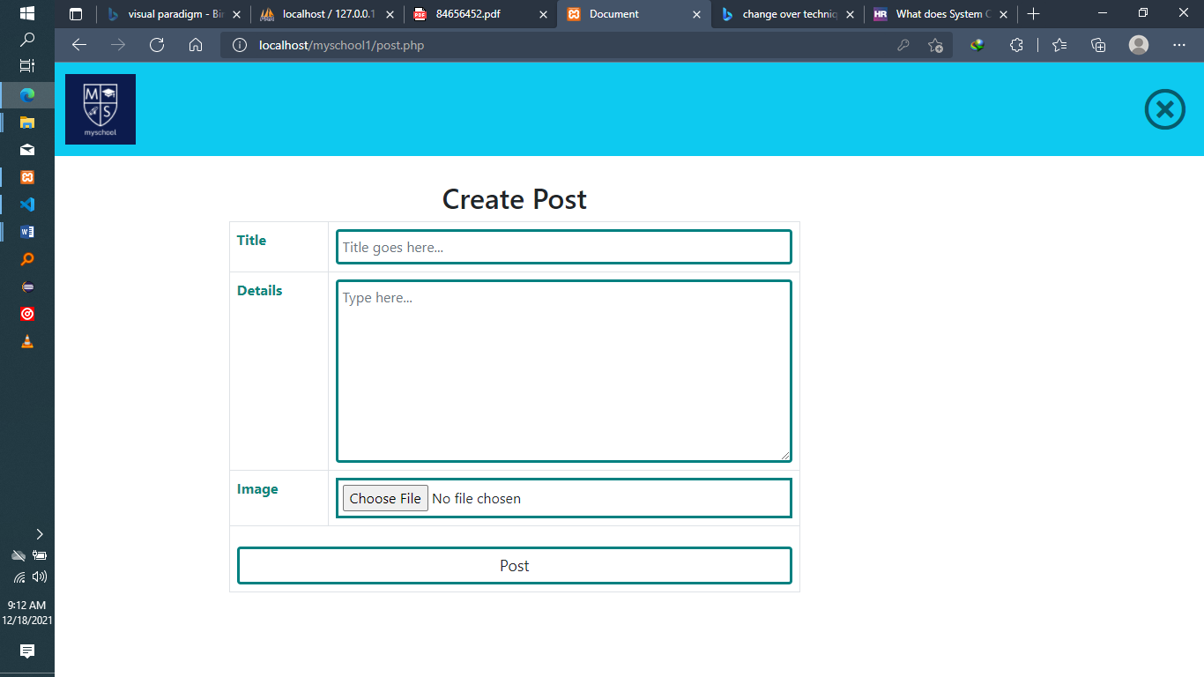

Figure :posts.php

# CHAPTER SIX

## SYSTEM IMPLEMENTATION

### INTRODUCTION

After developing the system’s databases, the implementation phase emerges and through this phase, several activities and techniques were used to develop the web app. The development of the web App starts with designing the website structure using HTML5, then the style of the website was designed using bootstrap and CSS. After that, enhanced user interfaces and dynamic website were developed using JavaScript and JQuery. Later on, the website contents and databases were managed through the use of PHP7.

This chapter also illustrates the last two phase of the project the testing and evaluation phases. In the testing phase, the functionality testing was performed. In addition, the evaluation was performed through these steps, School Admin, Student, and Parent users.

#### Functionality testing

All functions in the application, database connection, forms used to enter data for submission, editing, getting or deleting information from users were tested. Developers performed the test of the website. Some functionality requirements that were tested during the test: Admin creating users, admin grading students, students and parents viewing results.

#### Security testing

Security was tested by pasting internal URL directly into browser address bar without login. Pages are protected using php sessions which redirect users who aren’t logged in to the respective login pages before accessing them.

#### Database testing

Data consistency is very important. Data integrity and errors while editing, deleting, modifying the forms or do any DB related functionality were checked. More so, the entire database’s queries were checked to be executed correctly, data is retrieved correctly and even updated correctly.

#### Proposed changeover

**Parallel running:** In this changeover technique, both the old and the new systems are run side by side, using real data so that the managers and developers compare the efficiency and reliability of the new system. Once they are satisfied that the new system is working properly, the old system is taken offline and the new system is fully activated to be used across the organization.

Other change over techniques are:

1. **Phased implementation:** a staged method whereby one part of the overall system that need changing is changed. If any problems arise, they are limited in scope and therefore non-critical. Once the system has been successfully changed in one area, the other areas can follow suit, with any lessons learned during the initial changeover used to ensure the success of the changeover as a whole.
2. **Direct changeover:** there’s a single, fixed point where one system stops being used and the new one becomes live. This is the cheapest, quickest and easiest form of system changeover but is also the riskiest – if the system is broken or inefficient, the whole organization suffers.

# **CHAPTER SEVEN**

## LIMITATIONS, CONCLUSIONS AND RECOMMEDATIONS.

Limitations of the project.

-we encountered some barriers during our research, the time was limited for us to add all functionalities.

#### RECOMMEDATIONS

FUTURE WORK

Some ideas and features can be considered as a future work for this project. These features can be summarized in the following points:

- Let the student/parent see fee structures from the system.

-Let students/parents see fee balance from the system.

- Add a teacher user to the system.

-Generate graphs to visualize student performance in different exams

#### Conclusions.

In recent years, with the pace of technological development, people have become more and more demanding in terms of quality of life, and the schools managers in recent years look to improve a performance in their schools to get the highest rate of knowledge and experience in their student.

#### References

1. Duckett, J. Web Design with HTML, CSS, JavaScript and jQuery Set 1st Edition.
2. 2- Luke Welling, L. T. PHP and MySQL Web Development (4th Edition) 4th Edition.
3. 3- Chakraborty, N. R. Software Development Methodology: Live Prototyping Approach. 4- Thomas, D. The Pragmatic Programmer: From Journeyman to Master 1st Edition

# **APPENDIX**

##### Codes from the project.

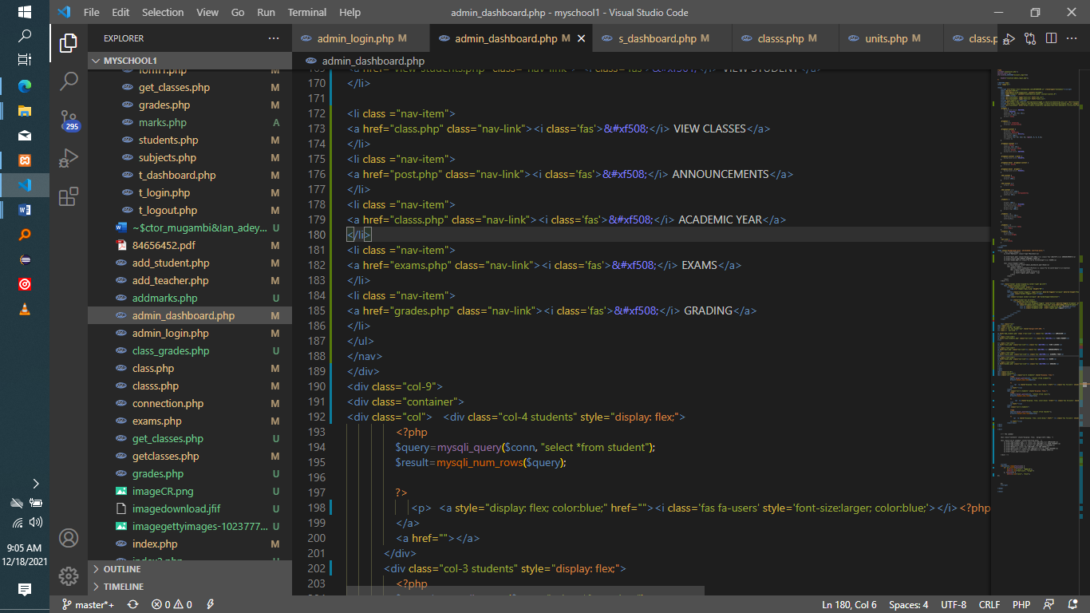

Figure : admin_dashboard.php

Grading page

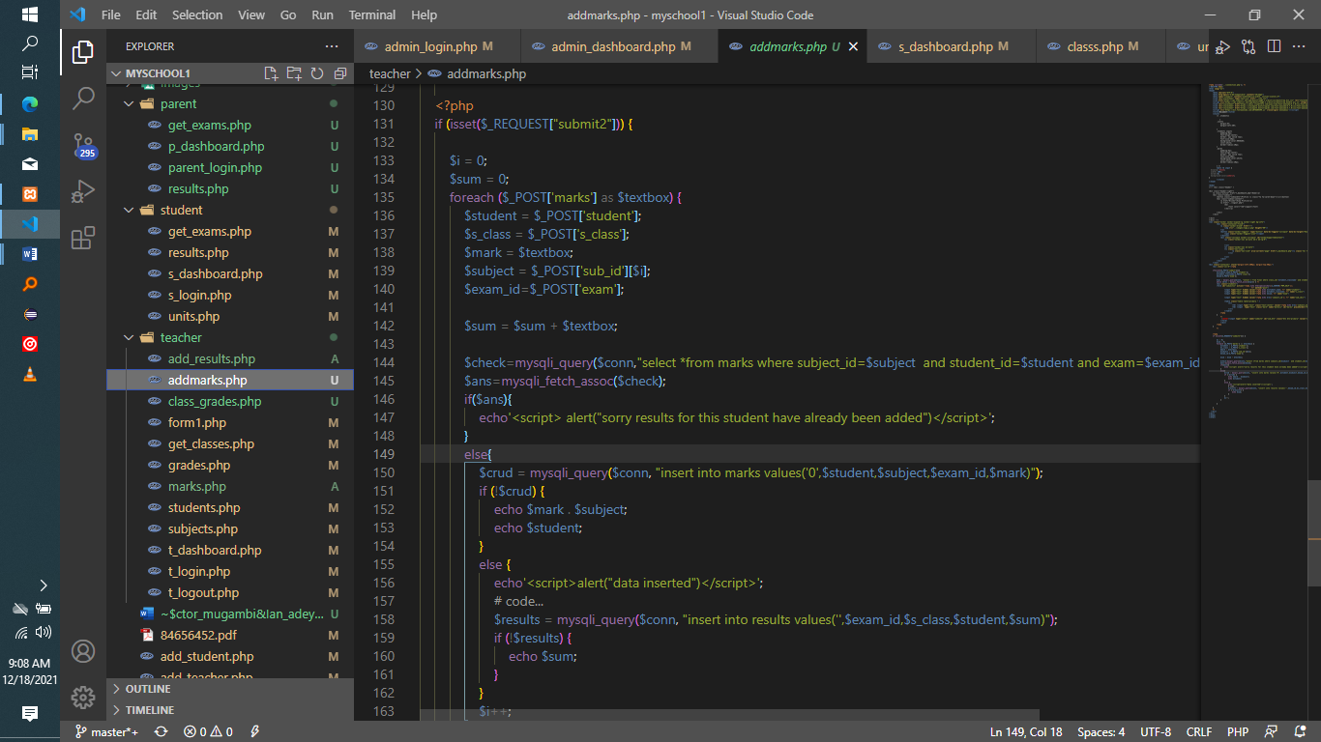

Figure : addmarks.php

Creating student users

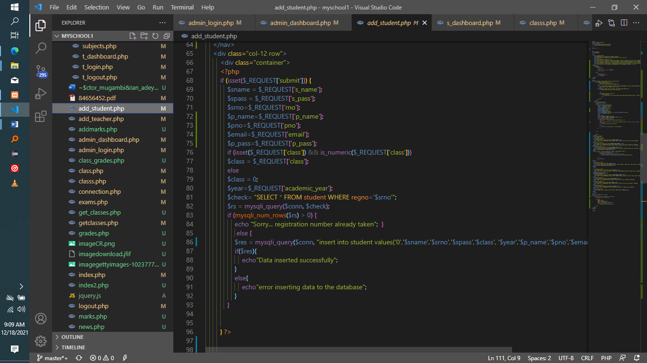

Figure : add_student.php