Assignment 1 markdown

### libraries used

* tidyverse
* ggplot2
* readxl

## Warning: package 'tidyverse' was built under R version 4.2.2

## ── Attaching packages ─────────────────────────────────────── tidyverse 1.3.2 ──  
## ✔ ggplot2 3.4.0 ✔ purrr 0.3.5   
## ✔ tibble 3.1.8 ✔ dplyr 1.0.10  
## ✔ tidyr 1.2.1 ✔ stringr 1.4.1   
## ✔ readr 2.1.3 ✔ forcats 0.5.2

## Warning: package 'tibble' was built under R version 4.2.2

## Warning: package 'tidyr' was built under R version 4.2.2

## Warning: package 'readr' was built under R version 4.2.2

## Warning: package 'purrr' was built under R version 4.2.2

## Warning: package 'dplyr' was built under R version 4.2.2

## Warning: package 'stringr' was built under R version 4.2.2

## Warning: package 'forcats' was built under R version 4.2.2

## ── Conflicts ────────────────────────────────────────── tidyverse_conflicts() ──  
## ✖ dplyr::filter() masks stats::filter()  
## ✖ dplyr::lag() masks stats::lag()

## Warning: package 'readxl' was built under R version 4.2.2

### **Part a** Appoach

* Load the dataset
* Summarize dataset
* calculate the mode of the overall performance
* Calculate the mode using the user function.
* print the mode

## ORIGIN VARIETY FRAGRANCE/AROMA FLAVOR   
## Length:75 Length:75 Min. :6.500 Min. :6.000   
## Class :character Class :character 1st Qu.:7.000 1st Qu.:7.000   
## Mode :character Mode :character Median :7.250 Median :7.500   
## Mean :7.409 Mean :7.341   
## 3rd Qu.:7.750 3rd Qu.:7.750   
## Max. :8.750 Max. :8.000   
## SALT/ ACID BITTER/ SWEET AFTERTASTE MOUTH FEEL BALANCE   
## Min. :6.000 Min. :6.00 Min. :6.00 Min. :6.250 Min. : 6.75   
## 1st Qu.:7.000 1st Qu.:7.00 1st Qu.:7.00 1st Qu.:7.000 1st Qu.: 7.00   
## Median :7.000 Median :7.25 Median :7.25 Median :7.000 Median : 7.50   
## Mean :7.143 Mean :7.24 Mean :7.22 Mean :7.185 Mean : 7.55   
## 3rd Qu.:7.500 3rd Qu.:7.50 3rd Qu.:7.50 3rd Qu.:7.500 3rd Qu.: 7.75   
## Max. :8.000 Max. :8.25 Max. :8.25 Max. :8.000 Max. :10.00   
## UNIFORMITY CLEAN CUPS OVERALL   
## Min. : 8.000 Min. : 8.000 Min. :6.000   
## 1st Qu.:10.000 1st Qu.:10.000 1st Qu.:7.000   
## Median :10.000 Median :10.000 Median :7.500   
## Mean : 9.867 Mean : 9.867 Mean :7.505   
## 3rd Qu.:10.000 3rd Qu.:10.000 3rd Qu.:7.750   
## Max. :10.000 Max. :10.000 Max. :9.000

#### Mode

## [1] 7.5

# breaking mean and median

### results

* Ibanda, Mityana and MUkono respectively.

summary(Ibanda$OVERALL)

## Min. 1st Qu. Median Mean 3rd Qu. Max.   
## 6.75 7.25 7.50 7.59 8.00 8.75

summary(Mityana$OVERALL)

## Min. 1st Qu. Median Mean 3rd Qu. Max.   
## 6.000 7.000 7.500 7.402 7.750 8.750

summary(Mukono$OVERALL)

## Min. 1st Qu. Median Mean 3rd Qu. Max.   
## 6.500 7.250 7.500 7.524 7.750 9.000

## The graphs

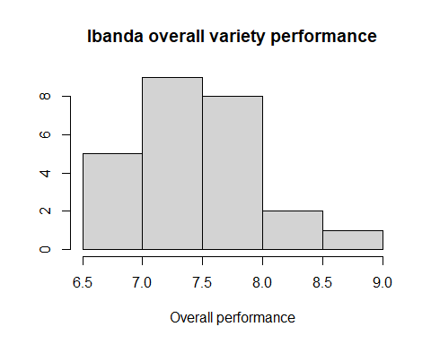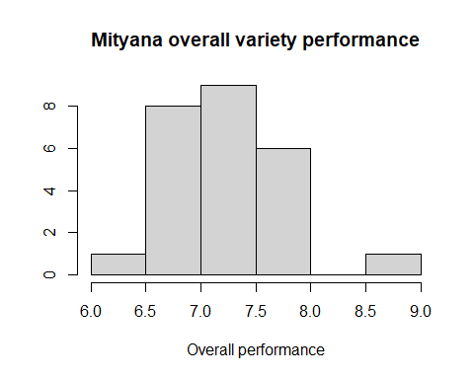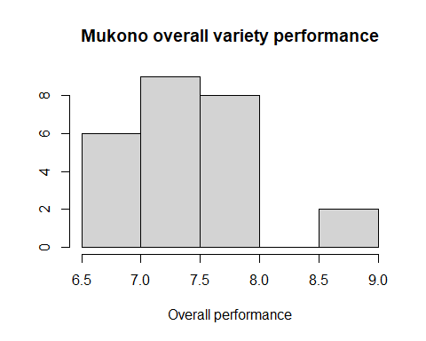

# **Part b**

## Appoach

* relationship between the variables
* Looking at effect of flavor on performance per district
* Looking at effect of aroma on performance per district
* Looking at effect of aftertaste on performance per district
* Looking at effect of salt/acid on performance per district

## Warning: Use of `coffe_dataset$FLAVOR` is discouraged.  
## ℹ Use `FLAVOR` instead.  
## Use of `coffe_dataset$FLAVOR` is discouraged.  
## ℹ Use `FLAVOR` instead.

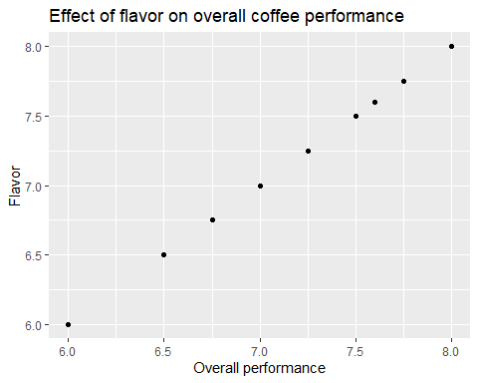

## Warning: Use of `Ibanda$FLAVOR` is discouraged.  
## ℹ Use `FLAVOR` instead.

## Warning: Use of `Ibanda$FLAVOR` is discouraged.  
## ℹ Use `FLAVOR` instead.

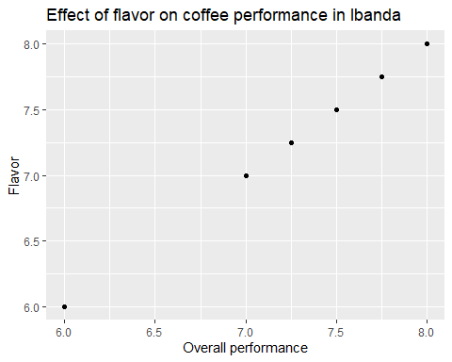

## Warning: Use of `Mityana$FLAVOR` is discouraged.  
## ℹ Use `FLAVOR` instead.

## Warning: Use of `Mityana$FLAVOR` is discouraged.  
## ℹ Use `FLAVOR` instead.

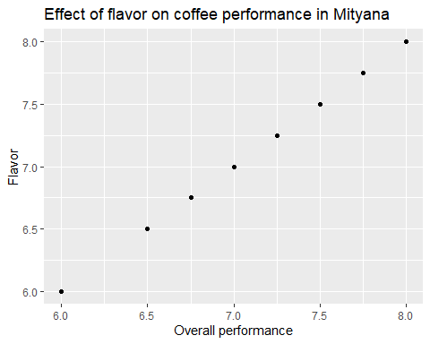

## Warning: Use of `Mukono$FLAVOR` is discouraged.  
## ℹ Use `FLAVOR` instead.

## Warning: Use of `Mukono$FLAVOR` is discouraged.  
## ℹ Use `FLAVOR` instead.

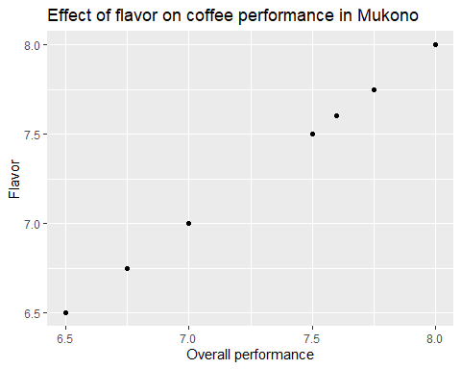

## Warning: Use of `coffe_dataset$"FRAGRANCE/AROMA"` is discouraged.  
## ℹ Use `FRAGRANCE/AROMA` instead.

## Warning: Use of `coffe_dataset$"FRAGRANCE/AROMA"` is discouraged.  
## ℹ Use `FRAGRANCE/AROMA` instead.

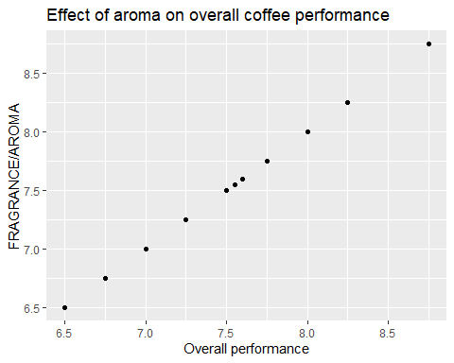

## Warning: Use of `Ibanda$"FRAGRANCE/AROMA"` is discouraged.  
## ℹ Use `FRAGRANCE/AROMA` instead.

## Warning: Use of `Ibanda$"FRAGRANCE/AROMA"` is discouraged.  
## ℹ Use `FRAGRANCE/AROMA` instead.

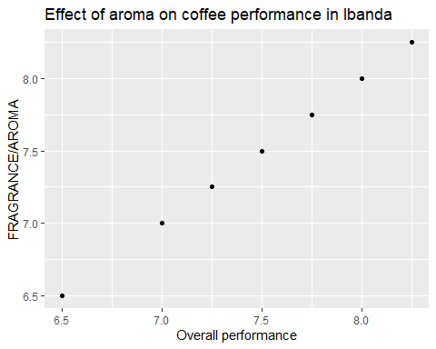

## Warning: Use of `Mityana$"FRAGRANCE/AROMA"` is discouraged.  
## ℹ Use `FRAGRANCE/AROMA` instead.

## Warning: Use of `Mityana$"FRAGRANCE/AROMA"` is discouraged.  
## ℹ Use `FRAGRANCE/AROMA` instead.

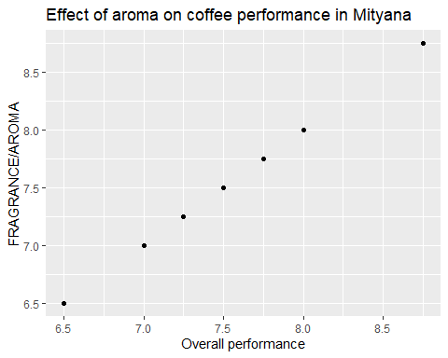

## Warning: Use of `Mukono$"FRAGRANCE/AROMA"` is discouraged.  
## ℹ Use `FRAGRANCE/AROMA` instead.

## Warning: Use of `Mukono$"FRAGRANCE/AROMA"` is discouraged.  
## ℹ Use `FRAGRANCE/AROMA` instead.

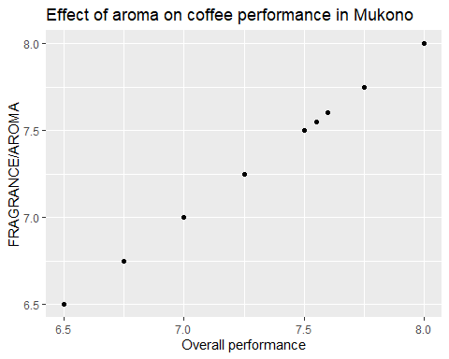

## Warning: Use of `coffe_dataset$AFTERTASTE` is discouraged.  
## ℹ Use `AFTERTASTE` instead.

## Warning: Use of `coffe_dataset$AFTERTASTE` is discouraged.  
## ℹ Use `AFTERTASTE` instead.

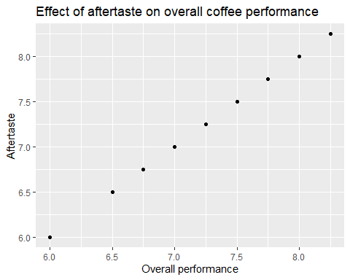

## Warning: Use of `Ibanda$AFTERTASTE` is discouraged.  
## ℹ Use `AFTERTASTE` instead.

## Warning: Use of `Ibanda$AFTERTASTE` is discouraged.  
## ℹ Use `AFTERTASTE` instead.

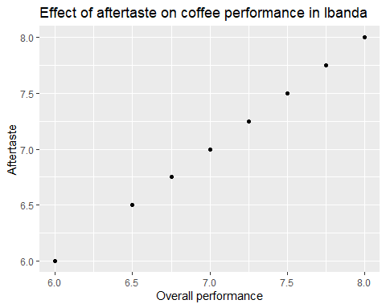

## Warning: Use of `Mityana$AFTERTASTE` is discouraged.  
## ℹ Use `AFTERTASTE` instead.

## Warning: Use of `Mityana$AFTERTASTE` is discouraged.  
## ℹ Use `AFTERTASTE` instead.

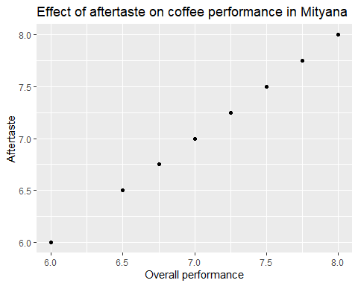

## Warning: Use of `Mukono$AFTERTASTE` is discouraged.  
## ℹ Use `AFTERTASTE` instead.

## Warning: Use of `Mukono$AFTERTASTE` is discouraged.  
## ℹ Use `AFTERTASTE` instead.

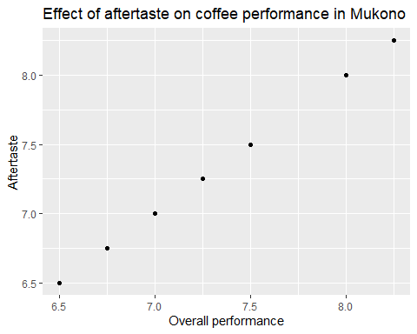

## Warning: Use of `coffe_dataset$"SALT/ ACID"` is discouraged.  
## ℹ Use `SALT/ ACID` instead.

## Warning: Use of `coffe_dataset$"SALT/ ACID"` is discouraged.  
## ℹ Use `SALT/ ACID` instead.

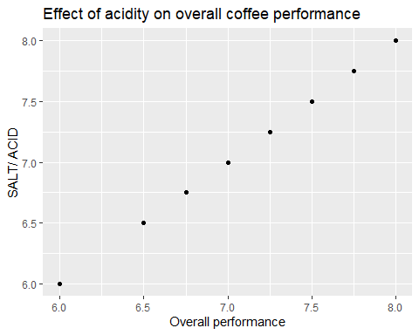

## Warning: Use of `Ibanda$"SALT/ ACID"` is discouraged.  
## ℹ Use `SALT/ ACID` instead.

## Warning: Use of `Ibanda$"SALT/ ACID"` is discouraged.  
## ℹ Use `SALT/ ACID` instead.

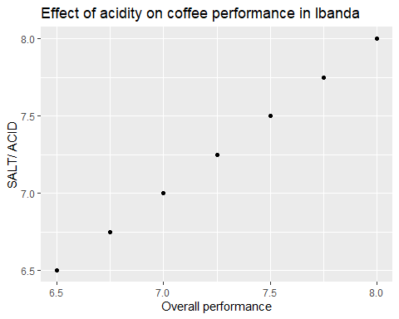

## Warning: Use of `Mityana$"SALT/ ACID"` is discouraged.  
## ℹ Use `SALT/ ACID` instead.

## Warning: Use of `Mityana$"SALT/ ACID"` is discouraged.  
## ℹ Use `SALT/ ACID` instead.

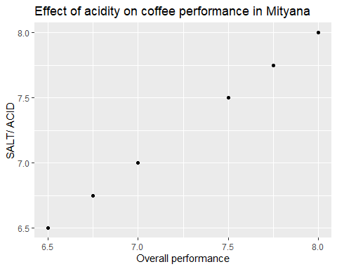

## Warning: Use of `Mukono$"SALT/ ACID"` is discouraged.  
## ℹ Use `SALT/ ACID` instead.

## Warning: Use of `Mukono$"SALT/ ACID"` is discouraged.  
## ℹ Use `SALT/ ACID` instead.

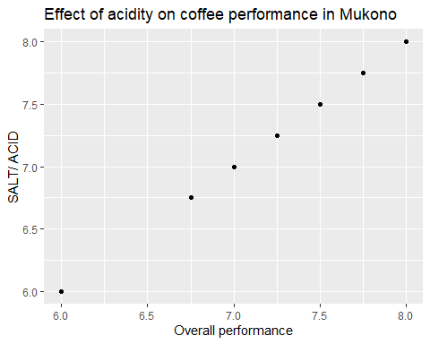

# **Part c(i)**

# PERFORMANCE BY VARIETY AND DISTRICT

#### concentrating on the mean of the overall performance

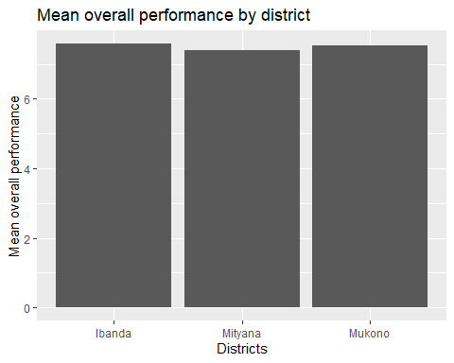

# **Part c(ii)**

# Performance of each variety

* Transform the coffe_dataset to subselected varieties individually
* calculating the mean of each variety
* Plot the means

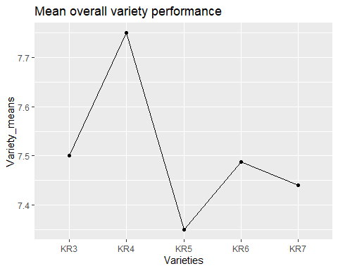

# **Part d** The distibution central tendency of the overall performance

### the distibution central tendency of each variable

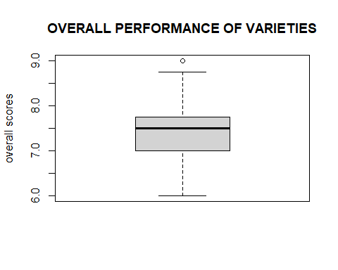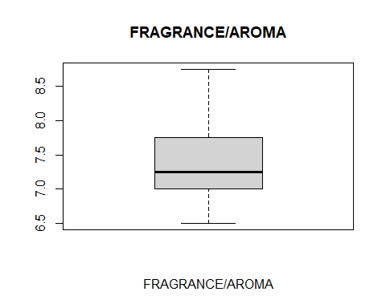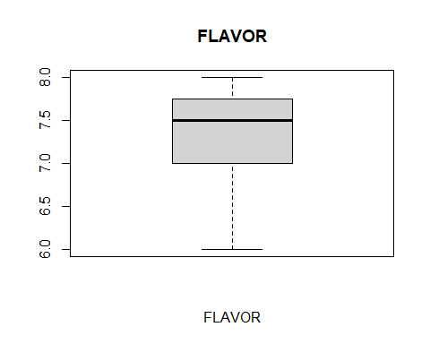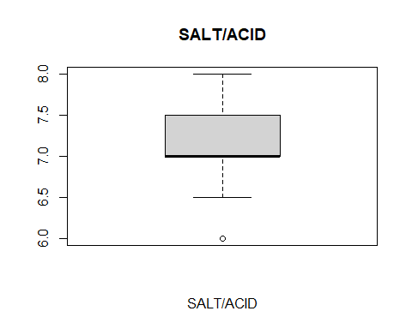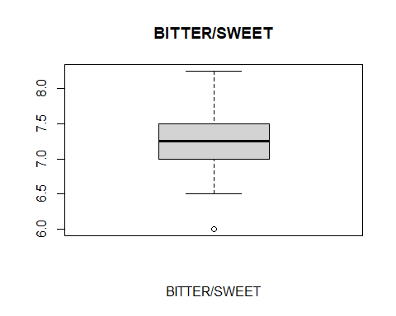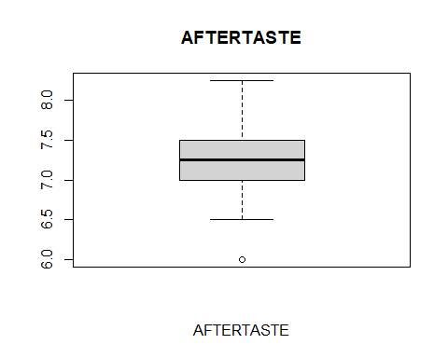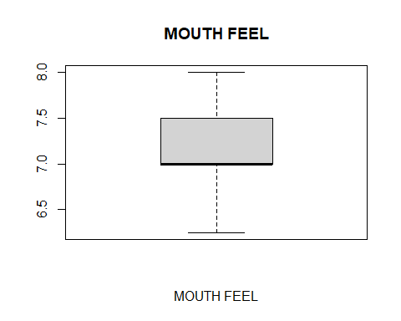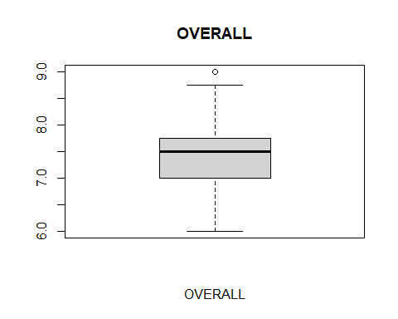

## **Part e** normal distribution tests

* Test the overall variable for normal distribution using the Shapiro-wilk test
* Null hypothesis based on research question: The overall performance of varieties across - districts is normally distributed. p-value >= 0.05
* Alternative hypothesis: Overall performance is not normally distributed across districts. - p-value =<0.05

##   
## Shapiro-Wilk normality test  
##   
## data: coffe_dataset$OVERALL  
## W = 0.95674, p-value = 0.01189

* p-value = 0.01189

## visualize the distribution of the overall variable

ggqqplot(coffe_dataset$OVERALL, ylab = "Overall scores",  
 ggtheme = theme_minimal())  
qqnorm(coffe_dataset$OVERALL)  
qqline(coffe_dataset$OVERALL, col = "steelblue", lwd = 2)

* the data is not normally distributed therefore we will use the non-parametric test
* One-sample Wilcoxon signed-rank test

##   
## Wilcoxon signed rank test with continuity correction  
##   
## data: coffe_dataset$OVERALL  
## V = 2850, p-value = 4.371e-14  
## alternative hypothesis: true location is not equal to 0.8