Assignment two markdown

## Packages used include;

* readxl
* tidyverse
* ggplot2
* ggpubr
* dplyr

## Warning: package 'readxl' was built under R version 4.2.2

## Warning: package 'tidyverse' was built under R version 4.2.2

## ── Attaching packages ─────────────────────────────────────── tidyverse 1.3.2 ──  
## ✔ ggplot2 3.4.0 ✔ purrr 0.3.5   
## ✔ tibble 3.1.8 ✔ dplyr 1.0.10  
## ✔ tidyr 1.2.1 ✔ stringr 1.4.1   
## ✔ readr 2.1.3 ✔ forcats 0.5.2

## Warning: package 'tibble' was built under R version 4.2.2

## Warning: package 'tidyr' was built under R version 4.2.2

## Warning: package 'readr' was built under R version 4.2.2

## Warning: package 'purrr' was built under R version 4.2.2

## Warning: package 'dplyr' was built under R version 4.2.2

## Warning: package 'stringr' was built under R version 4.2.2

## Warning: package 'forcats' was built under R version 4.2.2

## ── Conflicts ────────────────────────────────────────── tidyverse_conflicts() ──  
## ✖ dplyr::filter() masks stats::filter()  
## ✖ dplyr::lag() masks stats::lag()

## Warning: package 'ggpubr' was built under R version 4.2.2

# Importing data

# **Question 1**

### removing the missing values

work <- na.omit(work)

# **Question 2**

### Show the relationship between the prices and perception change.

### Appoach

* define the perception values.
* compute the percentage of each perception in response to price.

## Results as percentages of all perceptions.

postive

## [1] 2.977934

negative

## [1] 32.33265

partial_postive

## [1] 8.831819

partial_negative

## [1] 29.34545

Nuetral

## [1] 20.63416

## Displaying the covariation between the perception and price

ggplot(data = work, mapping = aes(x = price)) +  
 geom_freqpoly(mapping = aes(color = P), binwidth = 500)

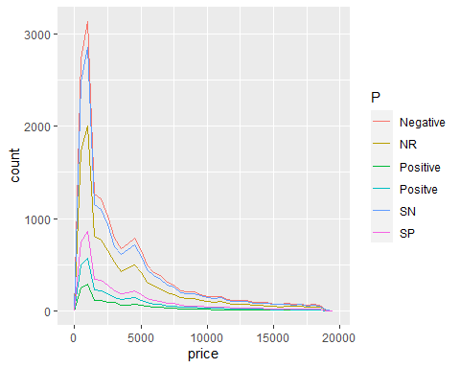

# **Question 3**

## Compare the perception change and diamond quality

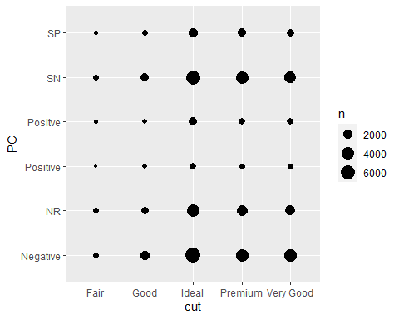

# **Question 4**

## Generating a boxplot of all the variables

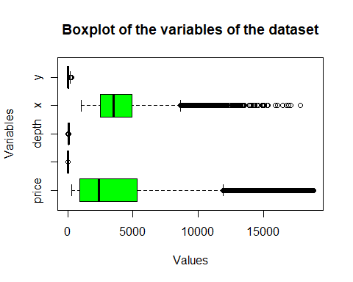

# **Question 5**

## Generating induvidual boxplots of the variables

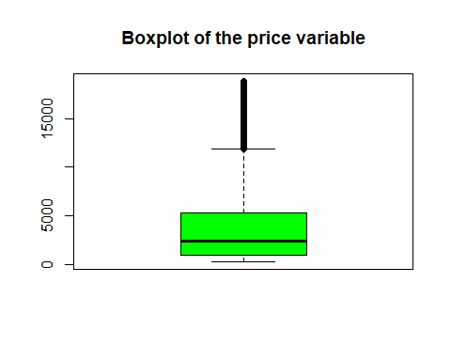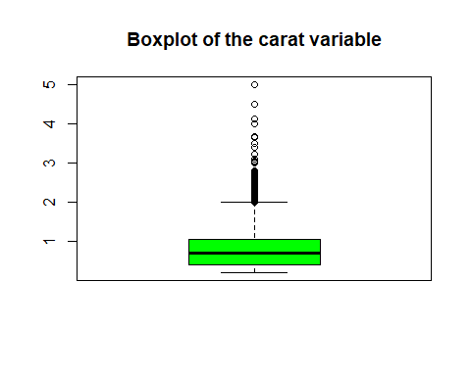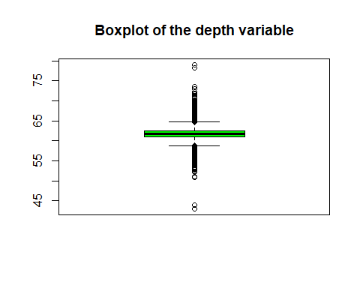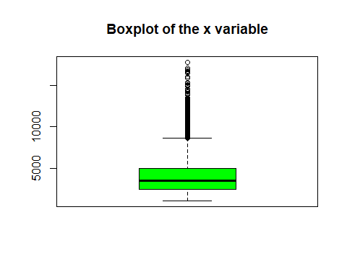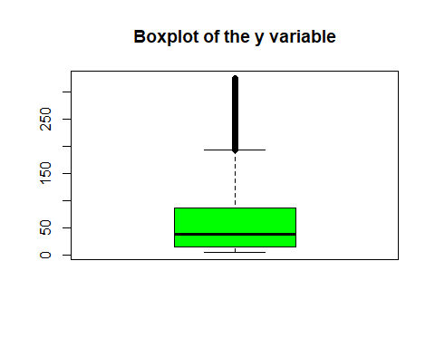

## A box plot that labels out the outliers

### Using the interquartile range to identify the outliers

### Appoach

* Compute the interquartile range.
* Compute the upper and lower limits.
* Identify the outliers.

# Plots without outliers

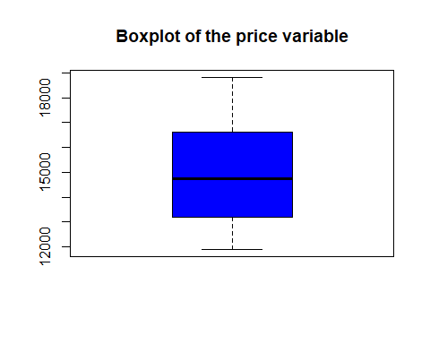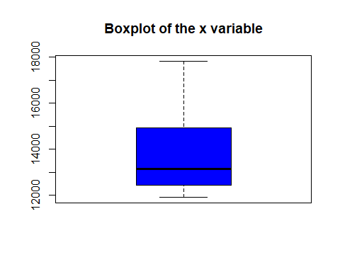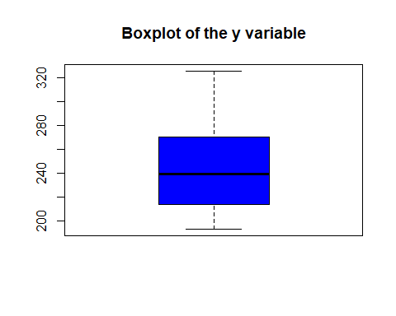

# **Question 6**

## creating a new csv file with the outliers removed

write.csv(new_work, file="D:/R/Assignment2_MugangaCharles.csv")

# **Question 7**

## Display the relationship between one qualitative variable and one finite variable in the dataset

* the selected variables are cut and price.

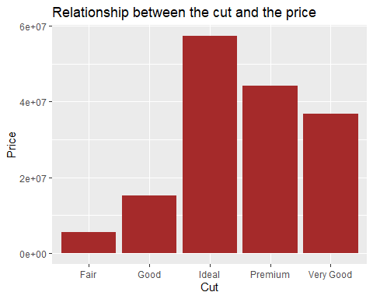

# **Question 8**

## Compute the variance between three groups; diamond carat, perception change and price

### Appoach

* Comparing mean, median and mode
* Calculating the mean and median of the variable “carat” in the diamonds dataset

## [1] 0.7239025

## [1] 0.7

## results

* Mean =0.72, Median = 0.7.
* The performance of carat is positively skewed.

# **Question 9**

### Appoach

* Compute the variance between three groups; diamond carat, perception change and price
* the groups are carat, price and perception change
* the variables are carat, PC and price
* The null hypothesis is that the groups have the same variance
* The alternative hypothesis is that the groups have different variances

#### Steps

* view the groups

## # A tibble: 50,393 × 3  
## carat PC price  
## <dbl> <chr> <dbl>  
## 1 0.23 Negative 326  
## 2 0.21 Negative 326  
## 3 0.23 Negative 327  
## 4 0.29 Negative 334  
## 5 0.31 Negative 335  
## 6 0.24 Negative 336  
## 7 0.24 Negative 336  
## 8 0.26 Negative 337  
## 9 0.22 Negative 337  
## 10 0.23 Negative 338  
## # … with 50,383 more rows

* Generate the random sample of the data.

## # A tibble: 6 × 4  
## PC mean sd n  
## <chr> <dbl> <dbl> <int>  
## 1 Negative 3144. 2768. 16291  
## 2 NR 3169. 2767. 10404  
## 3 Positive 3135. 2741. 1501  
## 4 Positve 3160. 2779. 2964  
## 5 SN 3174. 2771. 14789  
## 6 SP 3165. 2755. 4444

# Plots

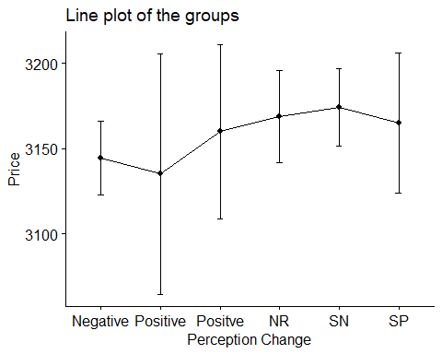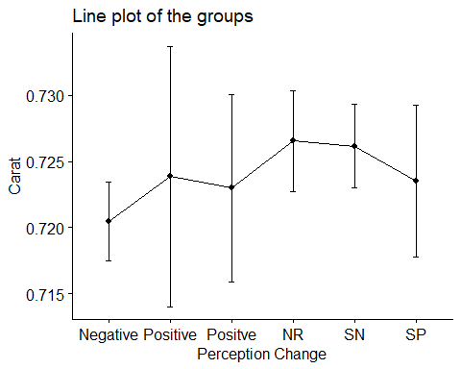

## Computng the variance betwen the groups

## Df Sum Sq Mean Sq F value Pr(>F)  
## PC 5 8.637e+06 1727312 0.226 0.952  
## Residuals 50387 3.859e+11 7658723

## Commenting on the results

* The p-value is 0.954 which is greater than 0.05 and therefore we fail to reject the null hypothesis therefore statistically not significant
* The posthoc test used is the Tukey HSD test
* The null hypothesis is that the groups have the same variance
* The alternative hypothesis is that the groups have different variances by aleast one group having a variance not equal to the others groups

# **Question 9(b)**

TukeyHSD(anova, conf.level = .95)

## Tukey multiple comparisons of means  
## 95% family-wise confidence level  
##   
## Fit: aov(formula = price ~ PC, data = groups)  
##   
## $PC  
## diff lwr upr p adj  
## NR-Negative 24.169212 -74.80432 123.1427 0.9824596  
## Positive-Negative -9.318170 -222.04699 203.4106 0.9999958  
## Positve-Negative 15.538464 -141.94572 173.0227 0.9997645  
## SN-Negative 29.562176 -60.01047 119.1348 0.9360071  
## SP-Negative 20.484454 -112.98113 153.9500 0.9979834  
## Positive-NR -33.487382 -251.23446 184.2597 0.9979638  
## Positve-NR -8.630748 -172.83035 155.5689 0.9999896  
## SN-NR 5.392965 -95.52036 106.3063 0.9999887  
## SP-NR -3.684758 -145.01169 137.6422 0.9999997  
## Positve-Positive 24.856634 -224.98191 274.6952 0.9997547  
## SN-Positive 38.880347 -174.75787 252.5186 0.9954693  
## SP-Positive 29.802624 -205.63546 265.2407 0.9992041  
## SN-Positve 14.023713 -144.68674 172.7342 0.9998632  
## SP-Positve 4.945990 -182.08024 191.9722 0.9999997  
## SP-SN -9.077723 -143.98807 125.8326 0.9999644

plot(TukeyHSD(anova, conf.level = .95))

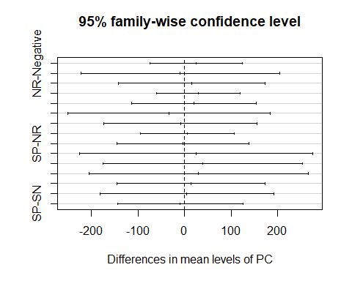

-The Tukey HSD test shows that the groups have different variances by aleast one group having a variance not equal to the others groups.