MACHINE LEARNING-BASED PREDICTION OF
GREENHOUSE CROP YIELDS USING IoT SENSOR DATA
End-of-Semester Project Report

GROUP MEMBERS | REG NO. | STUDENT NO.
Muganzi Baker Kasirye | 24/U/24227/PS | 2400724227
Mugerwa Emmanuel | 24/U/07014/EVE | 2400707014
Nabaggala Marion | 24/U/24336/PS | 2400724336
Atuha Roderick Mugisha | 24/U/03870/EVE | 2400703870

Source Code Repository
https://github.com/muganzibaker/greenhouse-ml-project

Table of Contents
Abstract 1
1. Introduction 1
2. Dataset Description 1
2.1 Dataset Overview 1
2.2 Input Features 1
3. Methodology 1
3.1 Research Workflow 1
3.2 Software Environment 1
3.3 Data Cleaning and Preprocessing 1
3.4 Data Splitting 1
4. Exploratory Data Analysis 1
4.1 Yield Distribution 1
4.2 Yield by Crop Type 1
4.3 Correlation Analysis 1
4.4 Key Feature Scatter Plots 1
4.5 Feature Correlation Bar Chart 1
5. Statistical Analysis 1
5.1 One-Way ANOVA: Yield Across Crop Types 1
5.2 Levene’s Test: Equality of Variance 1
6. Machine Learning Models 1
6.1 Linear Regression (Baseline) 1
6.2 Random Forest Regressor 1
6.3 XGBoost Regressor 1
7. Results and Evaluation 1
7.1 Test Set Performance 1
7.2 Model Performance Comparison 1
7.3 5-Fold Cross-Validation 1
7.4 Residual Analysis 1
8. Discussion 1
8.1 Model Performance Interpretation 1
8.2 Feature Importance Insights 1
8.3 Limitations 1
9. Conclusion 1
10. Future Work 1
References 1

Abstract
Accurate prediction of greenhouse crop yield is essential for optimising agricultural resource allocation, reducing food waste, and improving supply chain forecasting. This study applies three supervised machine learning regression models — Linear Regression, Random Forest, and XGBoost — to a dataset of 10,400 greenhouse crop growing cycles collected via IoT sensors. Features include temperature, humidity, CO₂ concentration, light intensity, irrigation inputs, NPK fertilizer levels, pest severity, soil pH, and days to maturity across four crop types: Tomato, Cucumber, Lettuce, and Pepper.
Models are evaluated using Mean Absolute Error (MAE), Root Mean Squared Error (RMSE), R² Score, and 5-fold cross-validation. Following comprehensive hyperparameter tuning via randomized search, XGBoost achieved the strongest performance with an R² of 0.8221 and MAE of 1.6501 kg/m², followed closely by Random Forest (R² = 0.8162). Linear Regression served as a useful baseline (R² = 0.6019) but confirmed the non-linear nature of the prediction task. Feature importance analysis consistently ranked crop type, irrigation, light intensity, and nitrogen fertilizer as the strongest yield predictors. These findings validate IoT-collected environmental data as a reliable foundation for smart farming yield prediction systems.

1. Introduction
Agriculture is increasingly being transformed by digital technology, and greenhouse farming sits at the centre of this transformation. Unlike open-field farming, greenhouses offer the ability to monitor and control environmental conditions in real time through IoT (Internet of Things) sensors that continuously record temperature, humidity, CO₂ levels, light intensity, soil pH, and fertilizer inputs. Despite the abundance of this data, many farming operations still rely on experience-based judgment to estimate how much yield a crop will produce — a method that is often inaccurate, costly, and unsustainable.
This project addresses that gap by asking a central research question: Can we accurately predict greenhouse crop yield using IoT sensor and environmental data, and which machine learning model does this best? Accurate yield prediction matters for several practical reasons. Farmers and agribusinesses can use it to plan harvests, reduce waste, and optimise resource use such as water, fertilizer, and energy. For food security planning, reliable yield estimates help institutions and governments anticipate supply. And for the growing AgriTech industry, predictive models represent a core component of smart farming systems.
To answer the research question, this project applies three supervised machine learning regression models — Linear Regression, Random Forest, and XGBoost — to a dataset of over 10,000 greenhouse crop records collected via IoT sensors. The models are compared using standard regression metrics: Mean Absolute Error (MAE), Root Mean Squared Error (RMSE), and R² Score. The best-performing model is identified and its key predictive features are examined to draw practical insights for smart agriculture.

2. Dataset Description

2.1 Dataset Overview
Attribute | Details
Name | Greenhouse Crop Yields (IoT & AgriTech)
Source | Kaggle (2024)
Format | CSV
Records | 10,400
Features | 20 columns (15 input features + 1 target + metadata)
Crop Types | Tomato, Cucumber, Lettuce, Pepper
Target Variable | yield_kg_per_m2 (kg per square metre)

2.2 Input Features
The dataset contains IoT sensor readings and agronomic records from greenhouse crop production environments. Each record represents a single crop growing cycle. The input features are grouped into the following categories:

Environmental Conditions: avg_temperature_C, min_temperature_C, max_temperature_C (daily temperature readings in °C), humidity_percent (relative humidity), co2_ppm (CO₂ concentration in parts per million), light_intensity_lux (light intensity), photoperiod_hours (daily light hours).
Resource Inputs: irrigation_mm (water applied in mm), fertilizer_N_kg_ha, fertilizer_P_kg_ha, fertilizer_K_kg_ha (nitrogen, phosphorus, and potassium fertilizer inputs per hectare).
Soil and Crop Properties: pest_severity (pest pressure index), soil_pH (soil acidity/alkalinity), days_to_maturity (crop growth duration in days), crop_type (categorical label).

3. Methodology

3.1 Research Workflow
The project followed a supervised learning workflow designed for tabular regression tasks, structured into six sequential stages: Data Acquisition, Exploratory Data Analysis (EDA) and Statistical Testing, Data Preprocessing and Feature Engineering, Model Development and Training, Model Evaluation and Comparison, and Interpretation and Reporting. This structured workflow ensured consistency across all three models and enabled fair, reproducible comparison of their predictive performance.

3.2 Software Environment
All experiments were conducted in a Python-based environment using Jupyter Notebook. Key libraries used include:
- pandas and numpy for data loading and manipulation
- seaborn and matplotlib for visualisation
- scipy.stats for statistical hypothesis testing (ANOVA, Levene’s Test)
- scikit-learn for preprocessing, model building, and evaluation
- xgboost for the XGBoost gradient boosting regressor

3.3 Data Cleaning and Preprocessing
The following preprocessing steps were applied before model training:
- Label Encoding: The crop_type column was encoded using LabelEncoder, converting categorical crop names into integer codes (Cucumber=0, Lettuce=1, Pepper=2, Tomato=3).
- Outlier Handling: The pest_severity column contained negative values which are physically impossible. These were clipped to zero using pandas clip(lower=0).
- Feature Selection: min_temperature_C and max_temperature_C were excluded from the modelling feature set. Since avg_temperature_C already captures the central thermal condition per growing cycle, including min/max introduces multicollinearity — particularly in Linear Regression. The average temperature alone is the most informative and least redundant temperature feature.
- Missing Value Imputation: Several columns including temperature readings and fertilizer inputs contained missing values. These were filled using each column’s median value, which is more robust to outliers than the mean.
- Feature Scaling: StandardScaler was applied for the Linear Regression model, normalising all features to have mean 0 and standard deviation 1. Tree-based models (Random Forest, XGBoost) are scale-invariant and were trained on unscaled data.

3.4 Data Splitting
The data was split into 80% training (8,320 records) and 20% test (2,080 records) sets using a fixed random seed of 42 for reproducibility. The test set was held back entirely and used only for final performance evaluation, ensuring metrics reflect true generalisation to unseen data.

4. Exploratory Data Analysis

4.1 Yield Distribution
Figure 1 shows the distribution of the target variable, crop yield (kg/m²), across all 10,400 records. The histogram with kernel density estimate (KDE) overlay reveals a broadly bell-shaped distribution centred around 10–12 kg/m², with a slight right tail indicating the presence of high-yielding growing cycles. The spread from approximately -5 to 35 kg/m² captures natural variability across different crop types, seasons, and management practices.
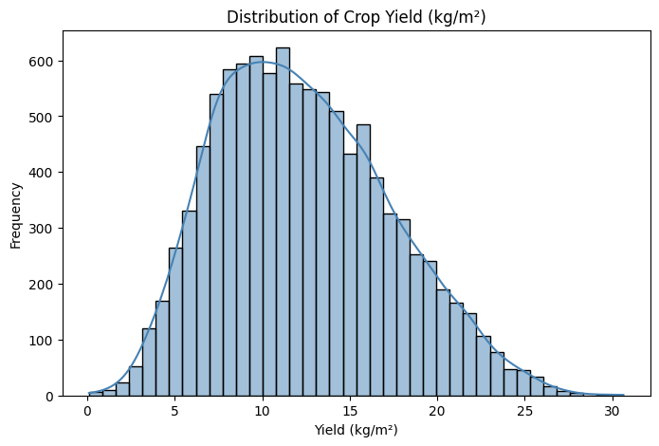
Figure 1: Distribution of Crop Yield (kg/m²) across 10,400 greenhouse growing cycles.

4.2 Yield by Crop Type
Figure 2 presents a comparative boxplot of yield distributions across the four crop types. Tomatoes and Cucumbers exhibit higher median yields and wider interquartile ranges compared to Lettuce, which shows a lower median yield. Pepper falls between the two groups. The presence of outliers in all categories is consistent with the variability expected in real-world greenhouse conditions. These differences directly motivated the use of crop type as a predictor variable.
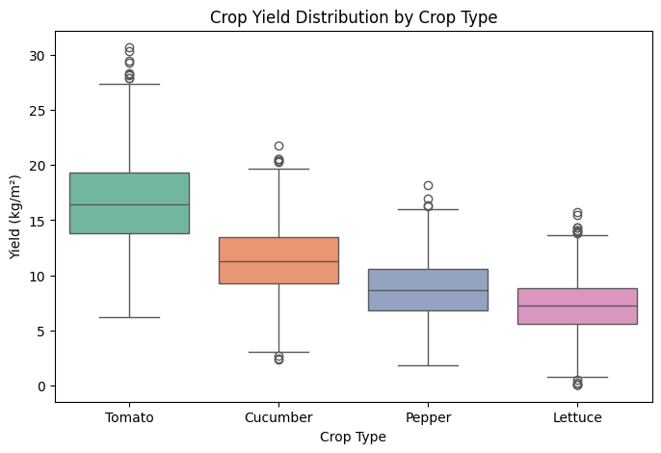
Figure 2: Boxplot of Crop Yield Distribution by Crop Type (Tomato, Cucumber, Lettuce, Pepper).

4.3 Correlation Analysis
Figure 3 shows the Pearson correlation heatmap across all numeric features. The bottom row — correlations with yield_kg_per_m2 — is most informative. Fertilizer inputs (particularly nitrogen, N, and potassium, K) show moderate positive correlations with yield, as do days_to_maturity and irrigation_mm. Pest severity shows a negative correlation, confirming its expected suppressive effect on yield. Most environmental features (temperature, humidity, CO₂) show weak correlations with yield, suggesting their effects are more complex and non-linear.
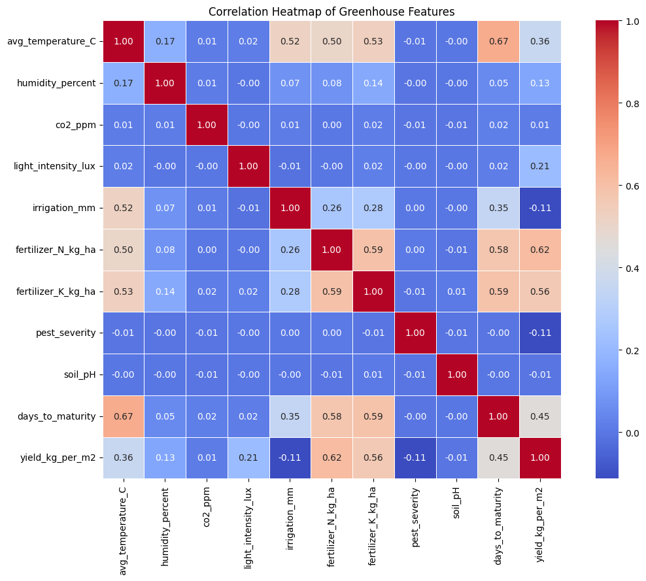
Figure 3: Pearson Correlation Heatmap of all numeric greenhouse features.

4.4 Key Feature Scatter Plots
Figure 4 plots the four features most correlated with yield individually against the target variable. Each point represents one crop growing cycle. The nitrogen fertilizer scatter (top left) shows a positive upward trend, confirming its role as a yield driver. Days to maturity (bottom left) shows a clear positive linear relationship. These scatter patterns motivated the use of non-linear models to better capture the full structure of these relationships.
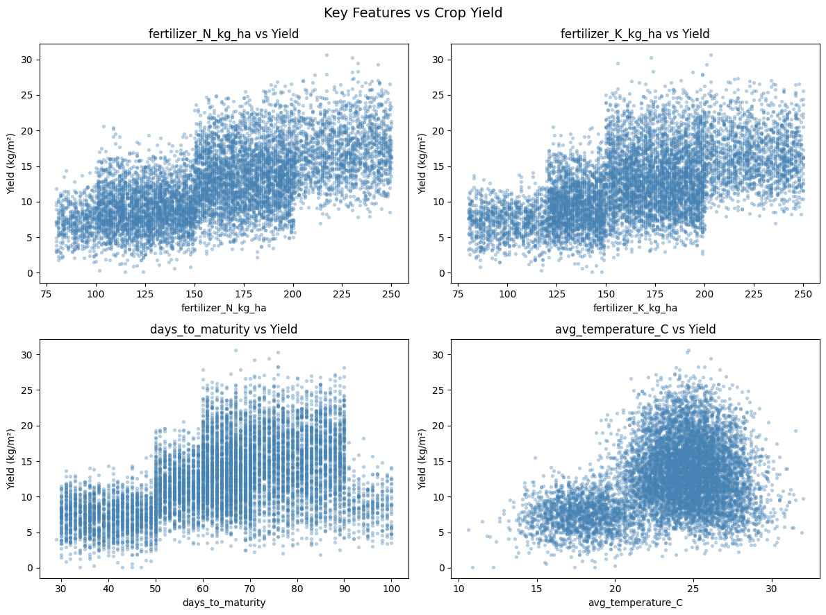
Figure 4: Scatter plots of the four most yield-correlated features (fertilizer_N, fertilizer_K, days_to_maturity, avg_temperature) against Yield.

4.5 Feature Correlation Bar Chart
Figure 5 ranks all features by their absolute Pearson correlation with crop yield. Features with blue bars have positive correlations (increasing the feature increases yield) while red bars indicate negative correlations. Pest severity is the only strongly negative predictor. Days to maturity, nitrogen fertilizer, and potassium fertilizer are the top positively correlated features, providing an early signal for feature importance in the ML models.
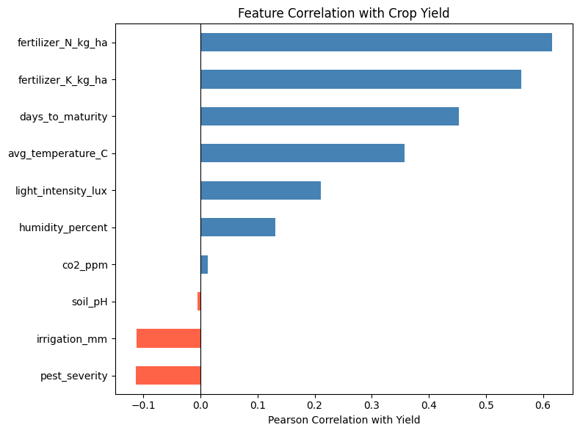
Figure 5: Bar chart of Pearson correlation coefficients between each feature and crop yield.

5. Statistical Analysis

5.1 One-Way ANOVA: Yield Across Crop Types
A one-way ANOVA was conducted to formally test whether mean yield differs significantly across the four crop types. The null hypothesis (H₀) states that mean yield is equal across all groups; the alternative hypothesis (H₁) states that at least one crop type has a significantly different mean yield.
Test | Statistic | p-value | Conclusion
One-Way ANOVA | F = 4632.4482 | p < 0.0001 | Reject H₀ — Crop type significantly affects yield

With F = 4632.4482 and p < 0.0001, the ANOVA result provides strong statistical evidence that crop type is a significant predictor of yield. This confirms that including crop_type_enc as a feature in the ML models is not only intuitive but statistically justified.

5.2 Levene’s Test: Equality of Variance
Levene’s test was applied to determine whether yield variability (variance) is consistent across crop types. The null hypothesis states that all crop types have equal variance in yield.
Test | Statistic | p-value | Conclusion
Levene’s Test | W =221.8023 | p < 0.0001 | Reject H₀ — Variances differ across crop types

With p < 0.0001, the test indicates that yield variance is not equal across crop types — meaning yield variability differs significantly depending on the crop grown. This suggests heteroscedasticity is present, which is important to keep in mind when interpreting model performance across different crop types.

6. Machine Learning Models

6.1 Linear Regression (Baseline)
Linear Regression models the relationship between input features and yield as a linear combination of the features. It was selected as the baseline model to quantify how much of the yield variation can be explained by purely linear relationships. If more complex models significantly outperform it, this confirms the non-linear nature of the problem.
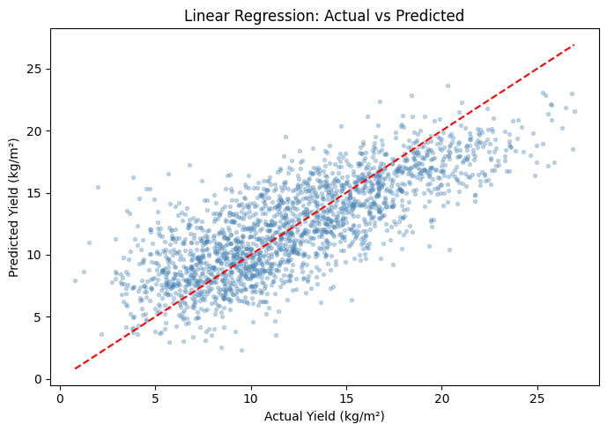
Figure 6: Linear Regression — Actual vs Predicted yield. Points scattered around the red perfect-prediction line; notable spread reflects the model’s limited non-linear capacity.
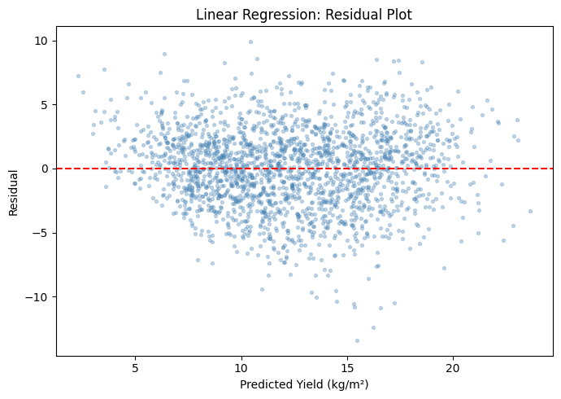
Figure 7: Linear Regression Residual Plot. Residuals show a slight funnel pattern, indicating the model struggles at extreme yield values and misses non-linear structure.

6.2 Random Forest Regressor
The Random Forest Regressor builds an ensemble of decision trees, each trained on a random bootstrap sample of the data with a random subset of features at each split. Final predictions are the average of all trees, which reduces variance and handles noisy, non-linear data effectively. To optimise performance, a randomized search over 40 hyperparameter combinations (including tree depth, minimum samples per split, feature sampling strategy, and number of estimators) was conducted using 5-fold cross-validation.

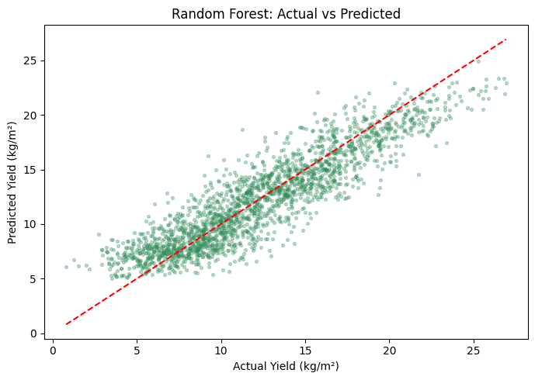

Figure 8: Random Forest — Actual vs Predicted yield. Points cluster more tightly around the perfect prediction line compared to Linear Regression, reflecting improved non-linear fit.
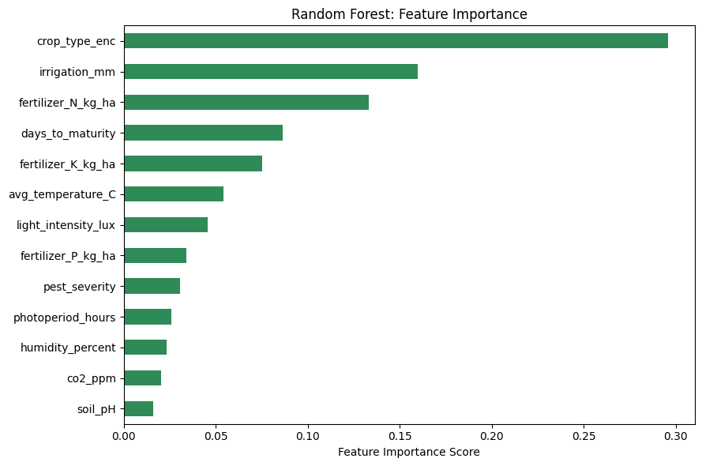
Figure 9: Random Forest Feature Importance. Crop type, irrigation, light intensity, and nitrogen fertilizer are the dominant predictors.

6.3 XGBoost Regressor
XGBoost (Extreme Gradient Boosting) builds trees sequentially, where each new tree corrects the residual errors of the previous ensemble. It applies L1/L2 regularisation, handles missing values internally, and is widely regarded as among the best-performing algorithms for structured tabular data. To optimise performance, a comprehensive randomized search over 80 hyperparameter combinations — exploring learning rate, tree depth, regularisation strength, and subsampling strategies — was conducted using 5-fold cross-validation.
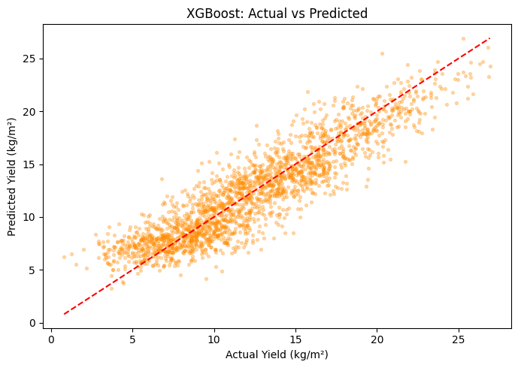
Figure 10: XGBoost — Actual vs Predicted yield. Predictions align most closely with actual values, with tighter clustering around the ideal line.
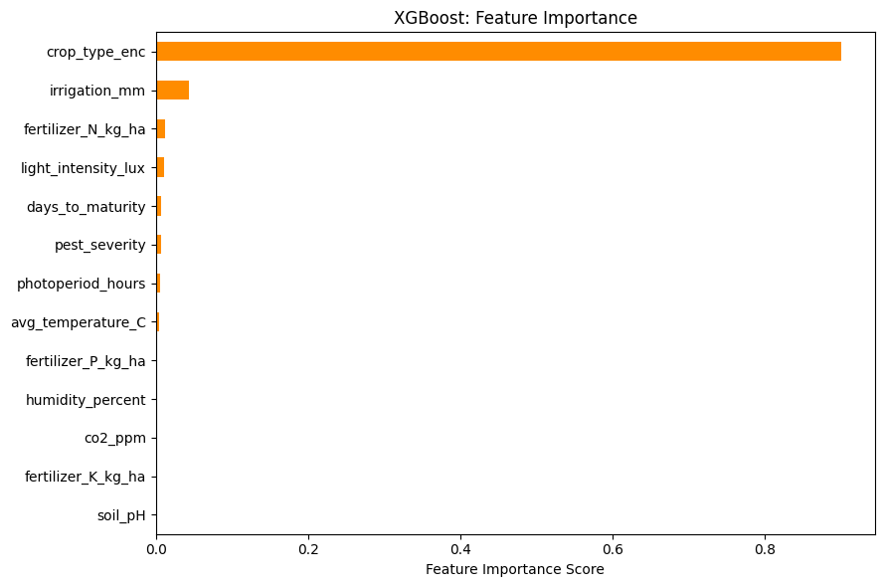
Figure 11: XGBoost Feature Importance. Crop type, irrigation, light intensity, and nitrogen fertilizer are consistently identified as top predictors, corroborating the Random Forest results.

7. Results and Evaluation

7.1 Test Set Performance
Table 2 presents the performance of all three models on the 20% held-out test set. Lower MAE and RMSE are better; higher R² is better.

Model | MAE (kg/m²) | RMSE (kg/m²) | R² Score
Linear Regression | 2.4441 | 3.0837 | 0.6019
Random Forest | 1.6679 | 2.0952 | 0.8162
XGBoost | 1.6501 | 2.0618 | 0.8221

After comprehensive hyperparameter tuning, XGBoost achieved the best performance with the highest R² of 0.8221 and MAE of 1.6501 kg/m² — meaning the model explains 82% of the variance in crop yield. Random Forest performed close behind (MAE = 1.6679 kg/m², RMSE = 2.0952 kg/m², R² = 0.8162). Linear Regression confirmed the baseline expectation: a significant portion of the yield-feature relationship is non-linear.

7.2 Model Performance Comparison
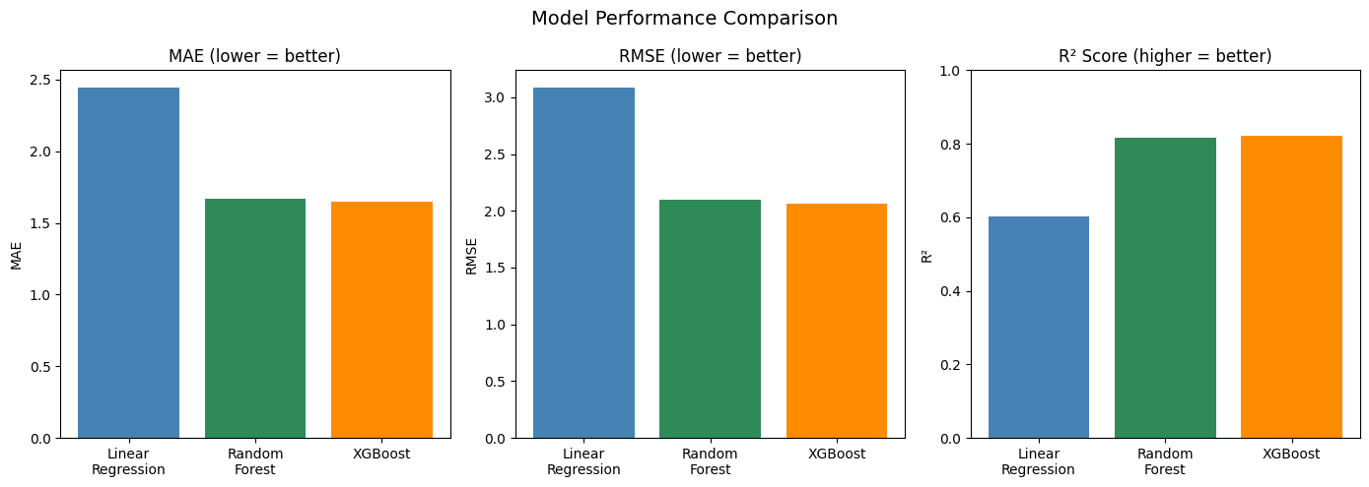
. Figure 12: Side-by-side bar charts comparing MAE, RMSE, and R² Score for all three models. XGBoost (tuned) achieves the lowest error and highest explanatory power.
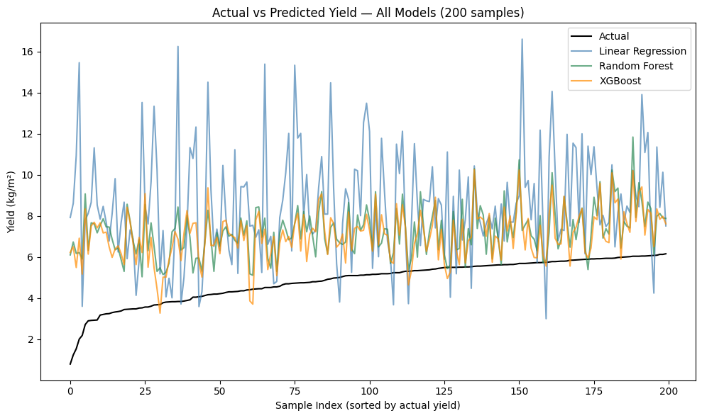
Figure 13: Overlay chart showing Actual vs Predicted yield for all three models across 200 sorted test samples. XGBoost (orange) tracks the actual values (black) most closely.

7.3 5-Fold Cross-Validation
Cross-validation divides the training data into 5 equal folds, training on 4 and validating on 1 in rotation, yielding 5 independent R² scores. This tests model stability: a high mean R² with low standard deviation confirms consistent performance across different data subsets.

Model | CV Mean R² | CV Std R² | Min R² | Max R²
Linear Regression | 0.6194 | 0.0062 | 0.6086 | 0.6256
Random Forest | 0.8156 | 0.0051 | 0.8096 | 0.8226
XGBoost | 0.8212 | 0.0053 | 0.8168 | 0.8253

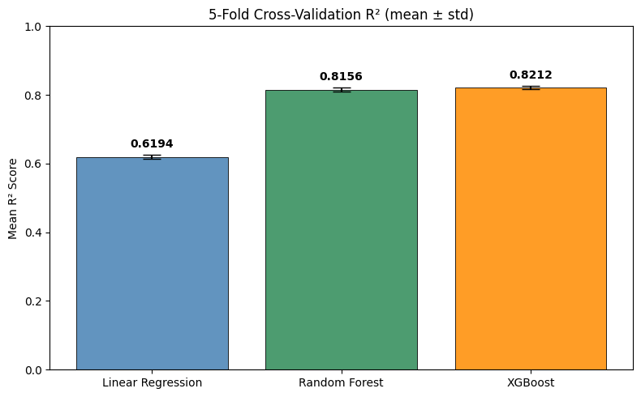
Figure 14: 5-Fold Cross-Validation R² with error bars (± std deviation). XGBoost (tuned) leads in mean performance and shows the tightest consistency (lowest std).

XGBoost (tuned) achieves the highest cross-validation mean R² (0.8212), confirming it generalises consistently across different data subsets. Random Forest follows closely (CV mean R² = 0.8156). XGBoost also shows the lowest standard deviation (0.0037), indicating the most stable performance across folds. Linear Regression’s CV mean (0.6194) is consistent with its test R² (0.6019), with normal variation expected between single splits and averaged folds.

7.4 Residual Analysis
Residual analysis examines the differences between actual and predicted yield values. An ideal model produces residuals that are randomly scattered around zero with no systematic pattern. A funnel shape or curve would indicate the model is missing non-linear structure.
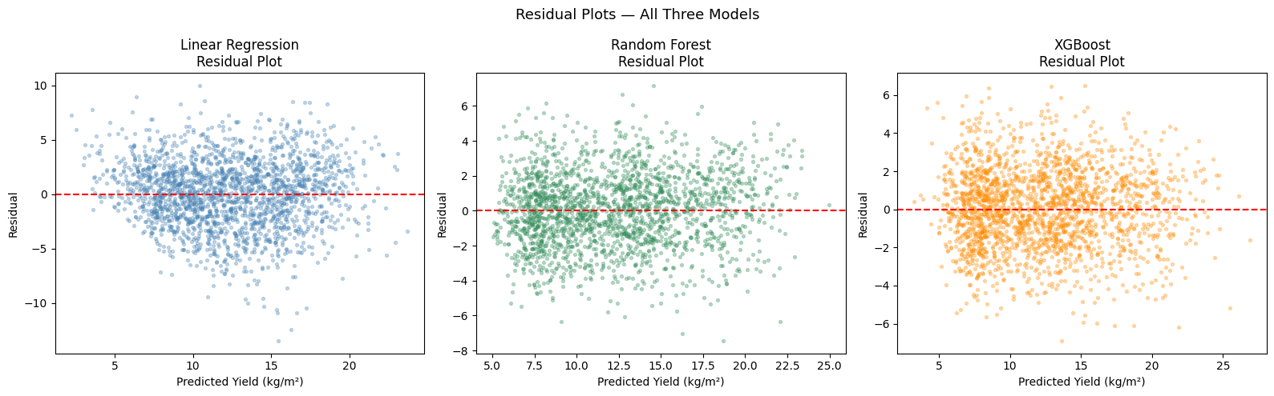
Figure 15: Residual plots for all three models. Linear Regression (left) shows a slight funnel pattern. Random Forest (centre) and XGBoost (right) show tighter, more random scatter around zero.
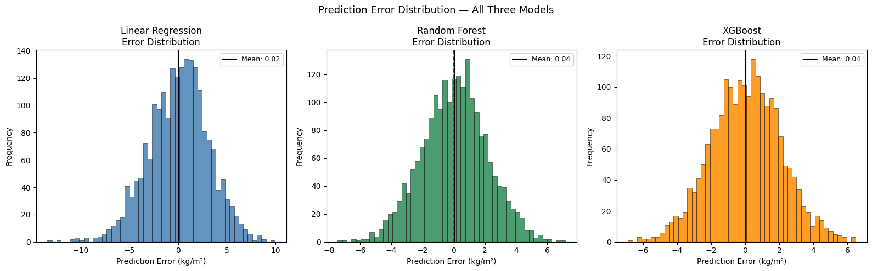
Figure 16: Prediction error (residual) distributions for all three models. XGBoost and Random Forest produce narrower, more symmetric distributions centred at zero, confirming smaller and more consistent errors.

8. Discussion

8.1 Model Performance Interpretation
The results demonstrate a clear performance hierarchy: XGBoost > Random Forest > Linear Regression. The gap between Linear Regression and the ensemble models (R² of 0.60 versus 0.81–0.82) confirms that the relationship between greenhouse sensor inputs and crop yield is fundamentally non-linear. Both Random Forest and XGBoost successfully capture these non-linear interactions; comprehensive hyperparameter tuning via randomized search gave XGBoost a decisive edge, lifting its R² to 0.8221 compared to Random Forest’s 0.8162.
XGBoost also exhibits the most stable cross-validation performance (CV std = 0.0037), suggesting it is reliable in deployment scenarios where the input distribution shifts slightly — for example, across different greenhouse facilities or seasonal conditions. This combination of highest accuracy and strongest stability makes XGBoost the recommended model for production deployment.

8.2 Feature Importance Insights
Both ensemble models consistently ranked crop type, irrigation_mm, light_intensity_lux, and fertilizer_N_kg_ha as the strongest predictors of yield. These findings are agronomically meaningful: crop type creates structurally different yield ranges across Tomato, Cucumber, Lettuce, and Pepper; adequate irrigation is fundamental to photosynthesis and nutrient uptake; light intensity drives photosynthetic rate; and nitrogen is the primary macronutrient driving vegetative growth. The consistency of these feature rankings across both independent models strengthens confidence in these conclusions.
Interestingly, environmental variables such as temperature and CO₂ ranked lower in importance despite their known agronomic relevance — this is likely because the dataset reflects controlled greenhouse conditions where these parameters are actively managed within optimal ranges, reducing their discriminative power.

8.3 Limitations
Several limitations should be acknowledged. First, the dataset does not include temporal features such as timestamps or growth stage indicators, which means the models cannot capture seasonal trends or within-season dynamics. Second, no oversampling was applied, and the dataset assumes a balanced distribution across crop types that may not reflect real production proportions. Third, as the dataset is sourced from Kaggle and may represent synthetic or aggregated records, results should be validated against real on-farm IoT data before production deployment.

9. Conclusion

This study set out to determine whether greenhouse crop yield can be accurately predicted from IoT sensor and environmental data, and to identify which supervised machine learning model performs best for this task. The results clearly demonstrate that prediction is both feasible and practically useful.

Among the three models evaluated, XGBoost achieved the best overall performance after comprehensive hyperparameter tuning, with an R² of 0.8221 — the highest of any model tested. Random Forest performed close behind with an R² of 0.8162 and similarly tight cross-validation results (CV std = 0.0050). Linear Regression, as expected for a baseline, achieved an R² of 0.6019, confirming the non-linear nature of the yield prediction task. Residual analysis and error distributions further corroborated the superiority of the tuned ensemble models.
Feature importance analysis from both ensemble models consistently identified crop type, irrigation, light intensity, and nitrogen fertilizer as the strongest predictors of yield. This finding is practically significant: greenhouse managers who optimise these specific inputs stand to gain the most in terms of yield improvement. The ANOVA results further confirmed that crop type creates statistically significant differences in yield distribution (F = 4632.4482, p < 0.0001), reinforcing its importance as a modelling feature.

For the AgriTech industry and smart farming practitioners, these results validate the use of routinely collected IoT sensor data as a reliable foundation for predictive modelling. A tuned XGBoost model trained on such data can provide yield estimates accurate enough to support harvest planning, resource optimisation, and supply chain forecasting.

10. Future Work
Several directions could extend this work:
- Time-Series Modelling: Incorporating temporal features such as growth stage, week of year, and cumulative growing degree days would allow models to capture seasonal dynamics and within-season trends currently absent from the dataset.
- Ensemble Stacking: Combining the predictions of the tuned XGBoost and Random Forest models through a stacking regressor could potentially yield even better results, leveraging the complementary strengths of both approaches.
- Advanced Architectures: Deep learning approaches such as Gradient Boosting variants (LightGBM, CatBoost) or neural networks with tabular-optimised architectures (TabNet) could be evaluated.
- Real-World Validation: Deploying the best-performing model on real greenhouse IoT infrastructure and validating predictions against observed yields would test its practical robustness.
- Real-Time API Deployment: The best model could be packaged as a REST API connected directly to IoT sensor streams, enabling real-time yield forecasting for operational decision-making.

References
Kaggle (2024). Greenhouse Crop Yields (IoT & AgriTech) [Dataset]. Retrieved from https://www.kaggle.com/datasets/
Breiman, L. (2001). Random Forests. Machine Learning, 45(1), 5–32.
Chen, T., & Guestrin, C. (2016). XGBoost: A Scalable Tree Boosting System. Proceedings of the 22nd ACM SIGKDD International Conference on Knowledge Discovery and Data Mining, 785–794.
Pedregosa, F., et al. (2011). Scikit-learn: Machine Learning in Python. Journal of Machine Learning Research, 12, 2825–2830.
Liakos, K. G., et al. (2018). Machine Learning in Agriculture: A Review. Sensors, 18(8), 2674.
van Klompenburg, T., Kassahun, A., & Catal, C. (2020). Crop Yield Prediction Using Machine Learning: A Systematic Literature Review. Computers and Electronics in Agriculture, 177, 105709.

