Build, Deployment

<https://continuousdelivery.com/foundations/test-automation/>

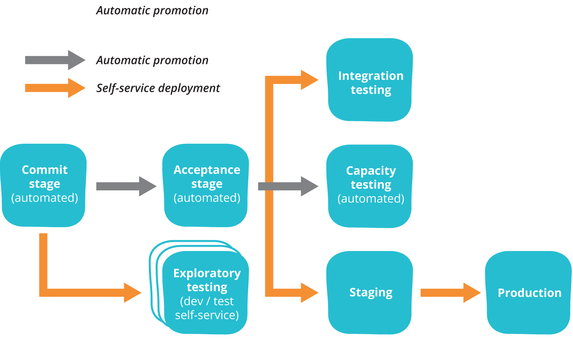

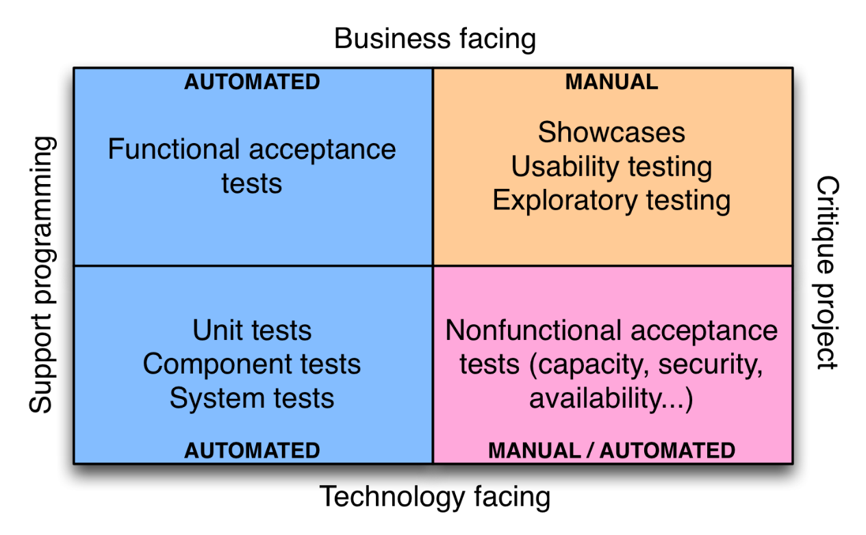

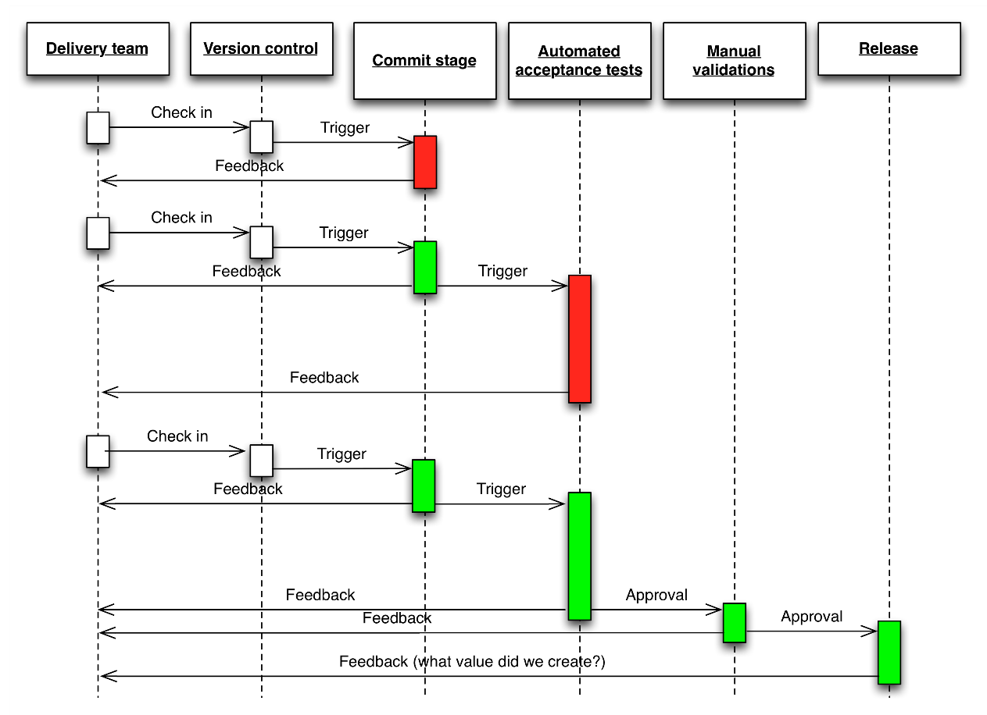

<https://testautomationu.applitools.com/test-automation-in-devops>

~1hr (primeros 3 capítulos)

Tools

<https://testautomationu.applitools.com/scaling-tests-with-docker/>

Install Docker, and Setup Selenium grid. Tips for parallelization

40min

<https://testautomationu.applitools.com/jenkins-tutorial/>

40min

Things to remark:

Jenkins distributed architecture (Jenkins Master - Slaves)

https://www.jenkins.io/doc/pipeline/tour/getting-started/

Configuration Management.

Pending. Pipeline