

**FACE RECOGNITION SOFTWARE FOR CAPTURING THE CLASS ATTENDANCE OF STUDENTS.**

**CYRIL MUGADA**

**B135/16224/2018**

Declaration

I do hereby declare without any reasonable doubt that the work presented in this research proposal report is my own original and independent work and it has not been presented before in any faculty of science for award of bachelor’s degree in computer science of university of Embu. No part of this research shall therefore be duplicated without my prior consent

Name **CYRIL MUGADA** Signature…………………………….

Supervisor ……………………………………………… Signature ………………………….

Date ………………………………………

**ACKNKOWLEDGMENT**

First I would like to thank he almighty God for the far and future he has planned and helped me achieve. I would like to express my gratitude and appreciation to all those who gave me the possibility to complete this report and course in general. Special thanks is due to my parents whose help and encouragement helped me. Also a special thanks to Madam Jennifer whose help, simulating suggestions and encouragements helped me all the time of the project and in writing this report.

I am ineffably indebted to the school and its lectures for the consistency, guidance and encouragement to accomplish this project.

**LIST OF ABBREVIATIONS**

**ABB MEANING**

**AMS Attendance management System**

**HOG Histogram of Oriented Gradients**

**RFID Radio Frequency Identification**

**ID Identification**

**SD secure digital**

**RCNN Region-Based Convolutional Neural Network**

**LBPH Local Binary Pattern Histogram**

**ML Machine Learning**

**GSM**

**ISDN**

**ABSTRACT**

Automation of face recognition technology has made a lot of improvements in our fast-changing world. Automated class attendance using face recognition is a real-world solution that we use in our day to day working. Face recognition for the class attendance is a process of recognizing the student face by taking the biometric face using High-definition cameras to take video that is used to capture the frames. In my proposed project my software, the computer system will be to detect and recognize student faces fast and accurately, captured through computer cameras. Main aims of this is to evaluate the already existing literature of the project similar to it. The design the software and finally test the whole system. Algorithms used in the whole process include face-recognition, face land mark estimation and classification algorithm using a linear SVM classifier. The producer of creating such software are first to collect the necessary images from Kaggel and locally. Then implement the image acquisition where we will be able input the images into the detection module. Then afterwards we implement them using the recognition model. In the recognition module we will be able to train the data sets. Using the known, unknown and a totally different picture. After that we generate the attendance list using the liner classifier algorithm.

Contents

**CHAPTER ONE** 7

**INTRODUCTION** 7

**Statement of the problem** 8

**BACKGROUNG STUDY** 10

**OBJECTIVES** 12

**1.3.1 Aim** 12

**1.3.2 Objectives include:** 12

**CHAPTER TWO** 13

**LITRATURE SURVEY** 13

**CHAPTER THREE** 18

**METODOLOGY** 18

**3.1 Proposed System** 18

**3.4.1.** **Face Recognition** 20

**3.4.2.** **Training Datasets** 26

**3.5.** **Attendance Generation** 28

**3.6.** **TOOLS USED** 29

**CHAPTER THREE** 30

**RESULT AND DISSCUSION** 30

**CONCLUSIONS** 35

**References** 36

**APPPENDIX** 38

# **CHAPTER ONE**

## **INTRODUCTION**

Face Detection and Recognition process by being able to detect and recognize specifically human fontal faces from an input any device i.e. more advanced and latest cameras that can be easily found in almost all know new gadgets. In most of today’s institution, it has been proven that students engage and participate better during lectures only when there is effective control in the classroom by instructors or by supervisors. The need for the most effective student engagement is very important to find out the attentiveness and concentration of the students. [24]

Attendance Register is a toll to record regularity of students on a day-to-day basis in a learning institution [1]. It is used by teaching instructors to determine which students have the required class time to sit for end of year or semester exams [1].

Anthony reports that, due to the remarkable ability of the human mind to generate near positive identification of images and facial recognition of individuals, this has drawn considerable attention for researchers to invest time in finding algorithms that will replicate effective face recognition on electronic systems for use by humans. The process of searching a faces using electronic components is called face detection. Face detection is to look for faces with the different expressions of faces, sizes of objects and angles of objects in the image in varying and different light and background and generates parameters of the mentioned face. Face recognition algorithms then processes images by extracting features and analyzes the patterns and comparing them to find the intended face from those in the database. [25]

Attendance is one of those administrative core and mandatory tasks that must be undertaken at the start of each lesson in a learning institution. However, in reality, the class attendance data are often names than those in class or less people during cats and many during exams. If you can rely on the **available school records**, use them All this method has proven to be tiresome, time-consuming and they have a lot of errors. Slowly and gradually, either increase of computers and technology, people and institutions started maintain records on the computers. An example normal way of taking student attendance in the begging of computer era is using excel sheets. There excite temples and management system utilizes excel to register students but this is still a lot of work for the parties involved. This amount of time wastage can be utilized in more fruitful tasks. [1]

Organizations of all sizes use participation frameworks to record when understudy or representatives start and stop work, and the office where the work is performed. A few associations additionally keep nitty gritty records of participation issues, for example, who phones in debilitated and who comes in late. A participation framework gives many advantages to associations. Some time ago the participation of the understudies and workers was set apart on registers.

Be that as it may, the people who have been a piece of the classes when participation registers were utilized expertise simple it was to manhandle such a technique for participation and imprint sham attendances for one another. Obviously, innovation needed to assume its part in this field similarly as well as it has done in different fields. The participation observing framework was made and it meaningfully impacted how attendances were checked. The participation checking framework has made the existences of educators and bosses more straightforward by making participation stamping methodology a piece of cake

With regards to schools and colleges, the participation observing framework is an incredible assistance for guardians and instructors both. Guardians are never ignorant of the steadfastness of their youngsters in the class on the off chance that the college is utilizing a participation checking framework. The registers could without much of a stretch be taken advantage of by understudies and assuming data was sent to the guardians, there were high possibilities that sends could be made to vanish before guardians even saw them. With the checking framework set up, the data can undoubtedly be printed or a delicate duplicate can be sent straightforwardly to guardians in their own email accounts. The framework began with two essential cycles - Manual cycles and Automatic cycles. Manual cycles are killed as need might have arisen to keep up with them. It is frequently hard to conform to guideline, yet a mechanized participation framework is important for guaranteeing consistence with guidelines.

## **Statement of the problem**

Currently manual student attendance marking technique is often facing a lot issues and a very slow process. Teacher’s or faculty calling names of student from their data sheet and student responding to them. But this existing process becomes very complex in large classes that consists so many students. Many times, students also mark proxies by responding to fake name. This makes disturbance in class and distracts the students during the exam times. Likewise, confirming the complete understudies present by counting them after participation, which takes a ton of tedious. Aside from calling names participation sheet is passed around homeroom during addresses particularly the classes comprising huge number of understudies could find it difficult to have participation sheet being gotten through around the class. Douglas Ahlers, Bernie DiDario, Michael Dobson, in 2006 gave the idea of participation global positioning framework. This structure comprises of character labels, with remote correspondence abilities, for every participant and the scanners for recognizing the participant's labels as they go into in that dispensed room. O.A. Idowu and O. Shoewu: Development of Attendance Management System by utilizing Biometrics. Participation is taken with the assistance of a finger impression gadget and the records of participation are put away in the data set. Participation is set apart after fruitful distinguishing proof.

This study and project is being carried out to address the concerns that will be highlighted in this section. With a few in the introductory part on the effective and efficient methods used by instructors use to take class attendance during a class session. The idea of students using Identity cards and writing down names and signing on a sheet of paper as a way to track student attendants has been the main promoter of this project. Attendance sheets are traditionally sheets of papers with tiny boxes that are hard to read and can be easy to make errors in.

Previously and in some current institution, the attendance registers were and are physically maintained on paper or books. All this is tiresome and contains errors (dishonesty and carelessness).This is not in any way to criticize the various methods used for student attendance, but to build a system that will detect the number of faces present in a classroom as well as recognizing them. Also, A teacher will be able to tell if a student was able to attend the required classes, but with the face detection and recognition system in place, it will be easy to tell if a student is actually present in the classroom or not. This system will not only improve classroom control during lectures, it will also possibly detect faces for student attendance purposes of the required percentage for student to sit for an examination.

## **BACKGROUNG STUDY**

In today’s world the branch of artificial recognition, Facial recognition has a quick uptake in today’s world and it is being integrated in day to day life. Some major industries have benefited from the increasing development in the field of facial recognition technology for the past 60 years. Some of this fields include; mobile technology, education m financial institutions and other major fields. The humankind advances in fields of Artificial intelligence the use of Facial recognition software, we will lookback and see where we have come from, what achievements we have come across and how the problem many problems were solved [22]. Woody Bledsoe, Helen Chan Wolf and Charles Bisson were the earliest pioneers of face recognition. Woody Bledsoe assisted by Charles Bisson in the year 1964-1965 began working to make computer recognize human faces. The two developed a manual way of marking various landmarks on a human face such as mouth size, nose length and eye centers. This was done by mathematical rotations by computers to compensate for the variations in poses. Distances between landmarks were automatically computed and a comparison done between the different images to determine identity [21].

Face acknowledgment was progressed in the 1970's lengthy the work including 21 explicit creators including hair tone and other essential face highlights to deliver a computerized face acknowledgment, this year prompted headway of RAND tablet innovation. In the 80/90s face acknowledgment was additionally evolved by utilizing direct polynomial math to tackle the facial acknowledgment issue. Throughout the year it has developed and become one of the most development field in Artificial insight. During the 2000s facial acknowledgment opened up and furthermore model advancements. In 2006 there was a significant lift in the innovation by presentation of Face Recognition Grand Challenge (FRGC) to help existing face acknowledgment exertion in the United States. For example, #D face sweeps and iris pictures for biometric locks. This headway has added to advancement of more secure and basic method of how things work [21].

Having gotten our business security and it being the critical mainstay of financial development, we ought to maintain our emphasis on empowering states, business and the overall society to figure out how to safeguard the protection by getting our sheets and accommodating our clients unafraid. Before very long the facial acknowledgment innovation will proceed to create and extend at a more noteworthy speed and the utilization likewise keeps on enlarging. For instance, the most involved face acknowledgment on the planet is by Tesla to assemble independent vehicles. As a result of such progressions in the field of facial acknowledgment constructing a face acknowledgment programming for a school establishment will be an accomplishment [23].

Fisher and Elschlagerb [30] ways to deal with measure various bits of the face and planned them all onto a worldwide format, which was observed that these elements don't contain an adequate number of special information to address a grown-up face. Another methodology is the Connectionist approach [31], which looks to group the human face utilizing a mix of both scope of signals and a bunch of recognizing markers. This is typically executed utilizing 2-layered design acknowledgment and brain net standards. More often than not this approach requires a colossal number of preparing countenances to accomplish good exactness; therefore it presently can't seem to be executed for a huge scope. The primary completely computerized framework [32] to be created used exceptionally broad example acknowledgment. It contrasted faces with a nonexclusive face model of anticipated includes and made a progression of patters for a picture comparative with this model. This approach is mostly factual and depends on histograms and the dim scale esteem.

Utilizing the generally accessible Open CV libraries, face acknowledgment Algorithms and accessible methods of participation I will actually want to catch understudy facial and register understudies as participation of a class. The framework will be great in running an establishment and expanding useful.

## **OBJECTIVES**

### **1.3.1 Aim**

The aim of the system is to develop a student automated attendance software that will be able to capture, process student images, recognize and generate student attendance in a classroom automatically using face recognition and face land mark estimation algorithms.

### **1.3.2 Objectives include:**

* Review the literature of exciting works in the field of face recognition in relation to automation of capturing class attendance.
* Design the face recognition using face recognition and face land mark estimation algorithms to come up with a working software.
* Test the system and validate the output from the system.

**JUSTIFICATION**

A teacher will be able to tell if a student was able to attend the required classes, but with the face detection and recognition system in place, it will be easy to tell if a student is actually present in the classroom or not.

This system will not only improve classroom control during lectures, it will also possibly detect faces for student attendance purposes of the required percentage for student to sit for an examination. Keeping a daily record of student attendance is instructors' and school administrators’ duties but this will be automated for their easing their work.

Also improve on the previous challenges faced by developers in the papers reviewed in the next slides.

# **CHAPTER TWO**

## **LITRATURE SURVEY**

Face detection and recognition is a subset of artificial intelligence that uses algorithms to determine the location and size of frontal face using the arbitrary (digital) image [4]. In this project, we are implementing Student Attendance system using face recognition and detection. The main purpose of the system is to detect the image automatically and maintain the student records for attendance. Therefore, the attendance of the student can be captured and be made available by recognizing the student faces.

Traditionally students were required to physically sign the attendance sheet every time a lecture took place [5]. This traditional method has proven to be cumbersome and time consuming by checking each student name and signing against it. Some of the other limitations include a student signing against other students names willingly or accidentally. This copy of the sheets can get lost or easily get messy because of using different pens and different handwriting [5].

Most of the attendance systems use paper based methods for taking and calculating attendance and this manual method requires paper sheets and a lot of stationery material. Previously a very few work has been done relating to the academic attendance monitoring problem. Some software’s have been designed previously to keep track of attendance [28]. But they require manual entry of data by the staff workers. So the problem remains unsolved. Furthermore idea of attendance tracking systems using facial recognition techniques have also been proposed but it requires expensive apparatus still not getting the required accuracy [29].

With the introduction of modern technology use of smartphones and computers s can help a teacher to automatically check the student attendance and check the average attendance of each student. Using the stored information in the different records the teacher can easily approve the percentage, check for errors and send mails to the school or parents updating them about the students and children college [6].

Fingerprint Based recognition system: This method of recognition requires a portable fingerprint scanner to be configured with the student’s figure [7]. When the lecture is about to start the student needs to place their finger on the configured device to ensure that they attend class for that day. The disadvantages of this system may include the following; they are not suitable for physically challenged people, some students are unfortunate and are not able to participate in the student enrolment. This might be due to loss or damage of figures which are important in this process. This may lead to some students not being recognized and it would be embarrassing for them, and even to offensive to others. This will be really tough for the students to cope with the system. The system also requires additional equipment which are expensive, inconvenient, and complex and need additional hardware integration. It also hindered by environmental factors. Some areas where it extremely cold the error rate is quite higher which is quite chaotic [7]. For example using a figure print scanner in cold areas might be hard because staking out your hands in such an environment might be harmful to a person, also in sandy areas and other environmental challenged areas [7].

Another disadvantage is unhygienic palms and figures. Figure print scanners are used by a lot of students and used a lot of time, this leads to the spread of germs and bacteria. A student might never know what they have carried on their figures after placing it on the device. This leads to transfer of diseases such as Covid19. During the pandemic this led to the rise of contactless methods which proved to be safer [14]. Some of this fingerprints are unchangeable and also other body parts that are unchangeable. We can reset user passwords but we can’t change our figure prints they are permanently fixed. The finger prints are stored in government public databases. This does not guarantee that it will be safe and not stolen. Current news about the breach of Indian citizen private data from Aadhaar database [15]. Another big breach happened in the US federal Government about 5.6 million workers fingerprints and other biometric data were stolen [16]. Another disadvantage is that if your password is stolen you can change but in case of fingerprints it cannot be changed [16].

Complexity and technicality is one of the most hindrance in fingerprint attendance. People who are non-technical or computer illustrate they will find it hard enough to use the system. This leads to employing highly experienced developers and programmers to maintain and teach the other which in turn becomes highly expensive. The scanners are also victims to technical failures such as power outages, computational errors and environmental factors. The system also has some exclusion to some people. The figure prints are selective to some people and over the time other become excluded. Example students who have a history with manual work may struggle to register their figure prints to the system. Other might have lost their figures or hands overtime [7 ].

Radio Frequency Identification system: RFID system are used to register class attendance of students The student is required to carry and Identity card containing a strip that has that students frequency to record their attendance for that specific day [11]. The system has some faults it being able to connect to RS232 may lead to fraudulent access to the records [11]. Some other students will give out their id so are their friends might register an attendance for them in the classroom, this will lead to misuses [12]. RFDI has a lot of securities issues that leads to unauthorized devices, owned by students that would be able to change the attendance without the knowledge of the original owner of the card [13]. This is man in the middle attacks, they would be able to get the tag data as it passes from the card to the reader thus stealing student information. Some countries have strict measure to curb the use of RFID technology collect peoples information thus making it impossible to work with the technology in other countries. The initial setup cost for the RFDI and the basic maintenance are quite high and would require a lot of funds. The generation of the cards for students and each reader would be quite high for a large population. RFID systems have limited capabilities. RFID systems cannot scan multiple items simultaneously. RFID tags contains more information this can be difficulty for the reader to read. The technology has a limitation of the line of sight meaning that it should work within a specific frequency range. This will be hard to do if the student card is far away or not in the line of sight. For example a barcode require a reader to be close to the barcode scanner or reader [13].

Situating administration utilizing Beacons are to a great extent arranged into three strategies Check Point, Zone, and ongoing following. Check point strategy works in a manner where sign is gotten from one Beacon and assuming an objective article goes through the area the information is recorded that target object went through the area and it is a technique where area information is checked when RFID labels pass a RFID peruser. In zone strategy at least one reference points are conveyed by signal reach and when the objective item is close to the particular Beacon the Beacon records information at that the objective article is around the Beacon area and most BLE Beacons utilize this technique. Continuously following technique various guides are disseminated by signal reach inside and the objective article sends ID sign and power from at least three reference points to sort out the area [1-2].

Iris Recognition System: This type of system requires that the student to stand in front of eye scanner or camera, to a mark the attendance [17]. The scanned student iris is captured and matched with that in the database. This would allow to update their attendance. This allow for reduced paper work for members in that facility. This allows for reduced errors in the records, thus keeping the student records safe [17]. Some of the limitations to this technology include; the first one is the system is expensive. This technology being the leading modern times, the iris devices are quite expensive. Large rich companies can afford this devices but the smaller institution and large institution can afford to pay for this devices. The eye being smaller it would be quite difficult. The distance required for this technology to work is quite small. The student need to be close to scanner for the people to be marked as present into the class. This setup requires setting up the proper recognition process [18]. Another concern is that the student has to be steady inform of the iris scanners and to avoid any sudden movements. This means that the iris scanner cannot work the same as face recognition system where it can scan the face regardless of the student movements. This is also cumbersome where trying scan the iris for the first time, you will need to make several attempts for it to mark the attendance. Another hindrance is that iris scanner can have issues with reflections. This can be caused by different factors including lenses, light and anything that can cause reflection. There is also health factors involved prolonged use of system can cause damage to the iris because of the infrared light produced by the scanner. Eyelids might also refuse to open or frequent blinking can make it difficult for the system to work. Their might also be a deformity of the eye iris making the pupil change in size to drug use or medical conditions, this will also lead to difficulties in the system[18].

Face recognition the attendance system is a typical example of this transition, starting from the traditional signature on a paper sheet to face recognition [19]. The paper proposes a method of developing a comprehensive embedded class attendance system using facial recognition with controlling the door access. The system is based on Raspberry Pi that runs on (Linux) Operating System installed on micro SD card. The Raspberry Pi Camera, as well as a 5-inch screen, are connected to the Raspberry Pi. By facing the camera, the camera will capture the image then pass it to the Raspberry Pi which is programmed to handle the face recognition by implementing the Local Binary Patterns algorithm LBPs. If the student's input image matches with the trained dataset image the prototype door will open using Servo Motor, then the attendance results will be stored in the MySQL database. The database is connected to Attendance Management System (AMS) web server, which makes the attendance results reachable to any online connected web browser. The system has 95 % accuracy with the dataset of 11 person images [19]. Challenges they encountered included the system was so expensive to create and required a lot of funding and maintenance. Other research methods used in attendance used it to count the student in class, impromptu attendance and also setting questions based on the latest topic [20].

Face discovery is a fundamental innovation of human-PC collaboration [27]. It can get data from the countenances in pictures or video. Face acknowledgment innovation dissect the face picture to remove the facial element, and afterward distinguish explicit objective. The advancement of profound learning innovation further works on the precision of face acknowledgment [3]. Profound Learning CNNs (Convolutional Neural Networks) have made critical leap forward in picture grouping [25] [26]. The profound learning model Deep ID created by the Computer Vision Research Group, have accomplished an acknowledgment pace of 99.15% on LFW data set, which is higher than that of natural eye with 97.52%.

Faster R-CNN is the best method of R-CNN series for target detection, in this paper face detection training is performed on the Faster R-CNN network using the face detection benchmark data set Wider Face [6]. The data set is ten times larger than the existing data set. Face recognition consists of three core modules, including face detection, face feature point positioning module and face recognition module. It uses traditional shallow network for face detection and feature point positioning to improve the speed, and uses the deep network for face recognition to ensure the accuracy of face recognition in the last step.

Viola-Jones algorithm is used to detect the face. A camera is set up in the classroom that scans the facial structure of the students. The detected face is extracted for further processing. 20 images of students are stored in the database as the dataset. These datasets are used to compare the biometrics

with the detected face for facial recognition. Facial recognition is done using LBPH. LBPH extracts the histogram of the image and concatenates it to form the face descriptor by segmenting the image into the local region. The distance between the biometrics of the probe image and the trained image is calculated. If the calculated distance is less than the threshold, then the probe image is recognized. Once recognized, the name is updated into an excel sheet.

# **CHAPTER THREE**

## **METODOLOGY**

Making of software projects and systems in the recent digital age has been done using different methodologies implemented by software developers in the different fields of computer technology [3]. As been discussed by, each methodology used is informed by the type of project, the organization and the developers involved in seeing the execution of the project to completion [3]. The said system works simply by collecting faces from a camera. These photos are stored into a database folder and the attendance software will pick each image one by one to establish each student name/id and time of entry.

### **3.1 Proposed System**

The proposed system for the student attendance system put into use several components and factors to be able to manage the student’s attendance in the specific class. The software that will facilitate student class control and attendance by face detection and recognition of students faces in a digital image taken by a normal laptop or mobile camera in real-time. The main purpose being to record regularity of students on a day-to-day basis in a learning institution. It is used by teach instructors to determine which students have the required class time to sit for end of year or semester exams. The system will be able to detect students’ faces using features and in a classroom within 90% accuracy. The system will be inexpensive and will work for any person as long as they have a face. The system can work in any weather conditions and with more investment can be made into a stand-alone system. Current it will be used within a computer system.

* 1. **METHODOLOGY DIAGRAM**

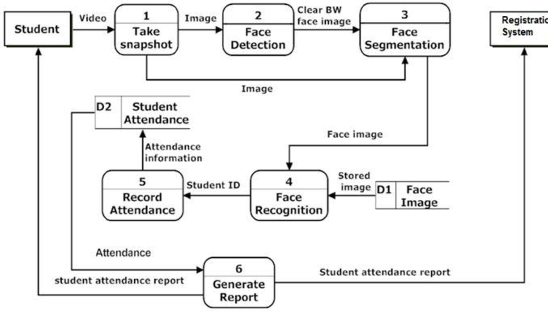

* 1. **GET STUDENT IMAGES**

A Function is created to capture images through the camera and an interface allows the user to input their information then it is saved in the database. There are also other test photos we took from phones and cameras just to increase the quality of the picture so that the module can better detect the faces by comparison.

* 1. **THE DETECTION**

After capturing the student’s faces we are going to them in this next phase.

Face recognition process works in a way that the captured images are compared with the stored images from different data sources using various techniques like features classification. Then we will check every pixel in our image, we will look each pixel as one and the ones directly adjusted to it and the surrounding pixels.

My application works with the following major algorithm’s face recognition and face land mark estimation algorithms to come up with a working software. This algorithms are found in python packages they include face recognition, dlib, Cmake and Openface(by open cv). The algorithms use a method invented in 2005 called Histogram of Oriented Gradients (HOG).

**First step.**

### **Face Recognition**

We will do is finding faces in our photos before telling them a part. This are the photos captured. This will be done using face detection pipeline.

The captured images are turned into black and white. This is because we do not really need color date for the algorithm to find faces.



Fig 1

After the image is changed to the black and white. The algorithm looks at evert pixel in the selected image one after the other. The aim of this is to check the adjacent pixels of the selected pixel. This is done for every pixel.

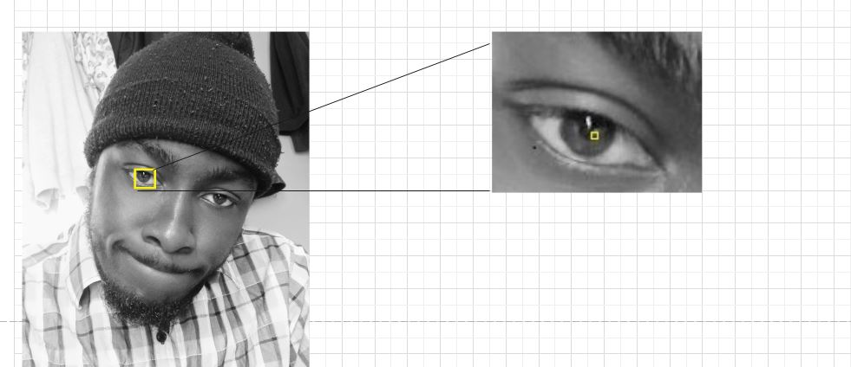

Fig 2

Then draw an arrow showing in which direction the image in getting darker.

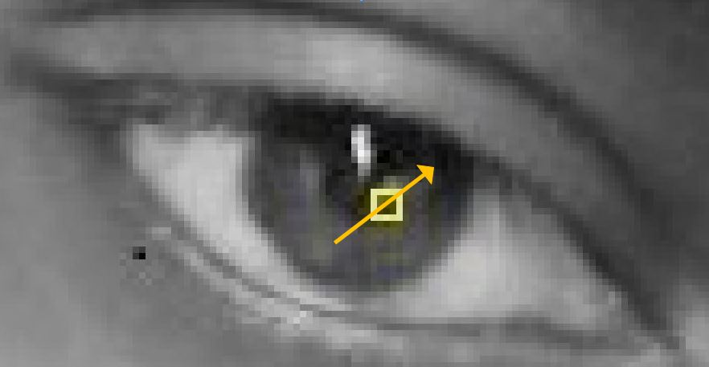

Fig 3

This procedure id done for every pixel. After all of them you end up with every pixel being replaced by an arrow. These arrows are called gradients and they are used to show the how the light flows from to darkness across the entire image.

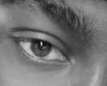

Fig 4

This process will allow for same people who took images in the dark or light to have similar pixel values. Through considering the direction of light we will end up with the same exact representation.

Now producing basic images patterns of the images we divide the image into smaller squares of 16X16 pixels. In each square well count up to how many gradients point in each major direction (points up, right and up-right). Afterwards we replace that square in the image with gradient directions that are stronger. After all of that the original captured image is turned into a simple HOG representation that gets the basic structures of the student face. To find the required face in this HOG image, we look for image similar to HOG pattern that was analyzed and extracted from the different images used in tanning faces.

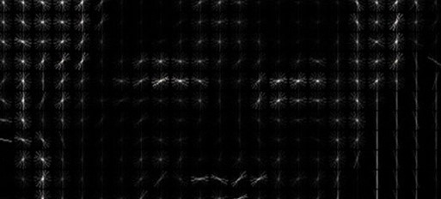

Fig 5

Now that I know were eyes, nose mouth and other landmarks are, we simply scale, shear and rotate the image so that the basic landmarks mentioned above are centered to the face clear possible. I am only going to use basic image transformation like shear, scale and rotation that preserve parallel (affine transformation)

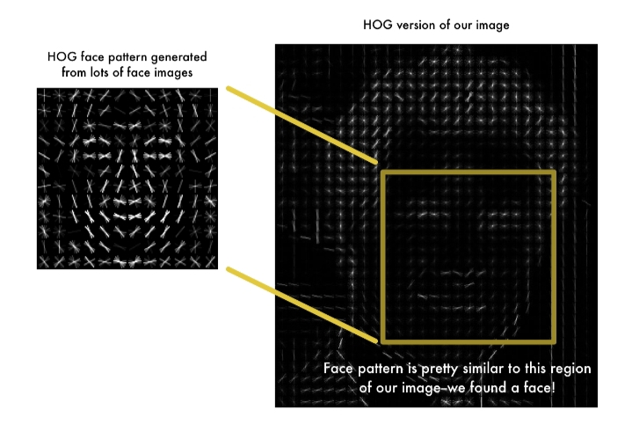

Fig 6

Then we find the images using this technique.

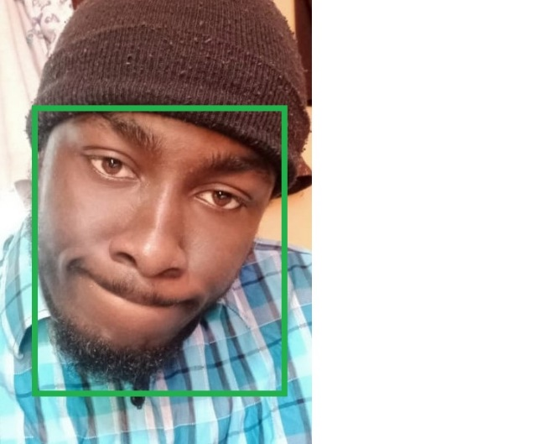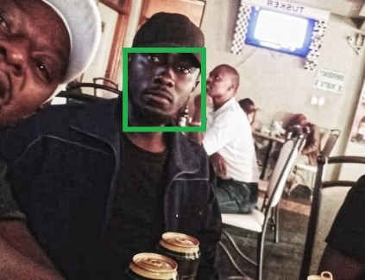

Fig 7

**We now do a feature extraction**

The choice at every hub depends on threshold the distinction of force values at a couple of pixels. This is a somewhat straightforward test, yet it is considerably more remarkable than single force threshold due to its relative obtuseness toward changes in worldwide lighting. Tragically, the downside of utilizing pixel contrasts is the quantity of expected split (highlight) up-and-comers is quadratic in the quantity of pixels in the mean picture. This makes it challenging to track down great θ's without looking over an exceptionally huge number of them. In any case, this restricting element can be facilitated, somewhat, by taking the design of picture information into account. We present an exponential prior

**P(u, v) ∝ e –λ||u−v||**

Over the distance between the pixels utilized in a split to urge nearer pixel matches to be picked.

We observed utilizing this basic earlier diminishes the expectation mistake on various face datasets. We analyzes the highlights chose with and without this earlier, where the size of the element pool is fixed to 20 in the two cases. It works in a way that it comes up with 60 plus (68 to be exact) landmarks, this landmarks are specific points in the image that are recognizable in all faces. This landmarks include; the top of the chin, shape of lips, size of nose and etc.

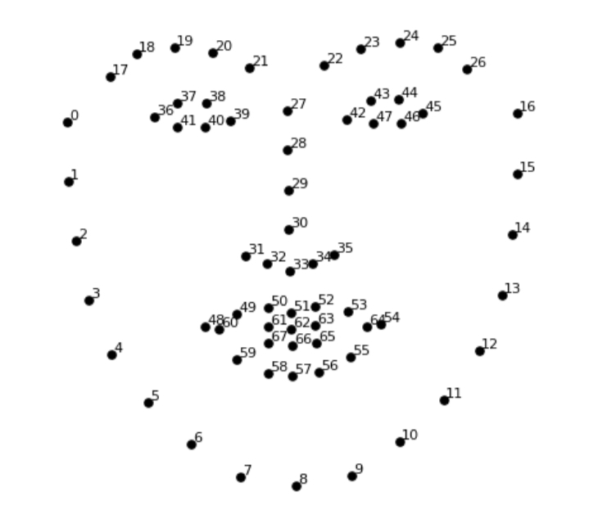

Fig 8

The result of locating the 68 face landmarks on our test image.

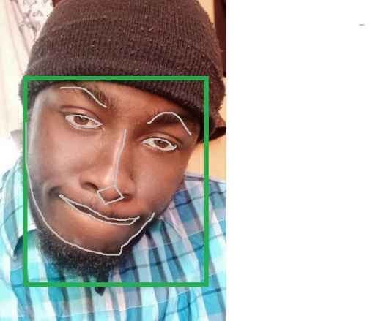

Fig 9

Now that we know where the eyes and mouth are, we’ll simply rotate, scale and [shear](https://en.wikipedia.org/wiki/Shear_mapping#/media/File:VerticalShear_m%3D1.25.svg) the image so that the eyes and mouth are centered as best as possible. We won’t do any fancy 3d warps because that would introduce distortions into the image. We are only going to u1se basic image transformations like rotation and scale that preserve parallel lines called [affine transformations](https://en.wikipedia.org/wiki/Affine_transformation):

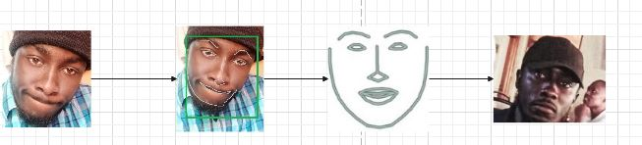

Original features extraction features detect face match

Fig 10

Now no matter how the face is turned, we are able to center the eyes and mouth are in roughly the same position in the image. This will make our next step a lot more accurate. If you want to try this step out yourself using Python and dlib, here’s the [code for finding face landmarks](https://gist.github.com/ageitgey/ae340db3e493530d5e1f9c15292e5c74) and here’s the [code for transforming the image](https://gist.github.com/ageitgey/82d0ea0fdb56dc93cb9b716e7ceb364b) using those landmarks.

### **Training Datasets**

After this we will do a face encoding. This is the part used to tell faces apart. The best approach to this recognition is to directly compare the unknown face and the know faces of students that are already tagged. When we find a previously tagged face saved in the image database that looks the most similar to our known face that contains the exact tagged student. This approach has a huge disadvantage.

For example, Instagram with billions and billions of users and trillion pictures this means it can’t possibly loop through every previous tagged face in the database and to compare it to every new uploaded pictures on the platform. This method will take longer time to identify a person.

For our case we will use a method to extract a few basic landmarks from each face then the program will measure our unknown student face using the same the strategy and find the known for the tagged faces with the closest measurements to the unknown.

To measure a face, we capture each face to build the known database containing the images and tagged (ear size, face shape, nose size etc.). I am going to train our system to recognize picture objects to generate 128 measurements for each face.

The training will work in with 3 images and 3 phases at a time;

* First capture and add a training image of known student
* Secondly capture and add another picture of same known student
* Last capture and add a picture of totally different student

The algorithm checks the three images through measurements currently generated by each image. The algorithm the configures the neural network slightly so as to make to generate the measurements for first and second image are slightly similar while making sure the embedding (measurements)for second and third image are slightly different .

* + 1. **Test using another image**

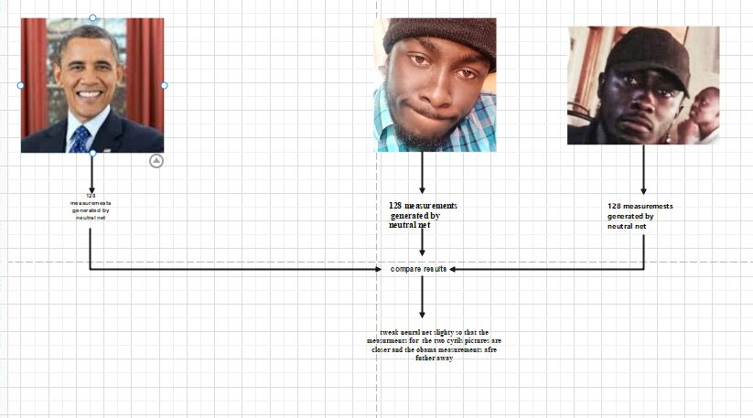

Fig 11

Retraining this algorithm a million times for hundreds of images of hundreds of different students. Through learning the neural network to effectively generate 128 embedding for each student i.e. 10 images of the same student will produce roughly the same measurements. This is enabled through machine learning where complicated raw data in our case pictures into list of generated numbers that a computer can understand.

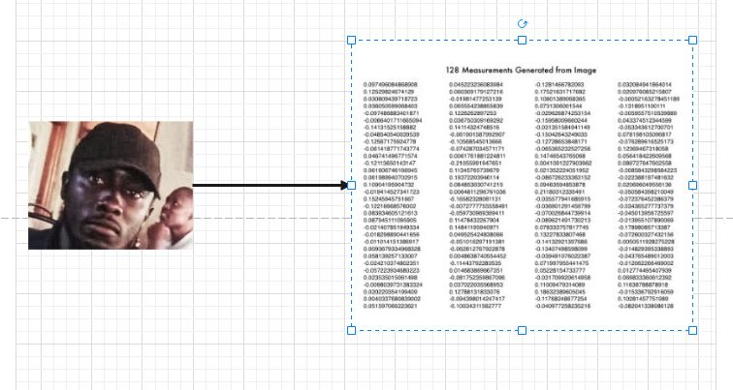

Fig 12

Using convolutional neural network to output face embedding that requires a lot of data and computing power this process is called encoding. After training the neural network it will be able to generate encodings for ant faces, even those that are unknown. What I need to do is to generate the student face images through the pre trained neural network to get the 128 measurements for each face.

### **Attendance Generation**

Then finally we get the person name tagged image from the encoding This is the final step we have to find the student in our image database of the known who has the most similarity in measurements to the captured test image. Done using basic classification algorithm using a linear SVM classifier. What will be required is to train the linear classifier to take the measurements of a new image and tell the know student, by finding the closest match. Running the classifier takes less time because it takes milliseconds the output being the student’s names.

# **TOOLS USED**

* **Laptop core i5 2.25GHz**
* **Ram 4GB**
* **Visual studio Code**
* **Python 3.10**
* **Pyqt5 Designer**
* **Anaconda for Cmake**
* **Microsoft Visual for dlib**
* **Test Students**
* **Mobile phone for better pictures**
* **Open Cv**

# **CHAPTER THREE**

## **RESULT AND DISSCUSION**

The students can interface with the framework utilizing a GUI. Here students will be essentially given two distinct choices, for example Capture new students and Attend class fig 13. Subsequent to tapping on Detect button, the web cam begins naturally and window as displayed in fig 15. Springs up and begins identifying the appearances in the casing Fig 16. Then it naturally begins clicking photographs until 60 examples are gathered. These pictures then, at that point, will be pre-handled and put away in preparing pictures envelope. The resources should enlist with the separate course codes alongside their name-id in the personnel enrollment structure gave during input Fig 14.

This window consists of the detecting faces. These faces detected are from the video.

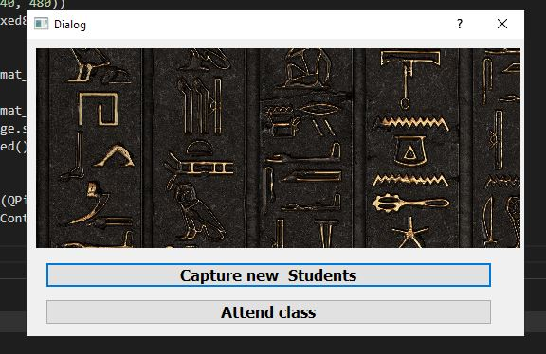

Fig 13

This is the welcome page this allows for choosing to take images or take the attendance of the images.

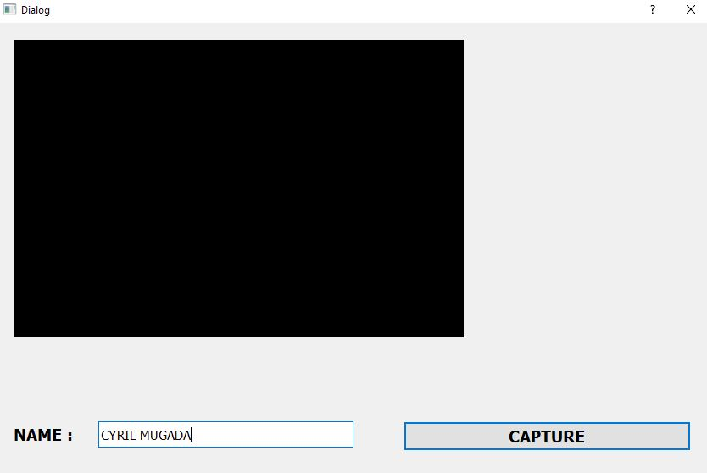

Fig 14

This window is used to capture students and allow for each student to enter their correct admission number or name.

Once enter the capture button store the data in a input folder that being our destination database where it will be fetched during recognition.

Each class name is entered through

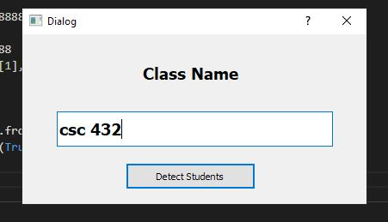

Fig 15

This allows for the excel sheet to be saved as a class name.

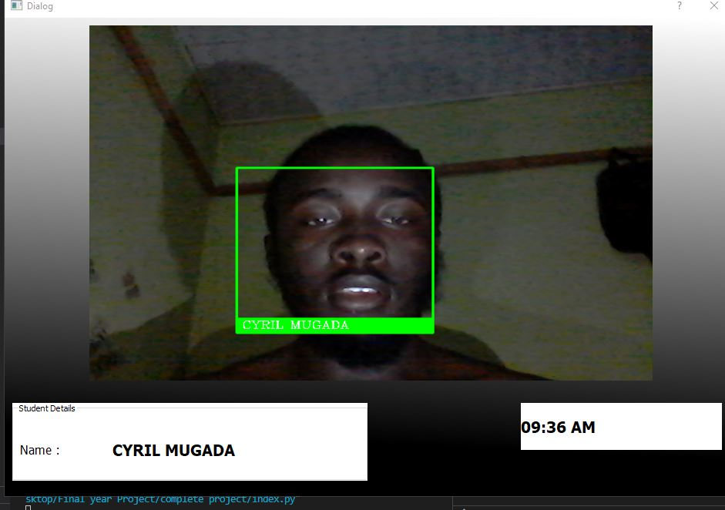

Fig 16

First the faces on the screen are traced out and the recognition process starts. During the recognition phase, the detected facial features are compared to the features stored in our specific excel sheet. If the system recognizes the features, the corresponding face is recognized and the name of the recognized student is displayed on the screen in message box.

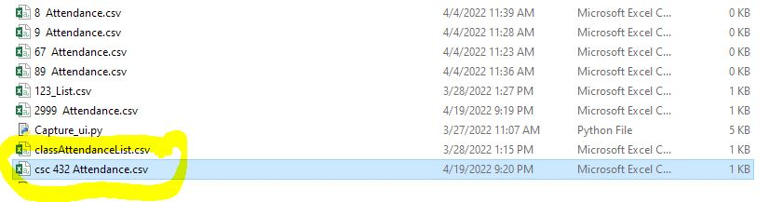

Fig 17

This will be the output to the program. This window shows the report of the marked attendance. Attendance is marked along with the date and the time for each student for that particular lecture in excel document.

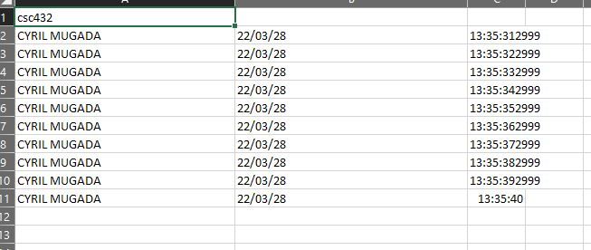

Fig 18

In this segment of this paper, the aftereffects of the created model will be examined. The created model works genuinely on the falsely evolved test information. The model works well by identifying each student. The students who are not registered in the system are not detected and not entered into the system.

**4.1. ADVANTAGES**

It saves there time and efforts.

The software stores the faces that are detected and automatically marks attendance.

The system is convenient and secure for the user.

The software can be used for security purposes in organization and secured zones.

**4.2. DISADVATNATGES**

It can only detect face from a limited distance

The system don’t recognized properly in poor light so may give false results.

**FUTURE SCOPE**

As vehicles proceed with their change from mechanical machine to computerized gadget, an ever increasing number of producers are integrating face acknowledgment innovation into their independent vehicles. Applications can go from observing the driver to alarm you on the off chance that you're nodding off to naturally changing the seat and mirror positions when the driver enters the vehicle. Different purposes of face acknowledgment for vehicles incorporate utilizing your face to supplant a key for of opening and beginning your vehicle and perceiving your sound inclinations by changing the radio broadcast.

For security reasons, we can use detection & recognition system. To identify culprits on bus stations, Railway stations 7 other public places, we can use this system. This will be helping hand to the police. In this system, we will use GSM module. Suppose if culprit is detected, then detected signal can be Transmitted using GSM module to the central control room of police station.

With the help of ISDN Number of GSM, culprit surviving area will be recognized

Utilizing facial acknowledgment, the emergency clinic registration cycle can be enormously improved by allowing an individual to concede themselves to an office without finishing up any administrative work or showing distinguishing proof - they just let the framework examine their face. As well as accelerating the interaction, facial acknowledgment could be utilized to check, recognize and permit the supplier to customize their experience. Patient consideration is smoothed out by opening clinical records to approved staff when and where they are required. The innovation can likewise assist with diagnostics. Face recognition is an illustration of a medical care application utilized by clinicians that can distinguish interesting hereditary circumstances. Consider Cornelia de Lange condition, where patients have specific facial highlights that can be missed by doctors since they just probably won't have gone over it during their clinical practice.

## **CONCLUSIONS**

Our software project, ―An face recognition for capturing class attendance has been envisioned for the purpose of reducing the errors that occur in the traditional (manual) attendance taking system. The aim is to automate and make a system that is useful to the organization such as an institute. The camera plays a crucial role in the working of the system hence the image quality and performance of the camera in real-time scenario must be tested thoroughly before actual implementation. This method is secure enough, reliable and available for use. No need for specialized hardware for installing the system in the classroom. It can be constructed using a camera and computer.

# **References**

[1]SHABBIR BHIMANI, (2020) ,What is Attendance Register? Types, Benefits and Tools [1]

[3]Veerapaneni and Rao, (2011, p.41) EXCELDATAPRO 2022

[4] Munish Kumar, (2019) August Artificial Intelligence Review

[5]Sepideh Mokhtari, Sakineh Nikzad, (2021), Articles from Journal of Education and Health Promotion are provided here courtesy of Wolters Kluwer -- Medknow Publications

[6] Tarimo and Hickey, (2017), Islam et al

[7]Chengsheng Yuan, (2021), AI and Cloud Computing

[8]Sheng Wu, (March 15, 2021), in Advances in Computers

[11] 2021 IEEE Control and System Graduate Research Colloquium

[12] Nagarjuna G (2014) Information and Knowledge Management Using GNOWSYS

[13]Seema Rani (2017)..Implementing RFID In Library .Methodlogies, Advantages and Disadvantages

[2]https://www.edglossary.org/assessment/ GLOSSARY OF EDUCATION REFORM 11.10.15

[14]Kenneth Okereafor,Iniobong Ekong, Ini Okon Markson,Kingsley Enwere(2020)Fingerprint Biometric System Hygiene and the Risk of COVID-19 Transmission

[15] Vidhi Doshi(2020)The Switch.A security breach in India has left a billion people at risk of identity theft

[16] Andrea Peterson(2020) The Switch.OPM says 5.6 million fingerprints stolen in cyberattack, five times as many as previously thought

[17] Kennedy O. Okokpujie; Etinosa Noma-Osaghae; Olatunji J. Okesola; Samuel N. John; Okonigene Rober(2017). IEEE. Design and Implementation of a Student Attendance System Using Iris Biometric Recognition

[18]Muhammed Tanriverdi,Refik Samet(2017).IEEE.Face Recognition-Based Mobile Automatic Classroom Attendance Management System

[19] Omar Abdul Rhman Salim,Rashidah Funke Olanrewaju (2018).IEEE. 7th International Conference on Computer and Communication Engineering (ICCCE)

[20]Niroj Kumar Bhattarai (2017)"WHAT FACTORS AFFECT SCHOOL ATTENDANCE? QUANTITATIVE AND QUALITATIVE STUDY OF EVIDENCE FROM NEPAL”

[21]de Leeuw, Karl; Bergstra,(2007). The History of Information Security: A Comprehensive Handbook. Amsterdam: Elsevier. pp. 264–265

[22]de Leeuw, Karl; Bergstra,(2020).PUBLICATIONS & MEDIA.A brief history of Facial Recognition

[23]Baishakhi Ray,uman Jana(2018)PUBLIC ACCESS. “Deep Test: automated testing of deep-neural-network-driven autonomous cars"

[24]Waldemar Wójcik, Konrad Gromaszek and Muhtar Junisbekov (2015) Face Recognition: Issues, Methods and Alternative Applications

[25] A. Krizhevsky, I. Sutskever, and G. E. Hinton, “Imagenet classification with deep convolutional neural networks,” in Advances in Neural Information Processing Systems 25: 26th Annual Conference on Neural Information Processing Systems 2012. Proceedings of a meeting held on December 3-6, 2012, (Lake Tahoe, Nevada, United States), pp. 1106–1114, 2012.

[26] Soniya, Paul S, Singh L. A review on advances in deep learning[C]// IEEE Workshop on Computational Intelligence: Theories, Applications and Future Directions. IEEE, 2015:1-6.

[27] Yang B, Yan J, Lei Z, et al. Convolutional Channel Features for Pedestrian, Face and Edge Detection [J]. Computer Science, 2015:82-90.

[28] K.G.M.S.K. Jayawardana, T.N. Kadurugamuwa, R.G. Rage and S. Radhakrishnan”, Timesheet: An Attendance Tracking

System”, *Proceedings of the Peradeniya University Research Sessions, Sri Lanka, Vol.13, Part II, 18th December 2008.*

[29] Yohei KAWAGUCHI, Tetsuo SHOJI , Weijane LIN ,Koh KAKUSHO *,* Michihiko MINOH ,“Face Recognition-based

Lecture Attendance System”, Department of Intelligence Science and Technology, Graduate School of Informatics,

Kyoto University. Academic Center for Computing and Media Studies, Kyoto University

[30] M. A. Fischler and R. A. Elschlager, “The Representation and Matching of Pictorial Structures,” IEEE Transaction on Computer, vol. C-22, pp. 67-92, 1973.

[31] S. S. R. Abibi, “Simulating evolution: connectionist metaphors for studying human cognitive behaviour,” in Proceedings TENCON 2000, vol. 1 pp 167-173, 2000.

[32] Y. Cui, J. S. Jin, S. Luo, M. Park, and S. S. L. Au, “Automated Pattern Recognition and Defect Inspection System,” in proc. 5 th International Conference on Comp

# **APPPENDIX**

Sample source code of the face recognition Algorithm.

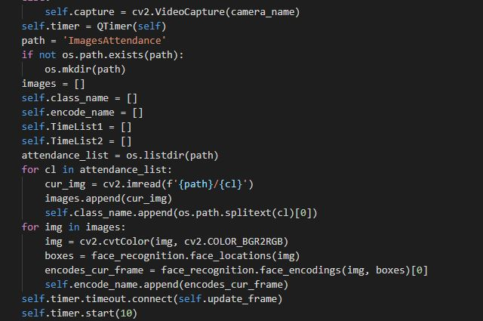

The main feature in this source code is to:

First load images on to the function (this are the triangle database images). Convert them to black and white .We detect our face location. We encode the detected face and append them to the array.

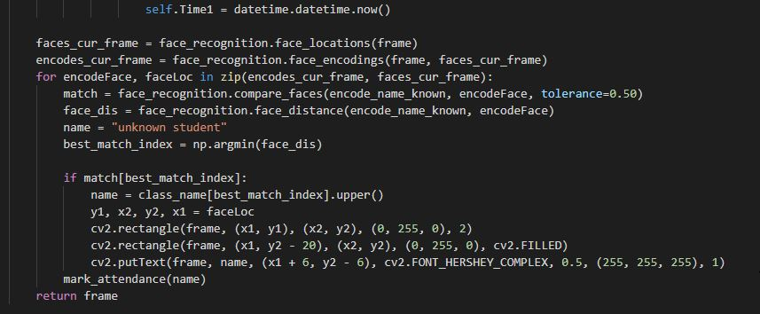

Send location to our recognition function encode and the new face from the camera . we use it to find the best match. The a comparison is done the picture with the best match is choosen and a bound box is drwan on the image and name displayed.

After inputting the video to the computer, frame generation is first performed by dynamic frame generation of video. We get no. of frames/images, the generation of frames/images per/sec is 30 to 40 frames. The length of the input video captured is 1 minute 8 sec, hence the generation of frame is huge, and so we can select the frames in between, between 99 to 1356. Hence the frames will be processed between 99 to 1356 frames.

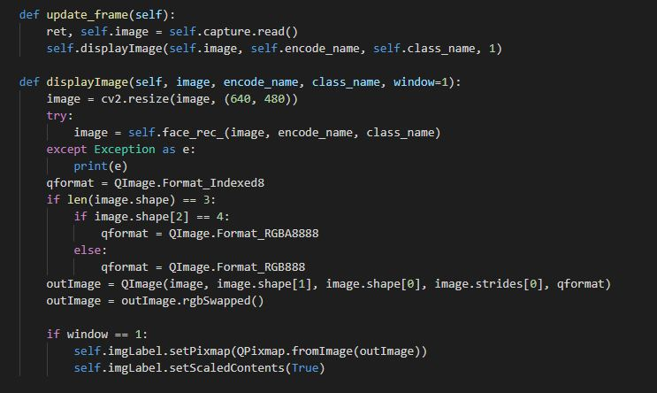

This portion works by capturing a frame from the video. This is used to get the real time image.

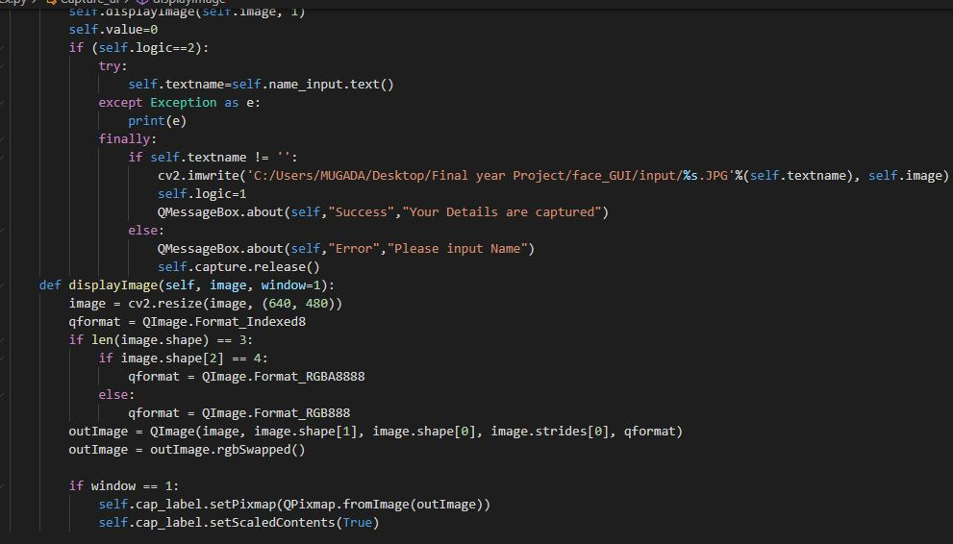

This is used to capture new student images and store them into the input folder.