2026.2.25 Test Result Feedback:
- In Settings — after selecting the track and date, then clicking “Execute All,” an error occurs: No module named ‘requests’.
If this function does not work, the software has no value at all.
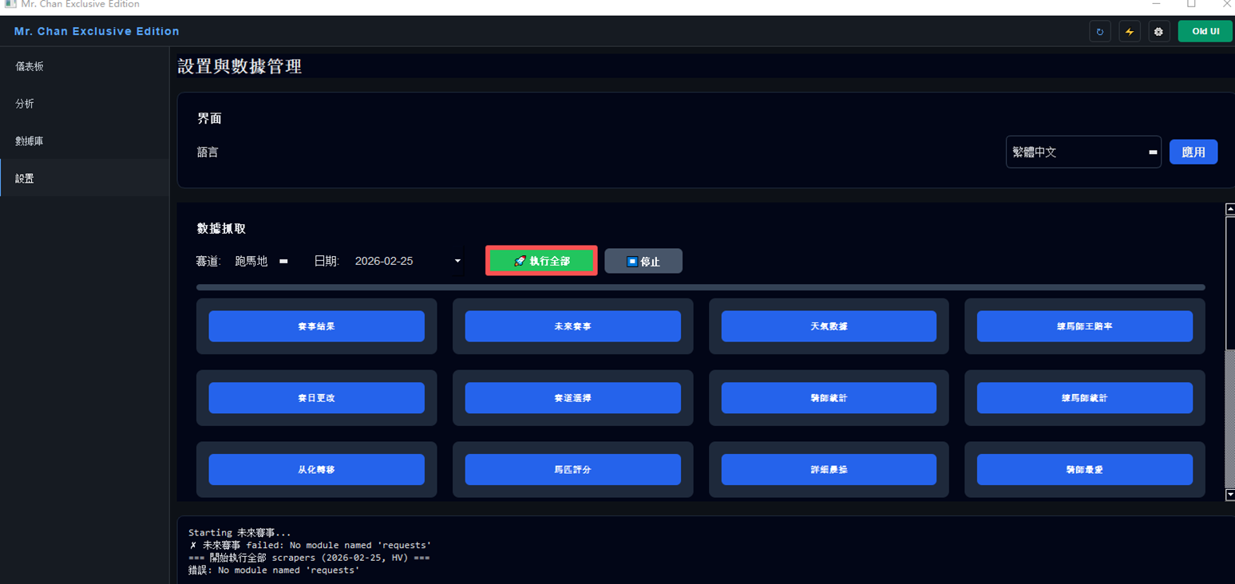

- Comparing the actual race results of Sha Tin on 2026.2.19 (a total of 11 races) with the software’s predictions, the software’s top recommendations (1st choice) were all inaccurate. Based on the current results, if the top-choice hit rate does not exceed 60%, then the software’s output has no meaning or value. The reasons need to be analyzed and the model algorithm needs to be adjusted.
For example, if the hit rate is 50% and the other 50% are losses, it would only break even at best, with no chance of making a profit—therefore, it is meaningless.


