Setting the global username and email, listing Git settings, and cloning an empty repository

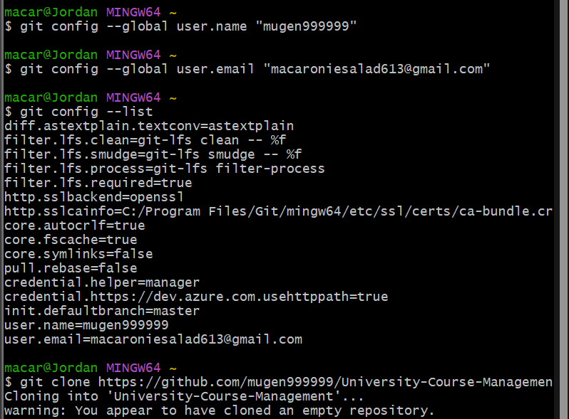

Adding a README.md file, committing it with a message, and pushing the changes to the main branch

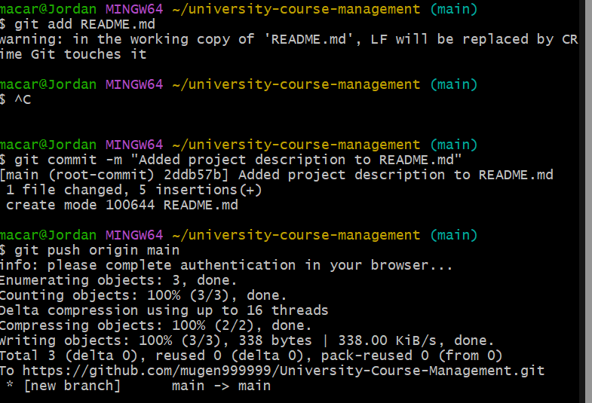

Initializing a repository, attempting to add a remote origin, and verifying the configured remote repository URL

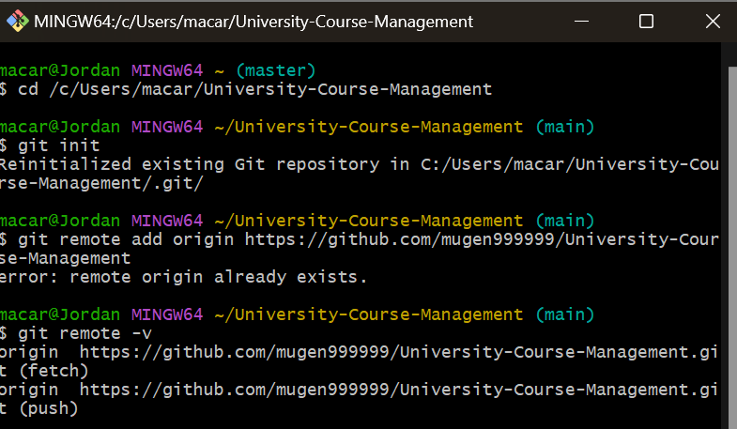

Process of setting up a Git repository for the university course management system and creating multiple feature branches.

