CUSTOMER SEGMENTATION USING DATA SCIENCE

**Segmentation Model Interpretation and Visualization**

Now that we have built our segmentation model, we need to assign clusters to each customer in the dataset:

pred = kmeans.predict(scaled_features)

frame = pd.DataFrame(new_df)

frame['cluster'] = pred

Let’s look at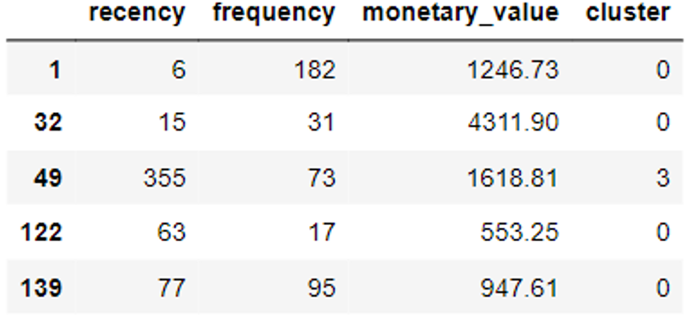 the head of the new dataframe we just created:

Then we must [visualize our data](https://365datascience.com/trending/chart-types-and-how-to-select-the-right-one/) to identify the distinct traits of customers in each segment:

avg_df = frame.groupby(['cluster'], as_index=False).mean()

**for** i **in** list1:

sns.barplot(x='cluster',y=str(i),data=avg_df)

plt.show()

The codes above will render the following charts:

