Bdc (call transaction method)
Op: 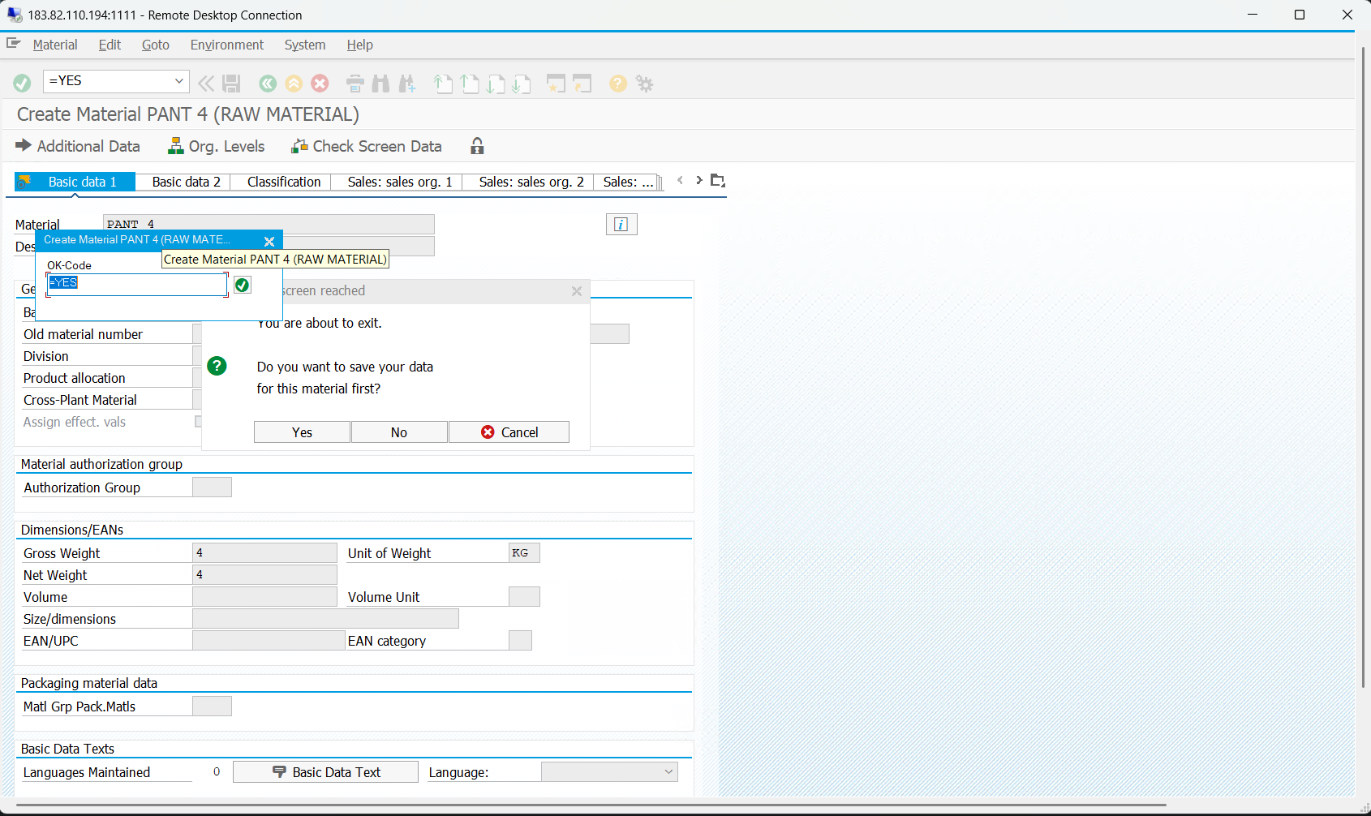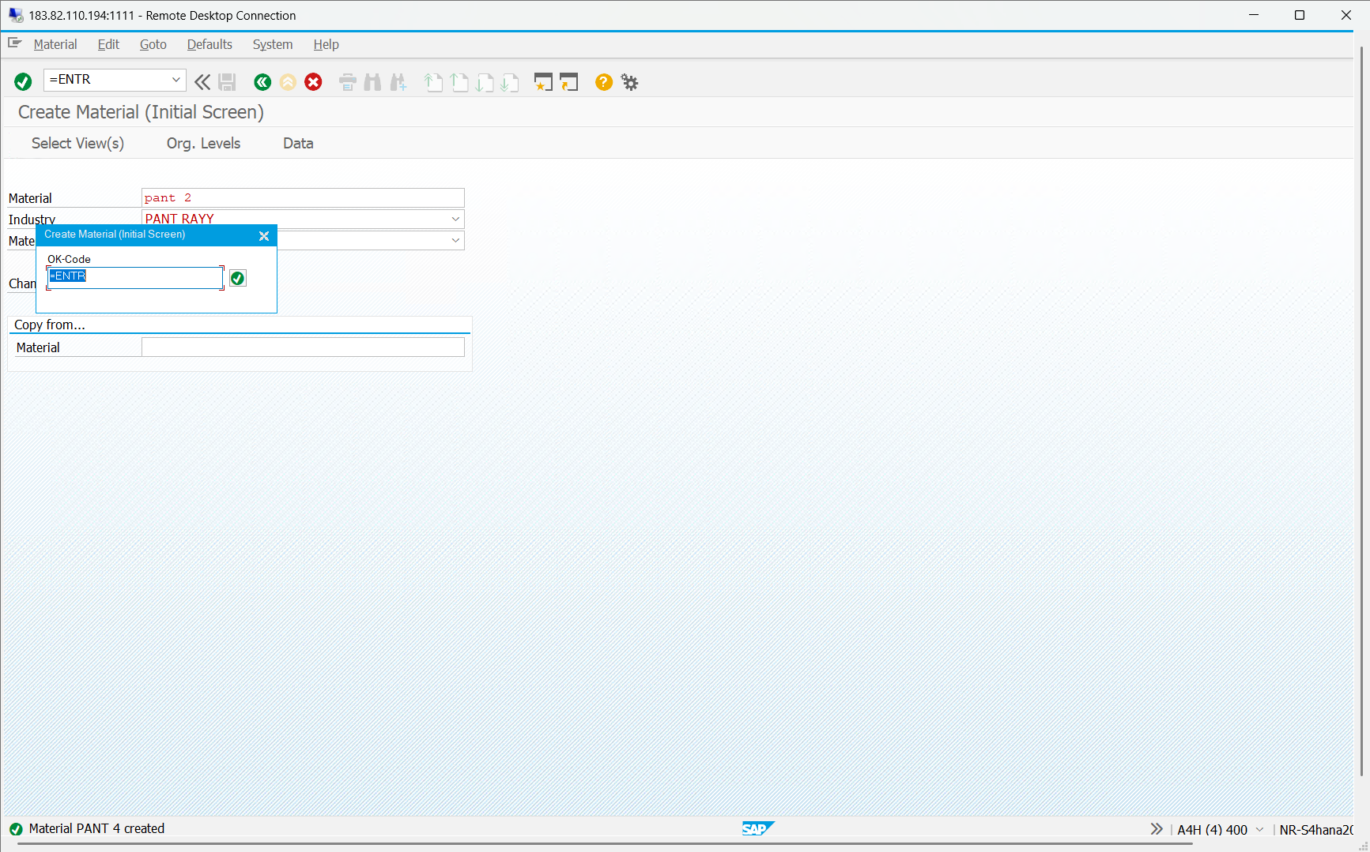
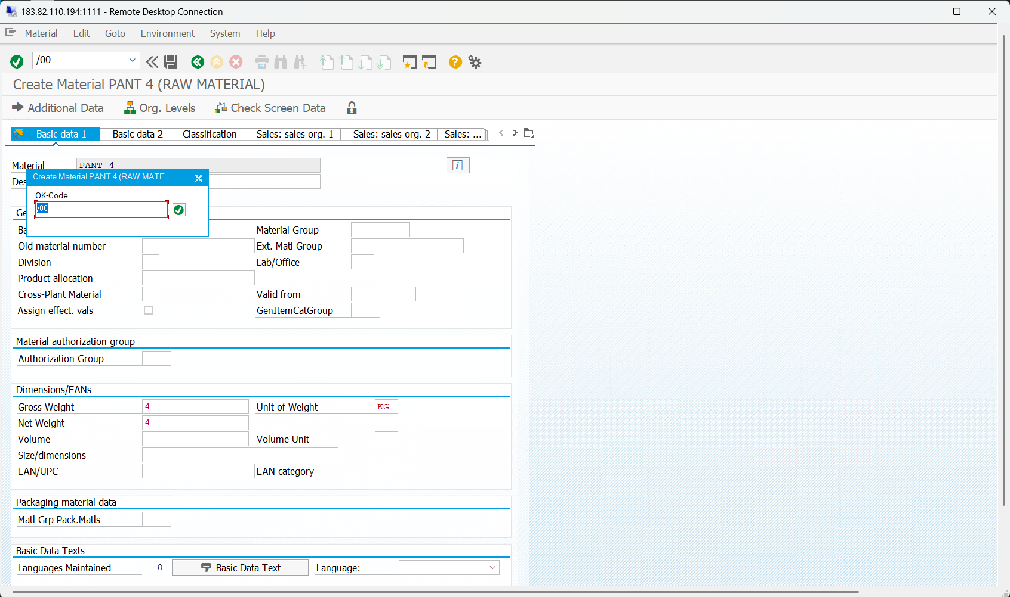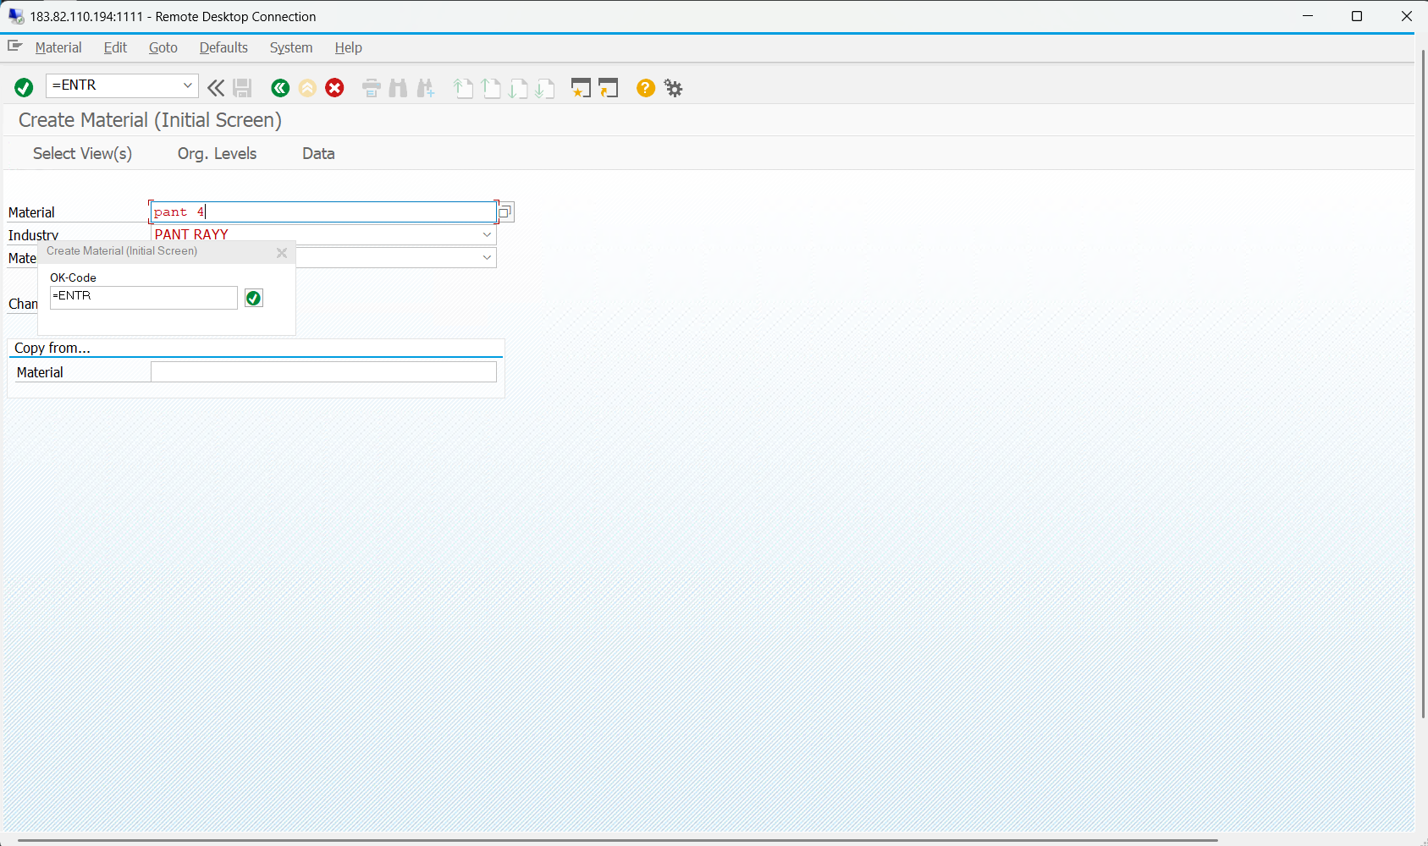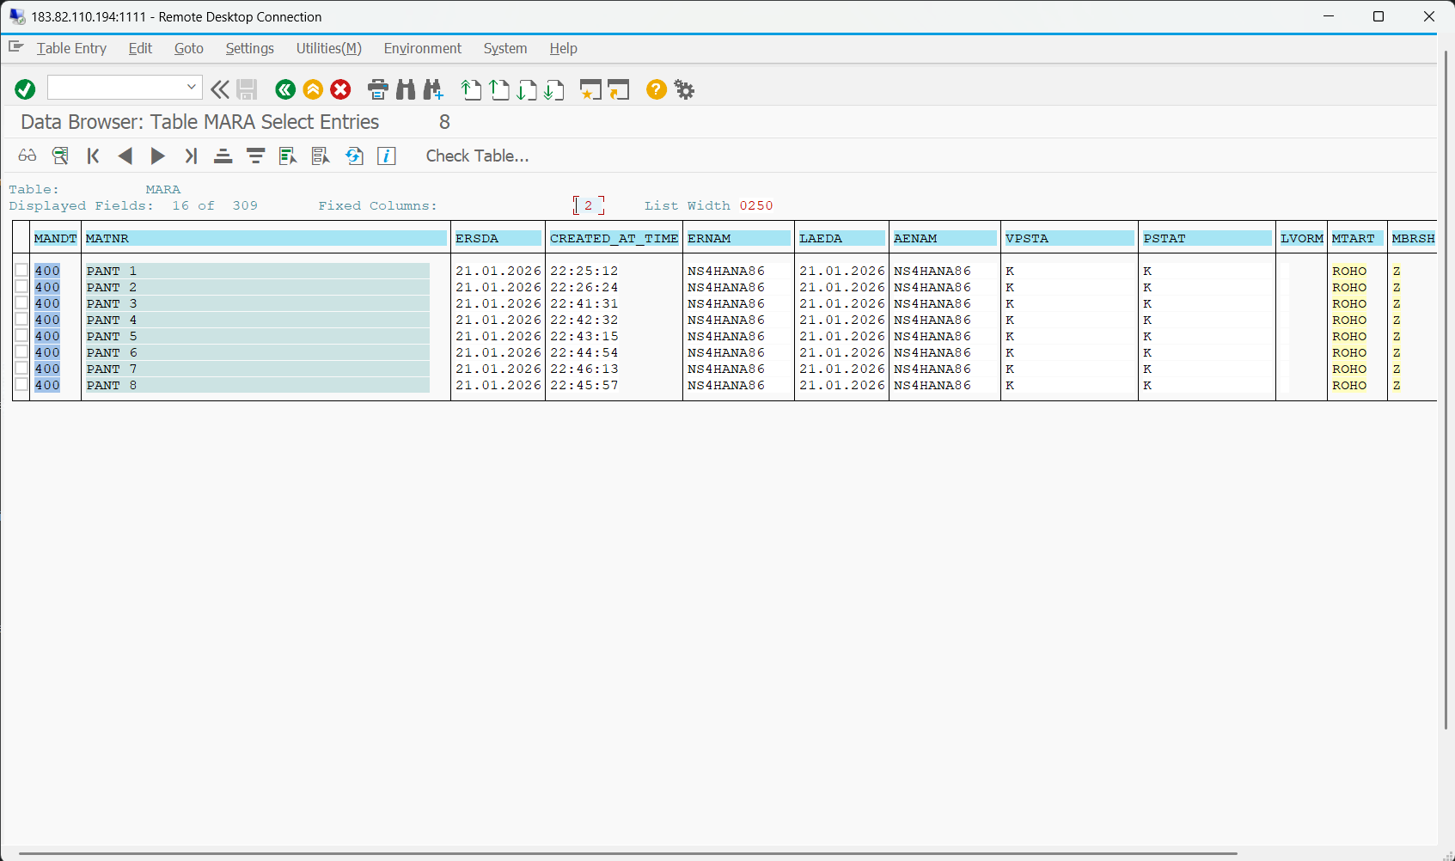
Code:
report ZDEMO_BDC3
no standard page heading line-size 255.
TYPES: begin of ty,
matnr TYPE matnr,
mbrsh TYPE mbrsh,
mtart TYPE mtart,
maktx TYPE maktx,
meins TYPE meins,
matkl TYPE matkl,
END OF ty.
data: it TYPE STANDARD TABLE OF ty,
wa TYPE ty.
data: it_bdc TYPE STANDARD TABLE OF BDCDATA,
wa_bdc TYPE BDCDATA.
* Include bdcrecx1_s:
* The call transaction using is called WITH AUTHORITY-CHECK!
* If you have own auth.-checks you can use include bdcrecx1 instead.
*include bdcrecx1_s.
start-of-selection.
CALL FUNCTION 'GUI_UPLOAD'
EXPORTING
filename = 'C:\Users\ns4hana86\Documents\MY 1ST BDC LEGECY DATA.txt'
FILETYPE = 'ASC'
tables
data_tab = it.
LOOP at it INTO wa.
refresh it_bdc.
*perform open_group.
perform bdc_dynpro using 'SAPLMGMM' '0060'.
perform bdc_field using 'BDC_CURSOR'
'RMMG1-MATNR'.
perform bdc_field using 'BDC_OKCODE'
'=ENTR'.
perform bdc_field using 'RMMG1-MATNR'
'BELT 6'.
perform bdc_field using 'RMMG1-MBRSH'
'B'.
perform bdc_field using 'RMMG1-MTART'
'0001'.
perform bdc_dynpro using 'SAPLMGMM' '0070'.
perform bdc_field using 'BDC_CURSOR'
'MSICHTAUSW-DYTXT(01)'.
perform bdc_field using 'BDC_OKCODE'
'=ENTR'.
perform bdc_field using 'MSICHTAUSW-KZSEL(01)'
'X'.
perform bdc_dynpro using 'SAPLMGMM' '4004'.
perform bdc_field using 'BDC_OKCODE'
'/00'.
perform bdc_field using 'MAKT-MAKTX'
'6TH BELT'.
perform bdc_field using 'MARA-MEINS'
'PC'.
perform bdc_field using 'MARA-MTPOS_MARA'
'NORM'.
perform bdc_field using 'BDC_CURSOR'
'MARA-NTGEW'.
perform bdc_field using 'MARA-BRGEW'
'4'.
perform bdc_field using 'MARA-GEWEI'
'KG'.
perform bdc_field using 'MARA-NTGEW'
'4'.
perform bdc_dynpro using 'SAPLSPO1' '0300'.
perform bdc_field using 'BDC_OKCODE'
'=YES'.
*perform bdc_transaction using 'MM01'.
*
*perform close_group.
call TRANSACTION 'MM01' USING it_bdc MODE 'A' UPDATE 'S'.
ENDLOOP.
FORM BDC_DYNPRO USING PROGRAM DYNPRO.
CLEAR wa_bdc.
wa_bdc-PROGRAM = PROGRAM.
wa_bdc-DYNPRO = DYNPRO.
wa_bdc-DYNBEGIN = 'X'.
APPEND wa_bdc to it_bdc.
ENDFORM.
*----------------------------------------------------------------------*
* Insert field *
*----------------------------------------------------------------------*
FORM BDC_FIELD USING FNAM FVAL.
IF FVAL <> SPACE.
CLEAR wa_bdc.
wa_bdc-FNAM = FNAM.
wa_bdc-FVAL = FVAL.
APPEND wa_bdc to it_bdc.
ENDIF.
ENDFORM.

