**Dark Souls**

**Dormant Ruins**

GD08 April

**Table of Contents**

1. Level Overview 2

2. Level Layout 3

3. Objectives and Challenges 4

4. Flow Chart 8

5. Beat Chart 8

6. Asset List 8

## Level Overview

### Level Concept

The Dormant Ruins is a hidden level of Dark Souls. It’s designed as a part of the *Lost Lzalith* which is located at the deepest place of the world and is full of lava. It will be placed after the room of the boss *Bed of Chaos.* The player can reach there after they beat the Bed of Chaos and open the hidden door behind it.

The level used to be a town of the *Lzalith*. There is a Colosseum in the deepest of the town where the strongest warrior stayed. After the power of the Abyss contaminated the world and the flame was going to extinct, the *Lzalith* went into chaos and wars. The lava was erupted and filled the town. The town became ruins and only demons remained there. The warrior was also contaminated. In order not hurt the creatures outside, he locked himself in the Colosseum. During countless years, his soul persisted in struggling with the tainted body and suffered the endless pain.

The player needs to explore the Dormant Ruins and find the secret of it. During the adventure, player will discover the main objective is to defeat the ancient warrior to release the soul of him.

### Narrative and Gameplay

The first step is to cross the narrow path and reach the circus. It quite easy for the player as player just need to walk through the path and be careful with the enemies hiding behind the wall.

Secondly, the front gate of the circus can’t be opened from this side. Player has to go to the side way to find the way to reach place behind the door. The enemies with the arrow and bow will shoot player, player should find obstacles and timing to cross the dangerous narrow path to keep himself not to fall. After player reach there, he can open the door from it back side which creates a shortcut.

Thirdly, there are two options. One of the path is a bonus path where a bonfire which is the save point is located. The other is a path to fight with the elite enemies. There are other enemies in the square to disturb players.

Fourthly, player should cross the bridge to reach the damp. When they reach the other end of the bridge, the bridge will break from that end and become a ladder which links the square and the ground. Player can interact with the dam to stop the lava. The lava will go lower and show the ground of the ruins.

Fifthly, there are two options again. One path is go to ground directly by the ladder beside right of the dam. Another is to turn left and return to the square by walking on the cliff. There is an NPC who will give the mission about the warrior and guide player to find him. The NPC is also a trader. The bridge ladder of the square can also send player to the ground.

Sixthly, there are several path on the ground. The main path is to go to the Colosseum and fight with the warrior. On the other path, there will be different bonus pickups and enemies. For example, a new bonfire is hidden under the dam. There are several groups of enemies blocking the road. There is an elevator near the Colosseum so that player can set their save-load point close to the Boss warrior.

Finally, after player defeat the warrior, there will be a new bonfire which can teleport the player to the normal world. The NPC will also appear there and give reward to the player.

## Level Layout

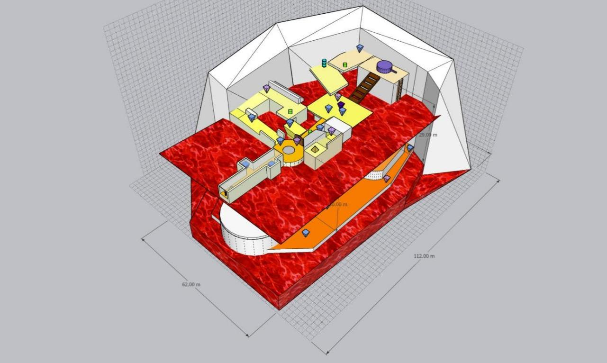 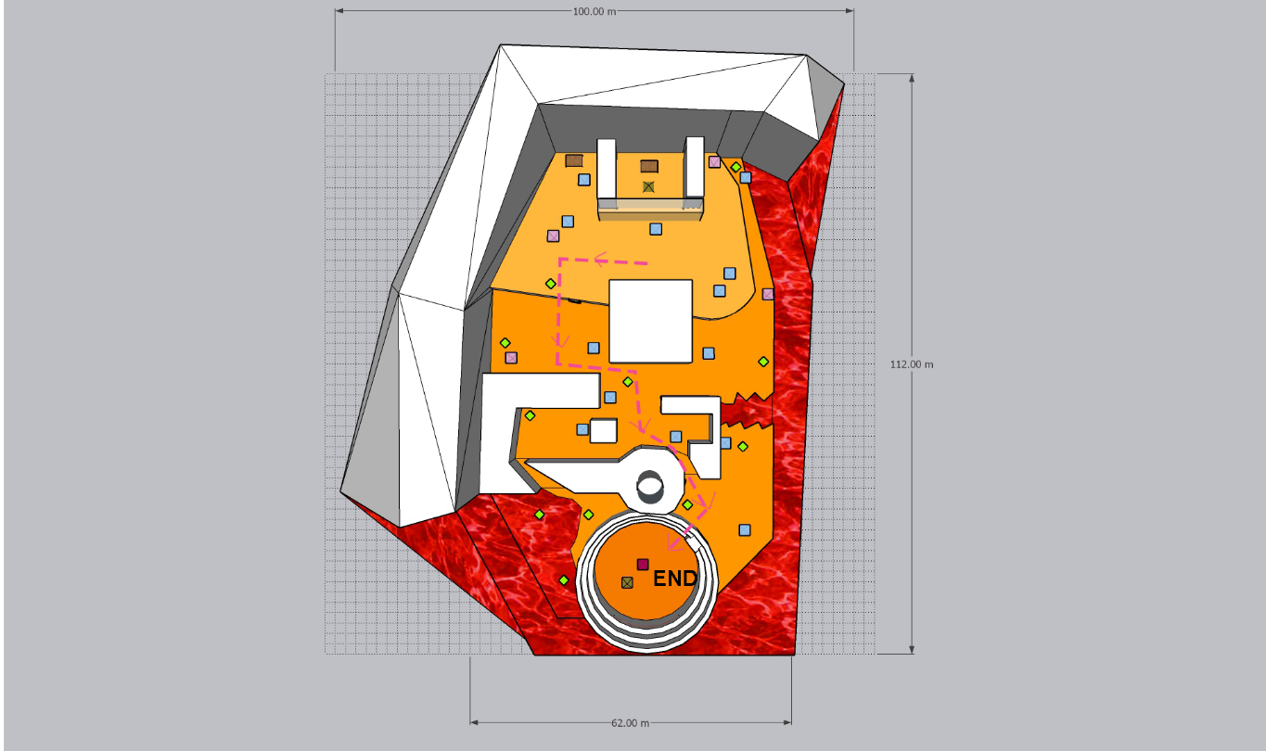

Grid Scale = 2*2 m

Overall level size = 62* 112m

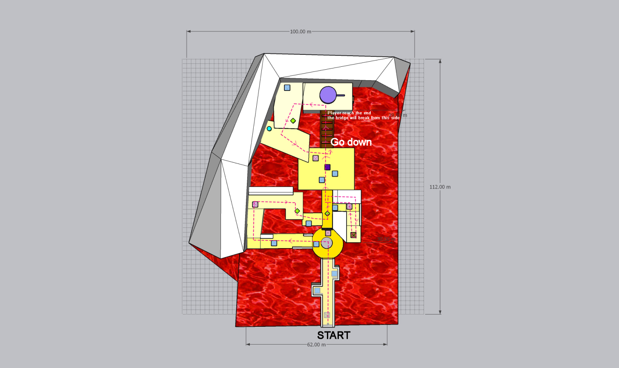

The roof level The ground level

## Objectives and Challenges

### Objective 1 – Open the gate of the circus

When the player reaches the level, he will see a narrow path, the only light from the circus will attract him. The gate in the circus can’t be open, so player should go to the side way.

#### ld4.1Challenges

* There are close combat enemies hidden behind the wall and will attack player in the narrow path.
* Player should find the way to open the gate.
* There are close combat enemies locating front of the player to attract the attention. And enemy with arrow and bow stay on the higher level will shoot the player. Being attack by arrow will be easy to fall.
* Player should jump off the platform to reach the place behind the gate.

#### Player Progression

* Player should pass the narrow path and deal with the enemies hidden behind the wall.
* When arrive the circus, player is facing the two enemies at the same time. After defeating them, player will found the gate can’t be open from this direction. Player has to walk around and find other path.
* When stepping on the side way path, the enemies will shoot player and the wall behind will also keep player from fall immediately. Player has to rush to the obstacle and defeat the enemies. They can defeat two enemies directly or use arrows too.
* Player can get a pickup and find there is platform to fall and reach the back of the gate. And player can open the gate from that direction.

### Objective 2 – Turn off the dam

The dam is located in quite high place and is big enough to be noticed. Player can see it clearly and set it as an objective.

### ld4.2

#### Challenges

* There is an enemy hidden behind the building and will push the player to the lava pool.
* The enemy with arrow will also shoot the player when he crosses the narrow path.
* There is a group of enemy patrol around the square. And there is an elite enemy among them keeping player from crossing the bridge.

#### Player Progression

* Player should observe the corner and run quickly to avoid the pushing from the enemy.
* (Optional) Player can defeat the enemies on the right path and discover a bonfire. Because bonfire mechanics are special in Dark Souls I. Player can’t teleport among every bonfire freely. This bonfire can only offer player to recover and level up.
* To reach the bridge, player should deal with the group of the enemies or run smartly to the avoid the combat. Player can also stand on the left high platform to use arrow to kill the enemies or use arrow to draw enemies’ attention one by one. (Optional) Elite enemy will disappear forever and leave a great weapon to the player if it is defeated.
* Player reach the dam and shut it down. The lava level will go lower and the whole ruins will appear. Player will found he is located on the roof of the ruins and there is a ground level under him.

### Objective 3 – Reach the ground

When player reach the end of the bridge, the bridge will break and become a ladder to link the square and the ground.

#### ld4.3Challenges

* There are two paths to go to the ground. Player should select the paths.
* In left path, player should fight with the enemy and find way to go back to the square.

#### Player Progression

* In left path, player can get a pickup and meet a NPC. The NPC will give the mission about the warrior and guide player to find him. He is also a trader so that player can purchase some medicine to endure the lava for a while. Player will reach the ground through the bridge ladder from the square.
* In the right path, there is also a ladder link the dam and the ground. But player will miss the NPC, but he can return to the dam through the ladder again.

### Objective 4 – Find the path to the Boss

The ground level is a quite wide place compared with the roof level. Player has various way to explore the ground level.

#### ld2.4Challenges

* There is an enemy waiting the player to slide from the ladder to attack him.
* When reaching the ground, there are two directions to go. And both directions are full of enemies.

ladder

* (Optional) In the right path, when player jump off the ground to the lower ground, the ground in front of the path to the Colosseum collapse. Player should find other ways and can’t return by the way he comes.
* In left path, player should fight with close combat and long-range combat enemies group, there is an enemy hiding in the corner.
* In the critical path, there are several enemy groups blocking the path.
* (Optional) In the bottom left corner, there is still a lava pool, player should measure the time they can stay to get the pickups.

#### Player Progression

* When fighting with the enemy beside the bridge ladder, if play hit the wall, they will find a hidden cave, there will be a bonfire and a treasure. This bonfire also only can offer recovery and level-up.
* (Optional) In right path, player should handle with several enemies and get two pickups.
* (Optional) Player should walk in the lava pool in a short time to get the pickups. The pickups are all useful items.
* In the critical path, after defeat the enemy groups, player will get a treasure and pickups. There are several enemies hidden in the corner to attach the player. Among the combat, player will find the narrow path which links to the Colosseum.
* In front of the gate of the Colosseum, there is an elevator in the corner which link the circus in the beginning. Player can return to the bonfire beside the circus to decrease the way to go to the Boss room if he fails to defeat the Boss.

### Objective 5 – Defeat the Boss Ancient Warrior

#### ld2.4Challenges

* The Boss Ancient Warrior is a powerful enemy and hard to defeat.
* When the Boss come to the second stage, he will run out of control and break the floor. Lava will float into the Colosseum. Player should keep careful to the floor.

#### Player Progression

* Player should defeat the Boss Ancient Warrior who has two stage in order to release his sole.
* After defeating the warrior, the NPC will appear and give player reward.
* The bonfire will also appear, so that player can teleport to the home.

## Flow Chart

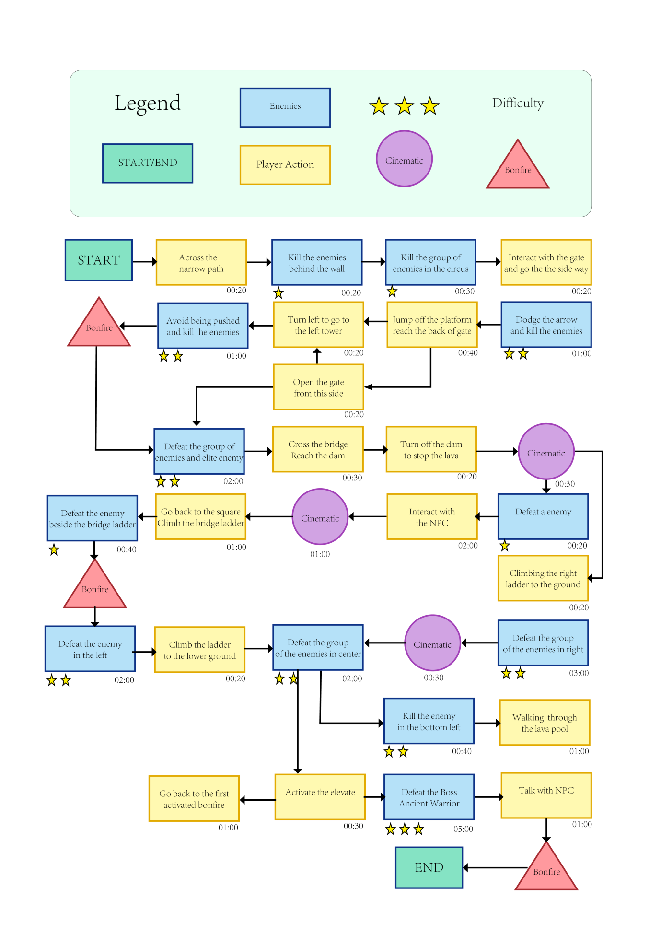

## Beat Chart

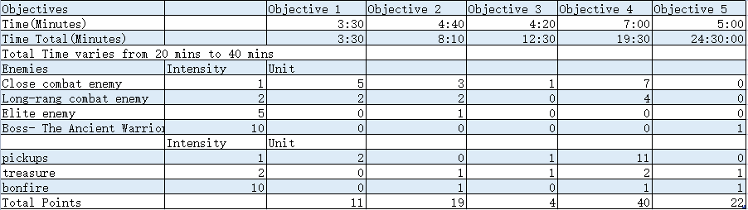

## Asset List

