**Level Design Base on Dark Souls – April**

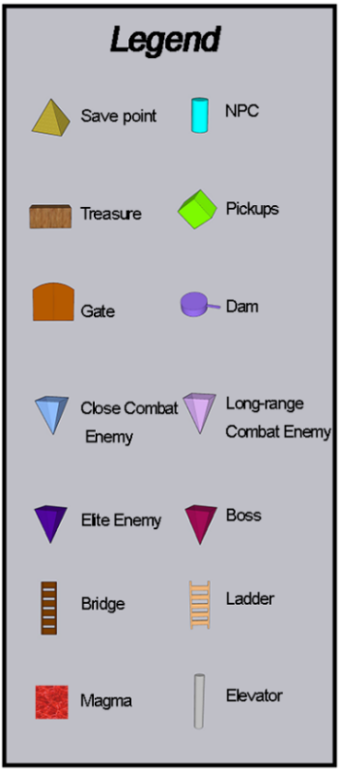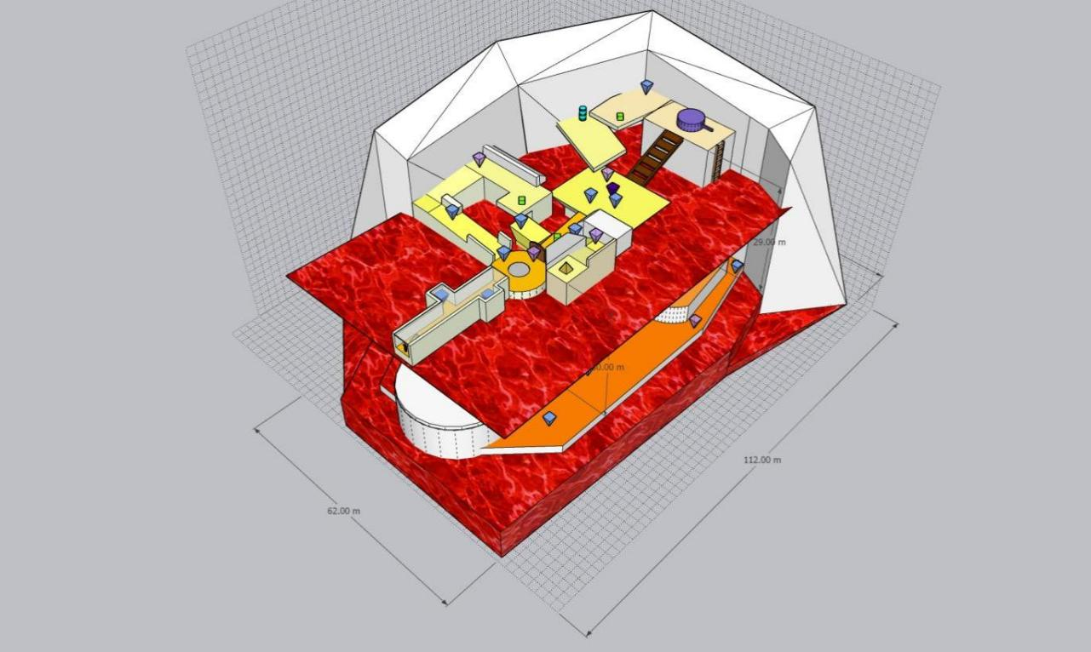**1.Overview Layout**

## 

Grid Scale = 2*2 m

Overall level size = 62* 112m

**2. Detail**

## C:\Users\GD Student\AppData\Local\Microsoft\Windows\INetCache\Content.Word\ld3.2.png

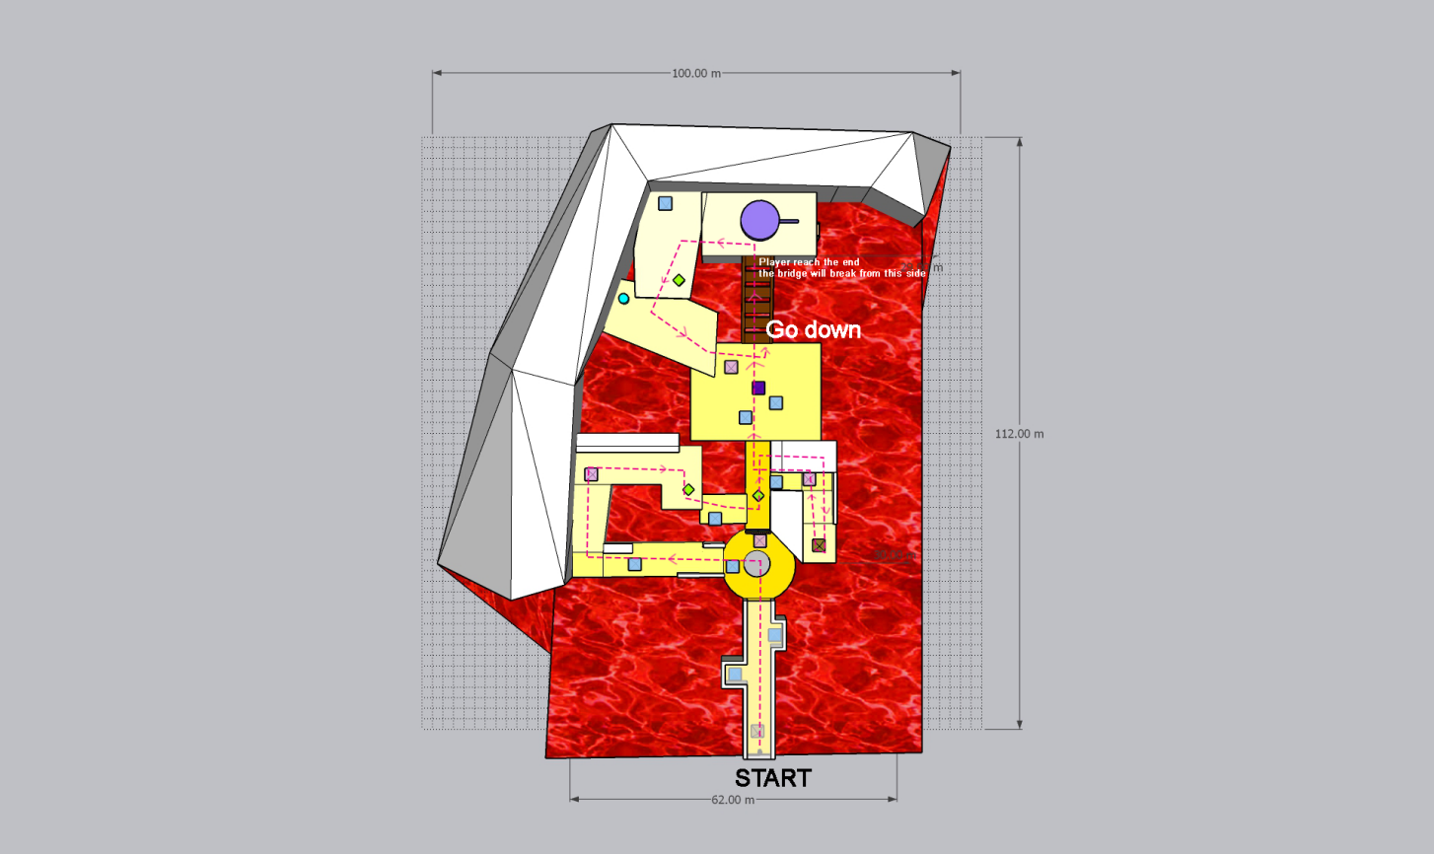

The roof level The ground level

#### ld4.3ld4.2ld4.1

#### 

