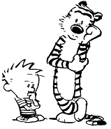***Make a quiz***

|  |
| --- |
| 1. ＿＿＿＿＿＿＿＿＿＿＿ |
| 1. ＿＿＿＿＿＿＿＿＿＿＿ |
| 1. ＿＿＿＿＿＿＿＿＿＿＿ |
| 1. ＿＿＿＿＿＿＿＿＿＿＿ |
|  |
| Who am I? ________________ |

**Who is it?**

|  |  |
| --- | --- |
| Round 1  1. . 2. . 3. . 4. .     Who am I? ________________. | Round 2  1. . 2. . 3. . 4. .     Who am I? ________________. |
| Round 3  1. . 2. . 3. . 4. .     Who am I? ________________. | Round 4  1. . 2. . 3. . 4. .     Who am I? _______________. |