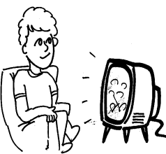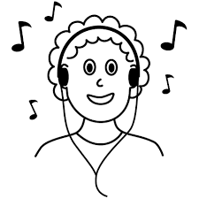

|  |  |
| --- | --- |
| 1. First, **what** did Muggli do? | https://i0.wp.com/i.imgur.com/f5GLLVF.jpghttp://sweetclipart.com/multisite/sweetclipart/files/imagecache/middle/kid_reading_line_art.png |
| 1. **Where** did Muggli go? | アメリカ |
| 1. **What** did Muggli do in Kochi? | Image result for surfing clipart black and whitehttp://images.clipartpanda.com/swimming-pool-clipart-black-and-white-p3.jpeg |
| 1. **What** festivals did Muggli go to? |  |

My summer vacation was **(1 )**.

First, I read books every day. I read over ten books this **(2 )**. I love reading books.

Also, I visited many **(3 )**. I went to Kyoto, Nara, and Kochi. I enjoyed surfing and swimming with my **(4 )** in Kochi.

It was very hot, but very fun.

Last, I experienced two **(5 )**. One was Tenjin Matsuri. I ate takoyaki with my friends. I was able to wear a **(6 )** too! Another festival I experienced was Yodogawa hanabi. It was very beautiful. I was very **(7 )**.

I really enjoyed my summer vacation.