|  |  |
| --- | --- |
| Lesson6-1 | **Listening Practice** |

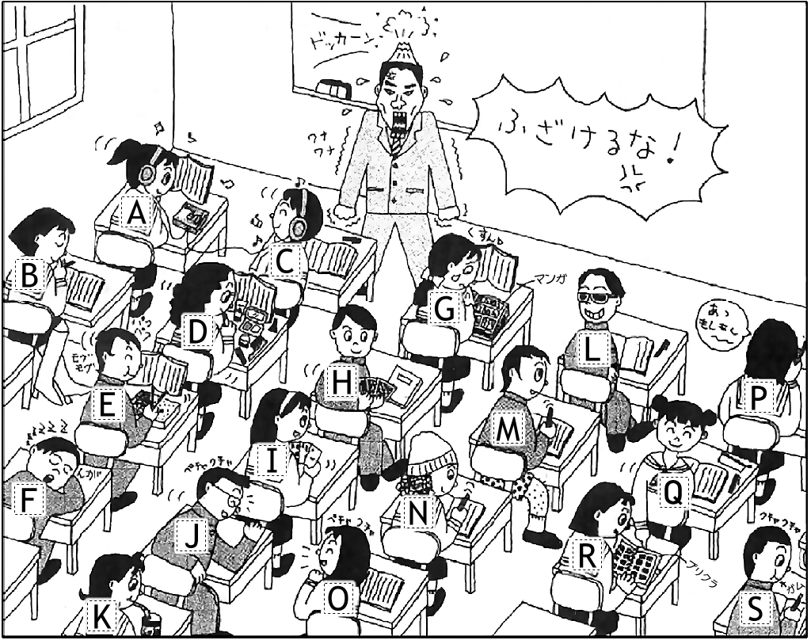**Memo**

1. Asami ( *B* ) *studying*
2. Takumi & Marie ( ) _________________
3. Maki ( ) ___________________
4. Daichi ( ) ___________________
5. Takasa ( ) ___________________
6. Aya ( ) ___________________
7. Saho & Mizuki ( ) ________________
8. Kenta ( ) ___________________
9. Maya ( ) ___________________
10. Mai ( ) ___________________
11. Takeshi ( ) ___________________
12. Mayumi ( ) ___________________
13. Chisato ( ) ___________________

**Lesson 6-1: Listening Answers**

1. [B] The girl studying quietly is Asami
2. [H / I] The boy and girl playing cards are Takumi & Marie.
3. [G] The girl reading comic books is Maki.
4. [L] The boy wearing sunglasses is Daichi.
5. [D] The girl putting on makeup is Takasa.
6. [K] The girl drinking Coca-cola is Aya.
7. [A / C] The girls listening to music are Saho & Mizuki.
8. [E] The boy eating lunch is Kenta.
9. [P] The girl talking on the phone is Maya.
10. [O] The girl talking to a boy is Mai.
11. [F] The boy sleeping on his desk is Takeshi.
12. [R] The girl looking at Purikura pictures is Mayumi.
13. [N] The girl wearing a hat is Chisato.