**EXAMPLE**

Hello, everyone.  
Today I’m going to talk about my dream.  
My dream is to visit England .  
I have three reasons.

First, I want to see Big Ben, a soccer stadium, and a

castle.

Second, I am interested in different foods. I want to eat

fish and chips. Also, I want to drink English tea.

Finally, my best friend is from England. I want to meet his

family and friends.

So, my dream is to visit England . Thank you.



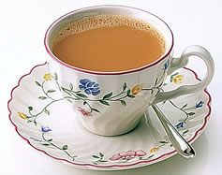

Hello, everyone.  
Today I’m going to talk about my dream.  
My dream is to .  
I have three reasons.

First,

Second,

.

Finally,

.

So, my dream is . Thank you.

**IDEAS**

～になりたい　→　I want to be~

～を見たい　→　I want to see~

～を経験したい　→　I want to experience~

～することは楽しい　→　It is fun to~

～することは大切だ　→　It is important for me to~

一度も～をしたことがない　→　I have never~

～することが好きだ　→　I like to~