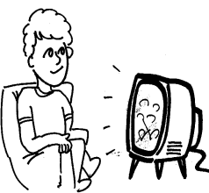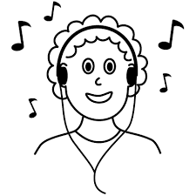

|  |  |
| --- | --- |
| 1. First, **what** did Muggli do? | https://i0.wp.com/i.imgur.com/f5GLLVF.jpghttp://sweetclipart.com/multisite/sweetclipart/files/imagecache/middle/kid_reading_line_art.png |
| 1. **Where** did Muggli go? | アメリカ |
| 1. **What** did Muggli do in Kochi? | Image result for surfing clipart black and whitehttp://images.clipartpanda.com/swimming-pool-clipart-black-and-white-p3.jpeg |
| 1. **What** festivals did Muggli go to? |  |

My summer vacation was **(1 )**.

First, I read books every day. It is fun for me to read many **(2 )( )** books. I read over ten books this summer.

Also, I saw many things this summer. It is **(3 )** for me to visit many places.

I went to Kyoto, Himeji, and Kochi. I enjoyed surfing and **(4 )** at the beach with my friends. Going to the beach **(5 )** me happy. It was very hot, but very fun.

Last, I **(6 )** two Japanese events. One was Tenjin Matsuri. The next event I enjoyed was the Yodogawa **(7 )**. It was very **(8 )**. I was very happy.

I really enjoyed my summer vacation.