SORRY!

「 Switch with a player! 」

Reverse

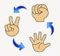

**Everyone Janken**

Winner's Turn

Oh no!!!

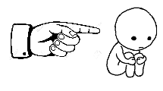

Go back to start.

Lucky!

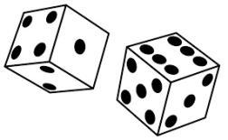

Roll again!