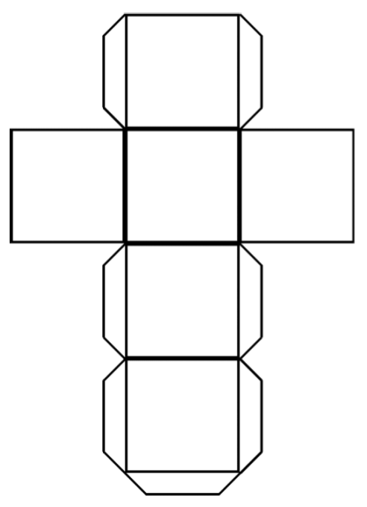



**Culture**



**Sports**



**Hobbies**



**Family**



**Food**



**School / Job**