**  
SANTA CLAUS IS COMING TO TOWN**

You better out

You better not cry

You better not pout

I’m telling you why

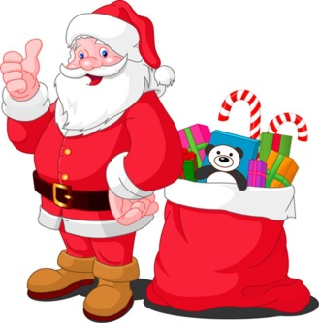Santa Claus is to town.

He’s a list.

And checking it twice.

He’s gonna find out

Who’s naughty or

Santa Claus is coming to town.

He sees you when you’re

He knows when you’re

He knows if you’ve been bad or good

So be for goodness sake!

Oh! You better watch out!

You better not .

You better not pout

I’m you why.

Santa Claus is coming to town.

Santa Claus is coming to town.

**WHITE CHRISTMAS**

I’m dreaming of a white Christmas

Just like the ones I used to .

Where the treetops glisten.

And children .

To hear sleigh bells in the snow.

I’m of a white Christmas

With every Christmas card I write.

May your be merry and bright

And may all your Christmases be .

I’m dreaming of a white Christmas

With every Christmas card I

May your days be merry and bright.

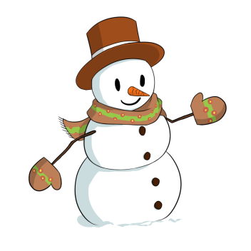And may your Christmases be white.