[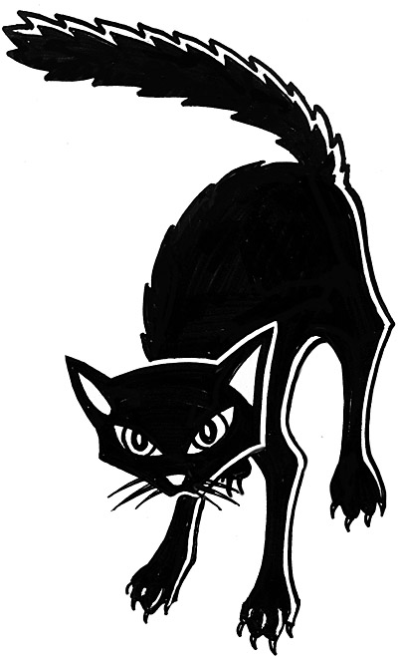](http://www.google.co.jp/url?sa=i&rct=j&q=&esrc=s&source=images&cd=&cad=rja&uact=8&ved=0ahUKEwj27NG44tnPAhWrj1QKHevdAOIQjRwIBw&url=http://www.dianliwenmi.com/postimg_4118513.html&bvm=bv.135475266,d.cGw&psig=AFQjCNELu7s0s83MEL78zZJEUcJAjFz6GA&ust=1476516320846121)





[](http://www.google.co.jp/url?sa=i&rct=j&q=&esrc=s&source=images&cd=&cad=rja&uact=8&ved=0ahUKEwjB8vqP49nPAhWmsVQKHexcBEwQjRwIBw&url=http://www.clipartpanda.com/categories/bat-clipart&bvm=bv.135475266,d.cGw&psig=AFQjCNFlDwHDBB_FEqEAPvpfx-9lx39tZA&ust=1476516546370285)

[](http://www.google.co.jp/url?sa=i&rct=j&q=&esrc=s&source=images&cd=&cad=rja&uact=8&ved=0ahUKEwi-w9LX5tnPAhXhsVQKHVsqAFEQjRwIBw&url=http://festival.1september.ru/articles/659593/pril.pptx&bvm=bv.135475266,d.cGw&psig=AFQjCNFVddIncJkf-XQ8pqMpyogB_kJxow&ust=1476517511185472)

[](http://www.google.co.jp/url?sa=i&rct=j&q=&esrc=s&source=images&cd=&cad=rja&uact=8&ved=0ahUKEwjdj_mtg-bPAhWBxJQKHdk0BdYQjRwIBw&url=http%3A%2F%2Fwww.clipartkid.com%2Fvampire-cliparts%2F&bvm=bv.135974163,d.dGo&psig=AFQjCNEq7X6iHjYyYEuXuwYswmlq1b1EGw&ust=1476937428970636)