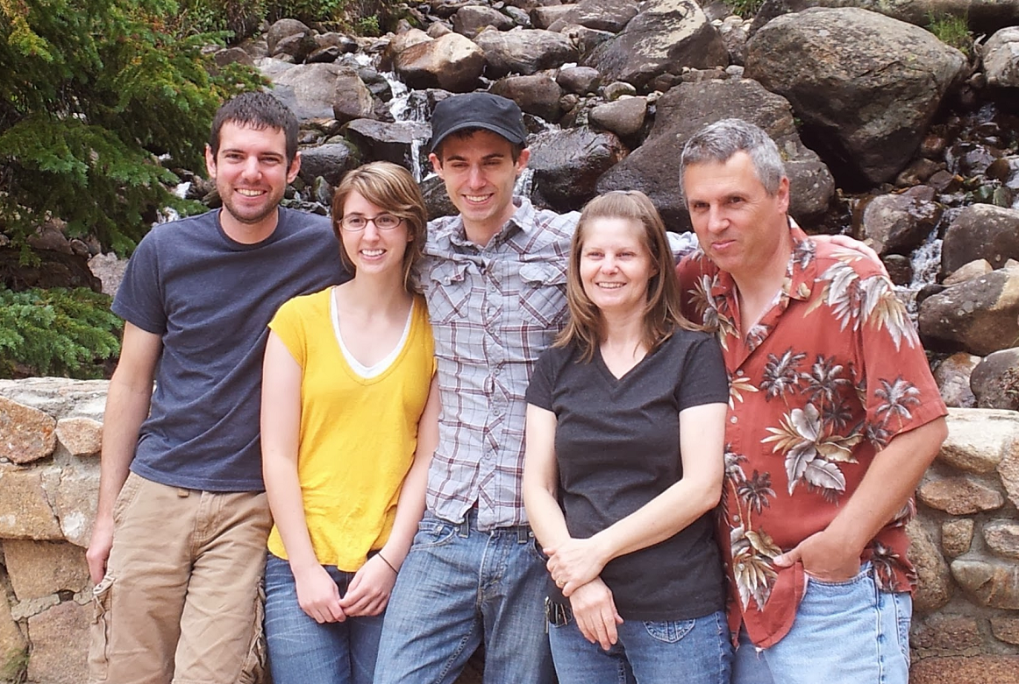

Hello. This is my family. We are from America.

This is Gary. He is my father.

He is about fifty-four years old.

He has two brothers and four sisters.

This is Deb. She is my mother.

She is fifty-three years old. She is short.

She likes watching TV dramas.

This is Jordan. He is my younger brother.

He is very smart. He likes cooking.

This is my younger sister. Her name is Ashley.

She wears glasses. She likes drawing pictures.

Thank you for listening.