Class( )No( )Name( 　　　 )

**Junior High School in America**

アメリカと日本の学校生活の違いを知ろう！

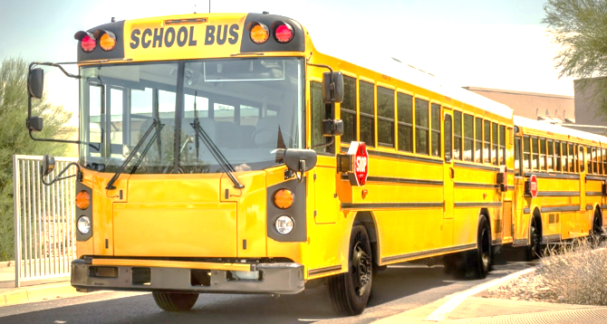

* 登校

In Japan, every student goes to school by walking.

But in America, Students go to school by walking, biking, or taking the (**1** ).

Students do not take off their (**2** ) at school.

* 授業

In Japan, students have their own classrooms.

In America, students don’t have their classrooms.

Students use lockers for their (**3** ) and (**4** ).

In Japan, every student studies (**5** ).  
In America, every student chooses a language.

* 昼ごはん

In Japan, students bring their lunch box and eat in their classrooms.

In America, students eat (**6** ) in the cafeteria.

* クラブ活動

In Japan, clubs are (**7** ).

In America, clubs are not on weekends or holidays.

* 掃除

In America, students do not have a homeroom class.

So, the students do not (**8** ) the rooms.

* 春休み・夏休み

In Japan, school ends in (**9** ).

The vacation is about (**10** ) weeks.  
In America, school ends in (**11** ).

The vacation is about (**12** ) weeks.

* 入試

In America, there is no entrance exam. So, all students go to the same (**13** ).

/13