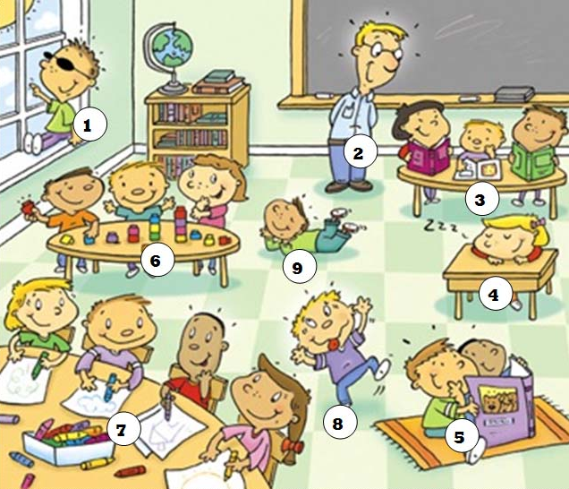

|  |  |  |
| --- | --- | --- |
| Lisa | Tom | Tomoko |
| Bob | Emma | Ken |
| Joe | James | David |