|  |  |
| --- | --- |
| Lesson9-1 | **Listening Practice** |

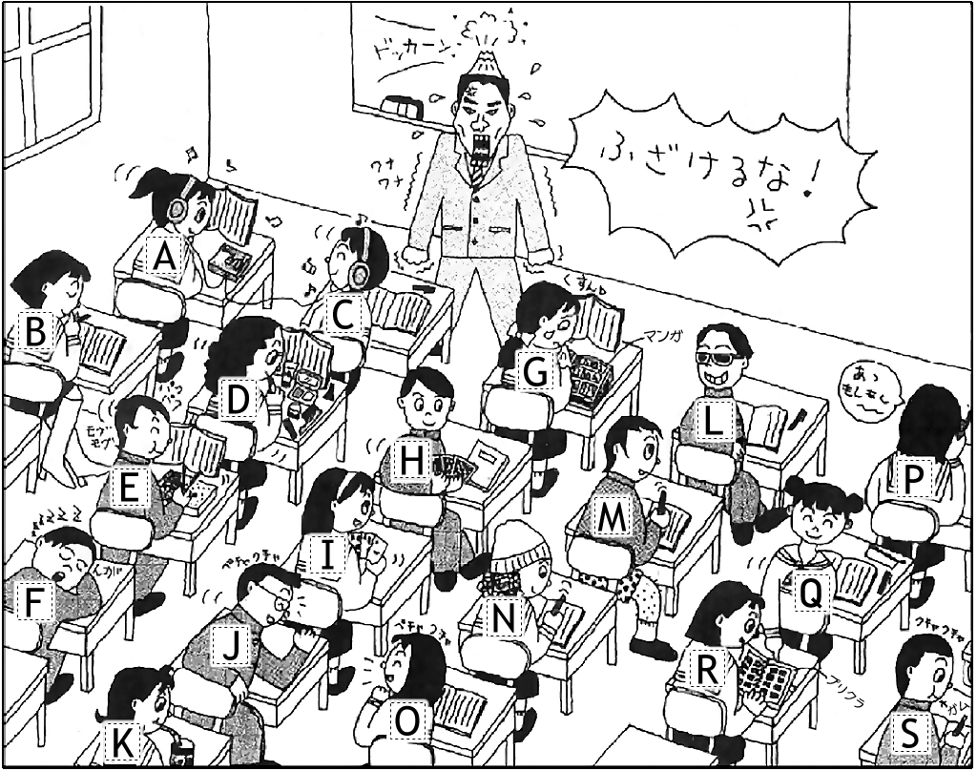**Memo**

1. Asami ( *B* ) *studied*
2. Takumi & Marie ( ) _________________
3. Maki ( ) ___________________
4. Daichi ( ) ___________________
5. Takasa ( ) ___________________
6. Aya ( ) ___________________
7. Saho & Mizuki ( ) ________________
8. Kenta ( ) ___________________
9. Maya ( ) ___________________
10. Mai ( ) ___________________
11. Takeshi ( ) ___________________
12. Mayumi ( ) ___________________
13. Chisato ( ) ___________________

**Lesson 9-1: Listening Answers**

1. [B] Asami studied quietly.
2. [H / I] Takumi & Marie played card games.
3. [G] Maki read a comic book.
4. [L] Daichi wore sunglasses.
5. [D] Takasa put on make-up.
6. [K] Aya drank coca-cola.
7. [A / C] Saho & Mizuki listened to music.
8. [E] Kenta ate lunch.
9. [P] Maya talked on a phone..
10. [O] Mai talked to a boy.
11. [F] Takeshi slept on a desk.
12. [R] Mayumi looked at purikura pictures.
13. [N] Chisato wore a hat.