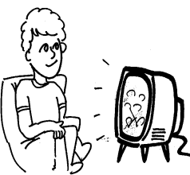

|  |  |
| --- | --- |
| 1. First, **what** did Muggli do? | http://sweetclipart.com/multisite/sweetclipart/files/imagecache/middle/kid_reading_line_art.pnghttps://i0.wp.com/i.imgur.com/f5GLLVF.jpg |
| 1. **Where** did Muggli go? | アメリカ |
| 1. **What** did Muggli do? | Image result for surfing clipart black and whitehttp://images.clipartpanda.com/swimming-pool-clipart-black-and-white-p3.jpeg |
| 1. **What** did Muggli go to? |  |

* My summer vacation：
* First, I read books every day. I read over ten books this summer. I love reading books.
* Next, I went to Kochi. In Kochi, I enjoyed surfing with my friend. It was very very hot, but very very fun.
* Last, I experienced two festivals. One was Tenjin Matsuri. I ate takoyaki there. Another was Yodogawa hanabi. It was very beautiful. I was very happy.
* I reallly enjoyed my summer vacation.